Nivolumab as adjuvant treatment of melanoma: 24 month predicted versus actual analysis and melanoma market review

Drug utilisation sub-committee (DUSC)

September 2022

Abstract

Purpose
Analysis of the predicted versus actual utilisation of nivolumab 24 months following its addition to the Pharmaceutical Benefits Scheme (PBS) for the adjuvant treatment of melanoma on 1 March 2020. A broad market review of all medicines used in the treatment of melanoma was also undertaken.

Data Source / methodology
PBS dispensing data was extracted from the PBS data maintained by the Department of Health and Aged Care, processed by Services Australia.

Key Findings
- In the first year of listing adjuvant nivolumab was utilised by 1,311 patients at a cost of $75 million (based on published prices) to the PBS/RPBS which was xxxx than predicted.
- In the second year of listing adjuvant nivolumab was utilised by 1,120 patients at a cost of $62 million (based on published prices) to the PBS/RPBS which was xxxx than predicted.
- Patients initiating on adjuvant nivolumab ranged between 140-190 new patients per quarter.
- The majority of patients beginning adjuvant nivolumab were males (1,495 since listing) with a median age of 68 years, while females numbered less (719 since listing) with a median age of 66 years.
- Rate of prescribing of adjuvant nivolumab was as expected with capital cities and Queensland being the primary locations.
- Median time on treatment for adjuvant nivolumab was 231 days with breaks and 211 days without breaks.
- Approximately 75% of supplies of adjuvant nivolumab were at 480 mg every four weeks, 20% 240 mg and 5% was dose reductions or dose by weight.
- The utilisation and expenditure of nivolumab and ipilimumab have increased considerably since restrictions were changed in 2018 and 2019 regarding use in the unresectable setting.
- Based on published prices, total expenditure for melanoma medications in 2021 was approximately $500 million with the majority of costs incurred by checkpoint inhibitors in the unresectable market followed by PD1 inhibitors in the adjuvant market and BRAF/MEK inhibitors in the unresectable market.

Purpose of analysis
Analysis of the predicted versus actual utilisation of nivolumab 24 months following its addition to the Pharmaceutical Benefits Scheme (PBS) for the adjuvant treatment of melanoma on 1 March 2020. A broad market review of all medicines used in the treatment of melanoma was also undertaken.

Background

Clinical situation

Melanoma is caused by the differentiation of melanocytes to cancerous cells as a consequence of aberrant changes at molecular and biochemical levels.¹ Melanocytes are responsible for the production of melanin that protect against DNA damage induced by UV radiation.¹ Keratinocytes are responsible for the growth of melanocytes and a melanoma develops when melanocyte growth becomes uncontrolled.¹
In Australia melanoma was the fourth most commonly diagnosed cancer in 2017 and is expected to become the third most commonly diagnosed in 2021 with an estimated 16,878 new cases diagnosed.² In 2021 it is estimated there will be 1,315 deaths caused by melanoma and a 0.41% risk of dying from melanoma by the age of 85 years² making it the deadliest form of skin cancer¹.
In the locoregional melanoma setting current guidelines suggest the surgical resection of the melanoma followed by adjuvant therapy, however there is emerging evidence for the use of neoadjuvant therapy.³
In the metastatic setting current guidelines recommend individualised treatments such as the use of targeted therapies B-Raf serine-threonine kinase (BRAF) inhibitors, Mitogen-activated protein kinase (MEK) inhibitors or immunotherapies such as nivolumab a programmed cell death protein 1/ ligand 1 (PD-1/PDL-1) inhibitor with ipilimumab which targets the cytotoxic T-lymphocyte-associated protein 4 (CTL-4) receptor.⁴

Pharmacology
Nivolumab is a monoclonal antibody which binds to programmed death-1 (PD-1) receptor and blocks its interaction with the ligands PD-L1 and PD-L2. The PD-1 receptor is a negative regulator of T-cell activity. In syngeneic mouse models, blocking PD-1 activity resulted in decreased tumour growth.⁵

Therapeutic Goods Administration (TGA) approved indications
Nivolumab is currently TGA approved for the following indications:
- Melanoma.
- Non-Small Cell Lung Cancer with/without ipilimumab.
- Malignant Pleural Mesothelioma with ipilimumab.
- Renal Cell Carcinoma with ipilimumab/cabozantinib.
- Classical Hodgkin Lymphoma.
- Squamous Cell Carcinoma of the Head and Neck.
- Urothelial Carcinoma.
- Hepatocellular Carcinoma.
- Oesophageal Squamous Cell Carcinoma.
- Adjuvant Oesophageal Cancer or Gastro-Oesophageal Junction.
- Gastric Cancer, Gastro-oesophageal Junction Cancer, or Oesophageal Adenocarcinoma in combination with fluoropyrimidine and platinum based chemotherapy.
There was a black box warning for nivolumab in combination with ipilimumab due to the increased incidence and severity of adverse reactions than when either is used as monotherapy.

Dosage and administration
Nivolumab is administered via a 30 minute intravenous infusion and the recommended dose in the adjuvant treatment of melanoma is:
- 3mg/kg every two weeks OR
- 240mg every two weeks OR
- 480mg every four weeks.
The current Product Information (PI) and Consumer Medicine Information (CMI) are available from the TGA (Product Information) and the TGA (Consumer Medicines Information).

PBS listing details (as at 5 August 2022)

Table 1: PBS listing of nivolumab for adjuvant therapy of melanoma
Item | Name, form & strength, pack size | Max. quant. | Rpts | DPMQ | Brand name and manufacturer
11900H | Nivolumab, 40mg/4mL injection, 4mL vial  Nivolumab, 100mg/10mL injection, 10mL vial | 480mg | 5 | $9557.05 | Opdivo,  Bristol-Myers Squibb Australia Pty Ltd
11906P | Nivolumab, 40mg/4mL injection, 4mL vial  Nivolumab, 100mg/10mL injection, 10mL vial
Source: the PBS website. Note: Special Pricing Arrangements apply.

Restriction
Resected Stage IIIB, IIIC, IIID or Stage IV malignant melanoma
Treatment Phase: Initial treatment
Clinical criteria;
The treatment must be adjuvant to complete surgical resection,
AND
Patient must have a WHO performance status of 1 or less,
AND
The treatment must be the sole PBS-subsidised therapy for this condition,
AND
Patient must not have received prior PBS-subsidised treatment for this condition,
AND
The treatment must commence within 12 weeks of complete resection,
AND
Patient must not receive more than 12 months of combined PBS-subsidised and non-PBS-subsidised adjuvant therapy.
Patients must only receive a maximum of 240 mg every two weeks or 480 mg every four weeks under a weight based or flat dosing regimen.
Note
In the first few months after start of immunotherapy, some patients can have a transient tumour flare with subsequent disease response. When progression is suspected, this should be confirmed through a confirmatory scan, taken at least 4 weeks later.
Treatment Phase: Continuing treatment
Clinical criteria:
Patient must have previously been issued with an authority prescription for this drug for adjuvant treatment following complete surgical resection,
AND
Patient must not have experienced disease recurrence,
AND
The treatment must be the sole PBS-subsidised therapy for this condition,
AND
Patient must not receive more than 12 months of combined PBS-subsidised and non-PBS-subsidised adjuvant therapy.
Patients must only receive a maximum of 240 mg every two weeks or 480 mg every four weeks under a weight based or flat dosing regimen.
For details of the current PBS listing refer to the PBS website.

Date of listing on PBS
Nivolumab was listed on the PBS for adjuvant therapy of melanoma following complete surgical resection on 1 March 2020.

Relevant aspects of consideration by the Pharmaceutical Benefits Advisory Committee (PBAC)
Nivolumab was considered as adjuvant treatment for melanoma by the PBAC over four submissions.
July 2018 PBAC Meeting
The first submission for nivolumab requested a listing for adjuvant treatment for completely resected Stage III or Stage IV melanoma on a cost-utility basis compared with observation or interferon alfa 2B. The submission was considered by DUSC and it was noted that the estimated population was uncertain due to difficulty in estimating disease progression from primary disease incidence, especially as USA data was used to inform assumptions which would likely differ to the Australian population.
The PBAC did not recommend the listing of melanoma due to the high uncertainty in magnitude of clinical benefit, high incremental cost-effectiveness ratio and high financial impact.
For further details refer to the Public Summary Document from the July 2018 PBAC meeting.
March 2019 PBAC Meeting
The second submission revised the sources for the financial estimates and used primarily Australian sources. The PBAC still considered that the estimated financial implications were uncertain, particularly with regards to the cost-offsets, which were not well justified, and the proportion of patients initially diagnosed with Stage I or II disease that experience a disease recurrence with resectable Stage III or Stage IV disease.
The PBAC did not recommend the listing of melanoma due to the high uncertainty in magnitude of clinical benefit, high incremental cost-effectiveness ratio and high financial impact.
For further details refer to the Public Summary Document from the July 2018 PBAC meeting.
July 2019 PBAC Meeting
The PBAC noted that the estimated financial implications of listing nivolumab on the PBS for use as an adjuvant in melanoma patients had been updated from the March 2019 submission and appeared more reasonable, although noted that the proportion of Stage III patients with completely resectable disease (86%) may have been overestimated.
The PBAC acknowledged that there was a high unmet clinical need for effective therapies to reduce the risk of recurrence for patients with resected Stage IIIB, IIIC, IIID or Stage IV melanoma. The PBAC deferred making a decision regarding the listing of nivolumab as adjuvant treatment for patients with completely resected Stage IIIB, IIIC, IIID or Stage IV melanoma to allow for further discussions regarding an acceptable price and risk sharing arrangement.
For further details refer to the Public Summary Document from the July 2018 PBAC meeting.
November 2019 PBAC Meeting
The PBAC recommended the listing of nivolumab for the adjuvant treatment of completely resected Stage IIIB, IIIC, IIID or Stage IV malignant melanoma. The PBAC noted changes made to the economic analysis and considered that the uncertainty surrounding uptake in the adjuvant setting and changes to use in the unresectable or metastatic setting would be managed by subsidisation caps through a Risk Sharing Arrangement (RSA).
The PBAC noted that the estimated financial implications of listing nivolumab on the PBS for use as an adjuvant in melanoma patients had been updated from the July 2019 minor resubmission and considered that the following assumptions were reasonable:
- That 81% of Stage III patients would have resectable disease;
- That the uptake rate of PD-1 inhibitors in BRAF mutant patients would be 74.1% in the adjuvant setting; and
- That the equivalent number of grandfathered patients to receive a full course of treatment on the PBS would be less than 500 in Year 1 of PBS listing
The sponsor proposed a RSA for patients receiving PD-1 inhibitors across the adjuvant and unresectable or metastatic settings.
For further details refer to the Public Summary Document from the July 2018 PBAC meeting.

Approach taken to estimate utilisation
An epidemiological approach was taken to estimate the utilisation of nivolumab as an adjuvant treatment in melanoma patients. The incidence of melanoma was estimated from the Australian Cancer Incidence and Mortality book published by the Australian Institute of Health and Welfare (AIHW) and the proportion of these patients diagnosed at different stages were estimated using data from Cancer Australia’s National Cancer Control Indicators. The number of patients experiencing disease progression from the various stages of melanoma was estimated using an epidemiological model based on the proportion of patients diagnosed at stages I and II who would progress to treatment as indicated in the DUSC 2017 report on melanoma. Patients with completely resectable disease was estimated based on a clinician survey and taking into account PBAC comments from the July 2019 submission. This represented the total eligible pool of patients for adjuvant therapy and a further input was applied to establish the number of patients with the BRAF V600 variant who would have a reduced uptake rate of nivolumab compared to the wild-type variant with supporting data from a clinician survey. Grandfathered patients were also added to the first year estimates.

Table 2: Summary of key inputs for estimates of the November 2019 submission.
Patient population size assumptions | Per Year
Incident population newly diagnosed melanoma | Xxxxxxxx
Stage III 3.0%, based on NCCI (2011) | Xxxxxxxx
Stage IV 2.1%, based on NCCI (2011) | Xxxxxxxx
92.1% Stage I/II disease, based on NCCI (2011) | Xxxxxxxx
% patients that progress from Stage I/II to Stage III/IV disease | Xxxxxxxx
% patients with completely resectable Stage III disease | Xxxxxxxx
% patients with completely resectable Stage IV disease | Xxxxxxxx
% of Stage III patients that are subgroup Stage IIIA | Xxxxxxxx
Treatment uptake rate | Xxxxxxxx
% BRAF MT | Xxxxxxxx
Uptake PD-1 therapy in BRAF MT eligible patients | Xxxxxxxx
Total new patients treated with PD-1 for AdjMEL | xxxxxxxx

Previous reviews by the DUSC
Nivolumab has been reviewed previously by DUSC for non-small cell lung cancer (June 2020), renal cell carcinoma (June 2020) and in combination with ipilimumab for Stage IV clear cell variant renal cell carcinoma (October 2021).
Melanoma listings for molecularly targeted drugs and immunotherapies were also reviewed by DUSC in October 2018 however at the time there were no listings for adjuvant therapies.
For details of the DUSC reviews refer to the Public Release Documents.

Methods
Data from 1 March 2020 to 30 July 2022 were extracted from the PBS data maintained by Department of Health and Aged Care, processed by Services Australia on or before 10 August 2022 for the PBS item codes corresponding to the adjuvant use of nivolumab in melanoma.
PBS prescription data were used to determine the number of prescriptions supplied and the PBS expenditure based on the published list prices. These data were also used to count the number of patients, both incident (new to treatment) and prevalent (number treated in each time period, i.e. year or quarter).
PBS prescription data also contains age and gender information. This information was used to perform a breakdown of prevalent patients by age and gender.
The Kaplan-Meier method was used to determine the length of treatment for patients on nivolumab. A break in treatment was defined as a gap of more than three times the median time between supplies which was found to be 28 days. A patient was deemed to be continuing treatment (classified as censored in the Kaplan-Meier analysis) at the end of the data period (i.e. the end of July 2022) if their last prescription was within three times the median time to resupply of this end date. Otherwise the patient was deemed to have ceased treatment with the treatment coverage end date being the supply date of their last prescription plus a median time to resupply. If a patient’s supply was after a gap of more than three times the median time to resupply, then the patient was deemed to have been re-treated.
Mapping data was created using patient post codes supplied upon dispensing. Prescriptions were then aggregated by approximate Statistical Area Level 4 (SA4) geographical areas as determined by the Australian Statistical Geography Standard established by the Australian Bureau of Statistics. Some patients were linked to post codes reserved for PO boxes that did not map to SA4 regions. Pharmacy post code data was used instead of patient post code for these prescriptions.
The Sankey diagram (Figure 4) was created based on the last processed prescription for each patient per month following initiation in those patients who began treatment in the first year of listing.
The estimates model used to present the estimated cost to the PBS/RPBS was a model that was agreed upon by both the Department of Health and Aged Care and the Sponsor. Refer to the ‘Approach to estimate utilisation’ section for further details on the development of the financial estimates.

Results

Analysis of nivolumab drug utilisation for resected melanoma

Overall utilisation

Figure 1: Utilisation of nivolumab for the adjuvant treatment of melanoma.
Prescription data between 2020Q1 to 2022Q2 presented as prevalent and initiating patients on nivolumab as adjuvant therapy in melanoma can be seen in Figure 1. There were a total of 437 new patients in the first quarter of listing 2020Q1. Following this the number of prevalent patients peaked in 2020Q2 at 788 patients before plateauing just under 600 prevalent patients per quarter since 2021Q3. The number of initiating patients has remained consistent ranging between 140 to 190 new patients per quarter.

Utilisation by relevant sub-populations/regions or patient level analysis

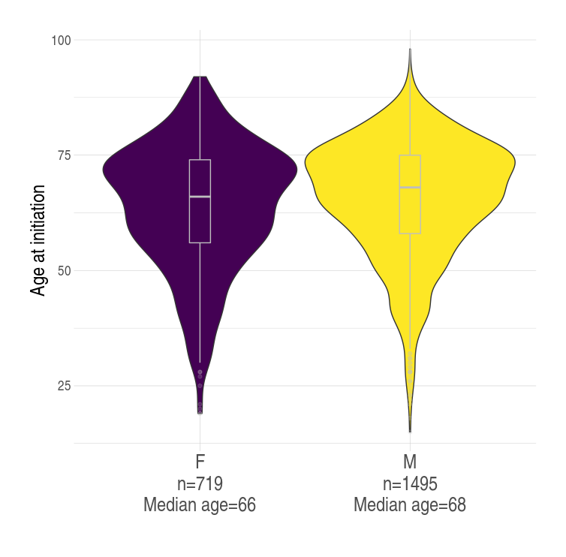
Figure 2: Violin plot of initiating patients on nivolumab as adjuvant therapy in melanoma by sex and age.
A breakdown of initiating patients on nivolumab as adjuvant therapy in melanoma can be seen in Figure 2. From the date of listing there were a total of 2,214 patients of which 719 were female and 1,495 were males. The median age at initiation varied between sexes with 66 years old in females and 68 years in males however the interquartile range (range representing 50% of the population) for both groups were largely similar between 65-75 years old.

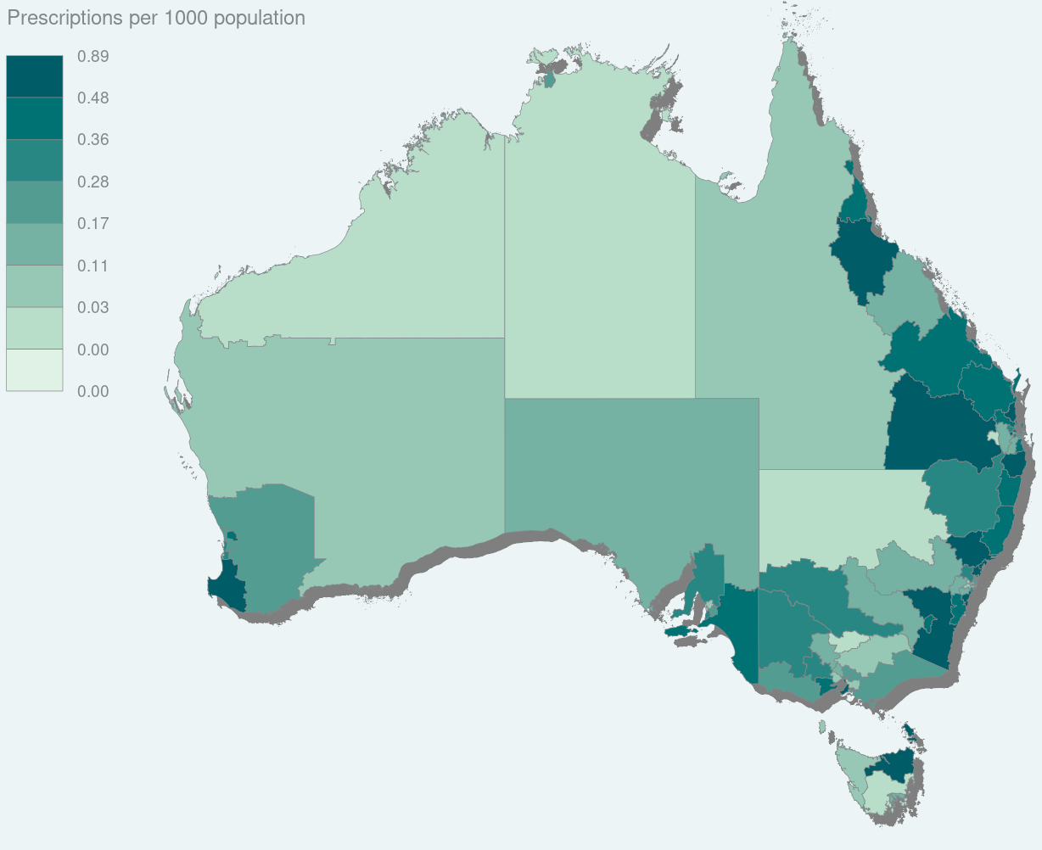Figure 3: Choropleth map shading by the number of prescriptions of nivolumab as adjuvant therapy in melanoma per 1000 population.
Prescription data was standardised by population according to SA4 regions. This data was mapped and presented in Figure 3 which shows that the majority of prescribing for nivolumab as adjuvant therapy in melanoma occurs around major metropolitan locations. Regions with the highest rates of prescribing aside from major cities were the Bunbury region of Western Australia, Townsville, Darling Downs – Maranoa of Queensland, Richmond – Tweed on the border of New South Wales and Queensland and the Capital and Hunter Valley region excluding Newcastle in New South Wales.

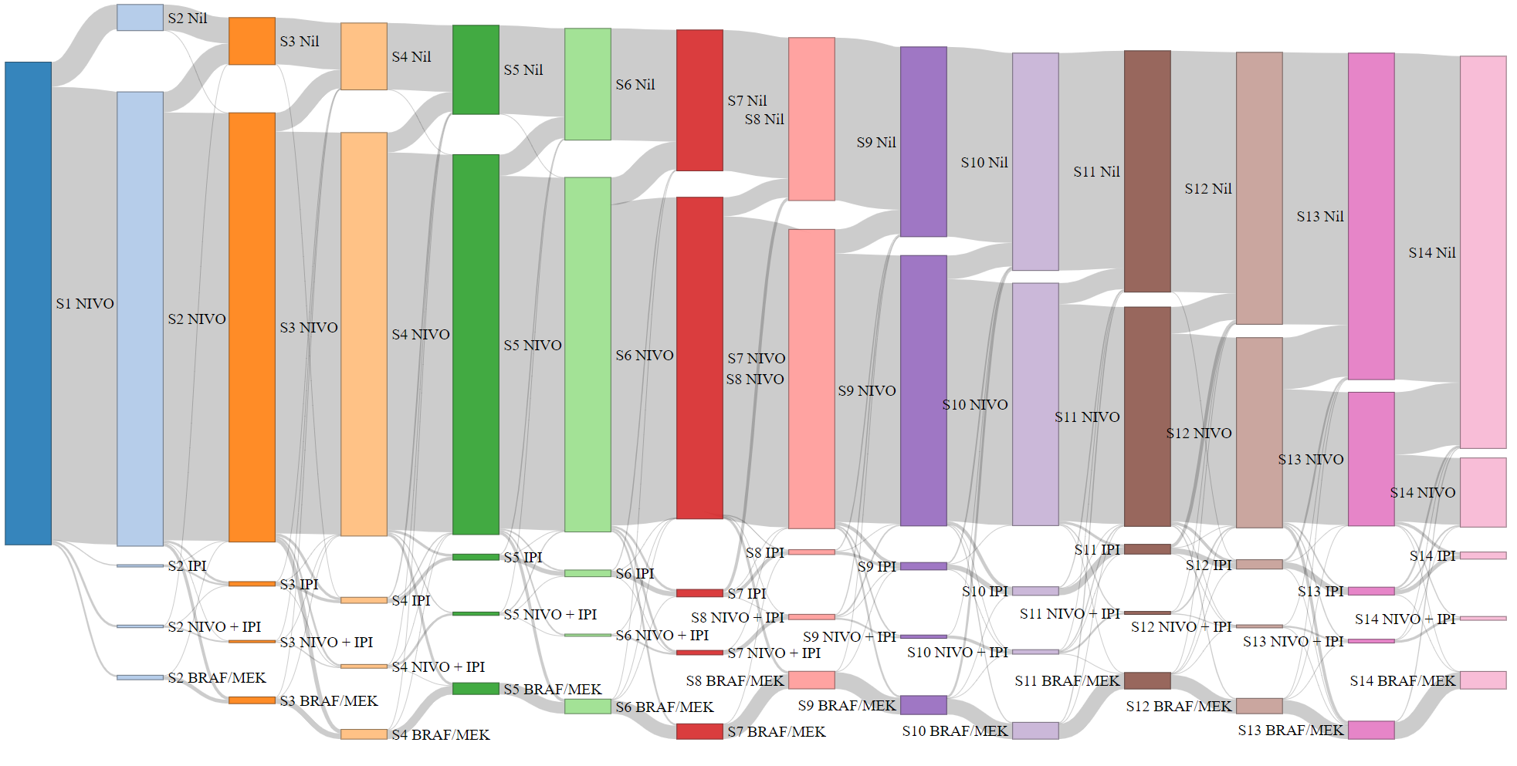

Figure 4: Sankey diagram illustrating the flow of patients each month following initiation of nivolumab as adjuvant therapy in melanoma.
Figure 4 represents a Sankey diagram showing the flow of patients each month after beginning treatment on nivolumab as adjuvant therapy in melanoma. The diagram follows patients who began treatment in the first year of listing and it can be seen that the majority of patients move towards no further treatments after ceasing nivolumab. A small proportion of patients in each step move towards treatment with ipilimumab while a larger proportion move to BRAF and MEK inhibitors.

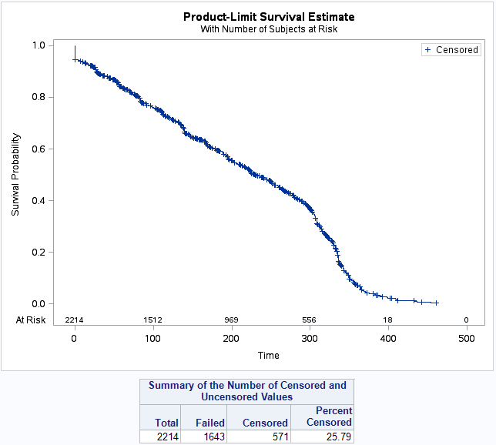
Figure 5: Kaplan-Meier analysis of the time on treatment of patients supplied nivolumab as adjuvant therapy in melanoma including treatment breaks.
The median time to resupply for nivolumab as adjuvant therapy in melanoma was 28 days. The Kaplan-Meier analysis in Figure 5 includes patients with identified treatment breaks of longer than 84 days. Figure 5 shows this analysis where 25.79% of patients were censored and the median time on treatment for the remaining 1643 patients was 231 days.

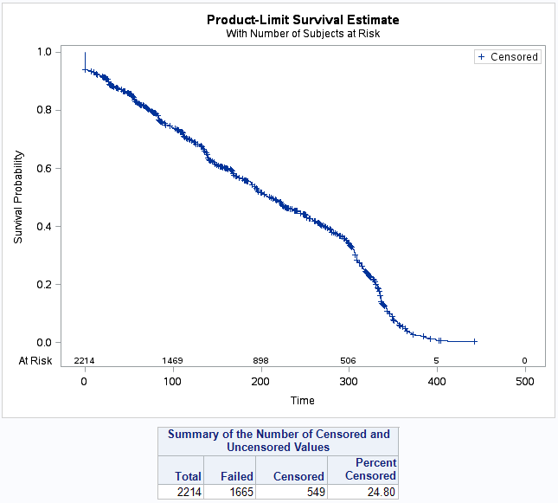
Figure 6: Kaplan-Meier analysis of the time on treatment of patients supplied nivolumab as adjuvant therapy in melanoma without treatment breaks (first episode of treatment).
Figure 6 shows another Kaplan-Meier analysis however does not include treatment breaks and therefore represents a patient’s first episode of treatment. A total of 24.80% of patients were censored from the analysis and the remaining 1665 patients had a median time on treatment of 211 days (95% CI 197-224).

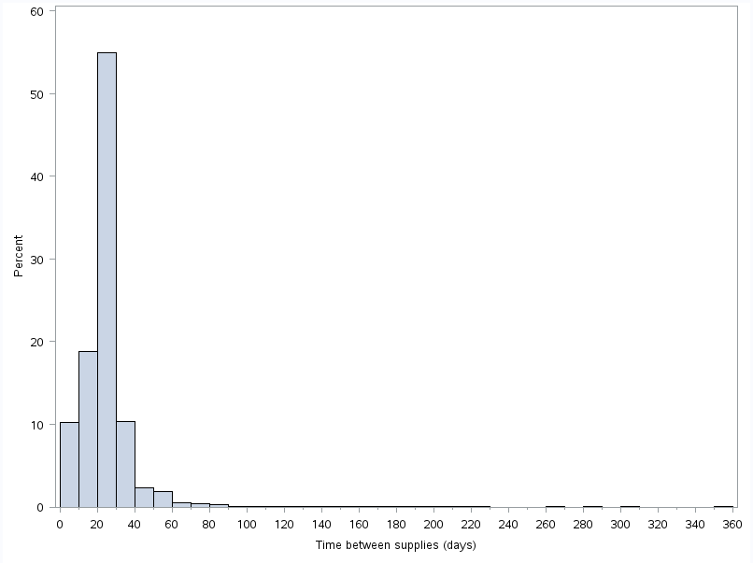

Figure 7: Histogram of time between supplies of nivolumab as adjuvant therapy in melanoma.
Nivolumab as adjuvant therapy in melanoma can be dosed on either a 2 or 4 week regimen. Figure 7 represents a histogram of the time between supplies of nivolumab as adjuvant therapy in melanoma and indicates that over 50% of patients were likely to be on the 4-weekly regimen while a smaller group of around 20% were closer to a 2-weekly resupply.
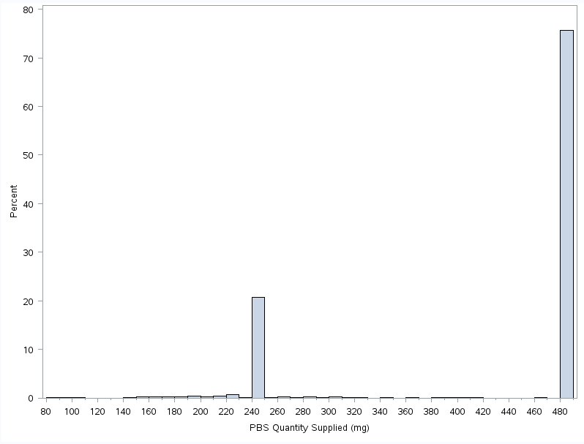

Figure 8: Histogram of the PBS quantity supplied per prescription of nivolumab for as adjuvant therapy in melanoma.
The 2-weekly regimen of nivolumab as adjuvant therapy in melanoma can either be dosed as mg/kg or a flat dose of 240mg while the 4-weekly regimen uses a 480mg flat dose. Figure 8 represents a histogram of the PBS quantity supplied per prescription of nivolumab as adjuvant therapy in melanoma. It shows that approximately 75% of patients were dosing at 480mg per supply, approximately 20% were dosing at 240mg per supply and the remaining 5% were either dose reductions or dosing according to weight.

Analysis of actual versus predicted utilisation

Table 3: Actual versus predicted utilisation and cost to the PBS/RPBS of nivolumab as adjuvant therapy in melanoma.
Nivolumab listing years |  | Year 1 | Year 2
 |  | March 2020- February 2021 | March 2021- February 2022
Patients | Predicted | xxxxxxxx | xxxxxxxx
 | Actual | 1,311 | 1,120
 | Difference | Xxxxxxxx | xxxxxxxx
Prescriptions | Predicted | xxxxxxxx | Xxxxxxxx
 | Actual | 8,777 | 6,799
 | Difference | Xxxxxxxx | xxxxxxxx
Net Cost PBS/RPBS | Predicted | xxxxxxxxXXXX | Xxxxxxxxxxx
 | Actual | $75,212,434 | $62,396,373
 | Difference | Xxxxxxxx | xxxxxxxx
Note: Net cost to PBS/RPBS figures based on published prices.
Table 3 presents a comparison of the predicted versus actual utilisation and expenditure of nivolumab as adjuvant therapy in melanoma since listing in March 2020. In the first year of listing the number of prevalent patients was 1,311 which is xxxxxxxx than what was predicted. The number of patients in Year 2 was 1,120 which is xxxxxxxx than the xxxxxxxx that was predicted. The number of prescriptions dispensed in all years of listing were xxxxxxxx than what was predicted and the cost to the PBS/RPBS mirror the amount of prescriptions that were dispensed and were xxxxxxxx than predicted.

Melanoma market overview
For the purpose of this review the melanoma market was categorised into the following groups presented in Table 4.

Table 4: Classification of melanoma medicines for this review.
Surgical classification | Class | Drug name
Post complete surgical resection | PD1 inhibitors | Nivolumab
 |  | Pembrolizumab
 | BRAF and MEK inhibitors | Dabrafenib
 |  | Trametinib
Unresectable | Checkpoint inhibitors | Ipilimumab
 |  | Nivolumab
 |  | Pembrolizumab
 | BRAF inhibitors | Dabrafenib
 |  | Encorafenib
 |  | Vemurafenib
 | MEK inhibitors | Binimetinib
 |  | Cobimetinib
 |  | Trametinib
 | Other | Fotemustine
 |  | Interferon Alfa-2B

Figure 9: Prevalent patients per year on melanoma medications according to surgical classification of restrictions.
Note: Total unresectable patients count contains patients who may have been considered in the post resection group in the same year. The two populations cannot be summed.
The number of patients using melanoma medications can be seen in Figure 9. In 2021 there were around 1,500 patients who used a medicine listed for post complete surgical resection and around 5,000 patients who used medicines for unresectable melanoma. It should be noted that some patients may have progressed from the post resection group into the unresectable group and as such the populations cannot be summed.

Table 4: Number of patients progressing from post resection to unresectable restrictions per year
Year | Overlap | Total patients on post resection medicines | Percent
2019 | 18 | 55 | 33%
2020 | 299 | 1434 | 21%
2021 | 326 | 1489 | 22%
Table 4 shows the number of patients who had a script dispensed as post-complete resection of melanoma and went on to also have a script dispensed for a medicine with an unresectable restriction in that year. The data from 2020 and 2021 indicate that approximately 20% of the patients of the post-resection group progressed to the unresectable group.

Figure 10: Utilisation of PD1 inhibitors post complete surgical resection of melanoma
The utilisation of PD1/L1 inhibitors for the treatment of previously surgically resected melanoma can be seen in Figure 10. As seen previously in Figure 1, the utilisation of nivolumab has plateaued at approximately 600 patients per quarter and the introduction of pembrolizumab for adjuvant treatment of melanoma in 2020Q3 appears to have had little impact on the utilisation of nivolumab. Pembrolizumab utilisation appears steady at less than 100 patients per quarter however recent data shows an uptick which may result in increased utilisation in future data.

Figure 11: Utilisation of BRAF and MEK inhibitors post complete surgical resection of melanoma.
The restriction for the BRAF inhibitor dabrafenib and the MEK inhibitor trametinib for use after surgical resection of melanoma state that they should be used together. Figure 11 shows the utilisation of these drugs for this indication and both prevalent and initiating patient numbers are matching with a plateau of approximately 100 prevalent patients per quarter and less than 40 new patients per quarter.

Figure 12: Utilisation of checkpoint inhibitors for unresectable melanoma.
Ipilimumab was the first checkpoint inhibitor for unresectable melanoma that was PBS listed and available since 2013Q3 while pembrolizumab was listed in 2015Q3 and nivolumab followed in 2016Q2. Figure 12 shows that ipilimumab utilisation had remained steady from 2013 until pembrolizumab was listed in 2015 which caused a substantial decrease in ipilimumab utilisation. Nivolumab however did not substantially impact the market when it listed in 2016Q2 however utilisation increased substantially after 2018Q3 and hasn’t appeared to plateau. During this same period pembrolizumab utilisation has decreased from 1300 to 800 prevalent patients per quarter.

Figure 13: Utilisation of BRAF inhibitors for unresectable melanoma.
Note: Any patient numbers less than five per quarter have been increased to five to prevent re-identification.
Dabrafenib was the first BRAF inhibitor for unresectable melanoma and was listed in 2013Q4. Since then it has increased in utilisation and peaking at approximately 700 prevalent patients per quarter before dropping considerably with the introduction of encorafenib in 2020Q2 (Figure 13). Vemurafenib was listed in 2017Q2 however does not appear to have substantially altered the market.

Figure 14: Utilisation of MEK inhibitors for unresectable melanoma.
Note: Any patient numbers less than five per quarter have been increased to five to prevent re-identification.
The utilisation of MEK inhibitors (Figure 14) mirrors that of the BRAF inhibitors with binimetinib utilisation being similar to dabrafenib, cobimetinib similar to encorafenib and trametinib similar to vemurafenib.

Figure 15: Utilisation of other medicines for unresectable melanoma.
Figure 15 shows the utilisation of other medicines such as fotemustine and interferon alfa-2B for malignant melanoma. The use of both medicines has declined since their introduction and interferon alfa-2B was delisted on 31 May 2018 and fotemustine was delisted on 31 July 2022.

Melanoma expenditure

Figure 16: Total PBS/RPBS expenditure for melanoma medications
Note: Expenditure figures based on published prices.

The total PBS/RPBS expenditure for melanoma medications can be seen in Figure 16. Three main groups make up the approximate $120 million dollars per quarter market. The largest share comprising of $80 million per quarter is due to the checkpoint inhibitors in unresectable melanoma, followed by $20million in the PD1 inhibitor resected market and $20 million in the BRAF/MEK inhibitor unresectable market. Total expenditure for 2021 was approximately $500 million.

Figure 17: Total PBS/RPBS expenditure for PD1 inhibitors post complete surgical resection of melanoma
Note: Expenditure figures based on published prices.

The total PBS/RPBS expenditure for PD1 inhibitors as adjuvant therapy in melanoma can be seen in Figure 17 which shows a gradual decline in nivolumab cost from a peak of over $20million per quarter to $15 million per quarter. Pembrolizumab has been increasing steadily since listing in 2020Q3 to approximately $3 million per quarter in 2022Q2.

Figure 18: Total PBS/RPBS expenditure for BRAF/MEK inhibitors post complete surgical resection of melanoma
Note: Expenditure figures based on published prices.

Figure 18 shows the total PBS/RPBS expenditure for dabrafenib and trametinib for surgically resected melanoma where the cost has been steady at $1.4 million per drug per quarter since 2020. The expenditure for both medicines is approximately the same reflecting the similar patient numbers seen in Figure 11.

Figure 19: Total PBS/RPBS expenditure for checkpoint inhibitors in unresectable melanoma
Note: Expenditure figures based on published prices.

Expenditure on checkpoint inhibitors in unresectable melanoma (Figure 19) mirrors that of the prevalent patient numbers seen in Figure 12. Ipilimumab expenditure first peaked at $25 million per quarter in 2014Q3 before declining to a low of $2 million per quarter in 2015Q4 which followed the PBS listing of pembrolizumab. Pembrolizumab expenditure increased to less than $40 million per quarter before it too declined with the increase in use of nivolumab plus ipilimumab following 2016Q3.

Figure 20: Total PBS/RPBS expenditure for BRAF inhibitors in unresectable melanoma
Note: Expenditure figures based on published prices.

Figure 21: Total PBS/RPBS expenditure for MEK inhibitors in unresectable melanoma
Note: Expenditure figures based on published prices.
Total PBS/RPBS expenditure for BRAF and MEK inhibitors in unresectable melanoma can be seen in Figures 20 and 21 respectively. Both figures illustrate a similar pattern of expenditure to the number of prevalent patients in Figures 13 and 14.

Figure 22: Total PBS/RPBS expenditure for other medicines in unresectable melanoma
Note: Expenditure figures based on published prices.

The total PBS/RPBS expenditure for other medicines can be seen in Figure 22 which shows a decline in cost since 2012 before finally reducing to near zero following the delisting of both medicines.

Discussion
Overall the total number of patients utilising medications with post complete surgical resection restrictions is similar to the number of patients estimated by the nivolumab as adjuvant therapy in melanoma submission. The actual number of patients using nivolumab in the first year of listing was xxx xxxx than predicted suggesting that the listing of the BRAF and MEK inhibitors in late 2019 as well as pembrolizumab in 2020Q3 have contributed to the xxxxxxxxxxxxxxxx.
The Australian population utilising nivolumab for adjuvant treatment of resected melanoma differed from the CheckMate-238 that was used as part of the submission. In the CheckMate-238 trial the majority of patients were aged less than 65 years old which differs from the interquartile range of 65-75 years that was seen in this analysis. This difference in age may also explain the difference in time on treatment. The trial saw patients have a median of 24 doses at two weekly intervals which is approximately equivalent to 336 days. The results from this analysis indicate that the median time on treatment was 231 days with treatment breaks and 211 days without. The difference in treatment lengths may therefore be due to an older and frailer population.
The final net effective cost of adjuvant nivolumab was calculated based on the advice from the July 2019 PBAC meeting which suggested 9% of patients would receive 240 mg at two weekly intervals, 88% at 480 mg four weekly and 3% as weight-based dosing (paragraph 5.7, November 2019 PBAC Public Summary Document). The data from this analysis suggests that 75% of patients were dosing at 480 mg per supply, approximately 20% were dosing at 240 mg per supply and the remaining 5% were either dose reductions or dosing according to weight.
The visualisation of the rate of prescriptions of adjuvant nivolumab shows that the higher rates of use are in central cities and Queensland which is in line with expectations. Cramb et al., 2020⁵ produced a choropleth map detailing the standardised incidence ratio for melanoma with similar regions of high incidence. Notable differences however were in the higher rates of prescribing in the Hunter Valley and Capital regions in New South Wales in Cairns and Townsville in north Queensland.
Nivolumab entered the unresectable melanoma market in 2016Q2 and did not substantially affect the market. Following a change in the restriction in 2018Q3 which allowed for combined use with ipilimumab as first line immunotherapy with a BRAF V600 negative variant and subsequent extension in 2019Q4 to include BRAF V600 positive variants, the utilisation of nivolumab in the unresectable setting has grown substantially.

DUSC consideration
DUSC noted that the total number of patients utilising medications with post complete surgical resection restrictions was similar to the number of patients estimated by the submission for nivolumab as adjuvant therapy in melanoma. DUSC noted the actual number of patients using nivolumab in the first year of listing was xxx xxxx than predicted suggesting that the listing of the BRAF and MEK inhibitors in late 2019 as well as pembrolizumab in 2020Q3 have contributed to the xxxxxxxxxxxxxxx.
DUSC noted that in the CheckMate-238 trial for adjuvant nivolumab the majority of patients were aged less than 65 years old which differed from the interquartile range seen in this DUSC analysis of 65-75 years. This difference in age may also explain the difference in time on treatment. The trial reported patients had a median of 24 doses at two weekly intervals which is approximately equivalent to 336 days. The results from the DUSC analysis indicated that the median time on treatment was 231 days with treatment breaks and 211 days without. DUSC noted the difference in treatment length was likely due to an older and frailer PBS population.
DUSC noted the final net effective cost of adjuvant nivolumab was calculated based on the advice from the July 2019 PBAC meeting which suggested 9% of patients would receive 240 mg at two weekly intervals, 88% at 480 mg four weekly and 3% as weight-based dosing (paragraph 5.7, November 2019 PBAC Public Summary Document). DUSC noted the data from this analysis suggested that 75% of patients were dosing at 480 mg per supply, approximately 20% were dosing at 240 mg per supply and the remaining 5% were either dose reductions or dosing according to weight.
DUSC noted the rate of prescriptions of adjuvant nivolumab was higher in central cities and Queensland which was in line with expectations.
DUSC noted nivolumab entered the unresectable melanoma market in 2016Q2 and did not substantially affect the market. Following a change in the restriction in 2018Q3 which allowed for combined use with ipilimumab as first line immunotherapy with a BRAF V600 negative variant and subsequent extension in 2019Q4 to include BRAF V600 positive variants, the utilisation of nivolumab in the unresectable setting grew substantially. DUSC considered that the growth of nivolumab use could be attributed to the combined listings with nivolumab and also an increasing prevalent pool due to no cessation criteria. DUSC considered emerging evidence for the superiority of combined ipilimumab and nivolumab in BRAF variant positive patients as first line treatment may have also contributed to the increased use.

DUSC actions
DUSC requested that the report be provided to the PBAC for consideration.

Context for analysis
The DUSC is a Sub Committee of the Pharmaceutical Benefits Advisory Committee (PBAC). The DUSC assesses estimates on projected usage and financial cost of medicines.
The DUSC also analyses data on actual use of medicines, including the utilisation of PBS listed medicines, and provides advice to the PBAC on these matters. This may include outlining how the current utilisation of PBS medicines compares with the use as recommended by the PBAC.
The DUSC operates in accordance with the quality use of medicines objective of the National Medicines Policy and considers that the DUSC utilisation analyses will assist consumers and health professionals to better understand the costs, benefits and risks of medicines.
The utilisation analysis report was provided to the pharmaceutical sponsors of each drug and comments on the report were provided to DUSC prior to its consideration of the analysis.

Sponsors’ comments
Bristol-Myers Squibb Australia Pty Ltd: The sponsor has no comment
Merck Sharp & Dohme (Australia) Pty Ltd: The sponsor has no comment
Novartis Pharmaceuticals Australia Pty Limited: The sponsor has no comment
Pierre Fabre Australia Pty Ltd: The sponsor has no comment
Roche Products Pty Ltd: The sponsor has no comment
Servier Laboratories (Aust.) Pty. Ltd.: The sponsor has no comment

Disclaimer
The information provided in this report does not constitute medical advice and is not intended to take the place of professional medical advice or care. It is not intended to define what constitutes reasonable, appropriate or best care for any individual for any given health issue. The information should not be used as a substitute for the judgement and skill of a medical practitioner.
The Department of Health and Aged Care has made all reasonable efforts to ensure that information provided in this report is accurate. The information provided in this report was up-to-date when it was considered by the Drug Utilisation Sub-committee of the Pharmaceutical Benefits Advisory Committee. The context for that information may have changed since publication.
To the extent provided by law, the Department of Health and Aged Care makes no warranties or representations as to accuracy or completeness of information contained in this report.
To the fullest extent permitted by law, neither the Department of Health and Aged Care nor any Department of Health and Aged Care employee is liable for any liability, loss, claim, damage, expense, injury or personal injury (including death), whether direct or indirect (including consequential loss and loss of profits) and however incurred (including in tort), caused or contributed to by any person’s use or misuse of the information available from this report or contained on any third party website referred to in this report.

Addendum
The following additional information was requested by the sponsor of nivolumab. The secretariat was also able to obtain updated date of death data and a basic analysis was done due to low numbers.

Mean time on treatment
Median times on treatment were reported as part of Figures 5 and 6. The mean time on treatment for patients which included treatment breaks was 214 ± 2.7 days. The mean time on treatment without breaks was 204 ± 2.7 days.

Breakdown of monotherapy and combination therapy lines of nivolumab for unresectable melanoma
Nivolumab therapy lines were reported as a group in Figures 12 and 19. The following figures represent nivolumab utilisation and cost by therapy type where streamlined authority numbers were used to distinguish between types.

Figure 23: Nivolumab utilisation by therapy type (monotherapy or combination with ipilimumab) in unresectable melanoma.

Figure 24: Nivolumab cost to PBS/RPBS by therapy type (monotherapy or combination with ipilimumab) in unresectable melanoma.
Note: Expenditure figures based on published prices.

Updated date of death data
Recent date of death data was obtained by the secretariat from Services Australia and indicated until approximately August 2022. The data shows that of the total 2,214 patients prescribed adjuvant nivolumab approximately 147 were reported as deceased. The distribution of time between last supply of adjuvant nivolumab and reported date of death can be seen in Figure 25 where the median time was 8 months.

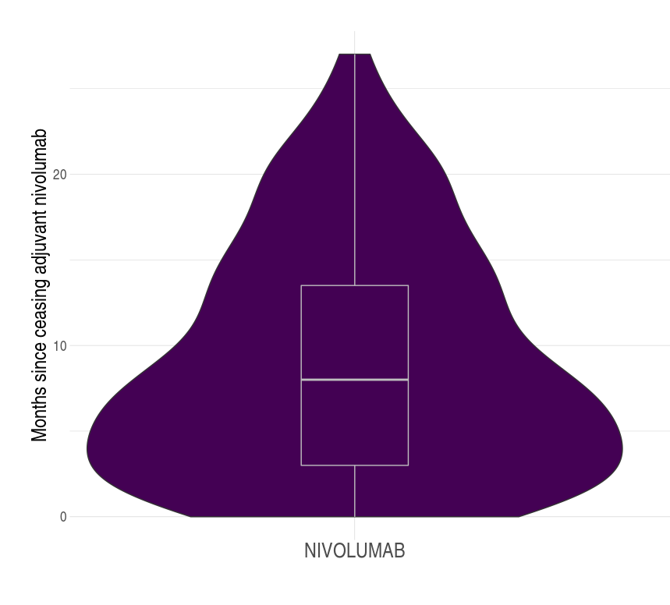
Figure 25: Distribution of months since last treatment of adjuvant nivolumab and reported date of death.

References
- Coricovac D, Dehelean C, Moaca E-A, Pinzaru I, Bratu T, Navolan D, Boruga O. Cutaneous Melanoma—A Long Road from Experimental Models to Clinical Outcome: A Review. International Journal of Molecular Sciences. 2018; 19(6):1566. https://doi.org/10.3390/ijms19061566
- Cancer Australia. (2019, December 18). Melanoma of the skin statistics. statistics | Cancer Australia. Retrieved August 5, 2022, from https://www.canceraustralia.gov.au/cancer-types/melanoma/statistics
- Michielin, O., van Akkooi, A., Lorigan, P., Ascierto, P. A., Dummer, R., Robert, C., Arance, A., Blank, C. U., Chiarion Sileni, V., Donia, M., Faries, M. B., Gaudy-Marqueste, C., Gogas, H., Grob, J. J., Guckenberger, M., Haanen, J., Hayes, A. J., Hoeller, C., Lebbé, C.,Keilholz, U. (2020). ESMO consensus conference recommendations on the management of locoregional melanoma: Under the auspices of the ESMO Guidelines Committee. Annals of Oncology, 31(11), 1449–1461. https://doi.org/10.1016/j.annonc.2020.07.005
- Keilholz, U., Ascierto, P. A., Dummer, R., Robert, C., Lorigan, P., van Akkooi, A., Arance, A., Blank, C. U., Chiarion Sileni, V., Donia, M., Faries, M. B., Gaudy-Marqueste, C., Gogas, H., Grob, J. J., Guckenberger, M., Haanen, J., Hayes, A. J., Hoeller, C., Lebbé, C., … Michielin, O. (2020). ESMO consensus conference recommendations on the management of metastatic melanoma: Under the auspices of the ESMO Guidelines Committee. Annals of Oncology, 31(11), 1435–1448. https://doi.org/10.1016/j.annonc.2020.07.004
- Cramb, S., Duncan, E., Aitken, J., Soyer, H., Mengersen, K., & Baade, P. (2020). Geographical patterns in melanoma incidence across Australia: can thickness differentials reveal the key drivers?. Annals Of Cancer Epidemiology, 4. doi:10.21037/ace-20-13

