Olaparib for ovarian, fallopian tube and primary peritoneal cancer

Drug utilisation sub-committee (DUSC)

June 2023

Abstract

Purpose
To review the utilisation of olaparib for ovarian, fallopian tube and primary peritoneal cancer as requested by DUSC at its February 2023 meeting.

Date of listing on the Pharmaceutical Benefits Scheme (PBS)
Olaparib was first PBS-listed for the second-line treatment of high grade serous ovarian, primary peritoneal and serous fallopian tube cancer on 1 February 2017.

Data Source / methodology
Data extracted from the PBS and Date of Death database maintained by the Department of Health and Aged Care, processed by Services Australia were used for the analyses.

Key Findings
- In 2022, 598 patients were treated with olaparib and supplied 4,864 prescriptions.
- In 2021, 543 patients were treated with olaparib and supplied 4,363 prescriptions.
- In 2021 and 2022, there was a greater proportion of olaparib patients treated for second-line ovarian, fallopian tube and primary peritoneal cancer, compared to first-line therapy.
- The median age of patients initiating treatment with olaparib was 63 years old. The median age of initiating first- and second- line patients were similar.
- Actual utilisation of olaparib for the first-line therapy was different from estimated. The number of treated patients was greater than estimated, whereas the number of prescriptions supplied was lower than estimated.
- The mean and median treatment duration for patients treated with olaparib in the first-line setting accounting for breaks in treatment was 9.17 months and 8.96 months, respectively. The treatment duration was less compared to the key trial, SOLO1.

Purpose of analysis
To review the utilisation of olaparib for ovarian, fallopian tube and primary peritoneal cancer as requested by DUSC at its February 2023 meeting.

Background

Clinical situation
Epithelial ovarian cancer is the most common type of ovarian cancer, accounting for approximately 90% of ovarian cancer cases. Epithelial ovarian, fallopian tube and primary peritoneal cancers all develop in the same type of tissue and are treated the same way.

In its early stages, ovarian cancer usually has no symptoms. When signs and symptoms do appear, the cancer is often advanced.¹ Mutations in the BReast CAncer (BRCA) 1 and BRCA 2 genes are attributed to most cases of hereditary ovarian cancer.

Advanced ovarian cancer has a high mortality rate. Despite high rates of response to first-line platinum-based chemotherapy, the majority of patients with advanced ovarian cancer relapse or progress within 3 years.

Pharmacology
Poly ADP-Ribose Polymerase (PARP) enzymes are required for the repair of DNA single strand breaks. Olaparib belongs to a group of medicines called PARP inhibitors. PARP inhibitors prevent DNA repair, causing cancer cells to die. These specific cancer cells can be identified by response to platinum chemotherapy or by looking for faulty DNA repair genes such as BRCA genes.

Therapeutic Goods Administration (TGA) approved indications
Olaparib is TGA indicated for:
- Monotherapy for the maintenance treatment of adult patients with advanced breast cancer susceptibility gene (BRCA) mutated (germline or somatic) high-grade epithelial ovarian, fallopian tube or primary peritoneal cancer who are in response (complete response or partial response) to first-line platinum-based chemotherapy. BRCA mutation status should be determined by an experienced laboratory using a validated test method.
- Monotherapy maintenance treatment of adult patients with platinum-sensitive relapsed high grade epithelial ovarian, fallopian tube or primary peritoneal cancer who are in response (complete response or partial response) after platinum-based chemotherapy. Prior treatment must have included at least 2 courses of platinum-based regimens.
- In combination with bevacizumab for the maintenance treatment of adult patients with advanced epithelial ovarian, fallopian tube or primary peritoneal cancer who are in complete or partial response to first-line platinum based chemotherapy and whose cancer is associated with homologous recombination deficiency (HRD)-positive status defined by either:
- a deleterious or suspected deleterious BRCA mutation (germline or somatic), and/or
- genomic instability HRD status should be determined by an experienced laboratory using a validated test method.

Olaparib is also TGA indicated for the treatment of:
- Breast cancer,
- Adenocarcinoma of the pancreas, and
- Prostate cancer.
Further information about olaparib’s registered indications is available from the Australian Register of Therapeutic Goods.

Dosage and administration
Treatment with olaparib should be initiated and supervised by a physician experienced in the use of anticancer medicinal products.

Patients should be instructed to take olaparib tablets at approximately the same time each day. Tablets should be swallowed whole and not chewed, crushed, dissolved or divided. Tablets can be taken with or without food.

Olaparib is available as 100 mg and 150 mg tablets. The recommended dose is 300 mg (two 150 mg tablets) taken twice daily, equivalent to a total daily dose of 600 mg. The 100 mg tablet is available for dose reductions only.

Patients must not substitute tablets (100 mg and 150 mg) with capsules (50 mg) due to differences in the dosing and bioavailability of each formulation.

The current Product Information (PI) and Consumer Medicine Information (CMI) are available from the TGA (Product Information) and the TGA (Consumer Medicines Information).

PBS listing details (as at 1 March 2023)
Olaparib is currently PBS-listed as monotherapy for different lines of treatment for ovarian, fallopian tube and primary peritoneal cancer.
- First-line therapy (1L): High grade stage III/IV epithelial ovarian, fallopian tube or primary peritoneal cancer where is treatment following a platinum-containing regimen.
- Second-line therapy (2L): High grade epithelial ovarian, fallopian tube or primary peritoneal cancer where treatment is following at least two platinum-containing regimens.

Table 1: PBS listing of olaparib for first-line therapy
Item code | Name, form & strength, pack size | Max qty packs | Rpts | DPMQ | Brand name and manufacturer
12170M | olaparib 100 mg tablet, 56 | 2 | 2 | $6,630.78 | Lynparza®  AstraZeneca Pty Ltd
12169L | olaparib 100 mg tablet, 56 | 2 | 5 | $6,630.78 | Lynparza®  AstraZeneca Pty Ltd
12157W | olaparib 150 mg tablet, 56 | 2 | 2 | $6,630.78 | Lynparza®  AstraZeneca Pty Ltd
12161C | olaparib 150 mg tablet, 56 | 2 | 5 | $6,630.78 | Lynparza®  AstraZeneca Pty Ltd
Source: the PBS website.
Notes:
- Applications for authorisation under this restriction may be made in real time using the Online PBS Authorities system or by telephone.
- Special Pricing Arrangements apply.
- For item codes 12170P and 12157W it is noted, “This drug belongs to the poly (ADP-ribose) polymerase (PARP) inhibitor drug class. The restriction refers to the following PARP inhibitors: olaparib, niraparib.”

Table 2: PBS listing of olaparib for second-line therapy
Item code | Name, form & strength, pack size | Max qty packs | Rpts | DPMQ | Brand name and manufacturer
11522K | olaparib 100 mg tablet, 56 | 2 | 2 | $6,630.78 | Lynparza®  AstraZeneca Pty Ltd
11503K | olaparib 100 mg tablet, 56 | 2 | 5 | $6,630.78 | Lynparza®  AstraZeneca Pty Ltd
11528R | olaparib 150 mg tablet, 56 | 2 | 2 | $6,630.78 | Lynparza®  AstraZeneca Pty Ltd
11539H | olaparib 150 mg tablet, 56 | 2 | 5 | $6,630.78 | Lynparza®  AstraZeneca Pty Ltd
Source: the PBS website.
Notes:
- Special Pricing Arrangements apply.
- For item codes 11522K and 11528R, applications for authorisation under this restriction may be made in real time using the Online PBS Authorities system or by telephone.

Restriction
First- line treatment for high grade stage III/IV epithelial ovarian, fallopian tube or primary peritoneal cancer (Authority Required)

Treatment Phase: Initial treatment
Clinical criteria:
- The condition must be associated with a class 4 or 5 BRCA1 or BRCA2 gene mutation, AND
- Patient must be in partial or complete response to the immediately preceding platinum-based chemotherapy regimen prior to commencing treatment with this drug for this condition, AND
- The treatment must be the sole PBS-subsidised therapy for this condition, AND
- Patient must not have previously received PBS-subsidised treatment with this drug for this condition.
Treatment criteria:
- Patient must be undergoing treatment with this drug class for the first time; OR
- Patient must be undergoing treatment with this drug class on a subsequent occasion, but only because there was an intolerance/contraindication to another drug in the same class that required permanent treatment withdrawal.

A response (complete or partial) to the platinum-based chemotherapy regimen is to be assessed using either Gynaecologic Cancer InterGroup (GCIG) or Response Evaluation Criteria in Solid Tumours (RECIST) guidelines.
Evidence of a BRCA1 or BRCA2 gene mutation must be derived through germline or somatic mutation testing.

Treatment Phase: Continuing treatment
Clinical criteria:
- Patient must have received previous PBS-subsidised treatment with this drug as first line maintenance therapy for this condition, AND
- The treatment must be the sole PBS-subsidised therapy for this condition, AND
- Patient must not have developed disease progression while receiving treatment with this drug for this condition, AND
- The treatment must not exceed a total of 24 months of combined non-PBS-subsidised and PBS-subsidised treatment for patients who are in complete response.

Second- line treatment for high grade epithelial ovarian, fallopian tube or primary peritoneal cancer (Initial listings are Authority Required, continuing listings are Authority Required (Streamlined)

Treatment Phase: Initial treatment
Clinical criteria:
- The condition must be associated with a class 4 or 5 BRCA1 or BRCA2 gene mutation, AND
- The condition must be platinum sensitive, AND
- Patient must have received at least two previous platinum-containing regimens, AND
- Patient must have relapsed following a previous platinum-containing regimen, AND
- Patient must be in partial or complete response to the immediately preceding platinum-based chemotherapy regimen, AND
- The treatment must be the sole PBS-subsidised therapy for this condition, AND
- The treatment must be maintenance therapy, AND
- Patient must not have previously received PBS-subsidised treatment with this drug for this condition.
Platinum sensitivity is defined as disease progression greater than 6 months after completion of the penultimate platinum regimen.
A response (complete or partial) to the platinum-based chemotherapy regimen is to be assessed using either Gynaecologic Cancer InterGroup (GCIG) or Response Evaluation Criteria in Solid Tumours (RECIST) guidelines.
Evidence of a BRCA1 or BRCA2 gene mutation must be derived through germline or somatic mutation testing.
Treatment Phase: Continuing treatment
Clinical criteria:
- Patient must have previously received PBS-subsidised treatment with this drug as a second line therapy for this condition, AND
- The treatment must be the sole PBS-subsidised therapy for this condition, AND
- The treatment must be maintenance therapy, AND
- Patient must not have developed disease progression while receiving treatment with this drug for this condition.

For details of the current PBS listing refer to the PBS website.

Changes to listing

Table 3: Chronology of changes to olaparib listing
Date | Change to listing
1 February 2017 | Olaparib (50 mg capsule) was PBS listed for second-line treatment of high grade serous ovarian, primary peritoneal and serous fallopian tube cancer.  This was recommended at the November 2016 PBAC Meeting.
1 December 2018 | A new form of olaparib was PBS listed (tablet 100 mg, tablet 150 mg).  This was recommended at the March 2018 PBAC Meeting.
1 May 2019 | The capsule form (50 mg) of olaparib was delisted.
1 August 2020 | The listing was extended to include patients with somatic BRCA1/2 mutations.  This was recommended at the March 2020 PBAC Meeting.
1 November 2020 | Listing was extended to include maintenance treatment following a partial or complete response to first line (1L) platinum-based chemotherapy in a patient with evidence of a BRCA1 or BRCA2 gene mutation (BRCAm) via germline or somatic testing.  This was recommended at the July 2020 PBAC Meeting.
1 September 2022 | Addition of treatment criterion due to PBS listing of niraparib for high grade stage III/IV epithelial ovarian, fallopian tube or primary peritoneal cancer:  - To allow patients with intolerance to niraparib to switch to olaparib.  - To prevent sequential treatment with olaparib after disease progression following treatment with niraparib.  This was recommended at March 2022 PBAC Meeting as part of the committee’s consideration of niraparib.

Current PBS listing details are available from the PBS website.

Relevant aspects of consideration by the Pharmaceutical Benefits Advisory Committee (PBAC)
The PBAC has considered seven olaparib monotherapy submissions for the treatment of ovarian, fallopian tube or primary peritoneal cancer. A summary of PBAC considerations can be found in Appendix A.

Previous reviews by the DUSC
DUSC reviewed the use of bevacizumab for Stage IIIB, IIIC or IV epithelial ovarian, fallopian tube, or primary peritoneal cancer at its September 2018 meeting. Since PBS listing on 1 August 2014, 17,550 prescriptions of bevacizumab were supplied to 1,765 patients under the PBS item codes for epithelial ovarian, fallopian tube, or primary peritoneal cancer. The number of patients starting on bevacizumab each month was steady, and the number of treated patients and dispensed prescriptions has been relatively stable since the beginning of 2016. The number of initiating patients was close to the number predicted, suggesting that most eligible patients have been able to access bevacizumab. However, the number of prescriptions dispensed was lower than predicted. This was likely because a large proportion of patients had not received the lifetime limit of 18 treatments.
For details of the DUSC consideration of bevacizumab for ovarian and primary peritoneal cancer refer to the Public Release Document from the September 2018 DUSC meeting.

Methods
Data extracted from the PBS claims database maintained by the Department of Health and Aged Care and processed by Services Australia were used for the analyses. Prescription data were extracted from 1 February 2017 up to and including 31 December 2022.
These data were used to determine the number of initiating and prevalent patients, number of prescriptions supplied and to analyse patient demographics such as age. Initiating and prevalent patients were counted by quarter of supply. An initiating patient was defined based on their first date of supply of olaparib. Line of therapy was derived based on item code.
The treatment duration of olaparib for first-line therapy was ascertained. A Kaplan-Meier curve was generated to present treatment duration. A cohort of initiating patients were selected from 1 June 2021, to account for the wash out period of grandfathered patients, up to and including 31 December 2021. These patients were followed until 31 December 2022, with patients censored if they were still continuing treatment. Another Kaplan Meier curve was generated accounting for breaks in treatment. A patient was considered to be on a treatment break if they did not receive a supply in more than two sets of standard treatment days. The median standard treatment days was calculated to be 29 days.
Date of death data were linked to the PBS claims data based on the unique de-identified patient identifier. This was used to determine the proportion of patients who ceased olaparib treatment due to death.
As this analysis uses date of supply prescription data, there may be small differences compared with publicly available Services Australia Medicare date of processing data. The publicly available Services Australia Medicare data only includes subsidised R/PBS prescriptions with prescriptions under the patient co-payment not included.
Data manipulation was undertaken using SAS.

Results

Analysis of drug utilisation

Overall utilisation

Table 4: Number of olaparib prescriptions supplied and patients treated by calendar year
 | 2017 | 2018 | 2019 | 2020 | 2021 | 2022
Patients | 193 | 252 | 259 | 402 | 543 | 598
Prescriptions | 1,109 | 1,551 | 1,983 | 2,200 | 4,363 | 4,864
Note: As olaparib was first PBS listed from February 2017, patient and prescription counts for 2017 are inclusive of February 2017 to December 2017.

Figure 1: Number of olaparib prescriptions supplied by supply quarter

In Figure 1, the number of olaparib prescriptions supplied has been increasing over time. A large increase in the number of olaparib prescriptions supplied was observed following 2020Q3. This was likely due to extension of PBS listing to include patients with somatic BRCA1/2 mutations in August 2020 and a further extension to include treatment for first-line olaparib patients in November 2020.

Figure 2: Number of initiating and prevalent olaparib patients by supply quarter

Similar to Figure 1, in Figure 2 the number of patients treated with olaparib has increased over time, with the large increase observed following extensions to listing following 2020Q3 and an increase in the number of patients initiating treatment in 2020Q4.

Utilisation by line of therapy

Figure 3: Number of olaparib prescriptions supplied by line of therapy and supply quarter

Figure 3 shows the number of olaparib prescriptions supplied by line of therapy based on item code. A greater number of prescriptions have been supplied for second-line therapy compared to first-line therapy.

Figure 4: Number of olaparib treated patients by line of therapy and supply quarter

Similar to Figure 3, Figure 4 shows a greater proportion of patients were treated with olaparib in the second-line setting compared to first-line.

Figure 5: Number of olaparib initiating patients by line of therapy and supply quarter

Figure 5 shows the number of patients who initiated treatment with olaparib based on line of therapy. Up until 2020Q3, there was an average of approximately 23 patients initiating treatment with olaparib per supply quarter.

Utilisation by relevant sub-populations/regions or patient level analysis

Table 5: Summary statistics of the age of initiating olaparib patients
 | Mean | Median | Q1  25th percentile | Q3  75th percentile | Range
First-line | 62 | 62 | 53 | 70 | 29 to 88
Second-line | 62 | 63 | 56 | 70 | 29 to 90
Overall | 62 | 63 | 55 | 70 | 29 to 90

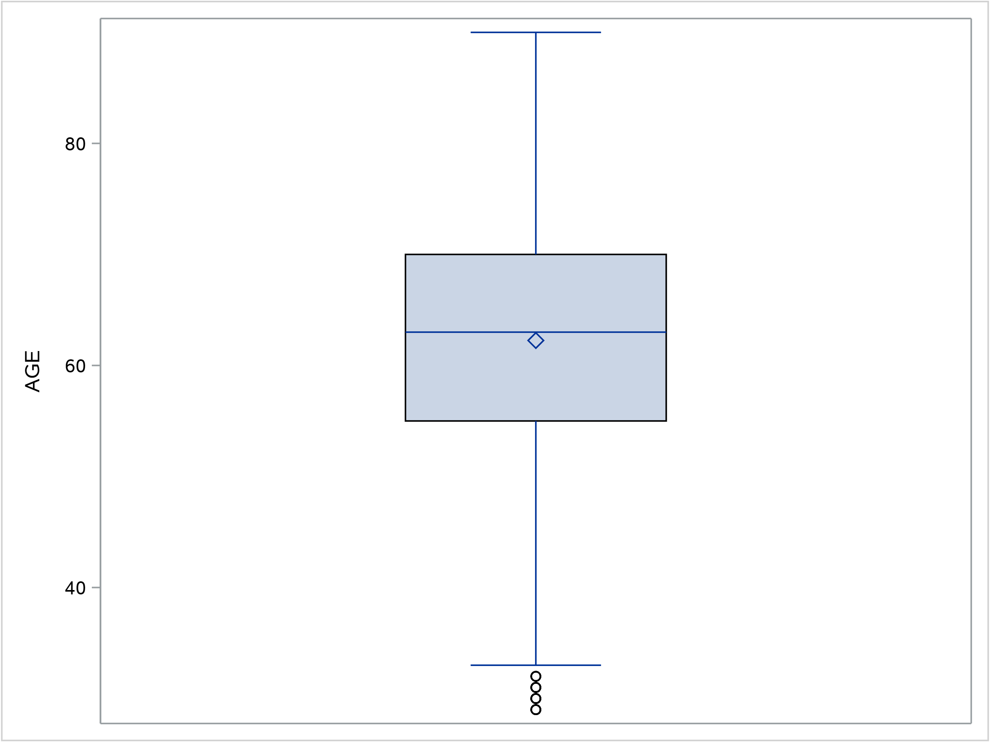

Figure 6: Age distribution of initiating olaparib patients

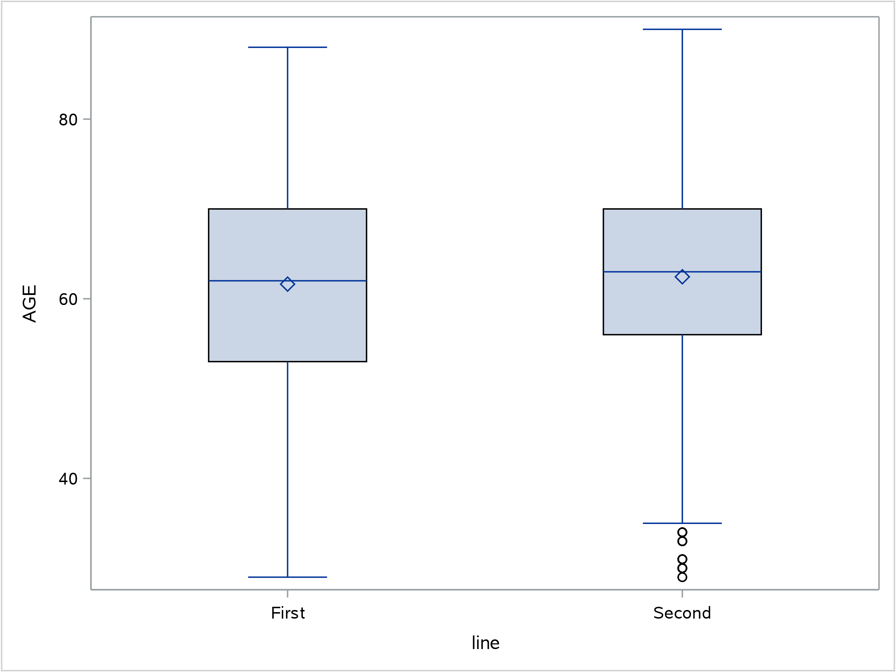

Figure 7: Age distribution of initiating olaparib patients by line of therapy

As shown in Table 5 and Figure 6 above, the mean and median age of initiating olaparib patients was 62 and 63 years, respectively. In Figure 7, the age distribution of first- and second-line patients was similar.

Table 6: Estimated length of treatment from Kaplan-Meier analysis in patients who initiated first-line olaparib treatment
 | Number of patients | Censored | Median (months) | Mean (months) | Standard error | 95% confidence interval (months)
Without accounting for breaks | 91 | 36 | 11.42 | 10.41 | 0.61 | 9.19 | 11.63
Accounting for breaks | 91 | 36 | 8.96 | 9.17 | 0.59 | 8.00 | 10.33

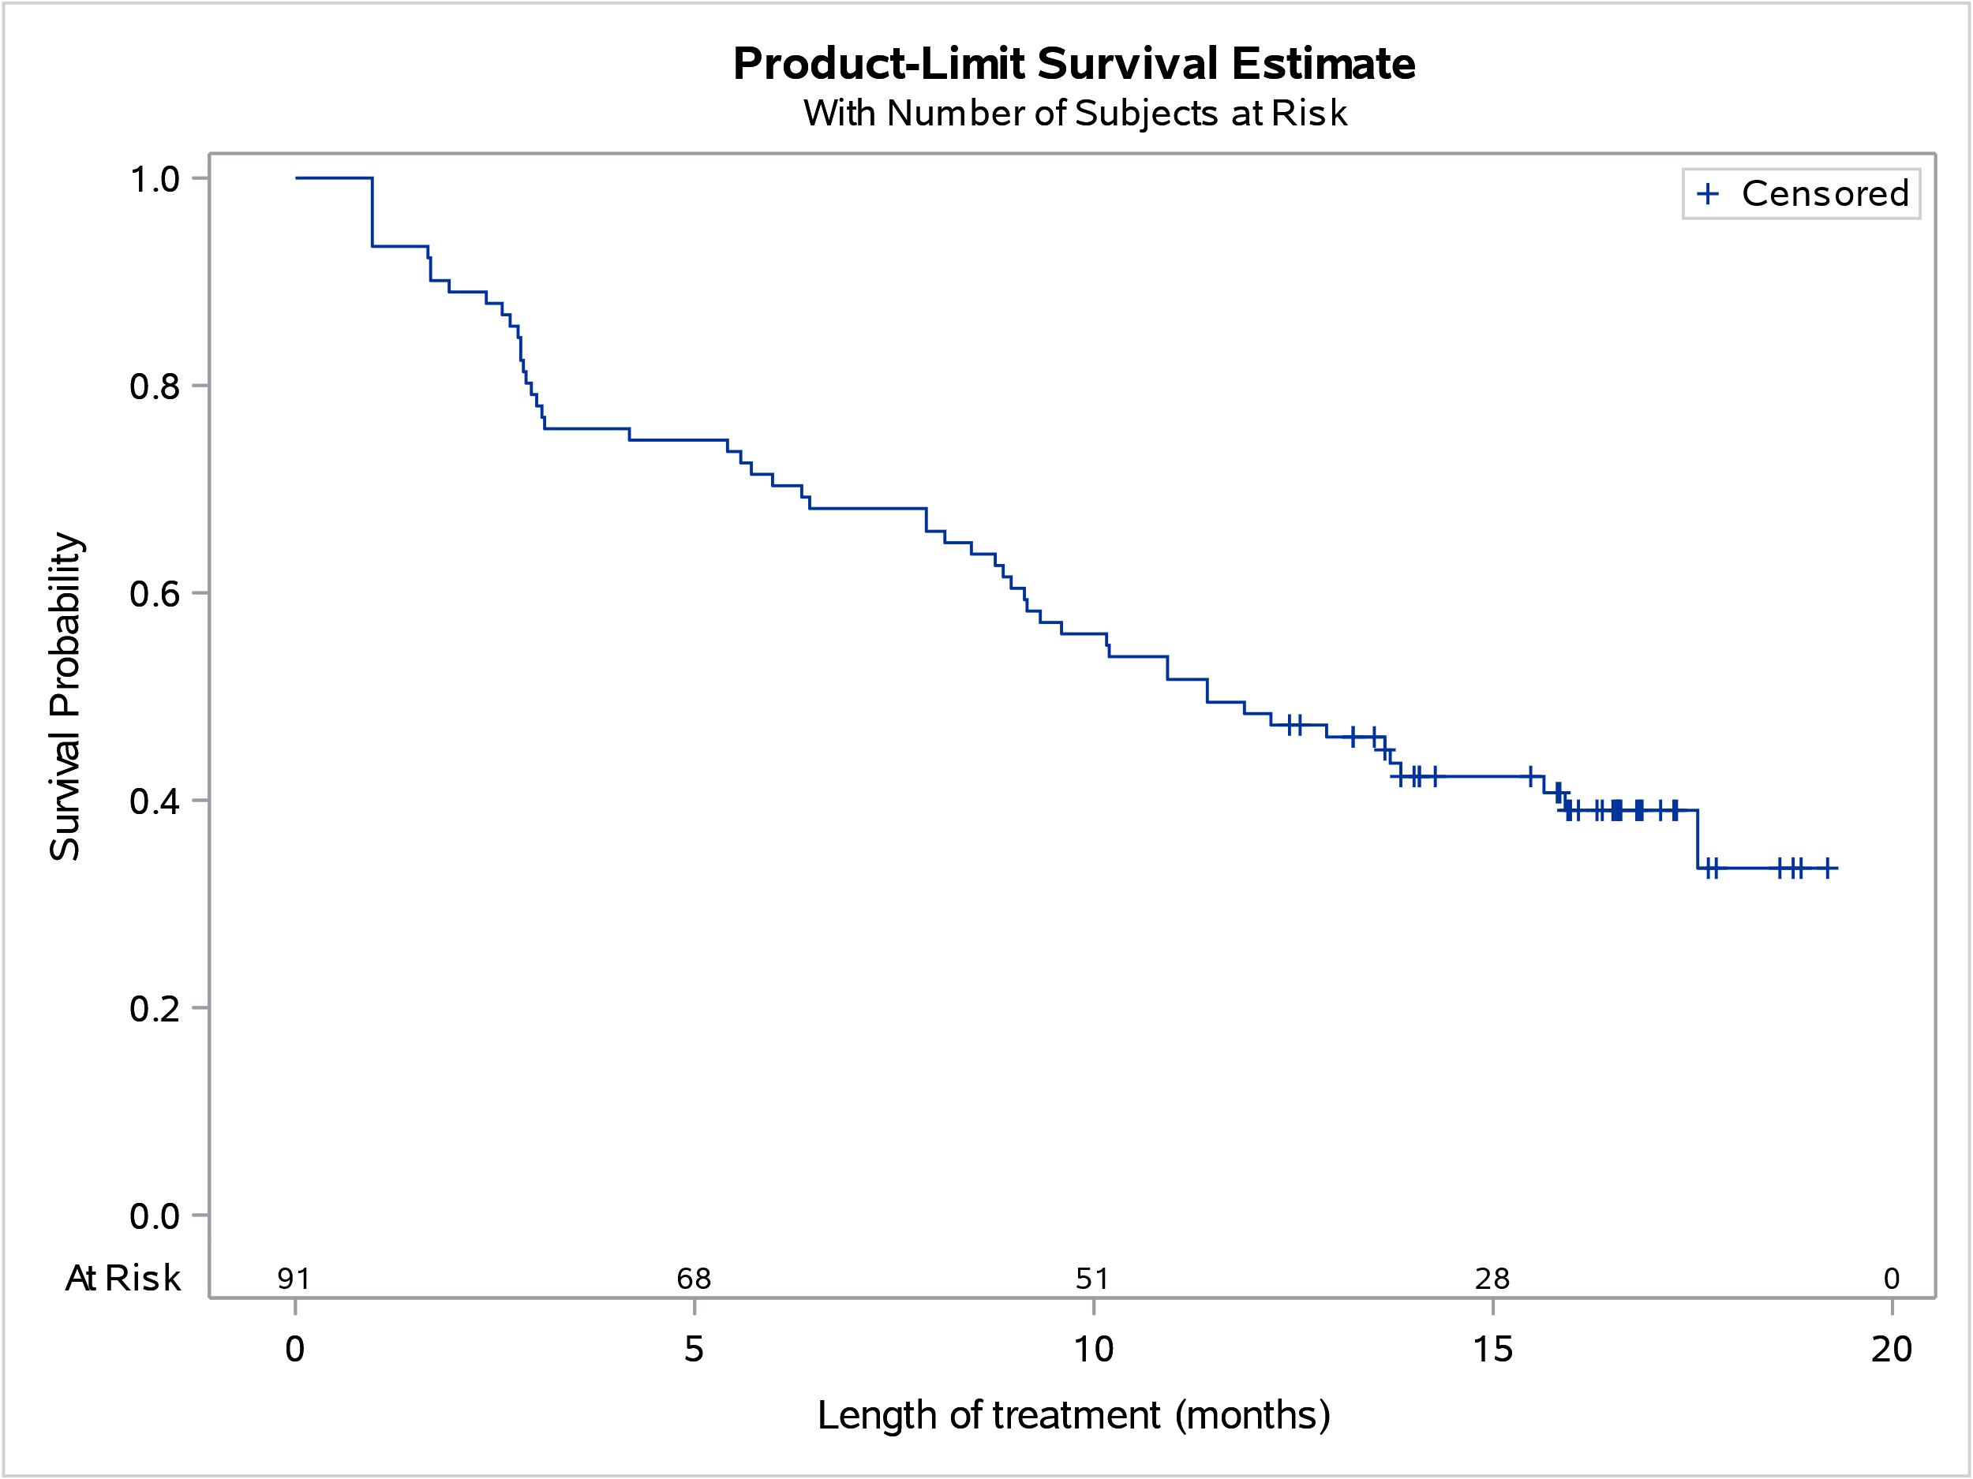

Figure 8: Treatment duration for patients who initiated first- line olaparib treatment
In Table 6 and Figure 8, of patients who initiated first-line treatment with olaparib between 1 June 2021 and 31 December 2021 and followed to 31 December 2022, the mean and median treatment duration was 10.41 and 11.42 months, respectively. 60.4% of these patients ceased treatment as at the analysis end date, with 5 patients who ceased treatment due to death.

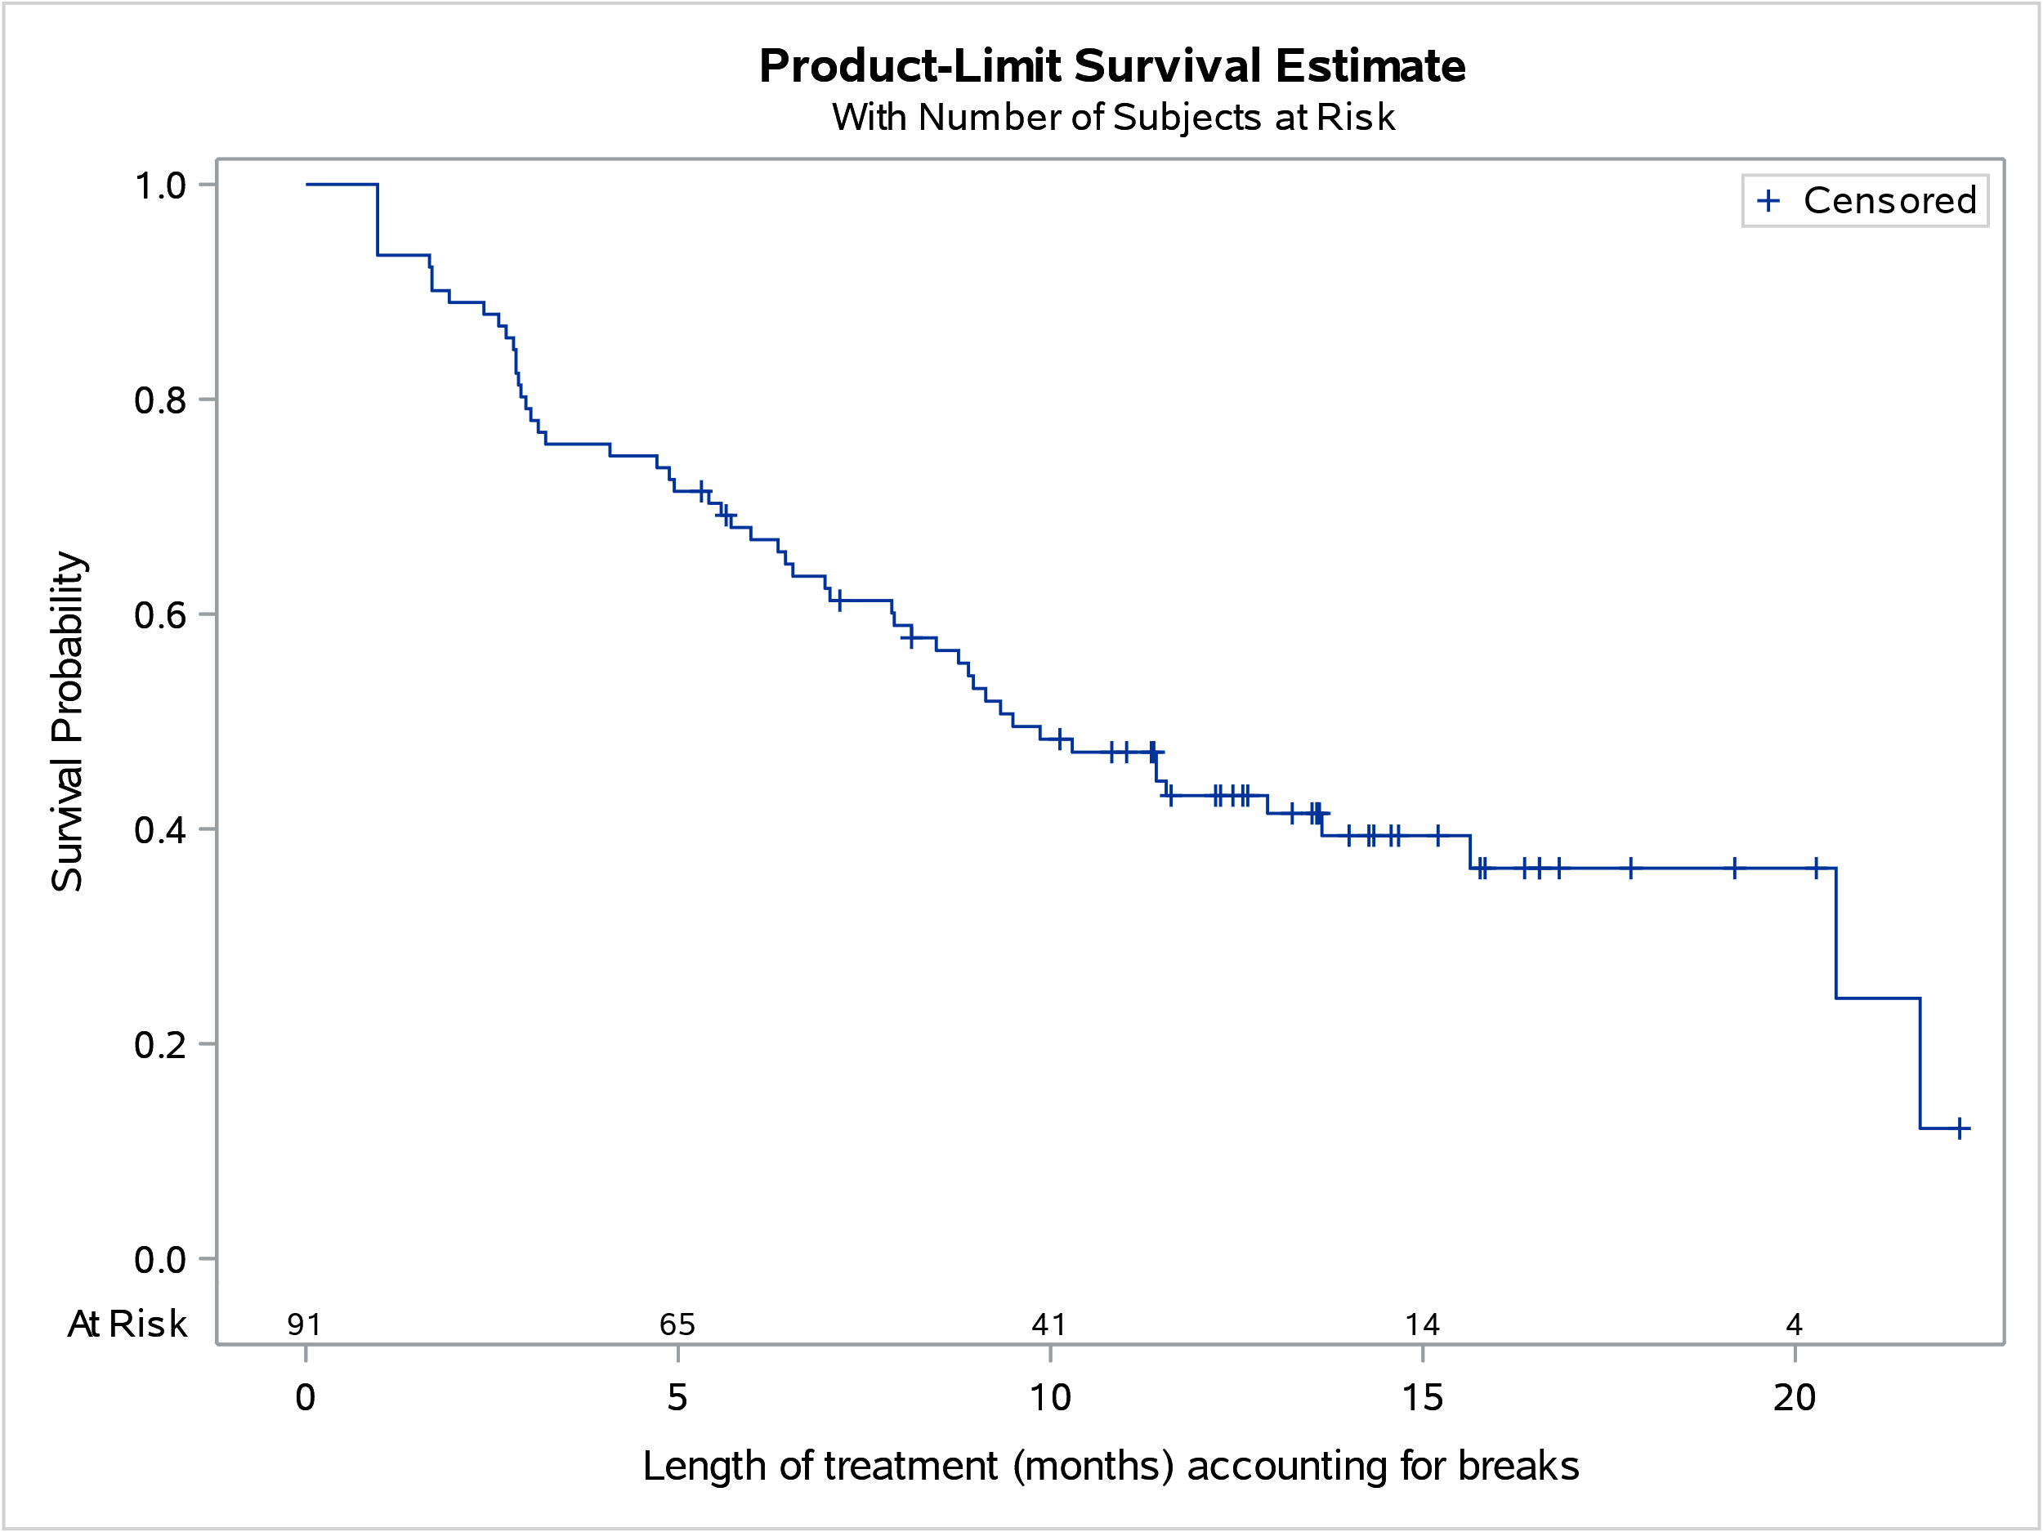

Figure 9: Treatment duration for patients who initiated first- line olaparib treatment, accounting for breaks in treatment

When accounting for breaks in treatment, the mean and median treatment duration was reduced. The mean treatment duration reduced from 10.41 months to 9.17 months and the median treatment duration reduced from 11.42 months to 8.96 months.

Figure 10: Number of patients treated for PBS-listed medicines for ovarian, fallopian, primary peritoneal cancer
Note: Patient counts of less than 5 have been replaced with 5 to protect patient confidentiality.
As shown in Figure 10, bevacizumab, niraparib and olaparib are the current PBS-listed medicines for ovarian, fallopian tube and primary peritoneal cancer.
Bevacizumab was a first-line listing for Stage IIIB, IIIC or Stage IV epithelial ovarian, fallopian tube or primary peritoneal cancer. Prior to 1 June 2021, a greater number of patients were treated with bevacizumab compared to olaparib. From 1 June 2021 onwards, the PBS listing for bevacizumab became unrestricted. As such, the number of patients treated for ovarian, fallopian tube and primary peritoneal cancer could not be determined following its restriction change.
Niraparib was recently PBS-listed in 1 September 2022 for the first-line treatment of high grade Stage III/IV epithelial ovarian, fallopian tube or primary peritoneal cancer.

Analysis of actual versus predicted utilisation of olaparib for first-line therapy

Approach taken to estimate utilisation
The resubmission considered by the PBAC at its July 2020 meeting used an epidemiological approach to estimate olaparib utilisation for first-line patients with Federation of Gynaecology and Obstetrics (FIGO) Stage III/IV ovarian, fallopian tube and primary peritoneal cancer. The resubmission’s utilisation estimates were based on:
- The incidence of ovarian cancer was based on AIHW data and revised to exclude non-epithelial cancers.
- The prevalence of germline BRCA mutations was estimated to be 20.3% and the prevalence of somatic BRCA mutations was estimated to be 5%.
- 95% of eligible patients would undertake tumour BRCA mutation testing, as 5% of patients would not undergo testing as these patients may be elderly or frail and do not undergo surgery and commence platinum-based chemotherapy.
- The average duration of 1L olaparib maintenance was based on time to treatment discontinuation curve from the key trial SOLO1. Treatment interruptions were estimated to account for 1 month out of a total of 21.5 months of treatment.

Table 7: Estimated use and financial implications (PBAC revised estimates)
 | Year 1 |  | Year 2 |  | Year 3 |  | Year 4 |  | Year 5 |  | Year 6
Estimated extent of use
Number of patients treated (resubmission estimates) |  | ''''''''ª |  | '''''''''' |  | '''''''' |  | ''''''''' |  | '''''''''' |  | ''''''''
PBAC revised number of patients treated ^{e} |  | '''''''''' |  | ''''''''' |  | ''''''''' |  | '''''''' |  | '''''''''' |  | ''''''''
PBAC revised number of scripts ^{b} |  | ''''''''''' |  | ''''''''''' |  | '''''''''''' |  | ''''''''''' |  | ''''''''''' |  | '''''''''''''
Estimated financial implications of 1L olaparib treatment
PBAC revised cost to PBS/RPBS less copayments (A) |  | $''''''''''''''''''''''''' |  | $''''''''''''''''''''''''''' |  | $'''''''''''''''''''''''''''' |  | $''''''''''''''''''''''''''' |  | $''''''''''''''''''''''''''' |  | $''''''''''''''''''''''''''''
Estimated financial implications for offset 2L olaparib
PBAC revised cost to PBS/RPBS less copayments^{c,d} (B) |  | $''''''''''''''''''''' |  | $''''''''''''''''''''''''' |  | $'''''''''''''''''''''''' |  | $'''''''''''''''''''''' |  | $'''''''''''''''''''''' |  | $'''''''''''''''''''''''''
Net financial implications
Net cost to PBS/RPBS |  | $''''''''''''''''''''''''' |  | $'''''''''''''''''''''''''''' |  | $''''''''''''''''''''''''''' |  | $''''''''''''''''''''''''' |  | $'''''''''''''''''''''''''''' |  | $''''''''''''''''''''''''''''
Net cost to MBS |  | $'''''''''''''''''' |  | $''''''''''''''''' |  | $''''''''''''''''''' |  | $''''''''''''''''''''' |  | $'''''''''''''''''' |  | $''''''''''''''''''''
Net cost to PBS/RPBS/MBS |  | $''''''''''''''''''''''''''''' |  | $'''''''''''''''''''''''''''' |  | $'''''''''''''''''''''''' |  | $''''''''''''''''''''''''''' |  | $''''''''''''''''''''''''''' |  | $''''''''''''''''''''''''''''
Previous submission: November 2019
Net cost to PBS/RPBS |  | $''''''''''''''''''''''''''' |  | $''''''''''''''''''''''''''''' |  | $'''''''''''''''''''''''' |  | $''''''''''''''''''''''''''' |  | $'''''''''''''''''''''''''''' |  | $'''''''''''''''''''''''''''
Source: xxxxxx xxxxxx xxxxxx xxxxxx xxxxxx xxxxxx xxxxxx xxxxxx xxxxxx xxxxxx xxxxxx x.Previous submission values from Table PBAC.15 6.05 olaparib PSD, November 2019 PBAC Meeting
ª Figure also includes '''''''''' grandfathered patients.
^{b} Number of scripts based on TTD curve from SOLO1, which allowed treatment beyond 24 months which was permitted according to the protocol for patients with residual disease who may continue to receive benefit according to investigator’s discretion. The resubmission appeared to make an error in converting the number of packs required (28 day supply) to the average number of months treatment in a calendar year (365.25/12= 30.4 days per month), this error has been corrected. The resubmission estimated that the average duration of therapy was 20.65 months, which would require 22.1 scripts. However, 22.44 scripts would actually be required for a treatment duration of 20.65 months. This included approximately 10% of patients who received treatment beyond 24 months. 1L script numbers reduced to account for treatment interruptions.
^{c} The resubmission only accounted for 82 germline GF patients. Revised to include 120 GF patients.
^{d} The resubmission stated that it was assumed that 12 packs were required per treatment per year. The number of scripts required per patient year is actually 13.04 scripts (365.25 days / 28 days per script). Further to this, the resubmission assumed that 3 scripts would also be required in the second year. This calculation was not explained by the resubmission and appeared incorrect.
^{e} Patient numbers revised to exclude non-epithelial ovarian cancers (16%), 1.14 multiplication factor removed, 5% somatic BRCAm, 100% of patients treated in year 1 but 64% uptake).

Table 8: Actual versus predicted utilisation of olaparib for first-line therapy
 |  | Year 1 | Year 2
 |  | November 2020-October 2021 | November 2021-October 2022
Patients | Predicted | xxxxxx | xxxxxx
 | Actual | 302 | 323
 | Difference | xxxxxx | xxxxxx
Prescriptions | Predicted | xxxxxx | xxxxxx
 | Actual | 1,646 | 1,865
 | Difference | xxxxxx | xxxxxx

From Table 8, in the first two years of PBS listing, the number of patients treated with olaparib was xxxxxx than estimated xxxxxxxxxxxx whereas the number of olaparib prescriptions supplied was xxxxxx than estimated xxxxxx xxxxxx

Discussion
Following its initial listing in February 2017 for second-line therapy, a number of changes have been made to the PBS listing of olaparib. The listing was extended to include patients with somatic BRCA1/2 mutations in August 2020. There was also a further extension to include maintenance treatment following a partial or complete response to 1L platinum-based chemotherapy in a patient with evidence of a BRCA1/2 mutation via germline or somatic testing in November 2020.
At its July 2020 meeting, the PBAC considered that 6 years after listing 1L olaparib, it is likely that all patients would be treated with 1L olaparib and that it was unlikely that there would be a market for use of 2L olaparib (paragraph 7.20, olaparib Public Summary Document July 2020). As shown in Figure 4, following the extension of listing to 1L olaparib, the number of patients treated for 2L remains greater than those treated for 1L olaparib. However, in Figure 5, a greater number of patients have been initiating olaparib treatment as 1L compared to 2L.
Utilisation of olaparib for 1L therapy was different from estimated. The number of treated patients was greater than estimated, whereas the number of olaparib prescriptions supplied was lower than estimated.
The lower than estimated number of prescriptions supplied corresponds with the shorter than estimated mean treatment duration compared to the key trial, SOLO1. The resubmission estimated that, “Treatment interruptions were estimated to account for 1 month out of a total of 21.5 months of treatment” (paragraph 6.48, olaparib Public Summary Document July 2020). As shown in Table 6, the mean treatment duration was approximately half of the treatment duration in the trial of 10.41 months and reduced to 9.17 months when accounting for breaks in treatment.
The shorter than estimated treatment duration may have been due to the differences in patient characteristics in the trial compared to the PBS population in practice. In the SOLO1 trial, the median age of patients was 53 years, whereas the median age of patients initiating treatment with PBS listed olaparib was 62 years.

DUSC consideration
DUSC considered possible reasons for the number of patients treated with olaparib for 1L therapy being greater than estimated.
- DUSC considered the impact of the COVID-19 pandemic on the delay in diagnosis and treatment. DUSC noted consumer input from Ovarian Cancer Australia who commented on the decrease in investigations for gynaecological cancers, however implications for diagnosis and treatment are uncertain.
- DUSC noted the utilisation estimates did not include patients who were waiting to initiate treatment who had already completed chemotherapy. DUSC noted less fitter patients were excluded from the SOLO1 trial.
- DUSC noted that there was an increase in the number of patients who initiated 2L therapy between June to October 2021, prior to the extension of listing to the 1L setting in November 2021. DUSC noted 26% of these patients had switched to 1L therapy.

DUSC considered possible reasons for the number of olaparib prescriptions supplied for 1L therapy being lower than estimated.
- DUSC noted the utilisation estimates accounted for dose interruptions assuming all patients would have on average, an interruption of one cycle treatment. DUSC commented that this may not be reflected in practice as a dose interruption would be more likely to reoccur if it had occurred before, as such a patient may undergo multiple dose interruptions.
- DUSC noted the utilisation estimates did not account for subsequent dose reductions or prescribing patterns. DUSC commented that dose reductions may result in cumulatively less prescriptions over time. DUSC noted the recommended dose of olaparib is 300 mg (two 150 mg tablets) taken twice daily. If the dose is reduced to 250 mg, patients would only be supplied a prescription for 100 mg as prior supplies for 150 mg would be used. DUSC commented that this would be further extrapolated with subsequent dose reductions.
- DUSC noted that the utilisation review was based upon 25 months of data since the extension of listing to the 1L setting. DUSC commented on the immaturity of the utilisation data and that with increased time and clinician familiarity, patients may be treated with olaparib for longer. DUSC noted the Pre-Sub-Committee Response commented on the immaturity of the utilisation data with regards to future utilisation in the 1L and 2L setting.
- DUSC commented that with an older and less fitter population in practice, these patients would experience more side effects leading to higher rates of discontinuation in practice.
- DUSC commented that in practice, there is likely to be a greater number of patients with partial response to treatment rather than complete response, and as such the likelihood of progression and discontinuation on olaparib may be higher than the numbers in the SOLO1 trial.

DUSC actions
DUSC requested that the report be provided to the PBAC for consideration.

Context for analysis
The DUSC is a Sub Committee of the Pharmaceutical Benefits Advisory Committee (PBAC). The DUSC assesses estimates on projected usage and financial cost of medicines.
The DUSC also analyses data on actual use of medicines, including the utilisation of PBS listed medicines, and provides advice to the PBAC on these matters. This may include outlining how the current utilisation of PBS medicines compares with the use as recommended by the PBAC.
The DUSC operates in accordance with the quality use of medicines objective of the National Medicines Policy and considers that the DUSC utilisation analyses will assist consumers and health professionals to better understand the costs, benefits and risks of medicines.
The utilisation analysis report was provided to the pharmaceutical sponsors of each drug and comments on the report were provided to DUSC prior to its consideration of the analysis.

Sponsors’ comments
AstraZeneca Pty Ltd: The sponsor has no comment.

Disclaimer
The information provided in this report does not constitute medical advice and is not intended to take the place of professional medical advice or care. It is not intended to define what constitutes reasonable, appropriate or best care for any individual for any given health issue. The information should not be used as a substitute for the judgement and skill of a medical practitioner.
The Department of Health and Aged Care has made all reasonable efforts to ensure that information provided in this report is accurate. The information provided in this report was up-to-date when it was considered by the Drug Utilisation Sub-committee of the Pharmaceutical Benefits Advisory Committee. The context for that information may have changed since publication.
To the extent provided by law, the Department of Health and Aged Care makes no warranties or representations as to accuracy or completeness of information contained in this report.
To the fullest extent permitted by law, neither the Department of Health and Aged Care nor any Department of Health and Aged Care employee is liable for any liability, loss, claim, damage, expense, injury or personal injury (including death), whether direct or indirect (including consequential loss and loss of profits) and however incurred (including in tort), caused or contributed to by any person’s use or misuse of the information available from this report or contained on any third party website referred to in this report.

Appendices

Appendix A: Summary of PBAC considerations for olaparib monotherapy for ovarian, fallopian tube or primary peritoneal cancer
Meeting date | PBAC consideration
March 2016 | The PBAC deferred its decision on whether olaparib should be listed on the PBS for the treatment of high grade serous ovarian, fallopian tube or primary peritoneal cancer. The PBAC considered that there was a strong clinical need for an oral maintenance treatment with manageable adverse events like olaparib, and the updated data demonstrated an improvement in overall survival in the requested BRCAm subgroup. However, the incremental cost-effectiveness ratio was substantially underestimated and unacceptably high at the price proposed because of concerns with key aspects of the modelled economic evaluation which would need to be addressed before the PBAC could complete its decision.  For further details refer to the Public Summary Document from the March 2016 PBAC meeting.
July 2016 | The PBAC did not recommended the listing of olaparib for the treatment of high grade serous ovarian, fallopian tube or primary peritoneal cancer on the basis that the magnitude of the overall survival benefit was significantly overestimated in the model presented and, as such, the ICER was substantially underestimated and would be unacceptably high when corrected.  For further details refer to the Public Summary Document from the July 2016 PBAC meeting.
November 2016 | The PBAC recommended the Authority Required listing of olaparib for the treatment of high grade serous ovarian cancer, high grade serous fallopian tube cancer, and high grade serous primary peritoneal cancer. The PBAC was satisfied that olaparib provides, for some patients, a significant improvement in efficacy over best supportive care.  For further details refer to the Public Summary Document from the November 2016 PBAC meeting.
March 2018 | The PBAC recommended the Authority Required (General Schedule) listing of a new tablet form of olaparib for the treatment of high grade serous ovarian, fallopian tube and primary peritoneal cancers, on a cost-minimisation basis to olaparib capsules. In making this recommendation, the PBAC noted that the sponsor intended to withdraw the capsule form of this medicine from the market, acknowledged that the new form represented a reduced pill burden for patients and advised that a price reduction was warranted for this listing to be cost neutral to the Commonwealth, at the equi-effective doses recommended by the Committee.  For further details refer to the Public Summary Document from the March 2018 PBAC meeting.
November 2019 | The PBAC did not recommend the listing of olaparib for the first-line maintenance treatment of ovarian, fallopian tube or primary peritoneal cancer. The PBAC considered that olaparib provided a substantial benefit to some patients in delaying recurrence, which it considered is likely to be a clinically important outcome. The PBAC considered that the modelled cost-effectiveness was uncertain due to an overly complex model including optimistic assumptions of the extent of the overall survival benefit which were not supported by the clinical evidence. The PBAC advised that the ICER was high at the sponsor’s proposed price. The PBAC considered the extent of use in the first-line setting was overestimated, and the reduction in use in the second-line setting was underestimated.  For further details refer to the Public Summary Document from the November 2019 PBAC meeting.
March 2020 | The PBAC recommended that the existing olaparib PBS listing for the treatment of platinum-sensitive relapsed ovarian, fallopian tube and primary peritoneal cancer in patients with germline BRCA1/2 (BReast CAncer gene) mutations be amended to also include patients with somatic BRCA1/2 mutations. The PBAC considered that it was reasonable to assume the cost-effectiveness of olaparib in patients with sBRCAm would be similar to that in patients with gBRCAm, as previously accepted by the PBAC. This followed MSAC’s support for MBS listing of somatic BRCA testing to help identify additional patients who may be suitable for treatment with olaparib at its November 2019 meeting.  For further details refer to the Public Summary Document from the March 2020 PBAC meeting.
July 2020 | The PBAC recommended the listing of olaparib for the treatment of high grade epithelial ovarian, fallopian tube and primary peritoneal cancers as maintenance following a partial or complete response to first line (1L) platinum-based chemotherapy in a patient with evidence of a BRCA1 or BRCA2 gene mutation (BRCAm) via germline or somatic testing. The PBAC was satisfied that 1L maintenance with olaparib provides, for some patients, a significant delay in the time to progression. The PBAC’s recommendation for listing was based on, among other matters, its assessment that the cost-effectiveness of olaparib would be acceptable if the ICER was less than $55,000 - $75,000/QALY for the revised economic model scenario.  For further details refer to the Public Summary Document from the July 2020 PBAC meeting.

Cancer Australia. Ovarian cancer: Types of ovarian cancer. Available from https://www.canceraustralia.gov.au/cancer-types/ovarian-cancer/types
Cancer Council Australia. Understanding Ovarian Cancer. April 2022. Available from https://www.cancer.org.au/
Lynparza® Tablets (olaparib). Australian Approved Product Information. Macquarie Park: AstraZeneca Pty Ltd Approved 23 May 2018, updated 4 October 2022. Available from < https://www.tga.gov.au/product-information-pi.>
PBS statistics. Australian Government Services Australia. Canberra. Available from <http://www.medicareaustralia.gov.au/provider/pbs/stats.jsp>.
National Gynae Oncology Registry. Ovarian Cancer Registry: The OvCR Annual Report July 2020-December 2021. Available from < https://ngor.org.au/index.php/news-and-reports/>
Lynparza® Tablets (olaparib). Australian Approved Product Information. Macquarie Park: AstraZeneca Pty Ltd Approved 23 May 2018, updated 4 October 2022. Available from < https://www.tga.gov.au/product-information-pi.>

