Analysis of galcanezumab and fremanezumab for chronic migraine

Drug utilisation sub-committee (DUSC)

June 2024

## Abstract

### Purpose

At its September 2023 meeting, the DUSC noted the increased consumer awareness of medicines for chronic migraine. DUSC considered that a review of the use of both galcanezumab and fremanezumab for chronic migraine should be undertaken, including a predicted vs. actual analysis of their utilisation since listing on the Pharmaceutical Benefits Scheme (PBS) on the 1st of June and August 2021, respectively. DUSC also requested an analysis on co-prescribing of analgesics and other migraine medicines with galcanezumab or fremanezumab and geospatial analyses to examine the supply of the medicines through specialty migraine clinics.

### Date of listing on the Pharmaceutical Benefits Scheme (PBS)

Galcanezumab was first listed on the PBS for chronic migraine on 1 June 2021.

Fremanezumab was first listed on the PBS for chronic migraine on 1 August 2021.

### Data Source / methodology

Authorities data and prescriptions data was extracted from the prescription database and

Authorities database maintained by the Department of Health and Aged Care, processed by

Services Australia from between 1 June 2021 and 29 February 2024, respectively. Data were extracted based on the date of supply.

### Key Findings

* Actual script numbers for fremanezumab were XXXX than predicted over the first two years of listing.
* Predicted patient numbers for galcanezumab were XXXX than the actual patient numbers over the first two years of listing.
* The age and gender pattern of those dispensed galcanezumab and fremanezumab mirrored that of migraine in Australia where the condition was more common in females.
* Only a small number of patients were being co-dispensed an analgesic with galcanezumab or fremanezumab while more were being co-dispensed a triptan and/or a first line medication for prophylaxis along with their galcanezumab and fremanezumab.
* While there was a consistent geographic pattern of dispensing of galcanezumab and fremanezumab provided through the PBS, this pattern did not match up with the provision of Botulinum toxin type A (Botox) services provided through the Medicare Benefits Schedule (MBS).

# Purpose of analysis

To review the use of both galcanezumab and fremanezumab for chronic migraine including a predicted vs. actual utilisation since their listing on the PBS (1 June 2021 and 1 August 2021 respectively). Analyses on the co-prescribing of galcanezumab or fremanezumab with analgesics and other migraine medicines and geospatial analyses to examine the supply of the medicines through specialty migraine clinics were also undertaken.

# Background

## Clinical situation

Migraine is a chronic neurological disorder characterised by attacks of moderate or severe headache and reversible neurological and systemic symptoms. The most characteristic symptoms associated with migraine include sensitivity of the eyes to light (photophobia), sensitivity to sounds (phonophobia), cutaneous allodynia (a type of nerve pain), and gastrointestinal symptoms such as nausea and emesis. Additionally, patients can have a variety of other neurological symptoms—e.g., vertigo, dizziness, tinnitus, and cognitive impairment1.

Migraine is a common brain disorder that can be triggered by several factors, and has a complex biology. It is thought that during an episode of migraine, sensory information about pain from the head is sent to peripheral trigeminal sensory nerves on the single pain centre of the trigeminocervical complex, a cluster of nerve tissue which connects the trigeminal nerve, upper neck and jaw. Distress signals through the trigeminal nerves are carried to the brain through central mechanisms, including neurotransmitter pathways such as serotonin, calcitonin gene-related peptide and other neuropeptides2.

Medicines that are commonly used for the management of migraine are summarised in Table 1.

**Table 1: Commonly used drugs for the management of migraine**

|  |  |
| --- | --- |
| **Drug class** | **Generic drug names** |
| **Acute migraine** | |
| Non-opioid analgesica | Aspirin, ibuprofen, diclofenac potassium, naproxen, paracetamol. |
| Triptan | Eletriptan, naratriptan, rizatriptan, sumatriptan, zolmitriptan. |
| **Migraine prophylaxis** | |
| First lineb/c | Amitriptyline, candesartan, nortriptyline, pizotifen, propranolol, sodium valproate, topiramate, verapamil. |
| Second line | Botulinum toxin type A (Botox), eptinezumab, galcanezumab, fremanezumab. |

Note:

a When the response to a nonopioid analgesic is suboptimal, consider adding an antiemetic (metoclopramide, domperidone, ondansetron, prochlorperazine) the antiemetic can improve treatment response by increasing drug absorption.

b Other first line treatments include: gabapentin, pregabalin, and venlafaxine.

cOnly pizotifen, propranolol, and topiramate are TGA indicated for prevention/prophylaxis of migraine.

Sources:

Therapeutic Guidelines: Neurology. Accessed on 22 February 2024 at [Topic | Therapeutic Guidelines (tg.org.au)](https://tgldcdp.tg.org.au/viewTopic?etgAccess=true&guidelinePage=Neurology&topicfile=migraine&guidelinename=Neurology&sectionId=toc_d1e728#toc_d1e728)

Schedule of Pharmaceutical Benefits for botulinum toxin type A, galcanezumab, fremanezumab. Accessed on 22 February 2023 at [Pharmaceutical Benefits Scheme (PBS) | PBS Publications](https://www.pbs.gov.au/browse/publications).

|  |  |  |  |  |  |  |  |  |  |  |  |  |  |
| --- | --- | --- | --- | --- | --- | --- | --- | --- | --- | --- | --- | --- | --- |
|  | |  | | | Migraine | | |  | |  | | |  |
|  |  | | |  | | |  | |  | | |  | |
| Episodic | | | | | | Frequent migraine (>2 a month) | | | | | | | |
|  |  | | |  | | |  | |  | | |  | |
| Analgesia | | | | | | | Prophylaxis – 1st line | | | | | | |
|  |  | | |  | | |  | | | | | | |
| If not relieved | | | | | | |  | | | | | | |
|  |  | | |  | | | Chronica | | | | HFEM/TRMb | | |
| Triptan | | | | | | |  | | | |  | | |
|  |  | | | Prophylaxis – 2nd line | | | | | | | Prophylaxis – 2nd line | | |
|  |  | | |  | | |  | |  | | | | |
| Botox | | | Eptinezumab | | | | Galcanezumab | | Fremanezumab | | | | |

Note:

a≥15 headache days per month, with at least 8 days of migraine, over a period of at least 6 months.

bHigh Frequency Episodic Migraine (HFEM)/ Treatment-resistant migraine (TRM) 8 migraine headache days per month, over a period of at least 6 months.

Source: Adapted from: Jenkins (2020) and Eller & Cheng (2022), Therapeutic Guidelines: Neurology. Accessed on 22 February 2024 at [Topic | Therapeutic Guidelines (tg.org.au)](https://tgldcdp.tg.org.au/viewTopic?etgAccess=true&guidelinePage=Neurology&topicfile=migraine&guidelinename=Neurology&sectionId=toc_d1e728#toc_d1e728), and Schedule of Pharmaceutical Benefits for botulinum toxin type A, galcanezumab, fremanezumab. Accessed on 22 February 2023 at [Pharmaceutical Benefits Scheme (PBS) | PBS Publications](https://www.pbs.gov.au/browse/publications).

**Figure 1: Treatment algorithm for migraine**

## Pharmacology

Galcanezumab1 and fremanezumab2 are humanised monoclonal antibody produced in Chinese Hamster Ovary cells by recombinant DNA technology.

Galcanezumab and fremanezumab bind Calcitonin gene-related peptide (CGRP) and prevents its binding to the CGRP receptor thereby inhibiting physiological signalling of the CGRP receptor. The relationship between the pharmacodynamic activity and the mechanism(s) by which galcanezumab and fremanezumab exerts their clinical effects has not been fully established, however inhibiting the binding of CGRP prevents the activation of the trigeminal system and it is believed that prevention of migraine is obtained by the effect of modulating the trigeminal system.

## Therapeutic Goods Administration (TGA) approved indications and notices

Galcanezumab was registered on the Australian Register of Therapeutic Goods (ARTG) on 28th of May 2019 for the prophylaxis of migraine in adults.

Fremanezumab was first registered on the ARTG on 20th of September 2019 (pre-filled syringe) (2nd of June 2021 for autoinjector) for the prophylaxis of migraine in adults.

Galcanezumab and fremanezumab product information includes a black triangle indicating that it is subject to additional monitoring in Australia. By being included in the Black Triangle scheme, this reminds health professionals and consumers to report suspected adverse events.

As of 29 April 2024, galcanezumab was reported on the [TGA’s Medicine shortage reports database](https://www.tga.gov.au/safety/shortages/medicine-shortage-reports-database) as having limited availability from 22 November 2023 to 13 March 2024, and fremanezumab was reported as having limited availability from 6 February 2024 to 4 April 2024.

## Dosage and administration

Table 2: Dosage and administration of galcanezumab and fremanezumab

| Brand name and sponsor | Product | Dose and frequency of administration |
| --- | --- | --- |
| Emgality® Eli Lilly Australia Pty Ltd | Galcanezumab – Two delivery forms are available - prefilled pen (autoinjector) or prefilled syringe contains 120 mg of galcanezumab in 1 mL. | 120 mg galcanezumab injected subcutaneously once monthly, with a 240 mg loading dose as the initial dose. |
| Ajovy® Teva Pharma Australia Pty Ltd | Fremanezumab – Two dosage forms are available:   * pre-filled syringe contains 225 mg fremanezumab in 1.5 mL (150 mg/mL). * autoinjector contains 225 mg fremanezumab in 1.5 mL (150 mg/mL). | Two dosing options are available:   * 225 mg once monthly (monthly dosing); or * 675 mg every three months (quarterly dosing). |

Treatment response should be evaluated by the prescriber after 8-12 weeks. Any further decision to continue treatment should be taken on an individual patient basis. Evaluation of the need to continue treatment is recommended regularly thereafter.

Source:

Australian Product Information – Emgality (Galcanezumab) Prefilled Pen and prefilled Syringe. Accessed 22 February 2024. [EMGALITY (tga.gov.au)](https://www.ebs.tga.gov.au/ebs/picmi/picmirepository.nsf/pdf?OpenAgent=&id=CP-2019-PI-01545-1&d=20240222172310101)

Australian Product Information Ajovy® (Fremanezumab) Solution for Injection. Accessed 22 February 2024. [AJOVY (tga.gov.au)](https://www.ebs.tga.gov.au/ebs/picmi/picmirepository.nsf/pdf?OpenAgent=&id=CP-2019-PI-01962-1).

The current Product Information (PI) and Consumer Medicine Information (CMI) are available from [the TGA (Product Information)](http://tga.gov.au/hp/information-medicines-pi.htm) and [the TGA (Consumer Medicines Information)](http://www.tga.gov.au/consumers/information-medicines-cmi.htm).

## PBS listing details (22 February 2024)

Galcanezumab was listed on the PBS on 1 June 2021 and fremanezumab was listed on the PBS on 1 August 2021 for chronic migraine.

Table 3: PBS listing of galcanezumab

| Item | Name, form & strength, pack size | Max. quant. | Rpts | DPMQ | Brand name and manufacturer |
| --- | --- | --- | --- | --- | --- |
| 12469G | Galcanezumab 120 mg/mL injection, 1 mL pen device | 1 | 5 | $522.56 | Emgality, Eli Lilly Australia Pty Ltd |
| 12478R | Galcanezumab 120 mg/mL injection, 1 mL pen device | 2 | 1 | $1037.13 | Emgality, Eli Lilly Australia Pty Ltd |

Source: the [PBS website](http://www.pbs.gov.au/pbs/home).

Note: A Special Pricing Arrangement is in place.

Table 4: PBS listing of fremanezumab

| Item | Name, form & strength, pack size | Max. quant. | Rpts | DPMQ | Brand name and manufacturer |
| --- | --- | --- | --- | --- | --- |
| 12603H | Fremanezumab 225 mg/1.5 mL injection, 1.5 mL syringe | 1 | 5 | $559.92 | Ajovy, Teva Pharma Australia Pty Ltd |
| 12611R | Fremanezumab 225 mg/1.5 mL injection, 1.5 mL syringe | 1 | 2 | $559.92 | Ajovy, Teva Pharma Australia Pty Ltd |
| 13115G | Fremanezumab 225 mg/1.5 mL injection, 1.5 mL pen device | 1 | 2 | $559.92 | Ajovy, Teva Pharma Australia Pty Ltd |
| 13129B | Fremanezumab 225 mg/1.5 mL injection, 1.5 mL pen device | 1 | 5 | $559.92 | Ajovy, Teva Pharma Australia Pty Ltd |

Source: the [PBS website](http://www.pbs.gov.au/pbs/home).

Note: A Special Pricing Arrangement is in place.

### Restriction

*Galcanezumab for Chronic migraine*

Treatment Phase: Initial treatment

Treatment criteria: * Must be treated by a neurologist, AND * Patient must not be undergoing concurrent treatment with the following PBS benefits: (i) botulinum toxin type A listed for this PBS indication, (ii) another drug in the same pharmacological class as this drug listed for this PBS indication.

Clinical criteria: * Patient must have experienced an average of 15 or more headache days per month, with at least 8 days of migraine, over a period of at least 6 months, prior to commencement of treatment with this medicine for this condition, AND * Patient must have experienced an inadequate response, intolerance or a contraindication to at least three prophylactic migraine medications prior to commencement of treatment with this drug for this condition, AND * Patient must be appropriately managed by his or her practitioner for medication overuse headache, prior to initiation of treatment with this drug. Population criteria: * Patient must be aged 18 years or older.

Prophylactic migraine medications are propranolol, amitriptyline, pizotifen, candesartan, verapamil, nortriptyline, sodium valproate or topiramate.

Patient must have the number of migraine days per month documented in their medical records.

Treatment Phase: Continuing treatment

Treatment criteria: * Must be treated by a specialist neurologist or in consultation with a specialist neurologist, AND * Patient must not be undergoing concurrent treatment with the following PBS benefits: (i) botulinum toxin type A listed for this PBS indication, (ii) another drug in the same pharmacological class as this drug listed for this PBS indication.

Clinical criteria: * Patient must have previously received PBS-subsidised treatment with this drug for this condition, AND * Patient must have achieved and maintained a 50% or greater reduction from baseline in the number of migraine days per month, AND * Patient must continue to be appropriately managed for medication overuse headache.

Patient must have the number of migraine days per month documented in their medical records.

Notes

* No increase in the maximum quantity or number of units may be authorised.
* No increase in the maximum number of repeats may be authorised.
* Special Pricing Arrangements apply.

*Fremanezumab for treatment-resistant migraine*

Treatment Phase: Initial treatment

Treatment criteria: * Must be treated by a neurologist, AND * Patient must not be undergoing concurrent treatment with the following PBS benefits: (i) botulinum toxin type A listed for this PBS indication, (ii) another drug in the same pharmacological class as this drug listed for this PBS indication.

Clinical criteria: * Patient must have experienced at least 8 migraine headache days per month, over a period of at least 6 months, prior to commencement of treatment with this medicine for this condition, AND * Patient must have experienced an inadequate response, intolerance or a contraindication to at least three prophylactic migraine medications prior to commencement of treatment with this drug for this condition, AND * Patient must be appropriately managed by their practitioner for medication overuse headache, prior to initiation of treatment with this drug. Population criteria: * Patient must be at least 18 years of age.

Prophylactic migraine medications are propranolol, amitriptyline, pizotifen, candesartan, verapamil, nortriptyline, sodium valproate or topiramate.

Patient must have the number of migraine headache days per month documented in their medical records.

Treatment Phase: Continuing treatment

Treatment criteria: * Must be treated by a neurologist; OR * Must be treated by a general practitioner in consultation with a neurologist, AND * Patient must not be undergoing concurrent treatment with the following PBS benefits: (i) botulinum toxin type A listed for this PBS indication, (ii) another drug in the same pharmacological class as this drug listed for this PBS indication.

Clinical criteria: * Patient must have previously received PBS-subsidised treatment with this drug for this condition, AND * Patient must have achieved and maintained at least 50% reduction from baseline in the number of migraine headache days per month, AND * Patient must continue to be appropriately managed for medication overuse headache.

Patient must have the number of migraine headache days per month documented in their medical records.

Notes

* Pharmaceutical benefits that have the form fremanezumab 225 mg/1.5 mL syringes and pharmaceutical benefits that have the form fremanezumab 225 mg/1.5 mL pen devices are equivalent for the purposes of substitution.
* No increase in the maximum quantity or number of units may be authorised.
* No increase in the maximum number of repeats may be authorised.
* Special Pricing Arrangements apply.

For details of the current PBS listing refer to the PBS website.

### Changes to listing

On 1 November 2023 the restriction for the initial treatment with fremanezumab changed from chronic migraine to treatment resistant migraine and the clinical criteria:

* Patient must have experienced an average of 15 or more headache days per month, with at least 8 days of migraine, over a period of at least 6 months, prior to commencement of treatment with this medicine for this condition.

Changed to:

* Patient must have experienced at least 8 migraine headache days per month, over a period of at least 6 months, prior to commencement of treatment with this medicine for this condition.

Current PBS listing details are available from the PBS website.

## Relevant aspects of consideration by the Pharmaceutical Benefits Advisory Committee (PBAC)

At its November 2019 meeting the PBAC deferred making a recommendation for fremanezumab for the treatment of chronic migraine The PBAC considered fremanezumab was an alternative treatment to Botox and galcanezumab for patients with chronic migraine and provided a similar reduction in monthly migraine days. The PBAC was of a mind to recommend fremanezumab for listing on the basis of cost-minimisation to Botox or galcanezumab but deferred making a recommendation to address the uncertainties regarding the number of patients who would be treated and the net financial cost of listing fremanezumab on the PBS. At its March 2020 meeting the PBAC recommended the listing of fremanezumab for the treatment of chronic migraine based on additional information provided by the sponsor to address the PBAC’s concerns from the November 2019 PBAC meeting.

At its March 2022 meeting the PBAC recommended amending the current PBS listing of galcanezumab for chronic migraine to include the treatment of patients with high frequency episodic migraine (HFEM) by removing the criteria for patients to have an average of 15 or more headache days per month. The resulting PBS listing for galcanezumab would be for the treatment of patients who have an inadequate response, intolerance, or a contraindication to at least three prophylactic migraine medications, with 8 or more migraine headache days per month.

For further details refer to the [Public Summary Document](https://www.pbs.gov.au/info/industry/listing/elements/pbac-meetings/psd/2022-03/galcanezumab-injection-120-mg-in-1-ml-pre-filled-pen-emgality) from the March 2022 PBAC meeting.

At its November 2022 meeting the PBAC recommended amending the listing of fremanezumab for chronic migraine to include the treatment of patients with treatment-resistant HFEM defined as patients having an average 8 to 14 headache days per month, and who have had an inadequate response, intolerance, or a contraindication to at least three prophylactic migraine medications. Consistent with its March 2022 recommendation for galcanezumab in this population, the PBAC considered fremanezumab would be cost-effective for the HFEM population at a price no higher than the effective price for fremanezumab for patients with chronic migraine (para 7.1 Fremanezumab PSD, November 2022 PBAC meeting with Out of Session Addendum August 2023).

PBAC noted that the proposed comparator, galcanezumab, was recommended by the PBAC in March 2022 for patients with HFEM (8 to 14 migraine days per month) who have

failed/tried ≥3 prophylactic migraine medications. The PBAC considered galcanezumab would be cost-effective for the HFEM patient population at a price no higher than the current effective price for patients with chronic migraine (para 7.1, Galcanezumab PSD, March 2022 PBAC meeting). Galcanezumab was not listed on the PBS for HFEM at the time of PBAC consideration.

For further details refer to the [Public Summary Document](https://www.pbs.gov.au/info/industry/listing/elements/pbac-meetings/psd/2022-11/fremanezumab-Ajovy-PSD-November-2022) from the November 2022 PBAC meeting.

## Approach taken to estimate utilisation

Galcanezumab

The submission to the July 2019 PBAC meeting took a mixed model approach, with a combination of market share displacement (substitution of Botox) and an epidemiological analysis (new patients) was used to estimate the usage and financial impact of the PBS listing of galcanezumab.

Within the agreed financial estimates the predicted uptake of galcanezumab was XXXXX in year 1 and XXXXX in year 2. It was estimated that continuation rate at 3 months of XXX with a probability of continuation for the remainder of the year (9 months) at XXXX.

Fremanezumab

The submission to the November 2019 PBAC meeting took a mixed market share and epidemiological approach to estimate the expected utilisation of fremanezumab.

The submission to the November 2019 PBAC meeting assumed that XXXXX of patients would continue treatment beyond 12 weeks based on the continuation rate for Botox at 24 weeks reported in the 2017 DUSC Botox review. The submission considered that fremanezumab would displace the use of Botox. In its resubmission to the March 2020 PBAC meeting the sponsor applied a yearly discontinuation rate of XXX.

## Previous reviews by the DUSC

June 2017

Botulinum toxin type A for chronic migraine

Key Findings

* There were 3,517 and 5,444 patients treated with botulinum toxin for chronic migraine in the first and second year of PBS listing, respectively. The number of patients treated was substantially higher than predicted.
* There were 7,826 and 13,873 services for the administration of botulinum toxin in the first and second year of listing, respectively, substantially more than expected.
* Continuation rate on treatment at 24 weeks (i.e. after 2 treatments), 71.4%, was more than double that predicted from trial data, 32.9%.
* PBS prescription data were insufficient to assess compliance with the PBS restriction regarding patients having experienced an inadequate response, intolerance or a contraindication to at least three prophylactic migraine medications and management of medication overuse headache prior to commencing botulinum toxin. Many prophylactic and acute treatments for migraine were available over the counter, could be provided on private prescription, and/or were priced under the general patient co‑payment and are not included in the PBS dataset.
* Treatment rates in most states were similar with approximately 23-32 patients per 100,000. Treatment rates were substantially higher in the ACT (105 per 100,000) and substantially lower in the NT (5 per 100,000).

For details of the DUSC consideration of Botulinum toxin type A for chronic migraine refer to the Public Release Document [Botulinum toxin type A for chronic migraine: 24 month predicted versus actual analysis](https://www.pbs.gov.au/info/industry/listing/participants/public-release-docs/2017-06/botulinum-toxin-chronic-migraine-june-2017-meeting) from the June 2017 DUSC meeting.

# Methods

Authorities data and prescriptions data maintained by the Department of Health and Aged Care, processed by Services Australia, was extracted from 1 June 2021. Data was extracted based on the date of supply. Unless otherwise specified, data is presented by listing year for the period June-May for galcanezumab and August-July for fremanezumab.

***Patient level analysis***

The number of prevalent patients was determined by counting the number of people supplied at least one PBS prescription using person specific numbers (non-identifying) in the data for the specified time periods. Patient initiation was defined as the date of supply of the first PBS or RPBS prescription.

Patient age was derived as the age at first supply.

PBS prescription data also contains age and gender information. This information was used

to perform a breakdown of prevalent patients by age and gender.

Changes in the pattern of usage of galcanezumab and fremanezumab in females was analysed by age group over time and presented as a contour graph where the level of changes in usage is indicated by varying coloured contours.

***Predicted versus actual analysis***

Predicted versus actual analysis of the number of patients treated, and prescriptions dispensed.

The differences in actual compared to predicted utilisation was determined using the following calculation:

Difference (%) = ((Actual – Predicted)/Predicted) x 100.

***Treatment duration analysis***

Time (days) on treatment for all patients initiating fremanezumab or galcanezumab for chronic migraine with follow-up to the end of February 2024. Kaplan-Meier analysis was undertaken to analyse the time on treatment. Time on treatment was determined with and without treatment breaks.

Patients were assumed to have had a break in therapy if there was a period of no supply equivalent to three times the median time between supplies.

Patients who had a supply within 90 days for galcanezumab or 98 days for fremanezumab of the analysis end date were assumed to be continuing on therapy. These patients were censored from the Kaplan-Meier analysis.

***Co-dispensing therapy analysis***

To determine the therapies being co-administered with fremanezumab and galcanezumab, prescription data for the drugs listed in Appendix A were extracted from June 2021 to the end of February 2024. These data were merged with patients who had been supplied fremanezumab or galcanezumab. Only non-opioid analgesia and first-line medications for migraine prophylaxis which were either unrestricted or had a PBS restriction (or ARTG indication) that included treatment or prevention of migraine were included.

***Treatment sequence***

To determine the therapy sequence from first line to second line treatment with either fremanezumab or galcanezumab, prescription data for the first line medications for the prophylaxis of migraine listed in Appendix A were extracted from the start of June 2021 to the end of February 2024. These data were merged with patients who had been supplied fremanezumab or galcanezumab to identify the last first-line medication which was used directly prior to the most recent use of fremanezumab or galcanezumab.

To determine the therapy sequence within the second line prophylaxis of migraine, prescription data for thesecond line medications for the prophylaxis of migraine listed in Appendix A were extracted from the start of June 2021 to the end of February 2024.

***Prescriber analysis***

Number and proportion of prescriptions dispensed by prescriber type over time was derived by specialities.

***Mapping***

Mapping data was created using patient post codes supplied upon dispensing. Prescriptions

were then aggregated by approximate Statistical Area Level 4 (SA4) geographical areas as

determined by the Australian Statistical Geography Standard established by the Australian

Bureau of Statistics. Some patients were linked to post codes reserved for PO boxes that

did not map to SA4 regions. Pharmacy post code data was used instead of patient post

code for these prescriptions.

Mapping data for service delivery of migraine treatment used a proxy measure based on Medicare Benefits Scheme data for services under Medicare Benefits Schedule item code 18377 (Botulinum Toxin Type A Purified Neurotoxin Complex (Botox), injection of, for the treatment of chronic migraine) aggregated by approximate SA4 geographical areas and geo-coded to the provider’s practice locations. Data was based on date-of-service processed to 25 March 2024.

# Results

## Analysis of drug utilisation

### Overall utilisation

**Table 5: Number of incident (new) prevalent (total treated) patients and scripts by listing year**

|  |  |  |  |
| --- | --- | --- | --- |
|  | **Year 1** | **Year 2** | **Year 3** |
| **Galcanezumaba** | | | |
| Incident patients | 9,759 | 4,056 | 2,035 |
| Prevalent patients | 9,759 | 10,521 | 9,139 |
| Total scripts supplied | 56,185 | 77,294 | 50,293 |
| **Fremanezumabb** | | | |
| Incident patients | 6,189 | 6,746 | 8,226 |
| Prevalent patients | 6,189 | 10,997 | 16,040 |
| Total scripts supplied | 34,774 | 70,866 | 68,990 |

Note:

aThe figures are presented in listing years (June to May). Utilisation in year to date in year 3 from 1 June 2023 to 29 February 2024 based on date of supply.

bThe figures are presented in listing years (August to July).Utilisation in year to date in year 3 from 1 August 2023 to 29 February 2024 based on date of supply.

**Figure 2: Number of treated prevalent patients and scripts by quarter for galcanezumab and fremanezumab**

Note:

Scripts (dotted line) are marked on the secondary axis.

Figure 2 shows that the number of scripts dispensed closely follows the prevalent patient pool. The divergence seen for fremanezumab from the fourth quarter of 2023 into the first quarter of 2024 may have been the result of an increase in patient numbers due to the broadening of the restriction combined with a limit in the supply of galcanezumab during this period. The same divergence may not have occurred with galcanezumab possibly as a result of the lower patient numbers being adequately supplied with the medication along with a proportion of patients substituting with fremanezumab or Botox when the supply of galcanezumab was limited over the same period.

### Utilisation by relevant sub-populations/regions or patient level analysis

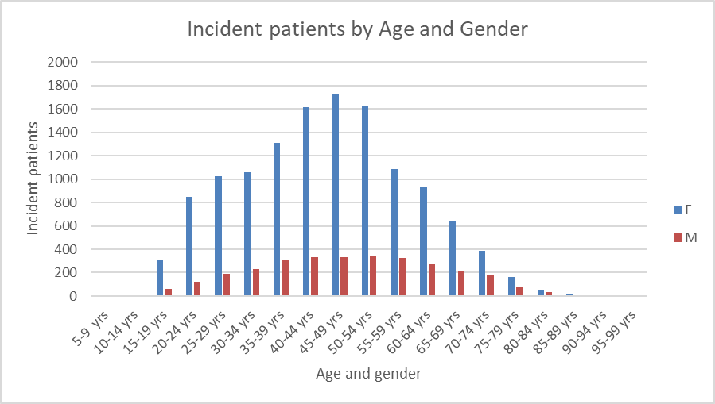

**Figure 3: Incident patients of galcanezumab by gender and 5-year age group**

Figure 3 provides a distribution of galcanezumab supply by age and gender from 1 June 2021 to 29 February 2024.

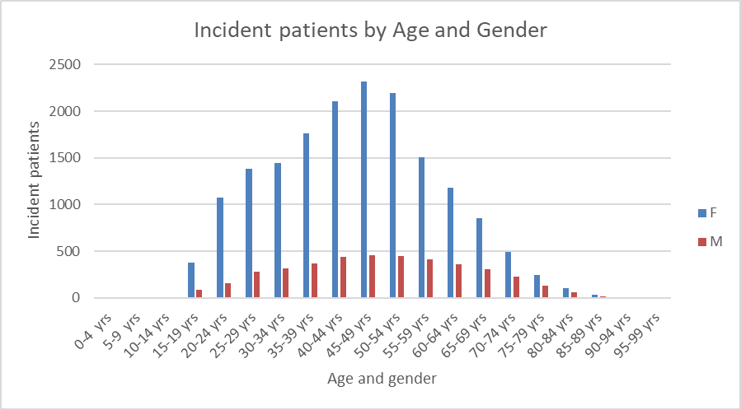

**Figure 4: Incident patients of fremanezumab by gender and 5-year age group**

Figure 4 provides a distribution of fremanezumab supply by age and gender from 1 June 2021 to 29 February 2024.

**Figure 5: Incident female patients of galcanezumab by quarter and 5-year age group**

**Figure 6: Incident female patients of fremanezumab by quarter and 5-year age group**

Figures 5 and 6 indicate that treatment with galcanezumab for females aged 40 to 54 has decreased quarter on quarter while treatment with fremanezumab for females of the same age group has increased over a similar time period. The rise in treatment with fremanezumab seen in the fourth quarter of 2023 is likely to be the result of the change in fremanezumab’s restriction that occurred on 1st November 2023 which removed the requirement for patients to have experienced an average of 15 or more headache days per month prior to commencement of treatment along with limits on the supply of galcanezumab during the same time period.

**Figure 7: Prevalent patients of galcanezumab by gender and list year**

**Figure 8: Prevalent patients of fremanezumab by gender and list year**

The ratio of female to male (prevalent patients) use of galcanezumab and fremanezumab is both approx. 4.4:1. Figures 7 and 8 indicates that this ratio has remained fairly stable over the analysis period. This compares with the female to male ratio of approx. 3:1 for migraine (prevalence) in Australia with similar rates of chronic migraine between the genders4,5.

### Changes in the use of other drugs

**Figure 9: Number of treated incident patients by quarter with migraine prophylaxis treatments**

Note:

Incident patients treated with first line therapy and triptans (dotted line) are marked on the secondary axis.

First line therapies are not PBS restricted to migraine prophylaxis and are used for other indications.

Quarter 4 data only includes the first two months of 2024.

Figure 9 shows an increase in the use of fremanezumab commencing in the fourth quarter of 2023 which is likely the result of the broadening of the restriction that occurred on 1 November 2023 when fremanezumab’s indication changed from chronic migraine to treatment resistant migraine and possibly to a lessor extant on the limits on supply of galcanezumab from 22 November 2023. The decrease in use of galcanezumab in the same period is likely the result of its limited availability from the end of November 2023 to 13 March 2024. The decline in the use of galcanezumab and the increased use of fremanezumab from the third quarter 2022 may possibly be due to some switching from galcanezumab to fremanezumab (see Table 13 within second line treatment sequences). The increase in the use of Botox in the fourth quarter of 2023 may have been the result of limits on the availability of galcanezumab from 22 November 2023. The limited availability of fremanezumab from 6 February 2024 does not impact on this analysis.

***Co-dispensing***

**Table 6: Patient co-dispensed analgesia along with galcanezumab1**

|  |  |
| --- | --- |
| **Analgesia** | **Patients** |
| Diclofenac | 160 |
| Ibuprofen | 11 |
| AspIrin | <5 |
| Opioid2 | 345 |

Note:

1Does not include patients being co-dispensed non-opioid analgesia over the counter.

2For severe pain (see Appendix A for list of medications).

Medication dispensed may not be specifically for treatment of migraine.

**Table 7: Patient co-dispensed a triptan or afirst line migraine prophylactic medication along with galcanezumab**

|  |  |
| --- | --- |
| **Triptan** | **Patients** |
| RIZATRIPTAN | 743 |
| ELETRIPTAN | 460 |
| SUMATRIPTAN | 448 |
| NARATRIPTAN | 93 |
| ZOLMITRIPTAN | 91 |
| **1st Line Prophylaxis** | **Patients** |
| AMITRIPTYLINE1 | 368 |
| TOPIRAMATE2 | 330 |
| CANDESARTAN1 | 249 |
| PROPRANOLOL1 | 173 |
| PIZOTIFEN3 | 78 |
| NORTRIPTYLINE4 | 52 |
| VALPROATE1 | 44 |
| VERAPAMIL1 | 41 |

Note:

1Medication dispensed may not be specifically for migraine prophylaxis.

2Authority Required (STREAMLINED) code 14901 for migraine.

3TGA indicated for Prophylactic (interval) treatment of vascular headaches including typical and atypical migraine, vasomotor headache, and cluster headache (Horton's syndrome).

4PBS restricted for major depression only.

**Table 8: Patient co-dispensed analgesia along with fremanezumab 1**

|  |  |
| --- | --- |
| **Analgesia** | **Patients** |
| Diclofenac | 122 |
| Ibuprofen | 17 |
| Asprin | <5 |
| Opioid2 | 104 |

Note:

1Does not include patients being co-dispensed non-opioid analgesia over the counter.

2For severe pain (see Appendix A for list of medications).

Medication dispensed may not be specifically for treatment of migraine.

**Table 9: Patient co-dispensed a triptan or afirst line migraine prophylactic medication along with fremanezumab**

|  |  |
| --- | --- |
| **Triptan** | **Patients** |
| RIZATRIPTAN | 956 |
| SUMATRIPTAN | 577 |
| ELETRIPTAN | 560 |
| ZOLMITRIPTAN | 92 |
| NARATRIPTAN | 75 |
| **First Line Prophylaxis** | **Patients** |
| AMITRIPTYLINE1 | 510 |
| TOPIRAMATE2 | 443 |
| CANDESARTAN1 | 304 |
| PROPRANOLOL1 | 257 |
| PIZOTIFEN3 | 113 |
| NORTRIPTYLINE1 | 89 |
| VERAPAMIL1 | 66 |
| VALPROATE1 | 58 |

Note:

1Medication dispensed may not be specifically for migraine prophylaxis.

2Authority Required (STREAMLINED) code 14901 for migraine.

3TGA indicated for Prophylactic (interval) treatment of vascular headaches including typical and atypical migraine, vasomotor headache, and cluster headache (Horton's syndrome).

4PBS restricted for major depression only.

Table 6 and 8 indicate that only a small number of patients are being co-dispensed analgesia along with galcanezumab or fremanezumab.

***Treatment sequence***

**Table 10: From Triptan tofirst Line Prophylaxisa**

|  |  |
| --- | --- |
| **Treatment sequence** | **Patients** |
| RIZATRIPTAN -> AMITRIPTYLINE | 11,487 |
| SUMATRIPTAN -> AMITRIPTYLINE | 9,502 |
| RIZATRIPTAN -> PROPRANOLOL | 7,204 |
| SUMATRIPTAN -> PROPRANOLOL | 6,440 |
| RIZATRIPTAN -> PIZOTIFEN | 3,065 |
| RIZATRIPTAN -> TOPIRAMATE | 2,914 |
| SUMATRIPTAN -> PIZOTIFEN | 2,782 |
| ELETRIPTAN -> AMITRIPTYLINE | 2,659 |
| RIZATRIPTAN -> CANDESARTAN | 2,011 |
| SUMATRIPTAN -> TOPIRAMATE | 1,931 |

Note:

aTen of the most common Triptan tofirst line prophylaxis sequences.

**Table 11: Fromfirst line to galcanezumaba**

|  |  |
| --- | --- |
| **Treatment sequence1** | **Patients** |
| AMITRIPTYLINE -> GALCANEZUMAB | 489 |
| TOPIRAMATE -> GALCANEZUMAB | 417 |
| PROPRANOLOL -> GALCANEZUMAB | 230 |
| CANDESARTAN -> GALCANEZUMAB | 203 |
| AMITRIPTYLINE -> TOPIRAMATE -> GALCANEZUMAB | 138 |
| PIZOTIFEN -> GALCANEZUMAB | 130 |
| TOPIRAMATE -> AMITRIPTYLINE -> GALCANEZUMAB | 101 |
| AMITRIPTYLINE -> PROPRANOLOL -> GALCANEZUMAB | 86 |
| VALPROATE -> GALCANEZUMAB | 78 |
| PROPRANOLOL -> AMITRIPTYLINE -> GALCANEZUMAB | 73 |

Note:

aTen of the most commonfirst line to galcanezumab sequences.

**Table 12: Fromfirst line to fremanezumaba**

|  |  |
| --- | --- |
| **Treatment sequence** | **Patients** |
| AMITRIPTYLINE -> FREMANEZUMAB | 1,022 |
| TOPIRAMATE -> FREMANEZUMAB | 855 |
| PROPRANOLOL -> FREMANEZUMAB | 561 |
| AMITRIPTYLINE -> TOPIRAMATE -> FREMANEZUMAB | 360 |
| CANDESARTAN -> FREMANEZUMAB | 324 |
| AMITRIPTYLINE -> PROPRANOLOL -> FREMANEZUMAB | 262 |
| PIZOTIFEN -> FREMANEZUMAB | 261 |
| PROPRANOLOL -> TOPIRAMATE -> FREMANEZUMAB | 201 |
| TOPIRAMATE -> AMITRIPTYLINE -> FREMANEZUMAB | 201 |
| PROPRANOLOL -> AMITRIPTYLINE -> FREMANEZUMAB | 193 |

Note:

aTen of the most commonfirst line to fremanezumab sequences.

Table 13 provides information on the sequence of second line therapies after a patient has been initiated on a second line therapy. It provides an insight into what, if any, other second line therapy a patient was moved (therapy switching) onto after being initiated on some other second line therapy. Analysis was up to 31 October 2023 to remove any cofounding effects of fremanezumab’s restriction change on 1 November 2023.

**Table 13: Sequence of therapy supplied during second line therapy**

|  |  |  |
| --- | --- | --- |
| **Treatment sequence** | **Patients** | **Percentage** |
| BOTULINUM TOXIN TYPE A | 16,012 | 38.1 |
| GALCANEZUMAB | 7,621 | 18.1 |
| FREMANEZUMAB | 7,534 | 17.9 |
| BOTULINUM TOXIN TYPE A -> GALCANEZUMAB | 2,193 | 5.2 |
| BOTULINUM TOXIN TYPE A -> FREMANEZUMAB | 2,176 | 5.2 |
| GALCANEZUMAB -> FREMANEZUMAB | 2,035 | 4.8 |
| GALCANEZUMAB -> BOTULINUM TOXIN TYPE A | 1,062 | 2.5 |
| FREMANEZUMAB -> GALCANEZUMAB | 755 | 1.8 |
| FREMANEZUMAB -> BOTULINUM TOXIN TYPE A | 717 | 1.7 |
| BOTULINUM TOXIN TYPE A -> GALCANEZUMAB -> FREMANEZUMAB | 482 | 1.1 |
| Other | 1,447 | 3.5 |
| **Total** | **42,034** | **100.0** |

Note:

Ten of the most common sequences for the supply of second line listings.

From 1 June 2021 to 31 October 2023.

Table 14 provides the same information as table 13 but for the entire analysis period which provides some indication on the effects of the restriction change to fremanezumab.

**Table 14: Sequence of therapy supplied during second line therapy**

|  |  |  |
| --- | --- | --- |
| **Treatment sequence** | **Patients** | **Percentage** |
| BOTULINUM TOXIN TYPE A | 17,032 | 37.1 |
| FREMANEZUMAB | 9,014 | 19.6 |
| GALCANEZUMAB | 4,831 | 10.5 |
| GALCANEZUMAB -> FREMANEZUMAB | 4,537 | 9.9 |
| BOTULINUM TOXIN TYPE A -> FREMANEZUMAB | 2,579 | 5.6 |
| BOTULINUM TOXIN TYPE A -> GALCANEZUMAB | 1,401 | 3.1 |
| BOTULINUM TOXIN TYPE A -> GALCANEZUMAB -> FREMANEZUMAB | 1,229 | 2.7 |
| GALCANEZUMAB -> BOTULINUM TOXIN TYPE A | 1,104 | 2.4 |
| FREMANEZUMAB -> BOTULINUM TOXIN TYPE A | 997 | 2.2 |
| FREMANEZUMAB -> GALCANEZUMAB | 690 | 1.5 |
| Other | 2,510 | 5.5 |
| **Total** | **45,924** | **100** |

Note:

Ten of the most common sequences for the supply of second line listings.

From 1 June 2021 to 29 February 2024.

The reduction in the number of galcanezumab patients in table 14 (4,537) as compared to table 13 (7,621) is likely a result of patients on galcanezumab switching to other second line therapy over the period 1 November 2023 to 29 February 2024 or ceasing therapy.

***Treatment duration analysis***

**Table 15: Time on treatment (days) for galcanezumab**

|  |  |  |  |
| --- | --- | --- | --- |
| **With breaks** | **Median** | **Mean** | **Precent censored** |
|  | 363 | 429 | 30% |
| **Without breaks** | | | |
|  | 222 | 348 | 23% |

**Table 16: Time on treatment (days) for fremanezumab**

|  |  |  |  |
| --- | --- | --- | --- |
| **With breaks** | **Median** | **Mean** | **Precent censored** |
|  | 661 | 512 | 67% |
| **Without breaks** | | | |
|  | 304 | 410 | 59% |

***Prescriber analysis***

**Table 17: Percentage of prescriptions supplied by prescriber type**

|  |  |  |  |  |  |
| --- | --- | --- | --- | --- | --- |
| **Speciality** | **Botox** | **Speciality** | **Fremanezumab** | **Speciality** | **Galcanezumab** |
| Neurology | 95.2% | Neurology | 69.2% | Neurology | 63.0% |
| Internal Medicine | 2.0% | VRGP | 22.6$ | VRGP | 27.3% |
| NONVRGP | 1.7% | GP Trainee | 2.2% | Internal Medicine | 3.6% |
| Nuclear Medicine | 0.6% | Internal Medicine | 2.1% | GP Trainee | 2.6% |

Note:

The data is for the period 1 June 2021 to 29 February 2024 for Botox and galcanezumab and 1 August 2021 to 29 February 2024 for fremanezumab.

NONVRGP – Non-vocationally registered GP

VRGP - Vocationally registered GP

**Table 18: Percentage of prescriptions supplied by prescriber type and treatment phase**

|  |  |  |  |  |
| --- | --- | --- | --- | --- |
| **Speciality** | **Galcanezumab Initial** | **Galcanezumab Continuation** | **Fremanezumab Initial** | **Fremanezumab**  **Continuation** |
| Neurology | 80.0% | 59.6% | 78.5% | 64.9% |
| VRGP | 11.9% | 30.4% | 13.4% | 26.8% |
| Internal Medicine | 2.8% | 3.7% | 2.3% | 2.1% |
| GP Trainee | 1.0% | 2.9% | 1.5% | 2.5% |
| NONVRGP | 2.2% | 2.0% | 2.5% | 1.9% |

Note:

The data is for the period 1 June 2021 to 29 February 2024 for galcanezumab and 1 August 2021 to 29 February 2024 for fremanezumab.

NONVRGP – Non-vocationally registered GP

VRGP - Vocationally registered GP

***Mapping of geospatial analyses***

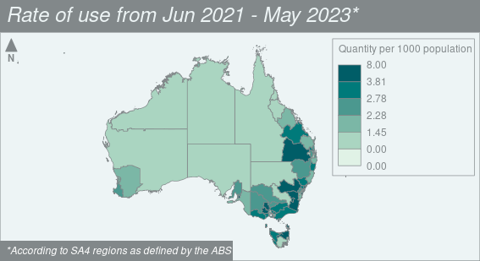

**Figure 10: Rate of dispensing of galcanezumab by Statistical Area 4**

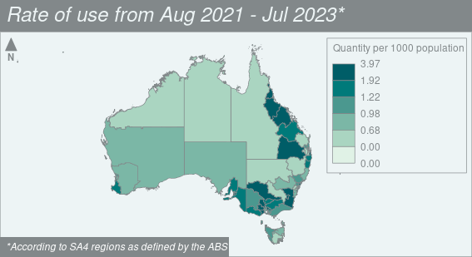

**Figure 11: Rate of dispensing of fremanezumab by Statistical Area 4**

The geospatial analysis is presented as listing year (the 12 months since the date of listing on the PBS) for galcanezumab (June to May) and fremanezumab (August to July) respectively.

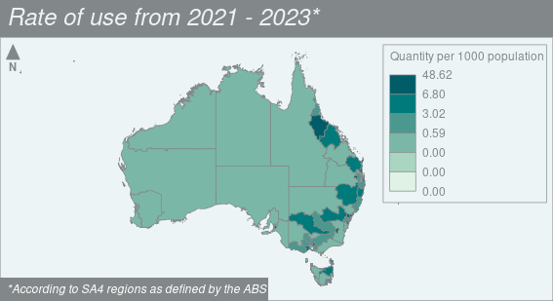

**Figure 12: Rate of use of Botox MBS services by Statistical Area 4**

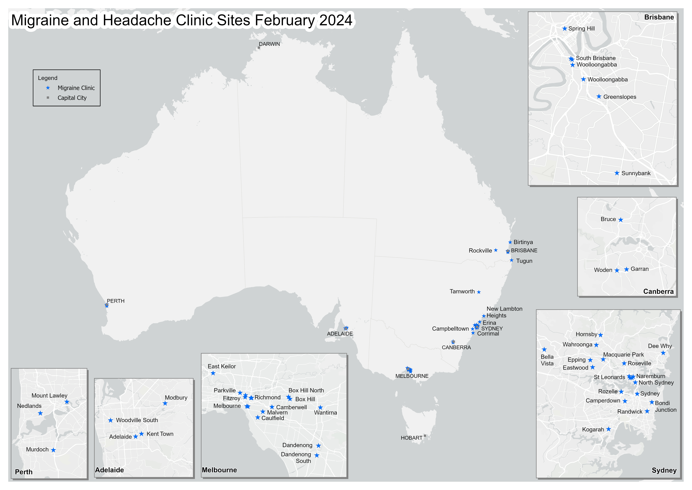

**Figure 13: Map of Locations of Medical Professionals Specialising in Migraine and Headache**

Note:

Sourced [Doctor Directory - Headache Australia](https://headacheaustralia.org.au/doctor-directory/) – Migraine and Headache Australia, Accessed 28 February 2024.

## Analysis of actual versus predicted utilisation

Table 19 and 20 compares the predicted versus the actual utilisation and cost to government of galcanezumab and fremanezumab respectively over the first two years of listing.

**Table 19: Comparison of predicted versus actual utilisation of galcanezumab for each year of listing**

|  |  |  |
| --- | --- | --- |
|  | **Year 1a** | **Year 2a** |
| **Number of patients** |  |  |
| Predicted | XXXXX | XXXXX |
| Actual | 9,759 | 10,521 |
| Difference b | XXXXX | XXXXX |
| **Number of scripts** |  |  |
| Predicted | XXXXXX | XXXXXX |
| Actual | 56,185 | 77,294 |
| Difference b | XXXXX | XXXXX |

Source: The predicted figures were sourced from the final version of the financial estimates model.

Note:

a The figures are presented in listing years (Jun to May).

b Difference is calculated as: ((Actual – Predicted)/Predicted) x 100.

**Table 20: Comparison of predicted versus actual utilisation of fremanezumab for each year of listing**

|  |  |  |
| --- | --- | --- |
|  | **Year 1a** | **Year 2a** |
| **Number of patients** |  |  |
| Predicted | XXXXX | XXXXXX |
| Actual | 6,189 | 10,997 |
| Difference b | XXXX | XXXX |
| **Number of scripts** |  |  |
| Predicted | XXXXXX | XXXXXX |
| Actual | 34,774 | 70,866 |
| Difference b | XXXXX | XXXXXX |

Source: The predicted figures were sourced from the submission to the March 2020 PBAC meeting for number of patients and the final version of the financial estimates model for the number of scripts.

Note:

a The figures are presented in listing years (Aug to Jul).

b Difference is calculated as: ((Actual – Predicted)/Predicted) x 100.

# Discussion

The predicted vs. actual utilisation of galcanezumab (Table 19) over the first two years of listing, there were XXXX patients initiated in year one than expected with the possibility that there were XXXX patients continuing treatment for longer than expected into year two. In year two there were XXXX initiating patients along with the XXXXXXXXXX continuing patients from year one with the possibility that some patients transitioned to fremanezumab starting in the third quarter of 2022. Within the agreed financial estimates, the predicted uptake of galcanezumab was XXXXX in year 1 and XXXXX in year two. The initial uptake was XXXXXX in years one and two. It was considered that the continuation rate at three months of XXX may have been an XXXXXXXXXXXXX.

The difference between the actual and predicted number of scripts for fremanezumab (Table 20) over the first two years of listing could be the result of XXXX patients initiating and continuing on treatment than expected. The number of initiating patients in the first and second years was XXXXXXX XXXX than predicted. There were XXXX continuing patients in year two then predicted from the November 2019 submission. In the first two years of listing, XXXXXXXXXXXX of scripts were for 675 mg dosing, possibly indicating an extremely limited amount of stockpiling by patients. The time on treatment (median 661 days with breaks and 304 days without breaks) indicates that XXXXX patients are discontinuing treatment than assumed in the March 2020 resubmission.

The November 2019 submission and March 2020 resubmission assumed a continuation rate of XXXXX after 12 weeks based on Botox. Given the dosing requirements for Botox, this may be a XXXXXX XXXXXXXXXXXXX and the March 2020 resubmission assumed a discontinuation rate of XXX after 12 months which may be a XXXXXXXX XXXXXXXXXXXX.

As would be expected, the age and gender pattern of the use of galcanezumab and fremanezumab mirrors that of demographics of migraine in Australia4. The reason for the change in usage pattern in the second half of 2022 between galcanezumab and fremanezumab is not apparent while the increase in use of fremanezumab in late 2023 can be attributed to the broadening of its restriction, and to a lesser extent, the shortages limiting the availability of galcanezumab.

It should be noted that the data on co-dispensing of analgesics (Tables 6 and 8) does not necessarily indicate co-administration. It was more likely that patients who are co-administering non-opioid analgesia along with their galcanezumab or fremanezumab are obtaining these medications over-the-counter rather than through the PBS. It was not possible to determine what if any analgesia (non-opioid or opioid) that patients may be co-administering nor was it possible to determine whether the co-dispensed medication is being taken for migraine or another condition.

Figure 9 indicates that after an initial decrease in the use of triptans and first line medications for prophylaxis, the use of these medications had levelled off after the introduction of galcanezumab or fremanezumab. Tables 7 and 9 indicated that, to some extent, triptans and first line medications for prophylaxis were being co-dispensed with galcanezumab or fremanezumab. There seemed to be a consistent pattern of co-dispensing triptans and first line medications for prophylaxis along with galcanezumab or fremanezumab. Use of triptans and first line medications for prophylaxis in those undergoing treatment with galcanezumab or fremanezumab may be for the treatment of breakthrough migraines. However, it should be noted that, particularly in the case of first line medications for prophylaxis which have indications other than migraine prophylaxis, co-dispensing may not indicate co-administration for migraine but use in co-morbidities. It was therefore likely that in the case of first line medications for prophylaxis, a proportion of patients were using these mediations for indications other than migraine. However, it was reasonable to consider that if a patient was being dispensed a first line medication for prophylaxis after a triptan (Table 10) it was likely that the first line medication was being used for migraine prophylaxis.

While it was difficult to determine whether a medication used for first line prophylactic therapy was being prescribed for migraine or another indication there was some evidence of a pattern, both in co-dispensing and treatment sequence, which may indicate a preference rank of these first line medications for use in migraine prophylaxis. The data on co-dispensing (Table 7 and 9) of first line prophylactic therapy, taken together with the data on the sequence of first line to second line prophylactic therapy (Tables 11 and 12) mimic the dispensing pattern of first line prophylactic therapy as standalone migraine therapy (as can be ascertained from the treatment sequence of first line prophylactic therapy) (Tables 10, 11 and 12). It was likely that those patients co-dispensed, or have a treatment sequence, which involves a first line prophylaxis therapy are being treated for relevant ARTG indications and likely represent patients with co-morbidities. However, given the pattern of use in co-dispensing and treatment sequence, it was likely that the preference rank of usage of triptans and first line medications presents an accurate picture of the preference for particular triptans and first line therapy for migraine.

Caution needs to be used when interpreting the service rates for Botox vs. the dispensing rates for galcanezumab and fremanezumab as patients (given the mode of administration of Botox) will likely travel in to receive their Botox service (injections) at a more central specialist clinic while the majority of patients may get their galcanezumab and fremanezumab prescriptions at a more central specialist clinic but have scripts dispensed at their local pharmacy. It was likely that some patients were getting their galcanezumab or fremanezumab continuing scripts at their local General Practice clinic (Table 17 and 18). While the dispensing of galcanezumab and fremanezumab did, to a certain extent, overlap (Figures 10 and 11) this was not the case with Botox administration, the majority of which took place in certain SA3 locations. A total of 15 SA3 locations accounted for 50% of Botox services, which compared to 63 SA3 locations accounting for 50% of fremanezumab scripts dispensed and 73 SA3 locations accounting for 50% of galcanezumab scripts dispensed. This indicated that Botox services were being delivered more centrally while scripts for galcanezumab and fremanezumab were being dispensed in a wider geographical area. Table 17 indicated that over 95% of Botox was being prescribed by neurologists as the current PBS restriction required that both treatment initiation and continuation be undertaken by a neurologist. Around one-third of galcanezumab and fremanezumab prescriptions were being written by specialities other than neurology (Table 17), which was likely to be the result of the current PBS restriction requirements that treatment initiation be undertaken by a neurologist while treatment continuation can be either be by a neurologist or in consultation with a neurologist (Table 18). This indicated that while the bulk of Botox was being prescribed and administered within specialist centres, a significant proportion of galcanezumab and fremanezumab was being prescribed outside of specialist centres, most likely as a result of continuing therapy being prescribed in primary care.

# DUSC consideration

DUSC considered that how chronic, or treatment-resistant migraine is defined within the current restrictions for galcanezumab and fremanezumab respectively was leading to behaviours to match the restrictions. This may be contributing to the overuse of over the counter (OTC) medications for migraine and headache, which in turn could be causing medication overuse headache for which patients are seeking medical care and prescriptions for chronic migraine. DUSC considered that some patients are then meeting the definitions under the relevant restrictions, but not due to the underlying pathophysiology associated with migraine but due to the overuse of OTC medication to treat migraine and headache.

DUSC noted that there were delays in seeing a neurologist for assessment and treatment initiation and considered that additional information and training could be provided to GPs in relation to the prevention and treatment of migraine and medication overuse headache. DUSC considered that additional information could be provided by the Australian Commission on Safety and Quality in Health Care in relation to migraine, medication overuse headache, and chronic pain management more generally as the overuse of OTC analgesics for chronic pain can lead to medication overuse headache.

DUSC noted that in their Pre-sub-committee response’s consumers XXX X XXXXXXX argued that it was inappropriate to use the utilisation of botulinum toxin type A (Botox) to estimate the use of calcitonin gene-related peptide (CGRP) antagonists. DUSC noted that the administration of Botox was significantly different from that of galcanezumab and fremanezumab, as was evident from the geospatial analysis, in that Botox requires numerous injections by a neurologist usually undertaken in a specialist centre.

DUSC considered that there was a significant unmet need for CGRP antagonists. DUSC considered that the CGRP antagonist’s clinical criteria and place in therapy could be examined via a post market review. DUSC considered that an age-standardised geospatial analysis as well as an analysis of stopping data would be of benefit. DUSC considered that CGRP antagonists had the potential to become an earlier line of therapy overtime if restrictions were to change due to greater familiarity with the therapy by physicians and consumers, a different side effect profile and therapeutic action than current first line prophylactic medication for chronic migraine.

DUSC did not consider that GPs should be initiating therapy with galcanezumab and fremanezumab due to current TGA black triangle warning, and need for additional education with CGRP antagonists. DUSC discussed whether the treatment criteria in the current restrictions for the initial treatment phase could be altered from ‘Must be treated by a neurologist’ to ‘Must be treated by a neurologist; OR Must be treated by a general practitioner in consultation with a neurologist’, which would align it with the continuing treatment phase.

# DUSC actions

DUSC suggested that a further analysis should be undertaken to examine an age-standardised geospatial analysis as well as an analysis of stopping data.

DUSC requested that the report be provided to the PBAC for consideration.

# Context for analysis

The DUSC is a Sub Committee of the Pharmaceutical Benefits Advisory Committee (PBAC). The DUSC assesses estimates on projected usage and financial cost of medicines.

The DUSC also analyses data on actual use of medicines, including the utilisation of PBS listed medicines, and provides advice to the PBAC on these matters. This may include outlining how the current utilisation of PBS medicines compares with the use as recommended by the PBAC.

The DUSC operates in accordance with the quality use of medicines objective of the National Medicines Policy and considers that the DUSC utilisation analyses will assist consumers and health professionals to better understand the costs, benefits and risks of medicines.

The utilisation analysis report was provided to the pharmaceutical sponsors of each drug and comments on the report were provided to DUSC prior to its consideration of the analysis.

# Sponsors’ comments

Teva Pharma Australia Pty Ltd:

TEVA highlights that in 2017 DUSC correctly noted that the disparity between the continuation rate on treatment at 24 weeks (i.e. after 2 treatments), 71.4%, was more than double that predicted from trial data, 32.9%. Similarly, patients on CGRPs are continuing on therapy in excess of what was predicted, likely because of their high levels of efficacy.

Eli Lilly Australia Pty Ltd: The sponsor had no comment.

# Disclaimer

The information provided in this report does not constitute medical advice and is not intended to take the place of professional medical advice or care. It is not intended to define what constitutes reasonable, appropriate or best care for any individual for any given health issue. The information should not be used as a substitute for the judgement and skill of a medical practitioner.

The Department of Health and Aged Care has made all reasonable efforts to ensure that information provided in this report is accurate. The information provided in this report was up-to-date when it was considered by the Drug Utilisation Sub-committee of the Pharmaceutical Benefits Advisory Committee. The context for that information may have changed since publication.

To the extent provided by law, the Department of Health and Aged Care makes no warranties or representations as to accuracy or completeness of information contained in this report.

To the fullest extent permitted by law, neither the Department of Health and Aged Care nor any Department of Health and Aged Care employee is liable for any liability, loss, claim, damage, expense, injury or personal injury (including death), whether direct or indirect (including consequential loss and loss of profits) and however incurred (including in tort), caused or contributed to by any person’s use or misuse of the information available from this report or contained on any third party website referred to in this report.

# References

1. Emgality® (Galcanezumab). Australian Approved Product Information. Eli Lilly Australia. Approved 28 May 2019, updated 11 January 2024. Available from [EMGALITY (tga.gov.au)](https://www.ebs.tga.gov.au/ebs/picmi/picmirepository.nsf/pdf?OpenAgent=&id=CP-2019-PI-01545-1&d=20240222172310101).
2. Ajovy® (Fremanezumab). Australian Approved Product Information. Teva Pharma Australia. Approved Ajovy pre-filled syringe: 20 September 2019, Ajovy autoinjector: 2 June 2021, updated 11 October 2023. Available from [AJOVY (tga.gov.au)](https://www.ebs.tga.gov.au/ebs/picmi/picmirepository.nsf/pdf?OpenAgent=&id=CP-2019-PI-01962-1).
3. Jenkins B. Migraine management. *Aust Prescr.* 2020; 43:148-51. <https://doi.org/10.18773/austprescr.2020.047>
4. Deloitte Access Economics (2018) Migraine in Australia, Accessed 27/2/2024, <https://www.deloitte.com/au/en/services/economics/perspectives/migraine-australia-whitepaper.html>
5. Eller M, Cheng S. Migraine management: an update for the 2020s. *Intern Med J*. 2022;52(7):1123-1128. doi:10.1111/imj.15843

**Appendix A**

**Non-opioid Analgesia**

IBUPROFEN

ASPIRIN

DICLOFENAC

PARACETAMOL

**Opioid Analgesia for severe pain**

HYDROMORPHONE

OXYCODONE

MORPHINE

BUPRENORPHINE

CODEINE

OXYCODONE + NALOXONE

PARACETAMOL + CODEINE

TAPENTADOL

TRAMADOL

**Triptans**

ELETRIPTAN

NARATRIPTAN

RIZATRIPTAN

SUMATRIPTAN

ZOLMITRIPTAN

**1st Line Therapy for Migraine Prophylaxis**

TOPIRAMATE

PIZOTIFEN

AMITRIPTYLINE

CANDESARTAN

PROPRANOLOL

VERAPAMIL

Sodium VALPROATE

nortriptyline – PBS restricted for major depression.

**Other 2nd Line Therapy for Migraine Prophylaxis**

BOTULINUM TOXIN TYPE A

EPTINEZUMAB