Analysis of fluticasone propionate in children with asthma

Drug utilisation sub-committee (DUSC)

February 2026

Abstract

Purpose
To review the recent utilisation of PBS-listed fluticasone propionate 50 microgram (mcg) in children following restriction changes in 2023 and 2024 as requested by the Pharmaceutical Benefits Advisory Committee (PBAC).

Date of listing on the Pharmaceutical Benefits Scheme (PBS)

Fluticasone propionate 50 mcg was first listed on the PBS on 1 May 2001.

Data Source / methodology
Data extracted from the PBS database maintained by Department of Health, Disability and Ageing, processed by Services Australia were used for the analyses.

Key Findings
- In the year prior to the PBS restriction change from Unrestricted to Authority Required (1 April 2022 to 1 April 2023), there were an average of 12,122 prescriptions per month of fluticasone propionate 50 mcg supplied to children 5 years of age and under, and 13,698 to those 6 years of age and over. In the 3 month period where the items were Authority Required (1 April 2023 to 1 July 2023) there were 5,600 and 5,090 prescriptions per month, respectively. In the year after the restriction change from Authority Required to Streamlined (1 July 2023 to 1 July 2024) there were 7,916 and 8,788 prescriptions per month, respectively.
- From 1 April 2022 to 1 April 2023, there were an average of 2,607 patients per month initiating to fluticasone propionate 50 mcg who were 6 years of age and over. This compares to 178 patients per month from 1 April 2023 to 1 July 2023 and 1,535 from 1 July 2023 to 1 July 2024. The initiations in these later two periods were outside the PBS restriction.
- General Practitioners (including VRGPs, GP trainees and non-VRGPs) were the leading prescribers of initial prescriptions for fluticasone propionate 50 mcg in patients aged 6 years and over.

Purpose of analysis
To review the recent utilisation of PBS-listed fluticasone propionate 50 microgram (mcg) in children following restriction changes in 2023 and 2024 as requested by the PBAC.

Background

Clinical situation
Fluticasone propionate 50 mcg is considered a low dose inhaled corticosteroid (ICS). It is the only metred aerosol for use in patients under 6 years of age and the only low dose metred aerosol registered for use in Australia by the Therapeutic Goods Administration (TGA). Relevant alternate ICS therapies are beclomethasone and budesonide.
Asthma in young preschool aged children (between ages 1 and 5 years) can be defined as those who present with recurrent episodes of wheeze, cough or difficulty breathing/activity limitation, all of which respond to a short acting beta agonist (SABA) such as salbutamol or terbutaline. The diagnosis of asthma in preschool aged children can be difficult as there is overlap with other common conditions and a lack of objective tests. The aim of therapy is adequate symptom control through regular titration of asthma treatment. A step approach to maintenance treatment is to be followed, such as Figure 1 below. Of note is that approximately half of children who wheeze during preschool years will have asthma at school age.
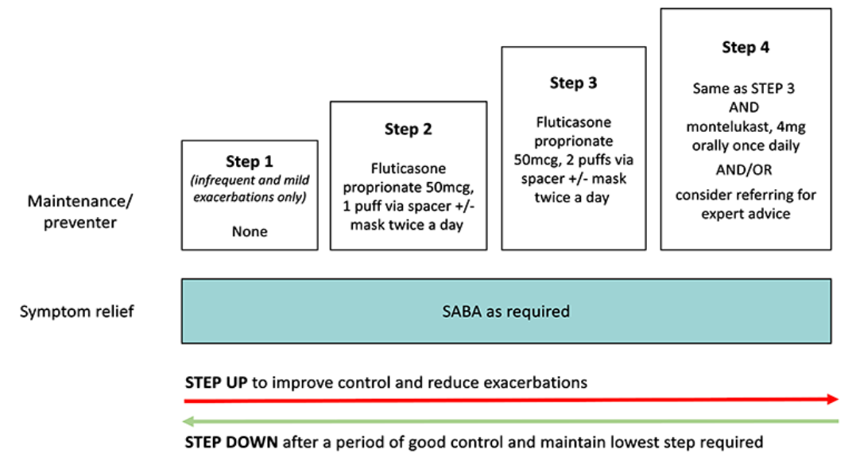
Figure 1: Step approach in maintenance treatment for preschool aged children with asthma¹
For school aged children (ages 6 and 11 years) who continue to present with asthma, diagnosis is based on symptoms (wheeze, breathlessness, cough) and treatment response (i.e. recurrent clusters of symptoms that respond to SABA or chronic symptoms that respond to an ICS) in the absence of red flags or alternate diagnoses.¹ See the step approach to maintenance treatment for this age group in Figure 2 below.
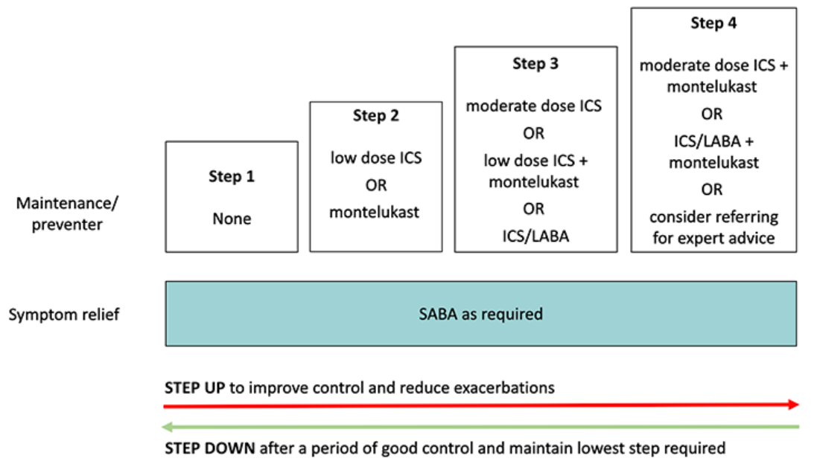
Figure 2: Step approach in maintenance treatment for school aged children with asthma¹

Pharmacology

Fluticasone propionate given by inhalation at recommended doses has strong anti-inflammatory and immune suppressive activity in the airway. This improves the symptoms of asthma, allows reduction of other drugs, such as bronchodilators, and may limit the risk of decline in lung function over time. Inhaled fluticasone propionate targets the lungs and has little effect on the rest of the body making it more suitable for asthma than taking orally administered corticosteroids.

Therapeutic Goods Administration (TGA) approved indications

For use in the prophylactic management of asthma in adults and children of ages 1 year and older.

Dosage and administration
Children 1 year and older
50 to 100 micrograms twice daily. Once asthma symptoms have been controlled, the dose of fluticasone propionate should be reduced to the lowest dose which maintains control of asthma symptoms.
The diagnosis and treatment of asthma should be kept under regular review.
In children under the age of eight, it is strongly recommended that a spacer device be used to administer a metered dose inhaler.
The current Product Information (PI) and Consumer Medicine Information (CMI) are available from the TGA (Product Information) and the TGA (Consumer Medicines Information).

PBS listing details (as at December 2025)

Table 1: PBS listing of fluticasone propionate 50 microgram/actuation inhalation
Item | Name, form & strength, pack size | Max. quant. | Rpts | DPMQ | Brand name and manufacturer
14487L | fluticasone propionate 50 microgram/actuation inhalation, 120 actuations | 2 | 5 | $28.62 | Axotide Junior  Apotex Pty Ltd
 |  |  |  | $36.62 | Flixotide Junior  GlaxoSmithKline Australia Pty Ltd
8516F |  | 1 | 5 | $21.20 | Axotide Junior  Apotex Pty Ltd
 |  |  |  | $25.20 | Flixotide Junior  GlaxoSmithKline Australia Pty Ltd
Source: the PBS website.

Restriction
The two item numbers have the same restriction for asthma:
Clinical criteria:
- The treatment must not be a PBS benefit where this 50 microgram strength is being initiated in a patient over the age of 6.00 years.
However, item number 14487L includes the following additional clinical criterion:
- AND the condition must be stable for the prescriber to consider the listed maximum quantity of this medicine suitable for this patient.
For details of the current PBS listing refer to the PBS website.

Date of listing on PBS
Fluticasone propionate 50 mcg was first listed on the PBS on 1 May 2001 under item code 8516F as an Unrestricted Benefit.
Item 14487L was listed on the PBS on 1 September 2024 as a Restricted Benefit with the restriction wording:
- The condition must be stable for the prescriber to consider the listed maximum quantity of this medicine suitable for this patient.

Changes to listing
Table 2: Changes to PBS listing arrangements for fluticasone propionate 50 mcg
Item code | Date of change | Description of change
8516F | 1 April 2023 | Unrestricted Benefit to Authority Required  Restriction wording  Asthma Population criteria:  * Patient must be less than 6.00 years of age.  Treatment criteria:  * Must be treated by a respiratory physician; OR  * Must be treated by a paediatrician; OR  * Must be treated by a health practitioner who is continuing treatment that was initiated by one of the specialists above.
8516F | 1 July 2023 | Authority Required to Streamlined Authority  Restriction wording  Asthma Clinical criteria:  * The treatment must not be a PBS benefit where this 50 microgram strength is being initiated in a patient over the age of 6.00 years.
14487L | 1 October 2024 | Restricted Benefit to Streamlined Authority  Restriction wording  Asthma Clinical criteria:  * The treatment must not be a PBS benefit where this 50 microgram strength is being initiated in a patient over the age of 6.00 years, AND  * The condition must be stable for the prescriber to consider the listed maximum quantity of this medicine suitable for this patient.

Current PBS listing details are available from the PBS website.

Relevant aspects of consideration by the Pharmaceutical Benefits Advisory Committee (PBAC)
At its May 2023 meeting, the PBAC recalled its previous advice to amend the restrictions for fluticasone propionate 50 mcg metered dose inhaler had been provided in the context of the sponsor’s request for Ministerial Discretion to avoid the 1 April 2023 catch up statutory price reductions. The PBAC had been asked to provide advice as to whether there were any clinical alternatives available on the PBS and whether the delisting of the item would result in an unmet clinical need.
At the time of its previous recommendation, the PBAC noted the relevant alternate therapies, beclomethasone and budesonide would remain available under the existing conditions. However, the PBAC noted that fluticasone propionate 50 mcg is the only metred aerosol for use in patients under 6 years of age and the only low dose metred aerosol registered for use in Australia by the Therapeutic Goods Administration (TGA). Therefore, the PBAC advised there was a clinical need to retain fluticasone propionate 50 mcg on the PBS for patients under 6 years of age due to the lack of clinical alternatives in this population. The PBAC noted the strong concerns that had been raised by clinicians and professional organisations regarding the restriction changes implemented on 1 April 2023.
The PBAC acknowledged these concerns, including that the current listings may create difficulties in patient access, particularly for those in rural or remote areas, those unable to secure timely respiratory specialist appointments, and those who cannot afford private consultations or the private cost of the medicine. The PBAC noted this had not been the intended effect of its previous advice.
Therefore, to reduce the impact on patient access, the PBAC recommended the following changes to the existing restrictions for fluticasone propionate 50 mcg:
- Remove existing restrictions on prescriber type, including the criterion that treatment must be initiated by a respiratory physician or paediatrician.
- Amend the authority approval method from Authority Required (Telephone/Online) to Authority Required (STREAMLINED).
- Allow patients who start and are stabilised on treatment before 6 years of age to continue PBS access beyond 6 years of age.
The PBAC recommended that a review of utilisation be undertaken in two years to assess any impact on utilisation resulting from these changes.
The PBAC recommended that fluticasone could return to an unrestricted listing if the price for patients aged 6 years and above were reduced as per the legislated 1 April 2023 catch up reduction. The PBAC considered that the cost-effectiveness of fluticasone propionate 50mcg would be acceptable under these circumstances, where the price would be more consistent with the alternative therapies. While the PBAC considered an unrestricted listing would provide the greatest patient access and reduction in administrative burden for prescribers, it noted that accepting a price consistent with the legislated 1 April 2023 catch up reduction would be a commercial decision for the medicine’s sponsor.
For further details refer to the May 2023 PBAC meeting.

Methods
Data extracted from the PBS claims database maintained by the Department of Health, Disability and Ageing and processed by Services Australia were used for the analyses. Prescription data were extracted for fluticasone 50mg (PBS item codes 14487L and 8516F) prescriptions supplied from 1 July 2019 to the end of September 2025.
Initiating fluticasone propionate 50 mcg was defined as no prescription since 1 July 2019 (i.e. the beginning of the extracted data). Since initiator counts are reported from 1 January 2021, these mean patients are deemed to have initiated if they have not had a prior prescription for at least 18 months.
As this analysis uses date of supply prescription data, there may be small differences compared with publicly available Services Australia Medicare date of processing data. The publicly available Services Australia Medicare data only includes subsidised R/PBS prescriptions with prescriptions under the patient co-payment not included. The prescription data used in this report does include under co-payment prescriptions from 1 April 2012.

Results

Analysis of drug utilisation

Overall utilisation
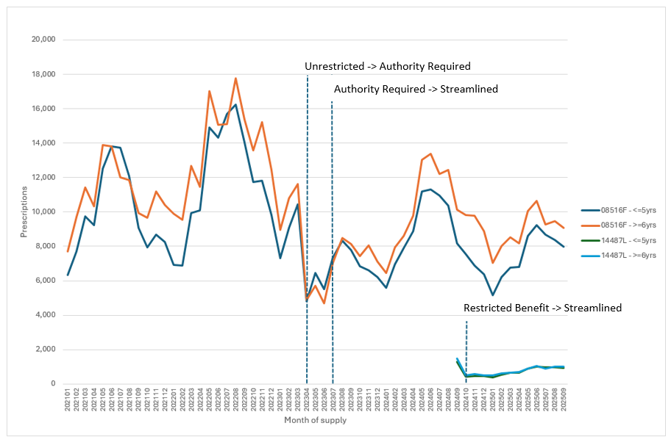Figure 1: Prescriptions for fluticasone propionate 50 mcg by PBS item and month of supply

Figure 1 illustrates that the restriction change in April 2023 (Unrestricted to Authority Required) and the change in July 2023 (Authority Required to Streamlined) both had an impact on the number of scripts supplied. This impact was slightly greater for patients 6 years of age and over (the orange line) than for patients 5 years and under (the dark blue line).

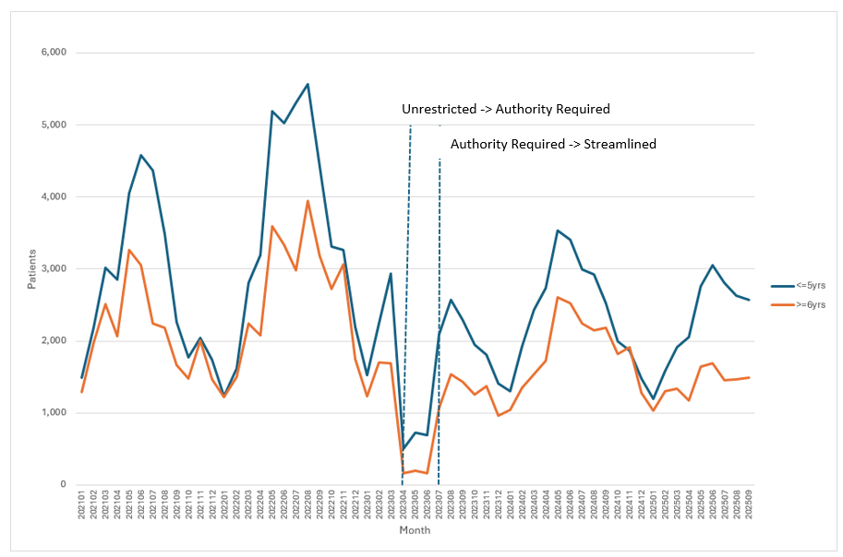
Figure 2: Number of patients initiating fluticasone propionate 50 mcg (using either item code) by age and month of supply

Figure 2 shows that the number of initiating patients 6 years and over (the orange line) was low when the restriction only allowed treatment of patients 5 years and under. However, this group recovered after the listing changed to Streamlined Authority despite this use being outside the PBS restriction.

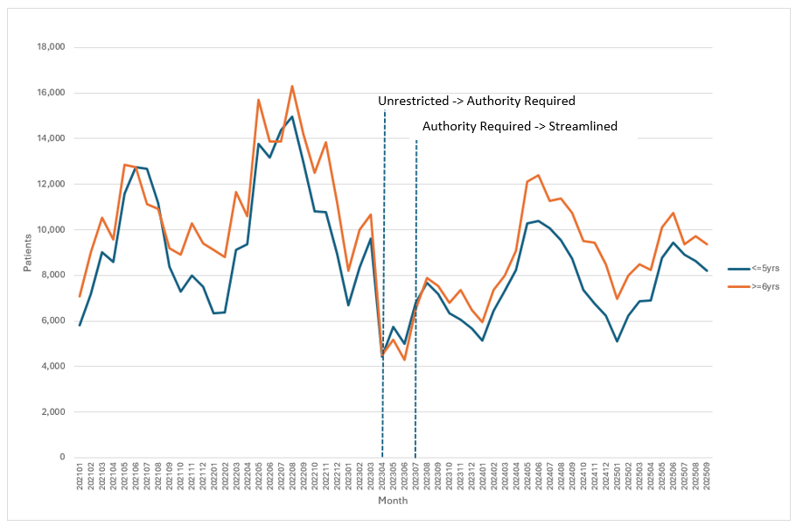
Figure 3: Number of patients supplied fluticasone propionate 50 mcg (using either item code) by age and month of supply

The trends seen in Figure 3 are similar to those of Figure 1. A potential reason for the number of prevalent patients aged 6 years and over not decreasing further following April 2023 is that both item codes have 5 repeats and so patients were being supplied scripts between April and June 2023 which were written prior to April 2023 (when the listing was Unrestricted).

Utilisation by prescriber type

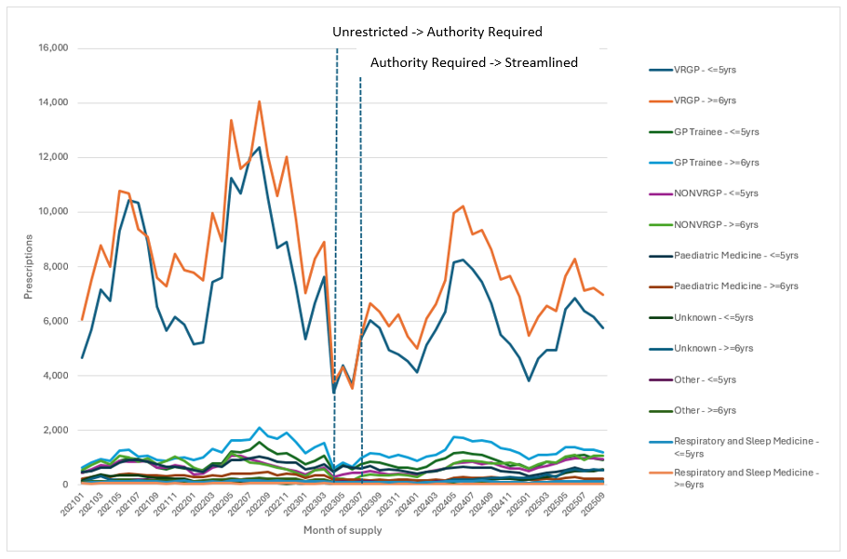
Figure 4: Number of prescriptions for fluticasone propionate 50 mcg (using either item code) by prescriber type, patient age and month of supply

Figure 4 shows that the predominant prescribers of this medicine are vocationally registered GPs (VRGP). All prescriber types less frequent than ‘Respiratory and Sleep Medicine’ have been grouped into the ‘Other’ category to reduce clutter.

Figure 5 below excludes VRGPs so that the other prescriber types can be seen more clearly.
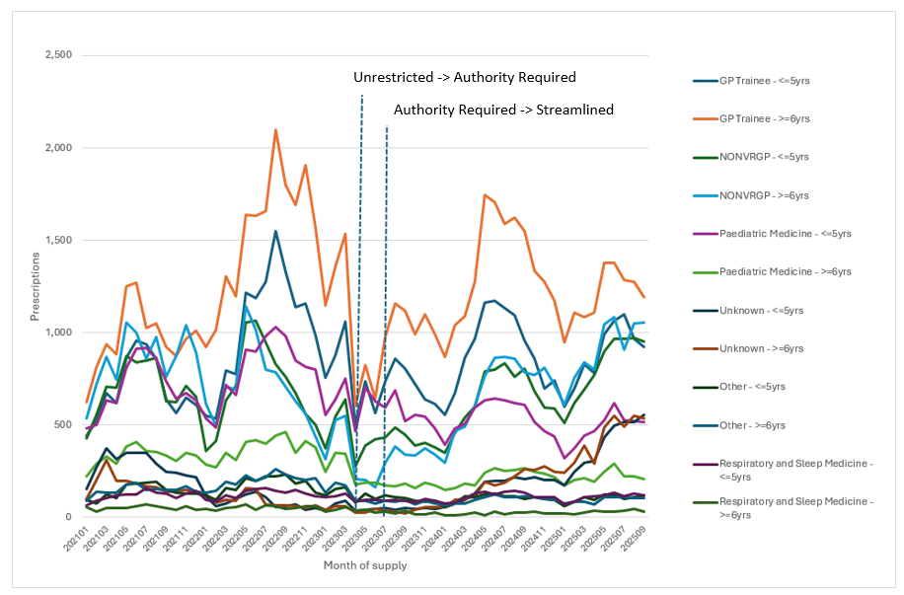
Figure 5: Number of prescriptions for fluticasone propionate 50 mcg (using either item code) by prescriber type (excluding VRGPs), patient age and month of supply

One feature of the analysis is that the prescribing by paediatric specialists to patients 5 years and under recovers quickly in the month after the 1 April 2023 restriction change. Paediatricians and respiratory physicians were the only specialists in the period 1 April to 1 July 2023 that were permitted in the PBS restriction to prescribe both initiating and continuing scripts to patients 5 years and under.

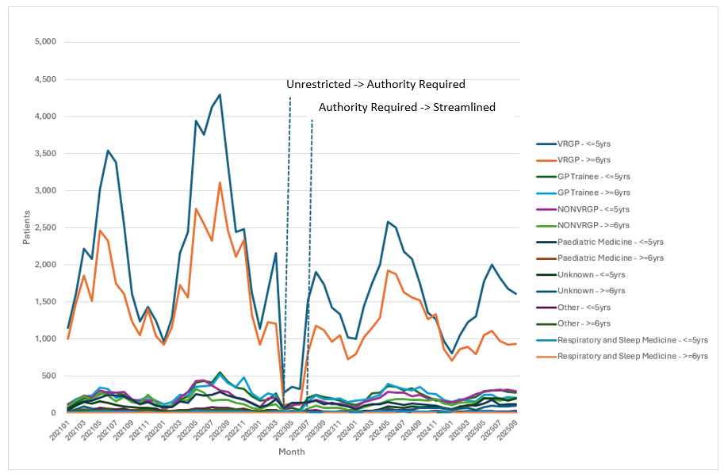
Figure 6: Number of patients initiating fluticasone propionate 50 mcg (using either item code) by prescriber type, age and month of supply

The decrease in initiations by VRGPs is very marked at April 2023, particularly for patients 6 years and over (the orange line). After the listing became Streamlined Authority on 1 July 2023, the number of initiations by VRGPs of patients 6 years and over returned to the pre 1 April 2023 level, which is outside the restriction.

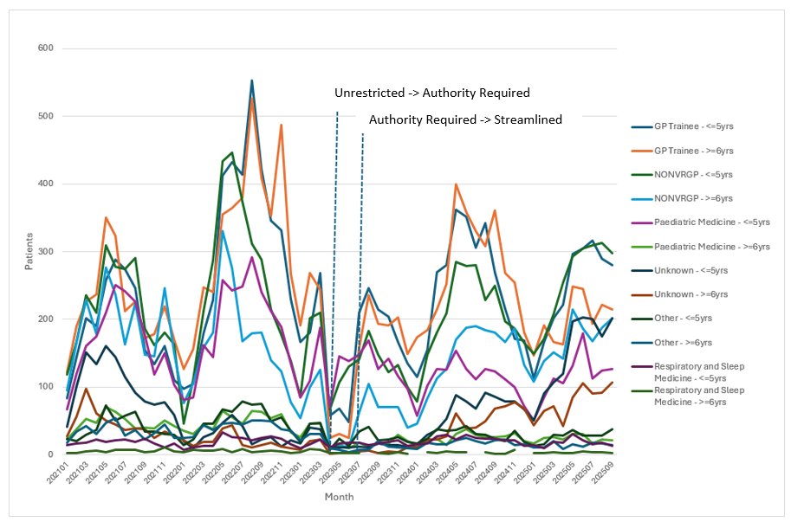
Figure 7: Number of patients initiating fluticasone propionate 50 mcg (using either item code) by prescriber type (excluding VRGPs), patient age and month of supply

Figure 7 has the VRGP group removed to see the trends in other prescriber types. The initiations by paediatricians of patients aged 5 years and under continued through the period 1 April 2023 to 1 July 2023, which was consistent with the restriction. The other specialties had low number of initiations in this period, with the exception of non-VRGPs for patients aged 5 years and under which was inconsistent with the restriction. Once the listing was Streamlined, most prescriber types (with the possible exception of paediatricians) returned to initiating patients 6 years and over which is inconsistent with the restriction.

Discussion and DUSC consideration
As fluticasone propionate 50 mcg is the only metred aerosol for use in patients under 6 years of age and the only low dose metred aerosol registered for use in Australia by the TGA, the PBAC advised there was a clinical need for it to be retained on the PBS for patients under 6 years of age due to the lack of clinical alternatives in this population. This decision was made in the context of the sponsor’s request for Ministerial Discretion to avoid the 1 April 2023 catch up statutory price reductions. The increase in Authority came into effect 1 April 2023. The subsequent change on 1 July 2023 (from Authority Required to Streamlined) was to address patient access issues.
Apart from a brief drop in use in the months between these two dates, the initiation of PBS fluticasone propionate 50 mcg in children aged 6 years and over appears to have returned to a similar level as that about 4 months prior to the 1 April 2023 restriction changes (see Figure 2), which is outside the current PBS restriction. DUSC acknowledged the sponsor’s response and that the initial restriction change to Authority Required by specialists led to reduced utilisation in the eligible population, and discussed that this was not the intent of the restriction change. DUSC further noted that immediately after the change to Streamlined Authority, there was a growth in utilisation but this was not necessarily sustained to the same extent a year later. DUSC also noted that there is substantial leakage within indication.
General Practitioners (including VRGPs, GP trainees and non-VRGPs) are the leading prescribers of initial prescriptions for fluticasone propionate 50 mcg in patients aged 6 years and over. Of note is that the relevant alternate therapies, beclomethasone and budesonide, are available on the PBS for this age group. DUSC discussed that there are no true structural barriers to the eligible population accessing therapy, and that prescriber behaviour drives the utilisation of inhalers in this patient group. There are also other steroid inhalers available for this population. DUSC discussed that a solution to appropriate inhaler prescribing is appropriate quality use of medicines. Of note is that the latest version of the Australian Asthma Handbook is still filtering through to prescriber practice.

DUSC Actions

DUSC requested that the report be provided to the PBAC for consideration.
Context for analysis
The DUSC is a Sub Committee of the Pharmaceutical Benefits Advisory Committee (PBAC). The DUSC assesses estimates on projected usage and financial cost of medicines.
The DUSC also analyses data on actual use of medicines, including the utilisation of PBS listed medicines, and provides advice to the PBAC on these matters. This may include outlining how the current utilisation of PBS medicines compares with the use as recommended by the PBAC.
The DUSC operates in accordance with the quality use of medicines objective of the National Medicines Policy and considers that the DUSC utilisation analyses will assist consumers and health professionals to better understand the costs, benefits and risks of medicines.
The utilisation analysis report was provided to the pharmaceutical sponsors of each drug and comments on the report were provided to DUSC prior to its consideration of the analysis.

Sponsors’ comments
Apotex Pty Ltd: The sponsor has no comment.
GlaxoSmithKline Australia Pty Ltd: The sponsor has no comment.

Disclaimer
The information provided in this report does not constitute medical advice and is not intended to take the place of professional medical advice or care. It is not intended to define what constitutes reasonable, appropriate or best care for any individual for any given health issue. The information should not be used as a substitute for the judgement and skill of a medical practitioner.
The Department of Health, Disability and Ageing has made all reasonable efforts to ensure that information provided in this report is accurate. The information provided in this report was up-to-date when it was considered by the Drug Utilisation Sub-Committee of the Pharmaceutical Benefits Advisory Committee. The context for that information may have changed since publication.
To the extent provided by law, the Department of Health, Disability and Ageing makes no warranties or representations as to accuracy or completeness of information contained in this report.
To the fullest extent permitted by law, neither the Department of Health, Disability and Ageing nor any Department of Health, Disability and Ageing employee is liable for any liability, loss, claim, damage, expense, injury or personal injury (including death), whether direct or indirect (including consequential loss and loss of profits) and however incurred (including in tort), caused or contributed to by any person’s use or misuse of the information available from this report or contained on any third party website referred to in this report.

The Royal Children’s Hospital Melbourne. Clinical Practice Guidelines : Preschool asthma (1-5 years) [Internet]. www.rch.org.au. 2023 June [cited 2026 July 21]. Available from: https://www.rch.org.au/clinicalguide/guideline_index/Preschool_asthma_(1-5_years)/
FLIXOTIDE JUNIOR® (fluticasone propionate). Australian Approved Product Information. GlaxoSmithKline Australia Pty Ptd. Approved 25 November 1993, updated 7 September 2021. Available from https://www.ebs.tga.gov.au/ebs/picmi/picmirepository.nsf/pdf?OpenAgent=&id=CP-2010-PI-05259-3&d=20251124172310101
PBS statistics. Australian Government Services Australia. Canberra. Available from <http://www.medicareaustralia.gov.au/provider/pbs/stats.jsp>.

