bDMARDs for severe chronic plaque psoriasis: analysis of utilisation

Drug utilisation sub-committee (DUSC)

June 2014

Abstract

Purpose
To examine the utilisation of the biological disease-modifying anti-rheumatic drugs (bDMARDs) adalimumab, etanercept, infliximab and ustekinumab for the treatment of severe chronic plaque psoriasis on the Pharmaceutical Benefits Scheme (PBS).

Background
The Pharmaceutical Benefits Advisory Committee (PBAC) requested the DUSC examine utilisation of bDMARDs for the treatment of severe chronic plaque psoriasis at its July 2012 meeting. At its March 2013 meeting in consideration of adalimumab for moderate to severe plaque psoriasis, the PBAC noted there may be a proportion of patients with moderate psoriasis who are receiving PBS subsidised treatment under the restriction for severe psoriasis. This utilisation analysis examined the utilisation of all bDMARDs listed for severe chronic plaque psoriasis in adults. An overview of etanercept utilisation in patients less than 18 years is presented in Appendix 1.

Data Source / methodology
The Department of Human Services (DHS) Medicare Authority Approvals database was used for the majority of analyses. The DHS Medicare Supplied Prescription database and Highly Specialised Drugs database were used for quantity supplied and expenditure analyses.

Key Findings
- The number of patients using bDMARDs for psoriasis has increased progressively between 2006 and 2013.
- Approximately 500 new patients have started treatment each year since 2006.
- Close to 3,500 patients received an Authority approval for a bDMARD for psoriasis in 2013.
- Treatment continuation is high with 86% of patients receiving a fourth Authority approval for a bDMARD.
- Ustekinumab is the most commonly used bDMARD, followed by adalimumab.

Purpose of analysis
The Pharmaceutical Benefits Advisory Committee (PBAC) requested the DUSC examine utilisation of bDMARDs for the treatment of severe chronic plaque psoriasis at its July 2012 meeting. At its March 2013 meeting in consideration of adalimumab for moderate to severe plaque psoriasis, the PBAC noted there may be a proportion of patients with moderate psoriasis who are receiving PBS subsidised treatment under the restriction for severe psoriasis. This utilisation analysis examined the utilisation of all bDMARDs listed for severe chronic plaque psoriasis in adults. An overview of etanercept utilisation in patients less than 18 years is presented in Appendix 1.

Background
The pharmacology, Therapeutic Goods Administration (TGA) approved indications and dosing and administration information below is sourced from the Product Informations (PI) and Consumer Medicines Informations (CMI). The current PIs and CMIs are available from the TGA Product Information web page and the TGA Consumer Medicines Information web page.

Pharmacology
Tumour necrosis factor alpha (TNF-α) in chronic plaque psoriasis: TNF is a naturally occurring protein that is involved in normal inflammatory and immune responses. Increased levels of TNF-α are found in psoriasis plaques compared to levels in uninvolved skin. TNF-α is considered to have a role in the inflammatory response, the proliferation and decreased maturation of keratinocytes (a type of skin cell) and the associated vascular damage that occurs in plaque psoriasis.
Adalimumab is a fully human monoclonal antibody. Monoclonal antibodies are proteins that recognise and bind to other unique proteins. Adalimumab binds to and prevents the actions of tumour necrosis factor alpha (TNF-α).
Etanercept is a fusion protein that binds to and prevents the actions of TNF-α.
Infliximab is a monoclonal antibody that is produced from human and mouse proteins by recombinant technology. Infliximab binds to and prevents the actions of TNF-α.
Ustekinumab is a human monoclonal antibody that binds to the proteins interleukin (IL) 12 and IL-23, which are involved in immune response. Abnormal regulation of IL-12 and IL-23 has been associated with immune-mediated diseases, such as psoriasis.

Therapeutic Goods Administration (TGA) approved indications
Adalimumab, etanercept and ustekinumab are indicated for the treatment of moderate to severe chronic plaque psoriasis in adult patients who are candidates for systemic therapy or phototherapy.
Infliximab is indicated for the treatment of adult patients with moderate to severe plaque psoriasis for whom phototherapy or conventional systemic treatments have been inadequate or are inappropriate.

Dosage and administration
Table 1 presents the standard dosing regimens for bDMARDs in plaque psoriasis.

Table 1: Dosage and administration of bDMARDs for plaque psoriasis
Brand name and sponsor | Product | Dose and frequency of administration
Adalimumab (Humira®)  AbbVie Pty Ltd | Prefilled syringe 40 mg  Prefilled pen 40 mg | Loading dose: 80mg SC  Maintenance: 40mg SC fortnightly starting 1 week after loading dose
Etanercept (Enbrel®)  Pfizer Australia Pty Ltd | Auto-injector 50mg  Prefilled syringe 50mg  Injection 25mg | Adults: 50mg SC weekly as 1 or 2 doses  Children >4 years: 0.8mg/kg SC once weekly to a maximum of 50mg
Infliximab (Remicade®)  Janssen-Cilag Pty Ltd | Injection 100mg | 5mg/kg IV at 0, 2 and 6 weeks followed by 5mg/kg IV every 8 weeks thereafter
Ustekinumab (Stelara®)  Janssen-Cilag Pty Ltd | Injection 45mg | <100kg: 45mg SC at 0 and 4 weeks then 45mg every 12 weeks thereafter.  >100kg: 90mg SC at 0 and 4 weeks then 45mg every 12 weeks thereafter.

Clinical situation
Psoriasis is common skin condition characterised by red, scaly areas or patches. The Psoriasis Area and Severity Index (PASI) score is used to assess the severity of psoriasis. Percentage reduction in PASI score is a measure used to assess the efficacy of treatments in clinical trials.

PBS listing details (as at 1 April 2014)
The PBS listing details as of bDMARDs for severe chronic plaque psoriasis as at 1 April 2014 are presented in table 2. Infliximab has a section 100 Highly Specialised Drugs Program listing and adalimumab, etanercept and ustekinumab have General Schedule listings. All four medicines require written Authority Approval by the Department of Human Services (DHS) Medicare prior to prescribing.

Table 2: PBS listing details of bDMARDs for severe chronic plaque psoriasis
Drug, brand name and manufacturer | Form, strength & quantity | Initial or Change | Initial or Change | Continuing | Continuing | DPMQ | Item Codes
 |  | Max Quantity | Repeats | Max Quantity | Repeats
Adalimumab  Humira®  Abbvie Pty Ltd | 40 mg syringe, 2 | 2 | 4 | 2 | 5 | $1774.57 | 9425C (initial)  9427E  (cont.)
Adalimumab  Humira®  Abbvie Pty Ltd | 40 mg cartridge, 2 | 2 | 4 | 2 | 5 | $1774.57 | 9426D (initial) 9428F  (cont.)
Etanercept  Enbrel®  Pfizer Australia Pty Ltd | Paediatric listing : <18 years initiating and continuing (up to 24 weeks treatment)ª
Etanercept  Enbrel®  Pfizer Australia Pty Ltd | 50mg autoinjector, 4 | 1 | 3 | 1 | 1 | $1774.58 | 1964J
Etanercept  Enbrel®  Pfizer Australia Pty Ltd | 50mg prefilled syringe, 4 | 1 | 3 | 1 | 1 | $1774.58 | 1963H
Etanercept  Enbrel®  Pfizer Australia Pty Ltd | 25mg injection, 4 | 2 | 3 | 2 | 1 | $1774.57 | 1954W
Etanercept  Enbrel®  Pfizer Australia Pty Ltd | Adult listing: >18 years
Etanercept  Enbrel®  Pfizer Australia Pty Ltd | 50mg autoinjector, 4 | 1 | 3 | 1 | 5 | $1774.58 | 9461Y (initial)  9462B (cont.)
Etanercept  Enbrel®  Pfizer Australia Pty Ltd | 50mg prefilled syringe, 4 | 1 | 3 | 1 | 5 | $1774.58 | 9091L (initial)  9431J (cont.)
Etanercept  Enbrel®  Pfizer Australia Pty Ltd | 25mg injection, 4 | 2 | 3 | 2 | 5 | $1774.57 | 9037P (initial)  9429G (cont.)
Infliximab  Remicade®  Janssen-Cilag Pty Ltd | 100 mg injection, 1 | 1^{b} | 3 | 1^{b} | 2 | $751.70 (public)  $788.40 (private) | 5758C (public)  9617E (private)
Ustekinumab  Stelara®  Janssen-Cilag Pty Ltd | 45 mg injection, 1 | 1  2 if  >100kg | 2 | 1  2 if  >100kg | 1 | $4601.63 | 9304Q (initial)  9305R (cont.)
Source: April 2014 PBS Schedule.
Special Pricing Arrangements apply to all bDMARD listings for psoriasis. Cont. = continuing, public = public hospital, private = private hospital.
ª For the paediatric etanercept listing, the continuing Authority is intended to provide the last 8 weeks of treatment
^{b} Infliximab has weight based dosing. The appropriate number of vials for the patient’s weight is approved.
For adult patients, an initial authority approval provides:
- 17 weeks adalimumab treatment or,
- 16 weeks etanercept treatment or,
- 22 weeks infliximab treatment or,
- 28 weeks ustekinumab treatment.
A continuing authority approval provides a sufficient quantity for 24 weeks treatment.

Restriction (abridged)
For adult patients to qualify for treatment with a bDMARD, patients must have severe chronic plaque psoriasis of:
- The whole body (baseline PASI greater than 15);
OR
- The face, a palm of a hand or the sole of a foot (2 of 3 PASI symptom sub-scores rated as ‘severe’ or ‘very severe’ or 30% or more of the area is affected);
- The lesions present for at least 6 months from initial diagnosis;
- Failed to achieve an adequate response based on PASI assessment, contraindicated or intolerant to at least 3 of the 4 following treatments:
  - phototherapy (UVB or PUVA) for 3 treatments per week for at least 6 weeks;
  - methotrexate at a dose of at least 10 mg weekly for at least 6 weeks;
  - cyclosporin at a dose of at least 2 mg per kg per day for at least 6 weeks;
  - acitretin at a dose of at least 0.4 mg per kg per day for at least 6 weeks.
Treatment must be as monotherapy or in combination with methotrexate. Patients must be treated by a dermatologist.
Patients are required to demonstrate an adequate response or maintenance of an adequate response. For patients with whole body psoriasis this is defined as a 75% reduction in PASI score from baseline (PASI 75 response). For patients with face, palm or sole psoriasis, response is defined as a reduction in all three PASI subscores to ‘slight’ or ‘none’ or 75% reduction in the area affected.
Initial Authority Approval is limited to 17 weeks treatment for adalimumab, 16 weeks for etanercept, 22 weeks for infliximab and 28 weeks for ustekinumab. Patients must be assessed for response to an initial treatment course after at least 12 weeks of treatment.
Patients are able to switch agents without having to experience a disease exacerbation or treatment failure.
Etanercept has a specific restriction for patients aged less than 18 years. The disease severity criteria for commencing treatment are the same as for adults however patients are limited to a maximum course of 24 weeks. Patients are able to be re-treated if they experience a disease exacerbation or fail to respond. Paediatric patients must be treated by a dermatologist.
This class of medicines has complex restrictions. For the full wording of the restrictions, including notes, refer to the current PBS Schedule.

Listing and relevant aspects of the PBAC consideration
Efalizumab was listed in April 2006 and was the first bDMARD to be listed on the PBS for chronic plaque psoriasis. The other agents were listed subsequently. Efalizumab was withdrawn in March 2009 due to safety concerns.
Table 3 presents a summary of the relevant PBAC recommendations and listing dates.

Table 3: Summary of PBAC recommendations and listing dates
PBAC Consideration | Date of listing
Efalizumab  November 2005 PBAC meeting  Recommended on the basis of acceptable cost-effectiveness over no systemic therapy in patients with severe psoriasis with failure of three of four prior therapies (methotrexate, cyclosporin, acitretin and phototherapy)  See Public Summary Document for further details. | 1 April 2006  Withdrawn March 2009
Etanercept (intermittent dosing)  March 2006 PBAC meeting  Recommended on a cost-minimisation basis that it was no worse than efalizumab.  See Public Summary Document for further details. | 1 August 2006
Infliximab  July 2006 PBAC meeting  Recommended on cost-minimisation basis with efalizumab. Its therapeutic relativity was subsequently revised and was recommended on a cost-effectiveness basis compared to efalizumab and etanercept.  See Public Summary Document for further details. | 1 December 2007
Adalimumab  March 2009 PBAC meeting  Recommended on cost-minimisation basis with efalizumab.  See Public Summary Document for further details. | 1 June 2009
Etanercept (continuous dosing)  March 2009 PBAC meeting  Recommended on a cost-minimisation basis to efalizumab.  See Public Summary Document for further details. | 1 June 2009
Ustekinumab  November 2009 PBAC meeting  Recommended on a cost-effectiveness basis with etanercept. Ustekinumab was considered to be more effective and no worse in comparative safety.  See Public Summary Document for further details. | 1 March 2010
Etanercept (paediatric listing)  March 2012 PBAC meeting  Recommended on the basis of acceptable cost effectiveness to best supportive care in the context of a high clinical need.  See Public Summary Document for further details. | 1 August 2012

The PBAC has considered issues relating to bDMARD use in psoriasis on a number of other occasions. A summary of other relevant considerations are presented as follows.

Stakeholder meeting
In December 2004, a PBAC Stakeholder meeting was held regarding the role of bDMARDs in psoriasis following the rejection of efalizumab and alefacept. The meeting included the PBAC Chair and members of the PBAC, representatives from the Department, the Australasian College of Dermatologists, pharmaceutical sponsors and Medicines Australia. With respect to utilisation issues, it was estimated there could be 5,000 to 10,000 patients eligible for treatment with bDMARDs. Alefacept was never listed on the PBS.

Etanercept - July 2008
The PBAC also considered a submission for etanercept to consider changes to allow:
- An additional 12 weeks initial treatment, to a total of 24 weeks, for patients with a response less than PASI 75 but greater than PASI 50; and
- Patients qualifying for continuing treatment to receive continuous or intermittent treatment.
Etanercept was only listed for intermittent therapy at the time of the meeting.
The PBAC rejected the submission at the time, noting that while more patients achieve a PASI 75 after 24 weeks compared to 12 weeks of initial therapy and that the continuous regimen offers advantages over the intermittent regimen in maintaining PASI 75 response; the trial evidence did not allow a comparison with the current regimen. As a result, and considering uncertainties in the economic model, the PBAC considered that the cost-effectiveness of the proposed changes to the continuing treatment period has not been established compared to the current listing restrictions.
See Public Summary Document from the July 2008 PBAC meeting for further details.

Etanercept – March 2009
The PBAC recommended changing the listing of etanercept to allow for continuous treatment in the management of chronic plaque psoriasis on the basis of cost-minimisation against efalizumab continuous treatment at the requested price. Unlike the previous consideration, the sponsor did not request the PBAC allow an additional 12 weeks initial treatment for patients with a PASI response between 50 and 75.
See Public Summary Document from the March 2009 PBAC meeting for further details.

Adalimumab for moderate psoriasis – March 2013
At its March 2013 meeting, the PBAC considered an extension to the listing of adalimumab to include moderate psoriasis defined as patients with PASI or Dermatological Life Quality Index (DLQI) greater than 10 but a PASI less than or equal to 15 and who had failed 2 prior systemic therapies, instead of three. The PBAC rejected the submission on the basis of highly uncertain cost-effectiveness. The PBAC was particularly concerned with the use of adalimumab (and monoclonal antibodies in general) in larger patient populations to treat milder forms of disease, albeit with high health distress, insofar as it increases exposure of patients to the adverse effects associated with use of these agents, particularly infection and malignancy.
See Public Summary Document from the March 2013 PBAC meeting for further details.

Approach taken to estimate utilisation
The submissions estimated the population eligible for psoriasis treatment with bDMARDs by estimating the prevalence of psoriasis, the prevalence of plaque psoriasis, the proportion of severe disease and failure of other therapies.
Psoriasis prevalence was estimated to be between 1.8 to 4.8% of the population. The percentage of plaque psoriasis was estimated to be between 85 and 90%, and severe disease was estimated to affect between 0.5 and 10% of people with psoriasis.
There was considerable variation in the estimations of eligible patients for treatment with bDMARDs for severe chronic plaque psoriasis across the PBAC submissions.
The proportion of patients achieving a PASI of 75 were estimated based on response rates in clinical trials were estimated across the submissions to be between 30 and 80% of patients, with approximately 65 to almost 100% estimated to maintain treatment.

Previous reviews by the DUSC
At its September 2007 meeting, the DUSC examined the utilisation of efalizumab in the first 12 months of listing. The analysis found lower than expected patient numbers (approximately 20% of predicted) but a higher rate of continuation than predicted. The DUSC considered the eligible population was probably overestimated due to uncertainty in the prevalence of the disease and the proportion of patients with severe disease that would qualify for treatment. The DUSC also noted this was the first written Authority for dermatologists and experience with rheumatologists showed that uptake of new treatments may be slow.

Methods
The Authority Approvals database was used to examine the number of patients, patient age and the proportion of patients continuing treatment after their initial course of therapy. Patients were counted as receiving treatment in a particular year if they received an Authority approval that year. It is assumed patients will receive at least one approval a year because no more than 28 weeks of treatment is approved for psoriasis at one time. This may be a small overestimate because some patients will receive an Authority approval but not have the medicine dispensed.
The DHS Medicare Supplied Prescriptions Database was used for expenditure and prescriptions supplied data for adalimumab, etanercept, ustekinumab and efalizumab. The Highly Specialised Drugs Database was used for expenditure and quantity supplied data for infliximab.
As this analysis uses date of supply data, there may be small differences compared with publicly available DHS Medicare date of processing data.

Results

Analysis of drug utilisation

Patient numbers
Figure 1 presents the number of patients receiving bDMARDs for severe chronic plaque psoriasis. The figure presents the total number of patients as well as the number of patients who commenced treatment that year. New patients were those who had not previously received a bDMARD Authority approval for psoriasis.
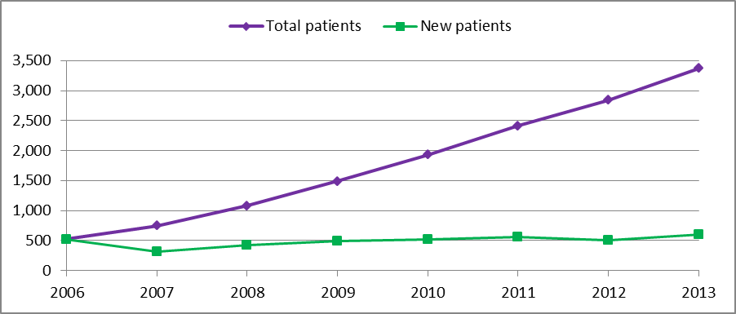Figure 1: Patients receiving bDMARDs for severe chronic plaque psoriasis
Source: Authority Approvals database, extracted March 2014
The total number of patients receiving bDMARDs for psoriasis is increasing steadily. The number of new patients starting treatment each year has been relatively consistent since the first bDMARD for severe chronic plaque psoriasis was listed.
Figure 2 shows the number of patients treated with each bDMARD for psoriasis. The number of patients in this figure cannot be added because patients may have switched medicines during the year.
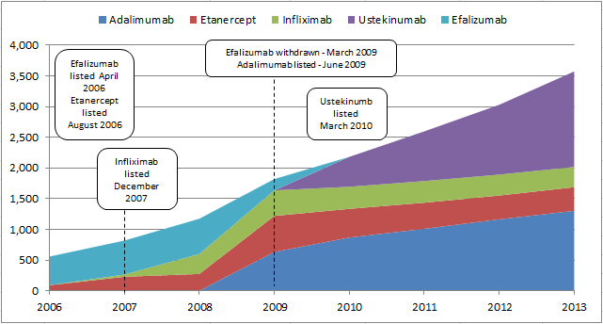Figure 2: Patients receiving bDMARDs for psoriasis by drug (stacked)
Source: Authority Approvals database, extracted March 2014
Figure 2 shows an increasing number of patients being treated with bDMARDs for psoriasis. Ustekinumab has been gaining an increasing share of the market. The number of patients treated with adalimumab has also increased, albeit at a slower rate.
Figure 3 presents the number of patients starting treatment with each bDMARD. The data in this figure include patients who started a bDMARD for the first time as well as patients who switched to a different bDMARD.
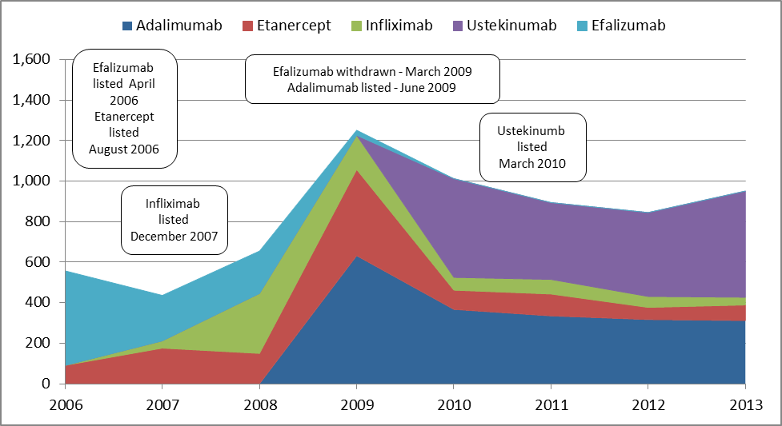 Figure 3: Patients starting a bDMARDs for psoriasis by drug (stacked)
Source: Authority Approvals database, extracted March 2014
A large number of patients started a new bDMARD in 2009. Ustekinumab has been the most popular medicine for patients starting a bDMARD for psoriasis since listing in 2010. The number of patients starting the other three bDMARDs has decreased. The DUSC noted the response by the sponsor of etanercept that bDMARDs have differing onset of action. Fast response is important to patients and therefore slower onset drugs, such as etanercept, may have lower uptake as a result.

Age of patients treated with bDMARDs for psoriasis in 2013
Figure 4 presents the age of patients who received at least one supply of a bDMARD for psoriasis. The ‘all patients’ series includes all patients who received at least one Authority approval in 2013. The ‘initiating patients’ series only includes patients who received their first approval in 2013.
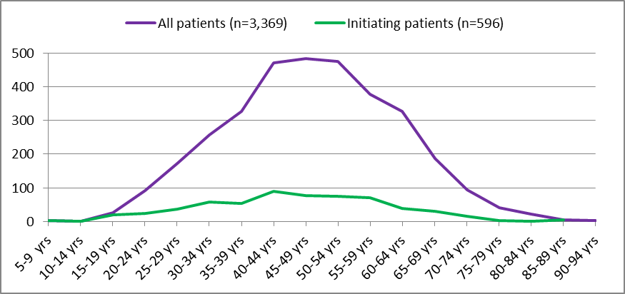
Figure 4: Age distribution of psoriasis patients with approval for a bDMARD in 2013
Source: Authority Approvals database, extracted March 2014. Note: Age data were missing for 4 patients in the all patients series and 3 patients in the initiating patients series.
The mean and median for all patients was 48 years (standard deviation = 13.13 for the mean). The mean age of initiators was 45 years (standard deviation = 14.24). The median age of initiating patients was 46 years.

Continuation
Table 4 presents the percentage of initiating patients who received a second (continuing) Authority approval for the same bDMARD and the percentage continuing with a different bDMARD. These patients started a bDMARD for psoriasis in 2011 or 2012.

Table 4: Continuation of bDMARDs for patients starting treatment in 2011 and 2012
Initiating  bDMARD | Initiating patients | % continuing with same bDMARD | PASI ≥75 response in trials | % continuing with different bDMARD | Total continuing bDMARDs
Adalimumab | 465 | 90.3% | 70.9%  (16 weeks) – Jul08 | 7.1% | 97.4%
Etanercept | 127 | 78.7% | 49.4%  (12 weeks) | 19.7% | 98.4%
Infliximab | 66 | 80.3% | 79%  (10 weeks) | 10.6% | 90.9%
Ustekinumab | 404 | 91.1% | 67.5%  (12 weeks) | 6.4% | 97.5%
Source: Authority Approvals database, extracted March 2014
UST = PASI response in ITT, ETN = March 2009 continuous treatment
Adalimumab and ustekinumab have higher continuation rates than etanercept and infliximab. Actual continuation rates were higher than in the trials for all bDMARDs except infliximab which has a similar continuation rate to the clinical trials.
The DUSC agreed with the sponsors of etanercept, infliximab and ustekinumab that due to assessment of response being later than the primary outcomes in the key trials, a larger proportion of PBS patients may achieve a PASI 75 response. The DUSC acknowledged there may be clinician and patient reluctance to withdraw a treatment where patients are achieving a partial response and are refractory to other treatment.

Longer term continuation
Figure 5 presents the proportion of patients who started their first bDMARD for psoriasis in 2011 who received first, second and third continuing approvals for the same bDMARD. The average time to the third continuing approval was 70 weeks (median = 69 weeks, interquartile range = 15 weeks).
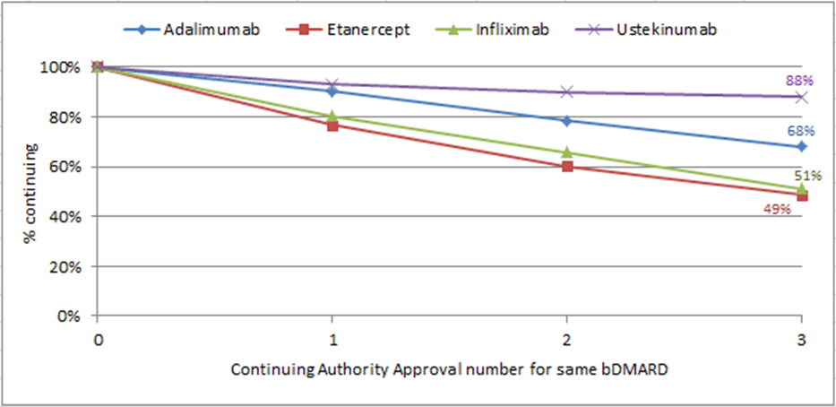Figure 5: Continuation with same bDMARD – 2011 initiators
Source: Authority Approvals database, extracted March 2014
Ustekinumab has the highest rate of continuation followed by adalimumab. Etanercept and infliximab had lower rates of continuation.
Figure 6 presents the rates of treatment continuation with any bDMARD for psoriasis for patients who started their first bDMARD in 2011. Patients are classified in the graph based on the bDMARD with which they started treatment.
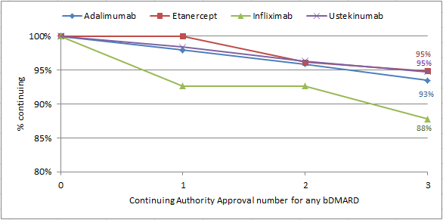Figure 6: Continuation with any bDMARD – 2011 initiators
Source: Authority Approvals database, extracted March 2014
Patients starting treatment with ustekinumab, etanercept and adalimumab have relatively similar rates of treatment continuation with bDMARDs. Patients who initiated treatment on infliximab appear to be more likely to discontinue PBS bDMARDs for psoriasis. Of the 555 patients who started a bDMARD for psoriasis in 2011, 86% received a third continuing approval for a bDMARD.
A relatively small proportion of patients appear to discontinue bDMARD treatment. The DUSC noted advice provided by the College of Dermatologists stating that although there are improvements and regressions in the natural history of psoriasis, remission is rare, hence chronic treatment is required.

Prescriptions and quantity
Table 5 presents the number of prescriptions dispensed for adalimumab, efalizumab, etanercept and ustekinumab as well the number of infliximab vials supplied. Infliximab has a weight based dosing regimen. Patients generally require multiple vials for a full dose.
Table 5: PBS bDMARD prescriptions supplied for psoriasis
Year | Adalimumab | Efalizumab | Etanercept | Infliximab (vials) | Ustekinumab
2006 | - | 2,701 | 196 | - | -
2007 | - | 4,710 | 838 | 38 | -
2008 | - | 5,169 | 1,168 | 11,137 | -
2009 | 3,112 | 1,351 | 3,681 | 18,061 | -
2010 | 8,182 | - | 4,700 | 17,328 | 1,344
2011 | 9,554 | - | 4,116 | 17,693 | 2,831
2012 | 11,415 | - | 3,864 | 17,746 | 4,047
2013  (Jan-Sept only) | 9,347 | - | 2,714 | 14,472 | 3,941
Source: DHS Medicare Supplied Prescription Database, extracted March 2014, Highly Specialised Drugs Database (infliximab only), extracted March 2014
The number of prescriptions dispensed has increased for most medicines except etanercept. The number of infliximab vials dispensed remained steady between 2010 and 2012.

Analysis of expenditure
Table 6 presents the PBS benefits paid for bDMARDs for use in psoriasis by calendar year since the listing of efalizumab in April 2006. The following table is based on the published prices of bDMARDs for psoriasis. Special pricing arrangements apply for all bDMARDs listed for psoriasis; hence the figures in the table are only indicative of trends. Expenditure has been reported based on date of supply data.
Table 6: PBS benefits paid (published) for psoriasis bDMARDs
 | 2006 | 2007 | 2008 | 2009 | 2010 | 2011 | 2012 | 2013  (Jan-Sept only)
Adalimumab | - | - | - | $5,450,864 | $14,314,340 | $16,706,187 | $19,958,072 | $16,334,139
Efalizumab | $3,968,628 | $4,932,434 | $5,350,535 | $1,371,880 | - | - | - | -
Etanercept | $604,224 | $1,456,979 | $2,040,310 | $6,468,347 | $8,258,117 | $7,210,082 | $6,772,361 | $4,744,748
Infliximab | - | $639,352 | $7,415,453 | $8,521,039 | $9,464,637 | $8,474,020 | $8,051,959 | $4,998,282
Ustekinumab | - | - | - | - | $8,726,002 | $17,930,733 | $25,489,886 | $24,606,551
Total | $4,572,853 | $7,028,765 | $14,806,298 | $21,812,130 | $40,763,096 | $50,321,022 | $60,272,278 | $50,683,719
Source: DHS Medicare Supplied Prescription Database, extracted March 2014, Highly Specialised Drugs Database (infliximab only), extracted March 2014
Note: Special pricing arrangements apply for all bDMARDs listed for psoriasis.
Annual expenditure has increased for most of the bDMARDs for psoriasis. Annual expenditure on infliximab and etanercept has slightly decreased. Ustekinumab and infliximab have higher prices than the other agents.
PBS benefits on bDMARDs for psoriasis have increased substantially since the first years of listing, with a particularly large increase in 2009 where expenditure almost doubled.

Discussion
There has been a steady increase in the total number of patients treated with bDMARDs for psoriasis. The number of new patients starting treatment has been relatively constant since the first listing in 2006 of approximately 500 new patients per year.
There was substantial variation in the estimated eligible patient numbers among the submissions. These varied from less than 1,500 patients treated with bDMARDs to over 10,000 patients eligible for treatment with bDMARDs. There were large variations in the estimates of severe disease and how many patients would have failed other therapies. This is likely to reflect a lack of data on the severity of psoriasis and the number of patients unsatisfactorily treated with non-biological therapies.
Psoriasis has a bimodal age of onset with the first peak of onset occurring from age 15 to 20 years of age and the second peak occurring at 55-60 years. Early onset psoriasis is considered to be more severe than later onset disease. The age analysis showed that the highest use of PBS subsidised bDMARDs for psoriasis was in patients aged between 40-55 years. The DUSC considered that this might be due to older patients having had the opportunity to trial and fail other therapies; and hence meet the restriction criteria.

The DUSC acknowledged that there may be use of bDMARDs for the treatment of moderate psoriasis through the PBS, although this cannot be ascertained from prescription data. In addition to the Baker et al 2013 consensus report that considers a wider group of patients are suitable for biological therapies than currently subsidised, the DUSC noted all four bDMARDs have clinical trial evidence and TGA registration for the broader moderate to severe psoriasis indication. The DUSC also noted the National Institute of Health and Care Excellence (NICE) guidance recommend use in moderate to severe disease. The DUSC considered that use outside the PBS restriction to patients with less severe disease might be occurring, while some patients with severe refractory disease remain unable to access bDMARDs.

The DUSC agreed with advice from the Australasian College of Dermatologists that the lack of access to dermatologists might be a barrier to access. This was considered to be particularly likely for patients unable to access private dermatologists due to cost or rural locality. The DUSC noted that there are generally long waiting lists for appointments with public hospital specialists. The DUSC noted from the College’s response that some patients are unwilling to use non-bDMARD systemic therapies due to the associated toxicity.

Long term extension studies suggest there may be some loss of response over time to bDMARD treatment. In an ustekinumab long term extension study, 80.1% of participants who achieved a PASI 75 response at week 12 maintained the response at 3 years. Similarly, an adalimumab long term extension study demonstrated that 76% of patients who had a PASI 75 response at 33 weeks maintained response at 160 weeks (3 years). In a long term follow up of etanercept, 51.1% of patients originally randomised to etanercept had a PASI 75 response at 96 weeks. This study found PASI 75 response peaks at week 48 when 63.0% of patients randomised to etanercept had a PASI 75 response. It should be noted that this study examined the use of etanercept 50mg twice weekly, not the once weekly regimen listed on the PBS.

There is some evidence to suggest that bDMARD withdrawal may result in disease recurrence. An ustekinumab long term extension study included a group of patients who were re-randomised to placebo. In these patients, a loss of PASI 75 response was seen in approximately 50% of patients within 16 weeks. An adalimumab extension study, where patients with stable psoriasis were withdrawn from treatment until relapse or a maximum of 40 weeks, also had similar results. Of 268 patients who ceased treatment, 178 (62%) experienced a relapse. The median time to relapse was 141 days. The potential loss of a partial response that is less than PASI 75 response may encourage continuation where patients have failed other systemic therapies.
In the context of high continuation rates, the DUSC considered a telephone authority approval may be suitable for continuing supply of bDMARDs for chronic plaque psoriasis. The DUSC referred this to the Post-market Review of Authority Required PBS Listings.
The number of children treated with etanercept was lower than expected. The PBAC had considered the submission estimates to be uncertain. The estimates of utilisation may have been overestimated.

DUSC actions
- The DUSC referred the report to the PBAC for information.
- The DUSC referred the report to the Post-market Review of Authority Required PBS Listings.

Context for analysis
The DUSC is a Sub Committee of the Pharmaceutical Benefits Advisory Committee (PBAC). The DUSC assesses estimates on projected usage and financial cost of medicines.
The DUSC also analyses data on actual use of medicines, including the utilisation of PBS listed medicines, and provides advice to the PBAC on these matters. This may include outlining how the current utilisation of PBS medicines compares with the use as recommended by the PBAC.
The DUSC operates in accordance with the quality use of medicines objective of the National Medicines Policy and considers that the DUSC utilisation analyses will assist consumers and health professionals to better understand the costs, benefits and risks of medicines.
The utilisation analysis report was provided to the pharmaceutical sponsors of each drug and comments on the report were provided to DUSC prior to its consideration of the analysis.

Sponsors’ comments
AbbVie Pty Ltd: AbbVie agrees with DUSC that in the context of high continuation rates of bDMARDs in chronic plaque psoriasis patients that a more simplified authority process may be suitable for continuing supply of medication and supports the referral of this matter to the Post-market review of Authority Required PBS Listings.
Janssen-Cilag Pty Ltd: Janssen's assessment of the review is that chronic plaque psoriasis patients treated with ustekinumab and infliximab are being treated within the PBS restriction and we look forward to hearing the outcome of the Post-market Review of Authority Required PBS Listings.
Merck Serono Australia Pty Ltd: The sponsor has no comment.
Pfizer Australia Pty Ltd: The sponsor has no comment.

Appendix 1: Utilisation of etanercept in paediatric patients
The utilisation of etanercept in paediatric patients was briefly examined due to the small number of patients receiving treatment under this indication.
At its March 2012 meeting, the PBAC recommended extending the Authority Required listing of etanercept powder for injection 25 mg and 50 mg to include the treatment of severe chronic plaque psoriasis in patients under 18 years of age who meet certain criteria on the basis of acceptable cost effectiveness to placebo in the context of a high clinical need. Further detail is available in the PBAC Public Summary Document.
The submission used an epidemiological approach to estimate the eligible population under 18 years of age. The estimates were based on continuous dosing. This was consistent with the requested restriction and the requested TGA indication. However, the approved TGA indication was for a 24 week course of treatment with subsequent courses if required. The submission estimated that approximately 50 patients per year would be treated from Year 2 onwards.
The number of children treated with etanercept was lower than expected. The PBAC had considered the submission estimates to be uncertain. The estimates of utilisation may have been overestimated.

Disclaimer
The information provided in this report does not constitute medical advice and is not intended to take the place of professional medical advice or care. It is not intended to define what constitutes reasonable, appropriate or best care for any individual for any given health issue. The information should not be used as a substitute for the judgement and skill of a medical practitioner.
The Department of Health (DoH) has made all reasonable efforts to ensure that information provided in this report is accurate. The information provided in this report was up-to-date when it was considered by the Drug Utilisation Sub-committee of the Pharmaceutical Benefits Advisory Committee. The context for that information may have changed since publication.
To the extent provided by law, DoH makes no warranties or representations as to accuracy or completeness of information contained in this report.
To the fullest extent permitted by law, neither the DoH nor any DoH employee is liable for any liability, loss, claim, damage, expense, injury or personal injury (including death), whether direct or indirect (including consequential loss and loss of profits) and however incurred (including in tort), caused or contributed to by any person’s use or misuse of the information available from this report or contained on any third party website referred to in this report.

Australasian College of Dermatologists. A-Z of skin: psoriasis [internet]. Australasian College of Dermatologists. [cited 2014 March 15]. Available from: http://www.dermcoll.asn.au/public/a-z_of_skin-psoriasis.asp
DermNet NZ. PASI score [internet]. DermNet NZ [cited 2014 April 1]. Available from: http://www.dermnetnz.org/scaly/pasi.html.
Langley RG, Krueger GG, Griffiths CE. Psoriasis: epidemiology, clinical features, and quality of life. Ann Rheum Dis. 2005 Mar; 64 Suppl 2:ii18-23; discussion ii24-5.
Baker C, Mack A, Cooper A, Fischer G, Shumack S, Sidhu S, Soyer P, Wu J, Chan J, Nash P, Rawlin M, Radulski B, Foley P. Treatment goals for moderate to severe psoriasis: an Australian consensus. Australas J Dermatol. 2013 May;54(2):148-54.
Kimball AB, Gordon KB, Fakharzadeh S, Yeilding N, Szapary PO, Schenkel B, Guzzo C, Li S, Papp KA. Long-term efficacy of ustekinumab in patients with moderate-to-severe psoriasis: results from the PHOENIX 1 trial through up to 3 years. Br J Dermatol. 2012 Apr; 166(4):861-72.
Gordon K, Papp K, Poulin Y, Gu Y, Rozzo S, Sasso EH. Long-term efficacy and safety of adalimumab in patients with moderate to severe psoriasis treated continuously over 3 years: results from an open-label extension study for patients from REVEAL. J Am Acad Dermatol. 2012 Feb;66(2):241-51.
Tyring S, Gordon KB, Poulin Y, Langley RG, Gottlieb AB, Dunn M, Jahreis A. Long-term safety and efficacy of 50 mg of etanercept twice weekly in patients with psoriasis. Arch Dermatol. 2007 Jun; 143(6):719-26.
Kimball AB, Gordon KB, Fakharzadeh S, Yeilding N, Szapary PO, Schenkel B, Guzzo C, Li S, Papp KA. Long-term efficacy of ustekinumab in patients with moderate-to-severe psoriasis: results from the PHOENIX 1 trial through up to 3 years. Br J Dermatol. 2012 Apr; 166(4):861-72.
Papp K, Crowley J, Ortonne JP, Leu J, Okun M, Gupta SR, Gu Y, Langley RG. Adalimumab for moderate to severe chronic plaque psoriasis: efficacy and safety of retreatment and disease recurrence following withdrawal from therapy. Br J Dermatol. 2011 Feb;164(2):434-41.

