Tyrosine kinase inhibitors for the treatment of Chronic Myeloid Leukaemia (CML)

Drug utilisation sub-committee (DUSC)
February 2014

Abstract

Purpose
The DUSC requested an analysis of the utilisation of PBS-listed tyrosine kinase inhibitors (TKIs), imatinib, dasatinib and nilotinib, for the treatment of CML. This analysis is a part of the routine analyses conducted by the DUSC investigating how the current utilisation of PBS medicines compares with the use as recommended by the PBAC.

Background
Imatinib, dasatinib and nilotinib inhibit the activity of the abnormal tyrosine kinase created by the Philadelphia chromosome abnormality in patients with chronic myeloid leukaemia.
The PBS restrictions for the TKIs for CML have evolved over time. The current PBS restrictions, when used in accordance with certain criteria, include:
  - imatinib, dasatinib and nilotinib as first line therapy in the treatment of the chronic phase of CML. Patients can switch between the three drugs within first line if intolerant, but not if they have failed;
  - imatinib in accelerated or blast phase;
  - dasatinib, after failure of first line imatinib or nilotinib, in any phase; and
  - nilotinib, after failure of first line imatinib or dasatinib, in the chronic or accelerated phase.
Authority applications are managed by the Department of Human Services (DHS) Medicare Specialised Drugs area. Initial applications require prior written approval. Subsequent applications for imatinib can be made by telephone.

Date of listing on PBS
For CML:
Imatinib: December 2001;
dasatinib: August 2007;
nilotinib: August 2008.

Data Source
The DHS Medicare prescription database provided supplied R/PBS prescription data and associated expenditure. The DHS Medicare Authority Approval database provided supplementary data on the phase of the disease and whether use was initial or continuing treatment.

Key Findings
- The number of patients on treatment, number of prescriptions and expenditure of TKIs for CML has increased steadily (i.e. linear tread) over a 12 year period from 2001 to 2013. This reflects the increasing prevalence of CML as mortality from CML declines and patients continue on treatment. Utilisation is expected to continue to increase in the future.
- The DUSC considered that the steadily increasing expenditure for TKIs in CML is explicable entirely on the basis of increased survival.
- The number of new patients commencing treatment has remained stable. This trend is consistent with incidence of CML reported by the AIHW.
- Listing of dasatinib and nilotinib for chronic phase CML after failure of imatinib, and subsequently as first line therapy, has not had a noticeable impact on the steady upward trend in prevalent patients, prescription utilisation and expenditure for CML drugs.

Purpose of analysis
The DUSC requested an analysis of the utilisation of PBS-listed tyrosine kinase inhibitors (TKIs), imatinib, dasatinib and nilotinib, for the treatment of CML. This analysis is a part of the routine analyses conducted by the DUSC investigating how the current utilisation of PBS medicines compares with the use as recommended by the PBAC.

Background

Pharmacology
Imatinib, dasatinib and nilotinib are protein-tyrosine kinase inhibitors that inhibit the activity of the BCR-ABL tyrosine kinase, the constitutive abnormal tyrosine kinase created by the Philadelphia chromosome abnormality in patients with CML.,,

TGA approved indications
Imatinib (Glivec®) is indicated for the treatment of patients with CML.
Dasatinib (Sprycel®) is indicated for the treatment of:
- adults aged 18 years or over with newly diagnosed Philadelphia chromosome positive (Ph+) CML in the chronic phase; and
- adults aged 18 years or over with chronic, accelerated or myeloid or lymphoid blast phase CML with resistance or intolerance to prior therapy including imatinib.

Nilotinib (Tasigna®) is indicated for the treatment of:
- adult patients with newly diagnosed Ph+ CML in chronic phase; and
- adults with chronic phase and accelerated phase Ph+ CML resistant to or intolerant of prior therapy including imatinib.
Imatinib and dasatinib are registered for indications other than CML. For more information, see the Product Information for details (http://tga.gov.au/hp/information-medicines-pi.htm).

Dosage and administration
Table 1: TGA approved doses of TKIs for CML
Phase | Drug | Dose
Chronic | Imatinib | Standard: 400 mg/day  Increased dose: 600–800 mg/day (disease progression, lack of response, loss of previous response)
 | Dasatinib | 100 mg/day  Increased dose: 140 mg/day (lack of haematological or cytogenic response)
 | Nilotinib | Newly diagnosed: 300 mg twice daily  Resistant or intolerant to prior therapy: 400 mg twice daily
Accelerated | Imatinib | Standard: 600 mg/day  Increased dose: 400 mg twice daily
 | Dasatinib | Standard dose: 140 mg/day  Increased dose: 180 mg/day (lack of haematological or cytogenic response)
 | Nilotinib | 400 mg twice daily
Blast | Imatinib | 600 mg/day  Increased dose: 400 mg twice daily
 | Dasatinib | 140 mg/day
 | Nilotinib | -

*On 1/4/2012 the PBS wording of the first-line restrictions was modified to include dose guidance. Patients should be commenced on a dose of imatinib mesylate 400mg (base) daily, dasatinib of at least 100mg (base) daily and nilotinib of 300mg twice daily.
The current Product Information (PI) and Consumer Medicine Information (CMI) are available from http://tga.gov.au/hp/information-medicines-pi.htm and http://www.tga.gov.au/consumers/information-medicines-cmi.htm.

PBS listing details (as at 1 November 2013)
The PBS restrictions for the TKIs for CML are complex and have evolved over time. The full restriction wording is available at pbs.gov.au. The restriction history is summarised in Appendix A.
PBS item codes for CML are shown in Table 2, Table 3 and Table 4. Some item codes have been superseded over time.

Table 2: PBS item listing history for imatinib for CML
Item Listing Date | PBS item code (stage) | Form and Strength | Maximum Quantity | Max. Repeats | DPMQ | Brand Name | Item End Date
1/12/2001 | 8549Y (AP/BP) | Capsules equivalent to 100 mg imatinib, 120 | 1 | 2 | $ 4,363.76 | Glivec | 31/01/2003
 | 8550B (AP/BP) | Capsules equivalent to 100 mg imatinib, 180 | 1 | 2 | $ 6,543.33 | Glivec | 31/01/2003
21/10/2002 | 6359Q (CP) | Capsules equivalent to 100 mg imatinib, 120 | 1 | 5 | $ 3,772.33 | Glivec | 30/11/2004
 | 6360R (CP) | Capsules equivalent to 100 mg imatinib, 180 | 1 | 5 | $ 5,658.50 | Glivec | 30/11/2004
 | 6361T (AP/BP) | Capsules equivalent to 100 mg imatinib, 120 | 1 | 2 | $ 3,772.33 | Glivec | 30/11/2004
 | 6362W (AP/BP) | Capsules equivalent to 100 mg imatinib, 180 | 1 | 2 | $ 5,658.50 | Glivec | 30/11/2004
1/05/2004 | 6444E (CP) | Tablet 100 mg (as mesylate) | 60 | 5 | $ 1,886.17 | Glivec | 31/10/2007
 | 6445F (CP) | Tablet 400 mg (as mesylate) | 30 | 5 | $ 3,772.33 | Glivec | 31/10/2007
 | 6446G (AP/BP) | Tablet 100 mg (as mesylate) | 60 | 2 | $ 1,886.17 | Glivec | 31/10/2007
 | 6447H (AP/BP) | Tablet 400 mg (as mesylate) | 30 | 2 | $ 3,772.33 | Glivec | 31/10/2007
1/11/2007 | 9113P (CP) | Tablet 100 mg (as mesylate) | 60 | 5 | $ 2,005.19 | Glivec | Current
 | 9114Q (CP) | Tablet 400 mg (as mesylate) | 30 | 5 | $ 3,863.81 | Glivec | Current
 | 9115R (AP/BP) | Tablet 100 mg (as mesylate) | 60 | 2 | $ 2,005.19 | Glivec | Current
 | 9116T (AP/BP) | Tablet 400 mg (as mesylate) | 30 | 2 | $ 3,863.81 | Glivec | Current
Source: PBS Item History file accessed 1 November 2013.
CP= chronic phase; AP = accelerated phase; BP = blast phase

Table 3: PBS item listing history for dasatinib for CML
Item Listing Date | PBS item code | Form and Strength | Maximum Quantity | Max. Repeats | DPMQ | Brand Name | Item End Date
1/08/2007 | 2478K | Tablet 20 mg | 60 | 5 | $ 3,095.66 | Sprycel | Current
 | 2482P | Tablet 50 mg | 60 | 5 | $ 5,004.01 | Sprycel | Current
 | 2485T | Tablet 70 mg | 60 | 5 | $ 6,160.40 | Sprycel | Current
1/11/2008 | 9282M | Tablet 20 mg | 60 | 2 | $ 3,246.36 | Sprycel | 31/03/2012
 | 9283N | Tablet 50 mg | 60 | 2 | $ 5,250.68 | Sprycel | 31/03/2012
 | 9284P | Tablet 70 mg | 60 | 2 | $ 6,465.01 | Sprycel | 31/03/2012
1/05/2010 | 9341P | Tablet 100 mg | 30 | 2 | $ 5,250.68 | Sprycel | 31/03/2012
 | 9342Q | Tablet 100 mg | 30 | 5 | $ 5,004.01 | Sprycel | Current
1/04/2012 | 1354G (CP) | Tablet 20 mg | 60 | 5 | $ 3,095.66 | Sprycel | Current
 | 1381Q (CP) | Tablet 50 mg | 60 | 5 | $ 5,004.01 | Sprycel | Current
 | 1415L (CP) | Tablet 70 mg | 60 | 5 | $ 6,160.40 | Sprycel | Current
 | 1416M (CP) | Tablet 100 mg | 30 | 5 | $ 5,004.01 | Sprycel | Current
Source: PBS Item History file accessed 1 November 2013. Shaded cells are for second line treatment in any phase.
CP= chronic phase; AP = accelerated phase; BP = blast phase

Table 4: PBS item listing history for nilotinib for CML
Item Listing Date | PBS item code | Form and Strength | Maximum Quantity | Max. Repeats | DPMQ | Brand Name | Item End Date
1/08/2008 | 9171Q (CP/AP) | Capsule 200 mg (as hydrochloride monohydrate) | 120 | 5 | $ 5,872.35 | Tasigna | Current
1/11/2008 | 9285Q (CP/AP) | Capsule 200 mg (as hydrochloride monohydrate) | 112 | 2 | $ 5,490.42 | Tasigna | 31/03/2012
1/04/2012 | 1309X (CP) | Capsule 150 mg (as hydrochloride monohydrate) | 120 | 5 | $ 4,468.08 | Tasigna | Current
Source: PBS Item History file accessed 1 November 2013. Shaded cells are for second-line treatment.
CP= chronic phase; AP = accelerated phase; BP = blast phase
All these drugs are Complex Authority Required (CAR) drugs, which means that the authority approval needs to be in writing and contain supplementary information. Second and subsequent applications for imatinib can be made by telephone. The CAR authority application forms for CML can be accessed from the DHS Medicare web site at: www.medicareaustralia.gov.au/provider/pbs/drugs1/cml-glivec.jsp.
Current PBS listing details are available from www.pbs.gov.au

Issues considered by the PBAC
In July 2011, the PBAC noted that the availability of dasatinib and nilotinib as first-line therapy for CML would change the current treatment algorithm. The PBAC considered that it was unlikely that imatinib would be used after failure of dasatinib due to resistance, or after failure of nilotinib, as there is little evidence for this use. The PBAC considered it possible that imatinib might be used after dasatinib in cases of intolerance to dasatinib but the most likely scenario after failure of dasatinib is second-line nilotinib; and the most likely scenario after failure of nilotinib, after dose escalation to 400 mg twice daily, is second-line dasatinib. The PBAC considered that the PBS listings for TKIs in the second-line setting would need reviewing due to the change in the treatment algorithm. The PBAC also considered that, in future, it would be critical to distinguish between the need to change the TKI because of intolerance and because of inadequate response. Second-line therapy after dasatinib or nilotinib should refer to the situation where there has been failure of response and should not include failure due to toxicity. Changes between TKIs should be possible in first-line therapy where there is intolerance to the first initiated TKI. The PBAC noted that further discussion would be needed with the sponsors and Stakeholders before finalisation of the restrictions for first and second-line treatment settings.
A copy of the Public Summary Document from the July 2011 PBAC meeting is available at www.health.gov.au/internet/main/publishing.nsf/Content/pbac-psd-dasatinib-july11

Previous reviews by DUSC
DUSC reviewed imatinib utilisation for CML at its August 2003 meeting for the period December 2001 to April 2003. At that time, actual usage was slightly lower than that estimated in the submission. The DUSC considered that the trend indicated that the number of imatinib prescriptions could continue to increase and if so could result in slightly higher utilisation than estimated in the submission. Neither dasatinib nor nilotinib have been reviewed by DUSC previously.

Methods
The number of PBS/RPBS prescriptions and benefits paid for imatinib, dasatinib and nilotinib for CML (see item codes in Tables 2–4) were extracted from the DHS Medicare Prescription database for the period 1 December 2001 to 30 June 2013. Data were extracted based on the date of supply of the prescription to the patient. The number of patients treated was determined by counting the number of individual de-identified personal identification numbers in the specified time period. New patients were defined as those with no prior prescription of a TKI since 1 December 2001.
The DHS Medicare Authority Approval database was used as a supplementary data source to classify approvals by disease phase and whether the approval was for initial or continuing treatment.

Results

Analysis of drug utilisation

Number of patients treated with TKIs for CML
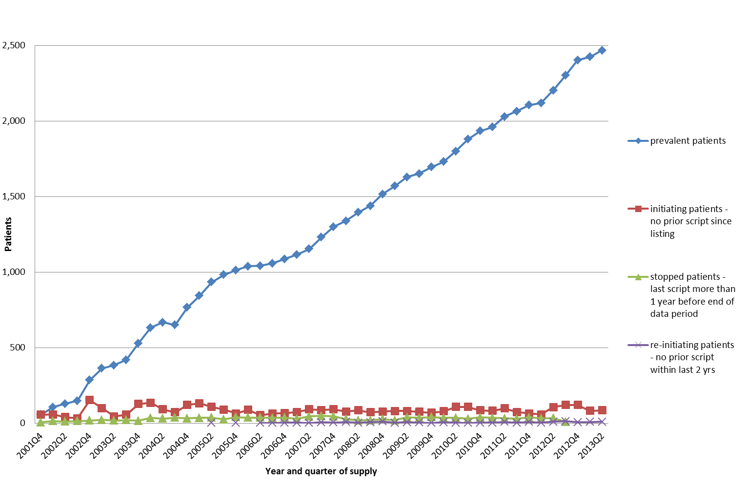
Figure 1: Number of CML patients treated – prevalent, initiating, stopped and re-initiating
Note: the number of stopped patients cannot be estimated for the last year of the data period
As shown in Figure 1, on average 84 new patients started treatment with a TKI each quarter (338 patients/year). The relatively stable trend in the number of new patients treated over the past 12 years is consistent with incidence trends reported by the Australian Institute of Health and Welfare (AIHW), but the total number of patients starting TKIs (338) is higher than the reported incidence of CML of about 280 patients per year.
The lower number of new patients commencing treatment in late 2011 and higher number in the second quarter of 2012 coincides with the listing of dasatinib and nilotinib as first-line therapies for chronic phase CML. This transient decrease and subsequent increase is probably due to patients transferring from patient access programs to PBS supply of dasatinib and nilotinib for first-line, chronic phase disease.
The total number of patients undergoing treatment with a TKI (prevalent patients) has increased steadily since 2001. In 2012/13 approximately 2,500 patients were treated with a TKI. Once TKI treatment has started, very few patients stop (or reinitiate) treatment accounting for the increasing prevalent treated population over time.

Number of prescriptions
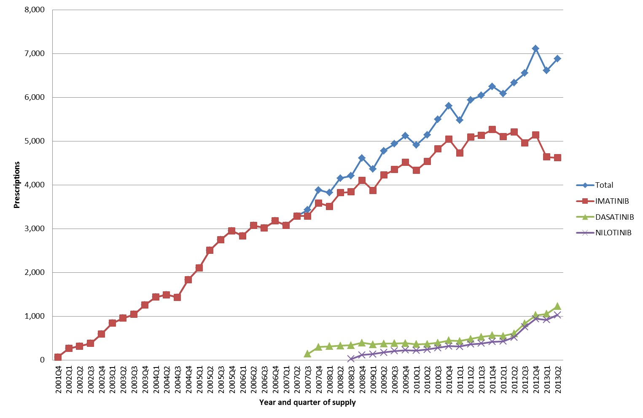
Figure 2: PBS/RPBS prescriptions for TKIs in CML (all phases)
Figure 2 shows the number of PBS/RPBS prescriptions supplied for imatinib, dasatinib and nilotinib in all phases of disease. Consistent with an increasing number of patients on treatment as shown in Figure 1, the number of prescriptions has increased steadily over time.
The vast majority of prescriptions are for chronic phase disease as demonstrated in Figures 3 and 4. This is consistent with the natural history of the disease – an initially indolent, chronic phase followed by accelerated phase and blast crisis.
Figure 3 shows the number of PBS/RPBS prescriptions supplied for imatinib, dasatinib and nilotinib for first-line therapy in chronic phase CML.
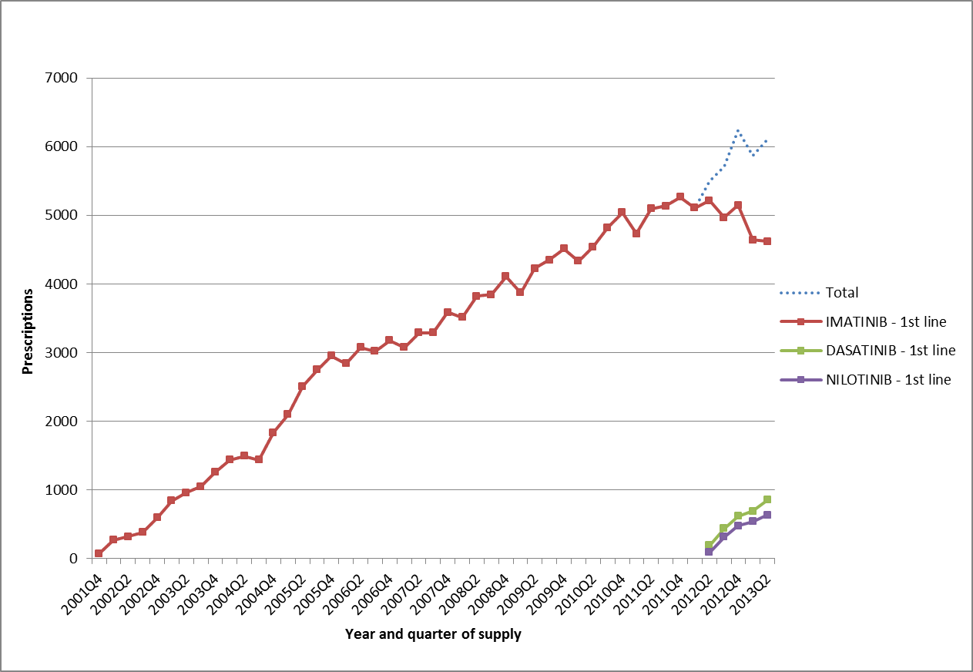
Figure 3: Supplied prescriptions for TKIs in first line therapy for chronic phase CML
Note: Data includes historical and current PBS item codes for first line chronic phase treatment: 1309X, 1354G, 1381Q, 1415L, 1416M, 6359Q, 6360R, 6444E, 6445F, 9113P and 9114Q. See Tables 2, 3 and 4 for item details
Following the extension to listing from April 2012 to include use of dasatinib and nilotinib as first-line therapy for chronic phase CML, utilisation of imatinib has declined. This is consistent with the basis of listing with dasatinib and nilotinib expected to substitute for imatinib.
The plateau in imatinib utilisation prior to April 2012 is probably due to use of dasatinib or nilotinib via patient familiarisation programs prior to PBS listing for first line chronic phase CML.
Figure 4 shows the number of PBS/RPBS prescriptions supplied for dasatinib and nilotinib for second-line therapy in CML.
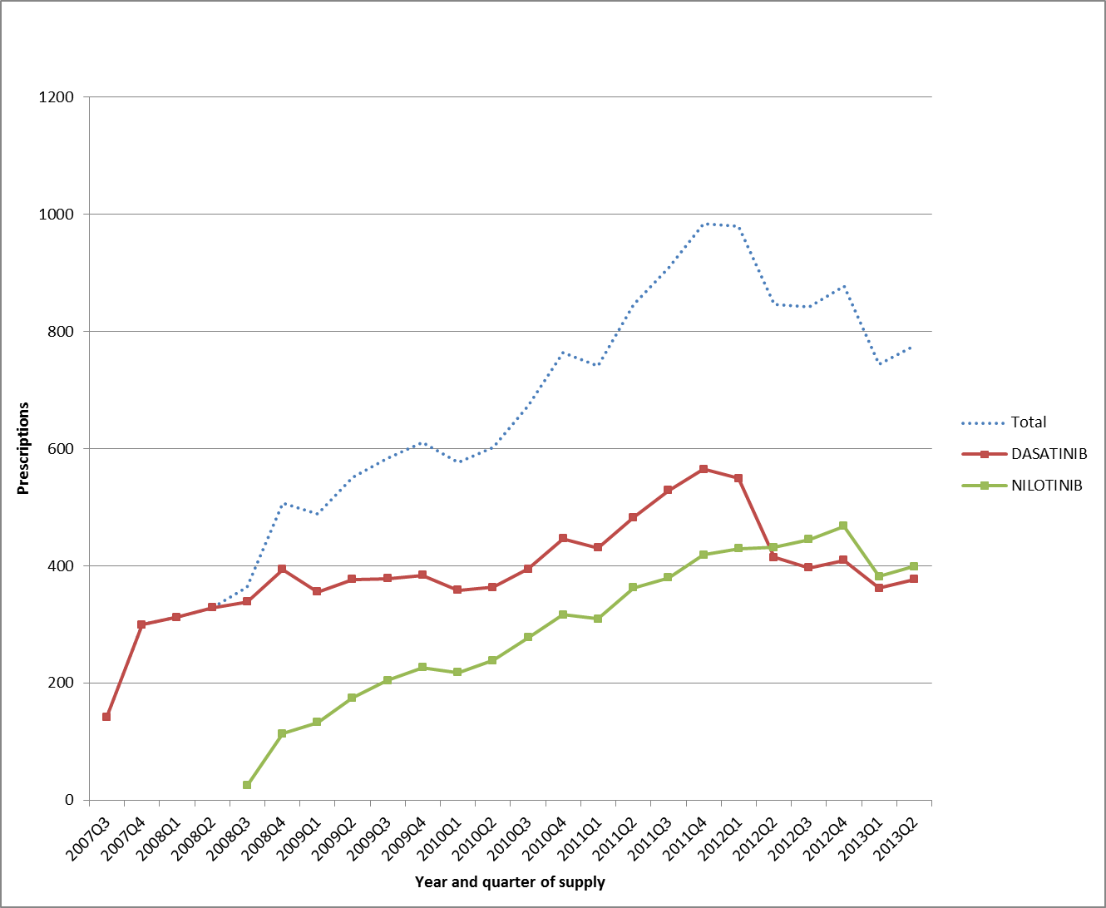
Figure 4: Supplied prescriptions for TKIs in second line therapy for CML
Note: Data includes PBS item codes for second line therapy: see Tables 3 and 4 for item details
The reduction in prescriptions supplied for second-line treatment from the second quarter of 2012 onwards coincides with the listing of dasatinib and nilotinib for first line treatment. This could indicate that some patients were receiving first line dasatinib or nilotinib prior to listing for this indication.

Analysis of Authority Approvals
The Authority Approvals data was used as an alternative source of data to inform utilisation.
Figure 5 shows the total number of approvals (initial and continuing) by disease phase, line of therapy and drug. This emphasises that the overall market is growing linearly and that this growth is driven the chronic first line use.
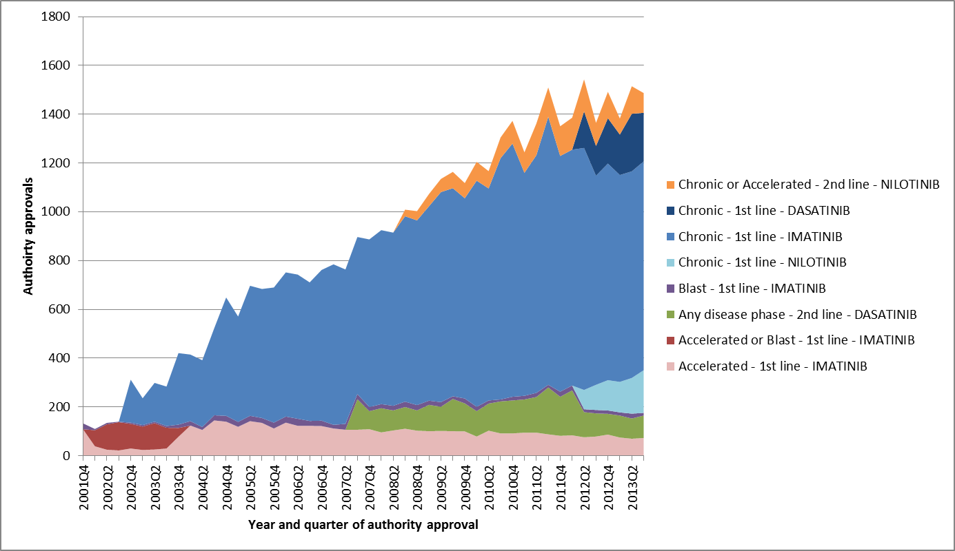
Figure 5: Authority approvals for TKIs in CML by disease phase, line of therapy and drug
When nilotinib and dasatinib were PBS listed, it was assumed that first line use of these drugs for chronic phase CML would substitute for first line imatinib.
The nilotinib submission took a market share approach, assuming substitution within the existing first line imatinib market. (REDACTED) (REDACTED) (REDACTED) (REDACTED) (REDACTED) (REDACTED) (REDACTED) (REDACTED) (REDACTED) (REDACTED) (REDACTED) (REDACTED) (REDACTED) (REDACTED) (REDACTED) (REDACTED) (REDACTED) (REDACTED) (REDACTED); (REDACTED) (REDACTED) (REDACTED) (REDACTED) (REDACTED) (REDACTED) (REDACTED) (REDACTED) (REDACTED) (REDACTED) (REDACTED) (REDACTED) (REDACTED) (REDACTED) (REDACTED) (REDACTED) (REDACTED) (REDACTED) (REDACTED) (REDACTED) (REDACTED). The submission assumed that (REDACTED)% of new patients would initiate on nilotinib in year 1, increasing to (REDACTED)% in year 5.
The dasatinib submission took an epidemiological approach, assuming substitution within the existing first line imatinib market. It was expected that the uptake of dasatinib in newly diagnosed patients would be (REDACTED)% in year 1, increasing to (REDACTED)% in year 5. The submission assumed that should nilotinib be listed in first line it would also take (REDACTED)% of the initiating market in year 1.
Initial authority approvals, which represent initiating patients, demonstrate that a higher proportion of patients commenced on dasatinib and nilotinib in first line than was expected in the submissions.
Table 5: Initial authority approvals for first line chronic phase CML treatment in the first year of nilotinib and dasatinib first-line listing
Quarter of supply | NILOTINIB | IMATINIB | DASATINIB | TOTAL
2012Q2 | 71 | 109 | 88
2012Q3 | 78 | 77 | 58
2012Q4 | 79 | 103 | 76
2013Q1 | 56 | 67 | 75
Total | 284 | 356 | 297 | 937
Percentage of total | 30% | 38% | 32% | 100%

Analysis of expenditure
Table 6: PBS/RPBS expenditure for CML by drug
Year | IMATINIB | DASATINIB | NILOTINIB | Total
2002 | $8,888,805 |  |  | $8,888,805
2003 | $19,088,705 |  |  | $19,088,705
2004 | $27,734,255 |  |  | $27,734,255
2005 | $43,456,003 |  |  | $43,456,003
2006 | $50,203,375 |  |  | $50,203,375
2007 | $53,760,354 | $2,542,707 |  | $56,303,060
2008 | $63,373,230 | $7,745,640 | $766,496 | $71,885,365
2009 | $70,699,507 | $8,166,481 | $4,102,175 | $82,968,162
2010 | $77,530,026 | $8,416,912 | $5,809,359 | $91,756,299
2011 | $82,587,179 | $10,803,104 | $8,063,187 | $101,453,470
2012 | $81,934,299 | $15,446,820 | $14,156,871 | $111,537,991

The increasing expenditure aligns with the increasing number of prescriptions dispensed over time (Figure 3).

Discussion
Utilisation and expenditure of the TKIs is steadily increasing. This is due, not to an increasing number of incident patients, but a high treatment continuation rate, leading to a steady increase in the number of prevalent patients. At the time of listing, continuation rates for first line TKI therapies in CML were expected to be high (greater than 80%). The DUSC considered that the steadily increasing expenditure for TKIs in CML is explicable entirely on the basis of increased survival.
Further growth in utilisation is expected into the future as mortality from CML declines and the population ages. At some point utilisation will plateau, but this is may not be until at least 2050, based on prevalence projections from the US. The DUSC considered that the average duration of treatment will be 20 to 30 years. This is because the median age at presentation is 50 to 60 years old and patients are unlikely to survive longer than the average life expectancy (i.e. approximately 80 years). Duration of treatment (in years) in a stable population is approximately equal to point prevalence divided by incidence (in a year), thus this ratio is unlikely to be greater than 20 to 30. This means that expenditure increase is likely to continue at the current rate for another 10 years (since it has already been increasing for 12 years) before a plateau begins to form.
Current Australian incidence of CML is approximately 300 patients and the prevalent treated population is approximately 2,500 patients.
While first line use of nilotinib and dasatinib is higher than what was predicted in the submission estimates, the total market utilisation has continued to increase in a steady linear trend. This implies that first line nilotinib and dasatinib have substituted within the imatinib market, and the extent of substitution for imatinib was greater than anticipated.
As the TKIs are complex authority required medicines, administered by the Specialised Drugs area of DHS Medicare, there is low risk of use outside of the restriction.

DUSC Actions
- DUSC referred the report to the PBAC for information.
- DUSC requested information be provided on dosage in first and second line therapy for each drug, for the purpose of checking predicted versus actual dosing.

Context for analysis
The DUSC is a Sub Committee of the Pharmaceutical Benefits Advisory Committee (PBAC). The DUSC assesses estimates on projected usage and financial cost of medicines.
The DUSC also analyses data on actual use of medicines, including the utilisation of PBS listed medicines, and provides advice to the PBAC on these matters. This may include outlining how the current utilisation of PBS medicines compares with the use as recommended by the PBAC.
The DUSC operates in accordance with the quality use of medicines objective of the National Medicines Policy and considers that the DUSC utilisation analyses will assist consumers and health professionals to better understand the costs, benefits and risks of medicines.
The utilisation analysis report was provided to the pharmaceutical sponsors of each drug and comments on the report were provided to DUSC prior to its consideration of the analysis.

Sponsors’ comments
Bristol-Myers Squibb Australia Pty Ltd:
Bristol-Myers Squibb welcomes the findings of the analysis. The increasing prevalence of CML is reflective of a reduction in mortality, which is attributable to the availability of innovative and effective treatments, the first and second generation TKIs, on the Pharmaceutical Benefits Scheme.
Novartis Pharmaceuticals Australia Pty Limited:
The Sponsor thanks the DUSC for the opportunity to review and comment on this review and agrees that the prevalence of CML is increasing over time due to the clinical efficacy of these therapies.

Appendix A
Restriction
The restriction changes for the CML indications of the three drugs can be summarised as follows:
- On 1/12/2001 imatinib was listed (S85) for first line treatment of CML in the accelerated or blast phases.
- On 21/10/2002 this was extended to first line treatment in the chronic phase and the listing changed to S100, Special Authority Program.
- On 1/8/2007 dasatinib was listed (S85) for second line treatment (i.e. failed an adequate trial of imatinib) in any disease phase.
- On 1/11/2007 all the imatinib items were changed from S100 to S85 to be consistent with the dasatinib listings.
- On 1/8/2008 nilotinib was listed (S85) for second line treatment (i.e. failed an adequate trial of imatinib) in chronic or accelerated phases.
- On 1/4/2012 dasatinib and nilotinib restrictions were extended to first line treatment in chronic phase. Dasatinib retained the restriction for second line treatment (i.e. failed an adequate trial of imatinib or nilotinib) for any disease phase and nilotinib retained second line treatment (i.e. failed an adequate trial of imatinib or dasatinib) for chronic or accelerated phases.
- On 1/4/2012 the wording of the first line restrictions were modified to include dose guidance. Patients should be commenced on a dose of imatinib mesylate 400 mg (base) daily, dasatinib of at least 100 mg (base) daily and nilotinib of 300 mg twice daily.
Tyrosine kinase inhibitors for the treatment of Chronic Myeloid Leukaemia (CML): Addendum

Drug utilisation sub-committee (DUSC)
October 2014
Abstract
Purpose
To assess the doses of imatinib, dasatinib and nilotinib for first and second line treatment of chronic myeloid leukaemia.
Background
At the February 2014 meeting, the DUSC considered an analysis of the utilisation of PBS-listed tyrosine kinase inhibitors (TKIs), imatinib, dasatinib and nilotinib, for the treatment of CML. The DUSC requested information be provided on dosage in first and second line therapy for imatinib, dasatinib and nilotinib in CML for the purpose of checking predicted versus actual dosing.
Data Source / methodology
The dosage information in this addendum comes from the quantity and strength information recorded in the Department of Human Services (DHS) Authorities Approval database for approvals from 2012 Q2 to 2013 Q3 inclusive.
The actual prescribed dose is not recorded in the database. The prescribed dose was estimated from the approval data by assuming the quantity prescribed on each prescription is intended to be for 30 days of treatment and summing the approvals for different strengths of a drug for a patient on a day, having regard to both the strength and the quantity requested.
Line of treatment (i.e. first or second line), disease phase and approval type (i.e. initial or continuing) were all defined from the analysis of the restriction text associated with the restriction codes recorded in the DHS Authorities Approval database.
Key Findings
The calculated dose relativities of imatinib versus dasatinib and imatinib versus nilotinib in the first line treatment of newly diagnosed patients are consistent with the values assumed by the PBAC when these drugs were recommended.

Disclaimer
The information provided in this report does not constitute medical advice and is not intended to take the place of professional medical advice or care. It is not intended to define what constitutes reasonable, appropriate or best care for any individual for any given health issue. The information should not be used as a substitute for the judgement and skill of a medical practitioner.
The Department of Health (DoH) has made all reasonable efforts to ensure that information provided in this report is accurate. The information provided in this report was up-to-date when it was considered by the Drug Utilisation Sub-committee of the Pharmaceutical Benefits Advisory Committee. The context for that information may have changed since publication.
To the extent provided by law, DoH makes no warranties or representations as to accuracy or completeness of information contained in this report.
To the fullest extent permitted by law, neither the DoH nor any DoH employee is liable for any liability, loss, claim, damage, expense, injury or personal injury (including death), whether direct or indirect (including consequential loss and loss of profits) and however incurred (including in tort), caused or contributed to by any person’s use or misuse of the information available from this report or contained on any third party website referred to in this report.

Glivec (imatinib) Product Information. Accessed 16 December 2013. Available from https://www.ebs.tga.gov.au/
Sprycel (dasatinib) Product Information. Accessed 16 December 2013. Available from https://www.ebs.tga.gov.au/
Tasigna (nilotinib) Product Information. Accessed 16 December 2013. Available from https://www.ebs.tga.gov.au/.
The average annual change in incidence rates for CML in Australia, 2002 to 2009, was 1.2%. Source: Australian Cancer Incidence and Mortality (ACIM) books, www.aihw.gov.au/acim-books/, accessed 17 December 2012.
Australian Cancer Incidence and Mortality (ACIM) books, http://www.aihw.gov.au/acim-books/, accessed 17 December 2012.
Huang X, Cortes J, Katarjian H. Estimations of the Increasing Prevalence and Plateau Prevalence of Chronic Myeloid Leukemia in the Era of Tyrosine Kinase Inhibitor Therapy. Cancer. 2012: 3123-7.

