Analysis of the utilisation of iron chelating agents

Drug utilisation sub-committee (DUSC)
February 2014
Abstract

Purpose
To review utilisation of iron chelating therapies. At its March 2013 meeting, the Pharmaceutical Benefits Advisory Committee (PBAC) considered that iron chelation therapy was overused in myelodysplastic syndrome (MDS) and may provide limited benefits in patients with short life expectancy. The PBAC requested a utilisation analysis of the iron chelating class of drugs (desferrioxamine, deferiprone and deferasirox).

Background

Desferrioxamine, deferiprone and deferasirox are listed on the Pharmaceutical Benefits Scheme (PBS) as iron chelating agents. Iron chelating therapy is used to remove excess iron in patients with transfusion-dependent conditions such as beta thalassaemia major, sickle cell anaemia and MDS. Frequent blood transfusions in these patient groups may result in an accumulation of iron in the body. Decreasing iron through the use of iron chelation therapy reduces the production of reactive oxygen species, thus reducing damage to critical organs.

Date of listing on the PBS
- Desferrioxamine: October 1992;
- Deferiprone: tablets February 2004, oral solution, June 2009;
- Deferasirox: 1 December 2006

Data Source / methodology

The analysis examined de-identified prescription and Government expenditure data for desferrioxamine, deferiprone and deferasirox from January 2009 until June 2013. The Highly Specialised Drugs (HSD) database was used to obtain information regarding the number of prescriptions, packs and cost of the drugs. A patient level analysis of de-identified Department of Human Services (Medicare) claim data was used to examine the age and sex of the patients.

Key Findings
- Utilisation and expenditure for the iron chelating agents has almost doubled between 2007 and 2013.
- The increase was predominantly driven by the increasing use of the 500 mg strength of deferasirox.
- The utilisation of deferasirox 500 mg is higher than that proposed at the time of listing.
- Most patients treated with deferasirox are over the age of 55. It is probable that much of the use in older patients is for MDS. The extent of use for MDS has been higher than expected at the time of listing and the incremental cost-effectiveness ratio of iron chelating agents used in MDS has not been established and is likely to be higher than for conditions such as thalassemia.
- PBS/RPBS expenditure for the 2012/13 financial year was:
- Desferrioxamine $764,161
- Deferiprone $638,223
- Deferasirox $20,460,390
- Total cost $21,862,774

Purpose of analysis
This analysis of the utilisation of PBS-listed iron chelating agents was requested by the Pharmaceutical Benefits Advisory Committee (PBAC). At its March 2013 meeting the PBAC considered that iron chelation therapy was overused in myelodysplastic syndrome (MDS) and may provide limited benefits in patients with short life expectancy.

Background
Iron chelating therapy is used to remove excess iron in patients with transfusion-dependent conditions such as beta thalassaemia major, sickle cell anaemia and MDS. Frequent blood transfusions in these patient groups may result in an accumulation of iron in the body. Decreasing iron through the use of iron chelation therapy reduces the production of reactive oxygen species, thus reducing damage to critical organs. This reduces morbidity and improves survival in beta-thalassemia. Iron chelating therapy is also used, although rarely, in haemodynamically unstable patients with haemochromatosis.

TGA approved indications
Desferrioxamine is indicated for the treatment of acute iron intoxication and of chronic iron overload due to transfusion-dependent anaemia.
Deferiprone is indicated for the treatment of iron overload in patients with thalassaemia major who are unable to take desferrioxamine therapy; or in whom desferrioxamine therapy has proven ineffective.
Deferasirox is indicated for the treatment of chronic iron overload due to blood transfusions (transfusional haemosiderosis) in adults and paediatric patients 6 years and older. It is also indicated for the treatment of chronic iron overload in paediatric patients aged 2 to 5 years who are unable to take desferrioxamine therapy or in whom desferrioxamine has proven ineffective.

PBS restrictions, dosage and administration

Table 1: Comparison of the iron chelating agents
Generic Name | Desferrioxamine [3] | Deferiprone [4] | Deferasirox [5]
PBS Restrictions*  Authority required (private hospital)  Authority required – STREAMLINED (public hospital) | Disorders of erythropoiesis associated with treatment-related chronic iron overload | Iron overload in patients with thalassaemia major who are unable to take desferrioxamine therapy;  Iron overload in patients with thalassaemia major in whom desferrioxamine therapy has proven ineffective. | Chronic iron overload in patients with disorders of erythropoiesis
Route of administration | Intravenous or subcutaneous infusion | Oral | Oral
Chelator: iron binding | 1:1 | 3:1 | 2:1
Dosage | Average daily dose of 20-60 mg/kg body weight daily. [3] | The usual dose for deferiprone tablets is 25mg/kg three times a day (total daily dose of 75mg/kg). The dosage per kilogram is calculated to the nearest half tablet. [4] | 20-30 mg/kg per day [5]
*Source: November 2013 PBS Schedule. Available from www.pbs.gov.au
The current Product Information (PI) and Consumer Medicine Information (CMI) are available from http://tga.gov.au/hp/information-medicines-pi.htm and http://www.tga.gov.au/consumers/information-medicines-cmi.htm.

PBS listing details (as at 1 November 2013)
Table 2 presents the details of the PBS listings for iron chelating drugs.
Table 2: PBS listing details (as at 1 November 2013)
Item | Name, form & strength, pack size | Max. quant. | Rpts | DPMQ | Brand name and manufacturer
5661Y  (Public) | Desferrioxamine mesylate 2 g injection, 1 x 2 g vial | 60 | 5 | $1944.00 | DESFERRIOXAMINE, Hospira Pty Limited
 |  |  |  | $1963.80 | Desferal 2 g, Novartis
5662B (Public) | Desferrioxamine mesylate 500 mg injection, 10 x 500 mg vials | 40 | 5 | $3240.80 | DESFERRIOXAMINE, Hospira Pty Limited
 |  |  |  | $3509.60 | Desferal 500 mg, Novartis
6270B (Private) | Desferrioxamine mesylate 2 g injection, 1 x 2 g vial | 60 | 5 | $1990.83 | DESFERRIOXAMINE, Hospira Pty Limited
 |  |  |  | $2010.63 | Desferal 2 g, Novartis
6113R (Private) | Desferrioxamine mesylate 500 mg injection, 10 x 500 mg vials | 40 | 5 | $3287.43 | DESFERRIOXAMINE, Hospira Pty Limited
 |  |  |  | $3556.23 | Desferal 500 mg, Novartis
5657R (Public) | Deferiprone 500 mg tablet, 100 | 6 | 5 | $2703.36 | Ferriprox, Orphan Australia Pty Ltd
5658T (Public) | Deferiprone 100 mg/mL oral liquid, 250 mL | 5 | 5 | $1126.40 | Ferriprox, Orphan Australia Pty Ltd
6416Q (Private) | Deferiprone 500 mg tablet, 100 | 6 | 5 | $2750.01 | Ferriprox, Orphan Australia Pty Ltd
9638G (Private) | Deferiprone 100 mg/mL oral liquid, 250 mL | 5 | 5 | $1173.03 | Ferriprox, Orphan Australia Pty Ltd
5654N (Public) | Deferasirox 125 mg tablet: dispersible, 28 | 6 | 5 | $1401.48 | Exjade, Novartis
5655P (Public) | Deferasirox 250 mg tablet: dispersible, 28 | 6 | 5 | $2802.90 | Exjade, Novartis
5656Q (Public) | Deferasirox 500 mg tablet: dispersible, 28 | 6 | 5 | $5605.80 | Exjade, Novartis
6499C (Private) | Deferasirox 125 mg tablet: dispersible, 28 | 6 | 5 | $1448.13 | Exjade, Novartis
6500D (Private) | Deferasirox 250 mg tablet: dispersible, 28 | 6 | 5 | $2849.55 | Exjade, Novartis
9600G  (Private) | Deferasirox 500 mg tablet: dispersible, 28 | 6 | 5 | $5652.45 | Exjade, Novartis
Source: November 2013 PBS Schedule. Available from www.pbs.gov.au
Note: Special pricing arrangements apply for deferasirox
Date of listing on PBS
Desferrioxamine was PBS listed in October 1992 and deferiprone tablets were PBS listed on February 2004. In June 2009 the deferiprone oral solution was listed on the PBS with the same restrictions as the tablet. The deferiprone and desferrioxamine PBS restrictions have not changed since the initial listing.
Deferasirox was PBS listed on 1 December 2006 for the treatment of chronic iron overload in adults, adolescents and children 6 years and older associated with disorders of erythropoiesis; chronic iron overload in paediatric patients aged 2 to 5 years, associated with disorders of erythropoiesis, who are intolerant to desferrioxamine or in whom desferrioxamine has proven ineffective. At the April 2011 meeting the PBAC recommended extending the deferasirox restriction to allow access to this therapy for the treatment of chronic iron overload as a first line agent for paediatric patients, therefore the listing is now for chronic iron overload in patients with disorders of erythropoiesis.
On 1 July 2010, the maximum quantity of deferasirox was increased from 1 pack (28 tablets) to 5 packs (168 tablets), deferiprone tablets from 1 pack (100 tablets) to 6 packs (600 tablets), desferrioxamine 500 mg powder for injection from 10 vials to 400 vials and 2g powder for injection from 1 vial to 60 vials.

Issues considered by the PBAC
Deferiprone
At the September 2003 meeting, the PBAC recommended the listing of deferiprone. The committee noted that there was uncertainty in the estimated number of patients undergoing deferiprone treatment. The PBAC noted that deferiprone is useful in controlling iron overload when desferrioxamine is discontinued, but it is associated with a higher level of toxicity.
Deferasirox
At the July 2006 meeting, the PBAC recommended the listing of deferasirox on a cost effectiveness basis versus the comparator, desferrioxamine. The PBAC noted that the incremental cost-effectiveness ratio was somewhat uncertain and was likely to be high. It was noted that the average age at baseline of the modelled cohort and the extent of the utility gain were two areas of uncertainty in the modelled economic evaluation of deferasirox. The base case, with an average starting age of 5 years, had an incremental cost-effectiveness ratio (ICER) of $36,420 per quality adjusted life year (QALY). This increased to around $60,000/QALY if the starting age was increased to 17 or the utility gain was lower.
The PBAC agreed that there was a clinical need for a safe and effective oral agent for the management of iron overload and predicted that the quality of life for these patients would be significantly enhanced by the availability of an oral agent.
A copy of the Public Summary Document from the July 2006 PBAC meeting is available at: www.health.gov.au/internet/main/publishing.nsf/Content/pbac-psd-deferasirox-july06.
At the April 2011 special meeting, the PBAC recommended an extension to the listing of deferasirox to allow first line access for the treatment of chronic iron overload in paediatric patients aged 2 to 5 years. This consideration was reached as deferasirox is well tolerated in paediatric patients compared with parenteral desferrioxamine, which can cause impaired growth, bone changes and administration difficulties.

Approach taken to estimate utilisation
Deferiprone
The September 2003 submission used a combined market share and epidemiological approach to estimate that there are approximately 420 patients with thalassaemia in Australia. The submission estimated that, in Years 3 and 4, between 40 and 50% of the estimated 420 patients that suffer from thalassaemia would be on deferiprone therapy.
Deferiprone is listed as a second-line treatment for patients who are unable to undergo treatment with desferrioxamine or who have an inadequate treatment response with desferrioxamine. It was assumed that a small proportion of substitution of desferrioxamine with deferiprone could occur.
Deferasirox
The July 2006 submission used a market share approach to estimate utilisation based on HSD data. The submission assumed that in Year 4, between 80 and 90% of the estimated (REDACTED) patients currently on desferrioxamine would switch to deferasirox. The submission stated the majority of patients not currently treated with desferrioxamine are those with MDS. The submission quantified that these patients would comprise of over 50% of the number of patients being treated with desferrioxamine.

Previous reviews by DUSC
A 12 month review of deferiprone was undertaken by DUSC in February 2006. It found that:
- The actual utilisation of deferiprone was much lower than predicted in the submission.
- The PBAC had advised that in some cases it would be appropriate for desferrioxamine and deferiprone to be used concomitantly. Analysis of Medicare Australia data (private hospital prescriptions) indicated no cases where the two drugs were being used concurrently. Concurrent use could not be ascertained from public hospital data.
- Safety concerns with deferiprone, such as neutropenia, agranulocytosis, liver toxicity and increased ferritin levels, may have contributed to low uptake and/or high discontinuation rates.
- The lower than expected uptake may also have been due to lower patient weight in the PBS population, and consequently average doses and number of packs per patient, being over-estimated in the submission.
- The prevalence of thalassaemia major is not evenly distributed across Australia as the condition occurs more frequently in some ethnic populations such as Greeks and Italians. Victoria and South Australia have the highest number of patients with thalassaemia per capita.
- The uptake of deferiprone was not evenly spread across the various States and Territories.

A 12-month review of deferasirox was undertaken by DUSC in June 2008. It found that:
- The estimate of patients treated with deferasirox in the first year of listing was significantly underestimated in the submission (actual less than 1000) patients. This may have been due to patients being treated earlier for iron overload.
- The submission estimated expenditure in Year 1 (2007) to be approximately less than $5 million however the actual expenditure of deferasirox was $9,524,233. This is more than 100% over that which was estimated by the sponsor.
- The proportion of pack sizes estimated in the submission was not reflected in the actual usage post PBS listing. There was considerably more of the 500 mg strength packs being used, contributing to the higher than expected expenditure.

Methods
Iron chelating drugs are part of the Section 100 Highly Specialised Drugs (HSD) Program.
For prescriptions supplied through public hospitals the vast majority of data are in aggregated form: number of packs supplied and expenditure per quarter and an estimate of the number of patients prescribed each drug in a given quarter. Thus the information available is extremely limited.
For private hospital prescriptions, full data capture occurs from the Department of Human Services (DHS) (Medicare) Authority approvals database and prescription processing system. Individual, de-identified, patient level data are available.
From 1 July 2010 public hospitals are able to process prescriptions through the DHS (Medicare). Public hospitals are increasingly processing HSD medicines through DHS. In the second quarter of 2013, 96% of total iron chelating drugs dispensed (public and private) had full data capture. Changes in data capture are presented in Figure 1.

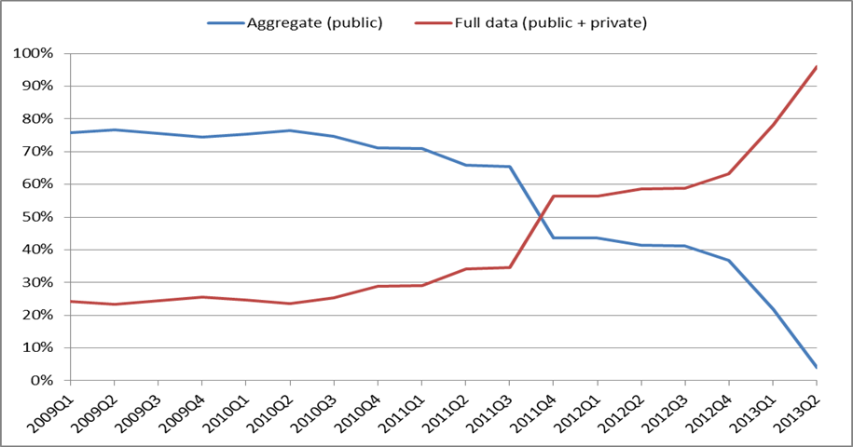
Figure 1: Highly Specialised Drugs data capture for iron chelating drugs
Source: Highly Specialised Drugs Database, extracted November 2013.
The time to next dispensing analysis used the available full data from July 2011 to July 2013. Prescriptions within the last 150 days of this period were excluded to reduce bias towards more frequent dispensing.
The patient age and sex analysis used the full data from the second quarter of 2013 because data for this period is almost complete (see Figure 1). Unique patient identification numbers (PINs) were used to ensure patients were counted once. The time to next dispensing analysis shows the majority of prescriptions are refilled within a 90 day period. At present, it is not possible to undertake an analysis of initiating patients. When public hospitals transition from bulk processing (aggregate data) to online processing (full data), patients appear as initiators on the online data although they were previously treated with iron chelating drugs.
Special pricing arrangements apply for deferasirox. Expenditure presented in this report is based on the prices published in the PBS schedule.
Results
Overall utilisation
The overall usage of the iron chelating agents desferrioxamine, deferiprone and deferasirox from January 2009 to June 2013 is presented in Figure 2.
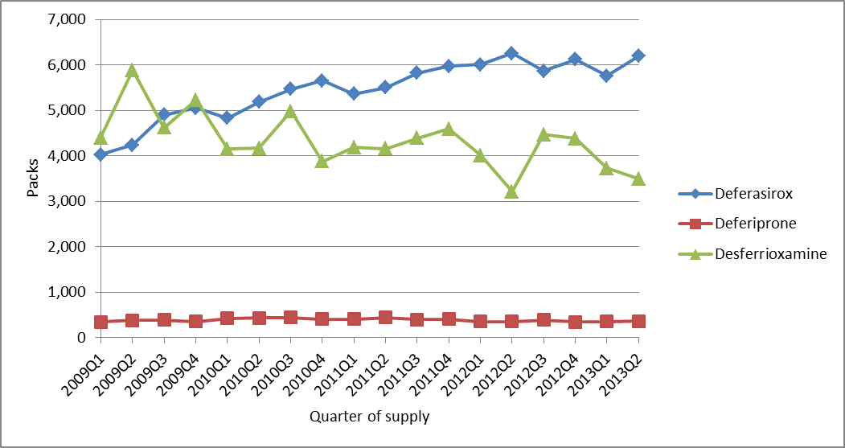Figure 2: Iron chelating drug packs - January 2009 (Q1) to June 2013 (Q2)
Source: Highly Specialised Drugs Database, extracted November 2013
The number of packs of deferiprone supplied has been stable over this time period while the number of desferrioxamine packs decreased. The total number of packs of deferasirox per quarter increased until the third quarter of 2011 and has remained relatively stable since. It should be noted that one pack of a drug may not last for the same duration as a pack of another drug. The maximum quantity per desferrioxamine prescription is 60 to 400 vials whereas the maximum quantity for deferasirox is 6 packs (168 tablets).
Figure 3 presents the utilisation of deferasirox by strength.
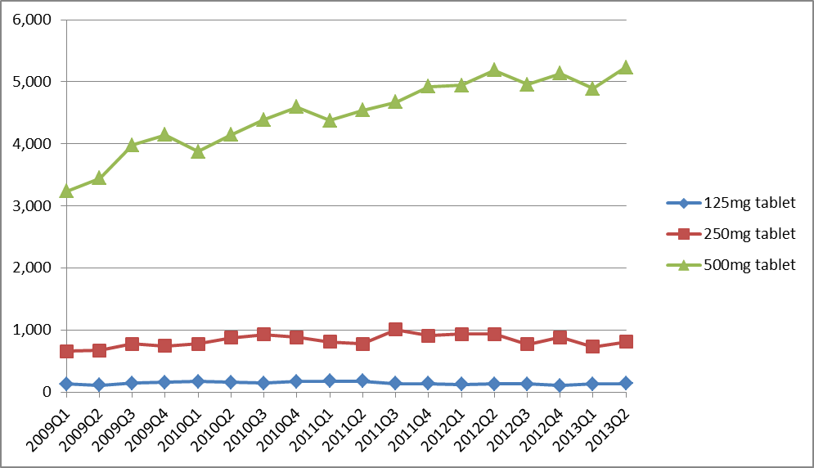
Figure 3: Deferasirox packs by strength - January 2009 (Q1) to June 2013 (Q2)
The 500 mg strength is the most commonly used strength. Use of this strength increased between the first quarter of 2009 and the fourth quarter of 2011.
Patient level analysis
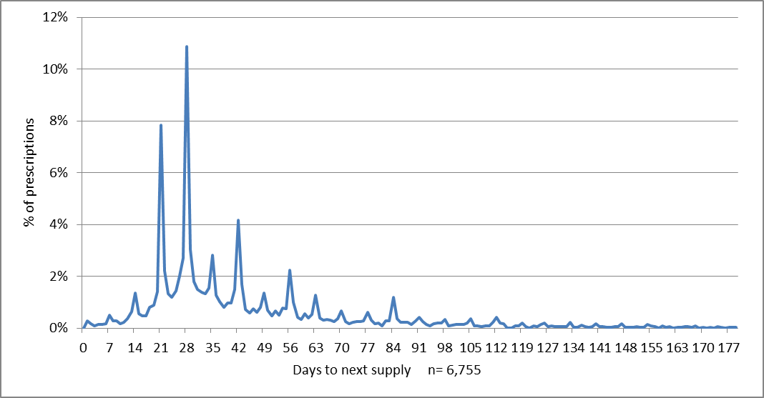Figure 4 presents the time to next dispensing analysis for all iron chelating agents. The individual medicines were not presented separately because deferasirox accounts for 91% of subsequent dispensing.
Figure 4: Time to next dispensing - all iron chelating drugs
Source: DHS Supplied Prescriptions Database, extracted November 2013

The results show that by 90 days, 89% of prescriptions were refilled. This suggests the majority of patients who are prescribed iron chelating agents would receive a supply in a 3-month period and would be captured in a quarter of dispensing data. The data for re-supply after 180 days was not presented because only 2% of refills occurred after this time period.
Figure 5 presents the age and sex distribution of patients who received any PBS iron chelating agent in the second quarter of 2013 (April–June 2013).
Figure 5: Age and sex of patients who received iron chelating drugs in April to June 2013 (Q2)
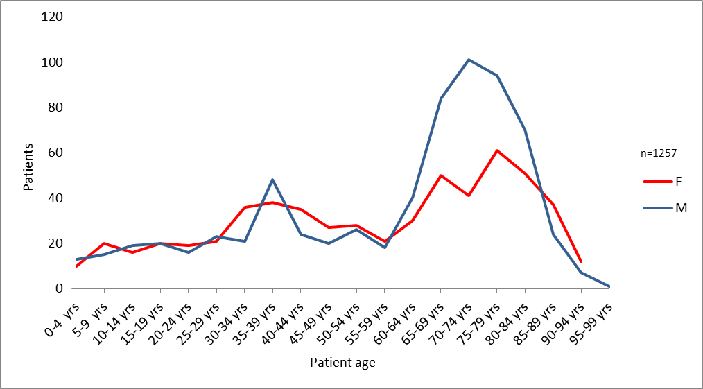
Source: DHS Prescription Claim Database, extracted November 2013
A total of 1,257 patients received a PBS iron chelating agent in the second quarter of 2013. Of these, 59% were 55 years of age or older. A larger proportion of patients aged 55 years or over were male compared to the younger age groups.
Due to the data limitations outlined in the methods section, the age that a patient commenced treatment with an iron chelating agent cannot be determined. Figure 5 represents the age of the prevalent treated population in the second quarter of 2013.

Analysis of expenditure
Table presents the total PBS/RPBS expenditure on the three iron chelating agents.
Table 5: PBS/RPBS expenditure on iron chelating drugs
 | 2009 | 2010 | 2011 | 2012 | 2013  (1st half)
Deferasirox | $13,268,025 | $15,685,323 | $19,038,592 | $20,601,860 | $10,234,971
Deferiprone | $637,727 | $740,226 | $723,090 | $640,553 | $313,257
Desferrioxamine | $1,070,243 | $898,305 | $856,414 | $817,508 | $331,835
Total | $14,975,995 | $17,323,854 | $20,618,096 | $22,059,921 | $10,880,063
Source: Highly Specialised Drugs Database, extracted November 2013
Deferasirox expenditure is substantially higher than the expenditure for deferiprone and desferrioxamine. Deferiprone expenditure appears relatively stable whereas desferrioxamine expenditure decreased each year between 2009 and 2012. Deferasirox has a special pricing arrangement.
Table presents the expenditure of deferasirox by strength.
Table 6: PBS expenditure of deferasirox by strength
 | 2009 | 2010 | 2011 | 2012 | 2013  (1st half)
125 mg | $111,280 | $132,788 | $147,845 | $116,456 | $63,162
250 mg | $1,167,187 | $1,439,405 | $1,631,827 | $1,639,448 | $730,493
500 mg | $11,989,557 | $14,113,130 | $17,258,920 | $18,845,955 | $9,441,316
Source: Highly Specialised Drugs Database, extracted November 2013
The results show that the 500 mg tablet of deferasirox is the most commonly used strength and accounts for the majority of deferasirox expenditure.

Analysis of actual versus predicted utilisation
Table 7: Predicted versus actual utilisation of iron chelating medicines
 | Submission estimate  Year 4 | Actual use for a 12-month period  prior to listing of deferasirox  Oct05-Sept06 | Actual use  after listing of deferasirox  Jan07-Dec07 | Actual use  June12 – May13
Desferrioxamine
2 g injection (x1) - Packs |  | 46,488 | 16,328 | 12,327
2 g injection (x1) - Cost |  | $1,649,232 | $648,670 | $444,831
500 mg injection (x10) - Packs |  | 20,591 | 7,610 | 3,518
500 mg injection (x10) - Cost |  | $1,896,311 | $755,209 | $315,550
Total Desferrioxamine - Cost |  | $3,545,543 | $1,403,879 | $760,381
Deferiprone
100 mg/ mL (250 mL x5) - Packs |  | n/a | n/a | 18
100 mg/ mL (250 mL x5) - Cost |  | n/a | n/a | $3,940
500 mg tablets (x100) - Packs |  | 1,072 | 1,195 | 1,405
500 mg tablets (x100) - Cost |  | $438,202 | $529,264 | $627,946
Total Deferiprone - Cost |  | $438,202 | $529,264 | $631,886
Deferasirox | Dec09-Nov10
125 mg tablet (x28)- Packs | (REDACTED) | n/a | 833 | 527
125 mg tablet (x28)- Cost | (REDACTED) | n/a | $157,282 | $122,726
250 mg tablet (x28)- Packs | (REDACTED) | n/a | 3,642 | 3,316
250 mg tablet (x28)- Cost | (REDACTED) | n/a | $1,369,673 | $1,552,754
500 mg tablet (x28)- Packs | (REDACTED) | n/a | 10,620 | 20,383
500 mg tablet (x28)- Cost | (REDACTED) | n/a | $7,997,278 | $19,000,335
Total Deferasirox - Cost | Less than $5 million | n/a | $9,524,233 | $20,675,814
Total Cost (Deferasirox + Deferiprone + Desferrioxamine) |  | $3,983,745 | $11,457,376 | $22,068,081
Source: Deferasirox July 2006 commentary (submission estimates, June 2008 Deferasirox Predicted versus Actual (actual utilisation Oct05–Sept06, Jan07–Dec07), Highly Specialised Drugs database (actual use Jun12– May13, extracted November 2013)

The results show that deferasirox expenditure was much higher than the Year 4 prediction. This is due to the substantially higher utilisation of the 500 mg strength, the use of which was more than three times higher than predicted for Year 4. The utilisation of the 125 mg strength and the 250 mg strength was lower than the Year 4 prediction.
This higher than predicted use is likely to be due to deferasirox being used largely in an adult patient population, which is supported by the patient age analysis presented in Figure 5.

Discussion
Utilisation and expenditure for iron chelating agents almost doubled between 2007 and 2013. The increasing utilisation and cost is predominantly driven by the 500 mg strength of deferasirox. Overall, there is higher than expected utilisation of deferasirox than anticipated at the time of listing. The DUSC considered this higher than expected utilisation is likely to be due to the extent of use of iron chelation therapy in patients with MDS. The results presented in Figure 5 show 59% of patients who received an iron chelating agent in the second quarter of 2013 were 55 years or older. These patients are unlikely to be thalassaemia patients because prior to the mid-1960s and the development of transfusion treatment, death before age 12 was common in patients with β-thalassaemia. As a result, there is unlikely to be many patients who suffer from β-thalassaemia who are over 55 years of age. Furthermore, Figure 5 shows a larger proportion of males receiving iron chelating drugs aged over 55 years. Such a pattern would not be observed in a genetic condition but would be expected in MDS which is more common in males than females.
The deferasirox submission estimates were calculated on the basis of deferasirox use being predominantly in thalassaemia patients. The submission did note there would be additional use of deferasirox by patients with MDS; however the use appears to have been underestimated. The submission predicted substantial reduction in the use of desferrioxamine, which appears to have occurred to some extent.
The use of iron chelating drugs, particularly deferasirox, in older patients with MDS may have cost-effectiveness implications. In the submission to the PBAC, the cost-effectiveness of deferasirox over the comparator desferrioxamine was based on a lifetime utility gain of a modelled cohort of patients with an average starting age of 5 years. The likely utility gain due to deferasirox treatment in patients with MDS is likely to be substantially lower. For MDS patients, death and morbidity occur less often as a direct result of iron overload because of the short life expectancy of the underlying disease. The DUSC noted that the incremental cost-effectiveness ratio (ICER) in the original deferasirox submission was highly sensitive to the age at which patients commenced therapy. The DUSC considered the ICER accepted in the PBAC submission is unlikely to apply to the current pattern of utilisation because the majority of patients are over 55 years of age. Deferasirox expenditure is substantially higher than that estimated in the PBAC submission due to higher than expected use of the 500 mg strength. This may have been due to the way the estimates were calculated in the submission, which assumed a low median patient weight. It is likely the current treated population have an average weight and age higher than that used to determine expenditure in the submission.

DUSC actions
- The DUSC referred the report to the PBAC to consider the findings that deferasirox is predominantly being used in a patient group not anticipated at the time of listing.
- The DUSC requested the Secretariat contact the Haematological Society for advice on the use of iron chelating medicines for MDS and other haematological conditions.

Context for analysis
The DUSC is a Sub Committee of the Pharmaceutical Benefits Advisory Committee (PBAC). The DUSC assesses estimates on projected usage and financial cost of medicines.

The DUSC also analyses data on actual use of medicines, including the utilisation of PBS listed medicines, and provides advice to the PBAC on these matters. This may include outlining how the current utilisation of PBS medicines compares with the use as recommended by the PBAC.

The DUSC operates in accordance with the quality use of medicines objective of the National Medicines Policy and considers that the DUSC utilisation analyses will assist consumers and health professionals to better understand the costs, benefits and risks of medicines.

The utilisation analysis report was provided to the pharmaceutical sponsors of each drug and comments on the report were provided to DUSC prior to its consideration of the analysis.

Sponsors comments
Hospira Pty Limited:
The sponsor has no comment.
Novartis Pharmaceuticals Australia Pty Ltd:
We appreciate the PBAC's interest in understanding the utilisation of iron chelating agents but consider that these agents are being prescribed appropriately, in accordance with Australian treatment guidelines. The sponsor considers that clinician review of the methodology, findings and conclusions of the review to be essential prior to determining next steps.

Orphan Australia Pty Ltd:
The sponsor has no comment.

Disclaimer
The information provided in this report does not constitute medical advice and is not intended to take the place of professional medical advice or care. It is not intended to define what constitutes reasonable, appropriate or best care for any individual for any given health issue. The information should not be used as a substitute for the judgement and skill of a medical practitioner.
The Department of Health (DoH) has made all reasonable efforts to ensure that information provided in this report is accurate. The information provided in this report was up-to-date when it was considered by the Drug Utilisation Sub-committee of the Pharmaceutical Benefits Advisory Committee. The context for that information may have changed since publication.
To the extent provided by law, DoH makes no warranties or representations as to accuracy or completeness of information contained in this report.
To the fullest extent permitted by law, neither the DoH nor any DoH employee is liable for any liability, loss, claim, damage, expense, injury or personal injury (including death), whether direct or indirect (including consequential loss and loss of profits) and however incurred (including in tort), caused or contributed to by any person’s use or misuse of the information available from this report or contained on any third party website referred to in this report.

Pharmaceutical Benefits Advisory Committee. Lenalidomide Public Summary Document. Pharmaceutical Benefits Advisory Committee; March 2013. Available from http://www.pbs.gov.au/info/industry/listing/elements/pbac-meetings/psd/2013-03/lenalidomide. Accessed 16 July 2014.
Modell B, Khan M, Darlison M. Survival in beta-thalassaemia major in the UK:data from the UK Thalassaemia Register. Lancet. 2000 Jun 10;355(9220):2051-2.
Desferal (desferrioxamine) Product Information. Accessed 16 December 2013. Available from https://www.ebs.tga.gov.au/
Ferriprox (deferiprone) Product Information. Accessed 24 October 2013. Available from https://www.ebs.tga.gov.au/
Exjade (deferasirox) Product Information. Accessed 24 October 2013. Available from https://www.ebs.tga.gov.au/
Olivieri NF, Brittenham GM. Iron-chelating therapy and the treatment of thalassemia. Blood. 1997;89(3):739.
Australian Institute of Health and Welfare & Australasian Association of Cancer Registries 2012. Cancer in Australia: an overview, 2012. Cancer series no. 74. Cat. no. CAN 70. Canberra: AIHW.

