Omalizumab: 24 month predicted versus actual analysis

Drug utilisation sub-committee (DUSC)

June 2014

Abstract

Purpose
To examine the utilisation of omalizumab in the 24 months after listing (1 July 2011 to 30 June 2013).

Background
The 12 month predicted versus actual (PvA) analysis presented at the February 2013 DUSC meeting showed lower than predicted use. The DUSC requested a second analysis of omalizumab once 24 months of data was available.

Data Source / methodology
The Authority Approvals Database was used for the majority of analyses. The Highly Specialised Drugs Database was used to analyse the quantity of vials supplied and cost to Government. The Supplied Prescriptions Database was used for a small number of analyses.

Key Findings
The utilisation of omalizumab over the first 24 months of listing was lower than estimated.
- 258 patients received an authority approval for omalizumab in the second year of listing, including 156 new patients. This is fewer total and new patients than predicted.
- Over 80% of patients who received an initial authority approval received a continuing authority approval.
- An average 3.76 vials was approved per prescription over the first two years of listing, which was approximately 20% more than predicted.

Purpose of analysis
The purpose of this analysis is to examine the utilisation of omalizumab in the 24 months after listing (1 July 2011 to 30 June 2013). The 12 month predicted versus actual (PvA) analysis presented at the February 2013 DUSC meeting showed lower than predicted use. DUSC requested a second analysis of omalizumab once 24 months of data was available.

Background

Pharmacology
Omalizumab is a recombinant DNA-derived humanised monoclonal antibody that is produced by DNA technology. It works by blocking a substance produced by the body called immunoglobulin E (IgE). IgE is involved in causing symptoms of asthma.

Therapeutic Goods Administration (TGA) approved indications
Omalizumab is indicated for the management of adult and adolescent patients with moderate to severe allergic asthma, who are already being treated with inhaled steroids, and who have serum immunoglobulin E levels corresponding to the recommended dose range.

Dosage and administration²
Omalizumab is administered subcutaneously at a dose of 150 mg to 375 mg every two to four weeks. The dose depends on a patient’s weight and baseline serum total IgE level. Doses less than 300 mg are administered every four weeks. Doses greater than 300 mg are split into two equal doses and administered every 2 weeks.
The current Product Information (PI) and Consumer Medicine Information (CMI) are available from the TGA Product Information web page and the TGA Consumer Medicines Information web page.

Clinical situation
The Thoracic Society of Australia and New Zealand 2009 consensus paper recommends use of omalizumab in patients meeting certain criteria (see Appendix A).

PBS listing details (as at 1 April 2014)
Omalizumab is listed on the section 100 Highly Specialised Drugs (HSD) Program with a Complex Authority Required listing. Prescribers are required to obtain written Authority approval for initial and continuing prescriptions from the Department of Human Services (DHS Medicare) before prescribing on the PBS.
Table 1: PBS listing of omalizumab
Item | Name, form & strength, pack size | Max. quant. | Repeats | DPMQ | Brand name and manufacturer
9745X (Public hospital) | OMALIZUMAB  Powder for injection 150 mg with diluent | 1ª | 0 ^{b} | $425.00 ^{c} | Xolair®,  Novartis Pharmaceuticals Australia Pty Ltd
9746Y (Private hospital) | OMALIZUMAB  Powder for injection 150 mg with diluent | 1ª | 0 ^{b} | $448.63 ^{c} | Xolair®,  Novartis Pharmaceuticals Australia Pty Ltd
Source: April 2014 PBS Schedule, available from www.pbs.gov.au.
ª Prescribers are able to request a larger quantity that is consistent with the Product Information dosing schema
^{b} Prescribers may request 6 repeats for initial treatment and 5 repeats for continuing treatment
^{c} Special pricing arrangements apply

Abridged restriction
Omalizumab has a complex restriction. An abridged version is presented.
Treatment of uncontrolled severe allergic asthma by a respiratory physician, clinical immunologist, allergist or general physician experienced in the management of patients with severe asthma, of a patient aged 12 years or older who has been under the care of this physician for at least 12 months. Patients must meet the following criteria:
- confirmed and documented diagnosis of asthma based on standard clinical features including on forced expiratory volume (FEV1) reversibility, airway hyperresponsiveness or peak expiratory flow (PEF) variability as defined in the restriction;
- duration of asthma of at least 1 year;
- FEV1 ≤ 80% of predicted on 3 or more occasions in the previous 12 months;
- past or current evidence of atopy;
- total serum human immunoglobulin E (IgE) greater than or equal to 76 IU/mL;
- signed the patient acknowledgement form;
- failed to achieve adequate control with optimised asthma therapy (OAT). OAT includes;
- adherence to maximal inhaled therapy, including high dose inhaled corticosteroid (budesonide 1600 micrograms per day or fluticasone propionate 1000 micrograms per day or equivalent), plus long-acting beta-2 agonist therapy (at least salmeterol 50 micrograms twice daily or eformoterol 12 micrograms twice daily) for at least 12 months, unless contraindicated or not tolerated; and
- oral corticosteroids (at least 10 mg per day prednisolone (or equivalent)) for at least 6 weeks, unless contraindicated or not tolerated.
The restriction for continuing treatment requires patients to achieve an adequate response defined as:
- a reduction in the Asthma Control Questionnaire (ACQ-5) score of at least 0.5 from baseline; or
- maintenance oral corticosteroid dose reduced by at least 25% from baseline, and no deterioration in ACQ-5 score from baseline.
The full PBS restriction is available on the PBS website. A copy of the ACQ-5 questionnaire is provided in Appendix B.

Date of listing on PBS
Omalizumab was listed on the PBS on 1 July 2011.

Relevant aspects of the PBAC consideration
Omalizumab was first considered by the PBAC in November 2009 and rejected because of a poorly targeted restriction, uncertain clinical benefit, and a high and unacceptable cost-effectiveness ratio. The DUSC provided detailed advice to the PBAC on projected usage and financial cost for omalizumab. For further details see the Public Summary Document (PSD) from the November 2009 PBAC meeting.
A PBAC Stakeholder meeting was held in April 2010 with the sponsor, clinicians and consumers to develop options to progress the PBS listing of omalizumab.
The main issues discussed at the Stakeholder Meeting included:
- the identification of a subgroup for listing, particularly in terms of defining severe asthma;
- the definition of optimal background therapy to qualify for initiation;
- the appropriate range of IgE in the Australian context;
- the most effective version of the Asthma Control Questionnaire for the restriction; and
- parameters of ongoing assessment for response.
At its November 2010 meeting, the PBAC considered a resubmission and deferred listing to seek a further price reduction from the sponsor as the incremental cost per QALY was too high for the Committee to recommend listing. For further details see the Public Summary Document (PSD) from the November 2010 PBAC meeting.
Subsequent to the November 2010 meeting, the PBAC received an offer of a price reduction sufficient for the PBAC to recommend the listing of omalizumab. The PBAC recommended the listing of omalizumab out of session on the basis of an acceptable cost effectiveness ratio in a severe patient group with limited treatment options, whose asthma was uncontrolled whilst on at least 10 mg per day prednisolone equivalent. For further details refer to the update to the November 2010 PSD.

Approach taken to estimate utilisation
The financial estimates were based on an epidemiological approach. A large number of steps and sources of information were required to derive the estimates. The DUSC considered the estimates of eligible population and likely treated population to be highly uncertain, but thought that it would be difficult to have greater certainty about the likely eligible population. Small differences in many of the assumptions have a large impact on the number of patients and consequently the cost of the drug to the PBS.
The estimates agreed between the Sponsor and the Department prior to PBS listing, upon which this review is based, vary slightly from the November 2010 resubmission due to a decrease in the number of grandfather patients (patients who were treated with non-PBS subsidised omalizumab prior to listing on the PBS and who met the PBS criteria) expected to be treated with PBS omalizumab.

Table 2: The main areas of uncertainty identified in the submission
Area of Uncertainty | Steps taken for Management
- Estimates of eligible patients including proportion of patients with asthma and:  - Severe allergic asthma; and  - Using including fixed combination and single agent products inhaled corticosteroids, long acting beta-2 agonist and maintenance oral corticosteroids  - Uncontrolled on OAT  - Number of grandfather patients  - Non responder and continuation rates, including number of non-responder patients who will retrial  - Number of vials/month and administration | - Detailed, written Authority Required Restriction  - Continuation criteria  - Patient required to sign acknowledgement that they may not be eligible for ongoing treatment if classified as non-responder  - Limit on prescriber type and length of relationship with prescriber  - 6 month waiting period before retrial in non-responders  - Risk Share Agreement

Patient numbers were estimated to be less than 1000 each year in the first five years of listing. It was estimated that approximately 60% of patients would respond to omalizumab and receive continuing therapy based on the trial response rates.
The dose of omalizumab depends on the patient’s weight and IgE level. Based on trial data presented in the submission, it was predicted that patients would require an average number of vials per month. The data from the trials was adjusted for the Australian context as it included results for children.
The cost to Commonwealth listing omalizumab was estimated to be less than $10 million in each of the first five years of listing.

Previous reviews by the DUSC
At its February 2013 meeting, the DUSC examined the utilisation of omalizumab in its first 12 months of PBS listing. The analysis found utilisation in the first year of listing to be much lower than expected. The DUSC noted the comprehensive and informative responses provided by the sponsor and clinicians outlining the reasons for low uptake. The DUSC did not consider that safety concerns or an uncertain place in therapy were the reasons for low utilisation. The DUSC considered that possible reasons may include:
- Overestimation of the eligible population;
- Difficulty for clinics to collect patient data to fulfil administrative requirements for eligibility;
- Reluctance by clinicians and patients to use long-term oral corticosteroids due to toxicity; and
- Low continuation rate, noting that patients who commenced treatment in the second half of the year would not have had an opportunity to be assessed for response and seek approval for continuing treatment.
The DUSC recommended reviewing use after 24 months of data were available. The Committee considered the use of omalizumab could be better understood by assessing response and continuation rates in the PBS population when further data were available and using the Australian Xolair Register data when available.

Methods
Omalizumab is a section 100 Highly Specialised Drug (HSD) that requires authority approval, via a written application, from DHS Medicare for both public and private hospital patients. The DHS Authority Approvals Database contains information on Authority applications for all patients treated with PBS/Repatriation PBS (RPBS) omalizumab.
From Authority approvals de-identified patient counts, treatment continuation, vials and repeats data were extracted from the Authority Database.
The DUSC HSD database consolidates all PBS/RPBS use of HSDs across public and private hospital settings. The HSD database provides aggregate information on the number of vials supplied, expenditure, patient location by state and whether the drug was supplied from a public or private hospital, by quarter of supply. This database was used to extract data relating to total vials supplied and expenditure.
Patient-level data in the DHS Medicare Supplied Prescriptions Database for omalizumab patients receiving treatment through public hospitals was incomplete to June 2013. Until this time, the majority of public hospital HSD prescriptions were processed through a bulk claiming system which did not provide patient-level data. Full data is available for public hospital HSD prescriptions from 1 July 2013. At the time of the analysis, complete patient level data was only available for the third quarter of 2013 (2013-Q3).
Data were also sourced from initial PBS Authority Applications approved by the DHS, Medicare. The data presented relate to the 109 patients whose applications were approved from 1 July 2011 to 31 December 2011, the first six months of omalizumab listing. The data were manually collated by the DHS Medicare. This data includes the IgE, patient weight and oral corticosteroid use as recorded in the Severe Allergic Asthma (omalizumab) Initial PBS Authority Applications supporting information forms required to be submitted to DHS Medicare with the initial authority prescription application. The dataset includes grandfathered patients for whom complete data may not be available.
The Australian Xolair (omalizumab) Registry collects data on an enrolled subset of patients receiving treatment with omalizumab. This includes some patients receiving omalizumab via the PBS and some outside the PBS (private patients). For further information see the Australian Xolair Registry website, including publications and reports using de-identified patient data from the Registry.

Results

Analysis of drug utilisation

Patients
In the second year of listing, 258 patients received an authority approval for omalizumab, including 156 new patients. In the first year of PBS listing 148 patients received an authority approval for omalizumab.
While the total number of patients treated with omalizumab has increased from the first year of listing, it continues be substantially lower than predicted. A patient count was also undertaken for 2013-Q3, the only quarter where patient-level HSD data was available at the time the report was prepared. This analysis found 260 patients were supplied omalizumab in 2013-Q3.
Figure 1 presents the number of patients given their first Authority Approval for omalizumab by quarter.
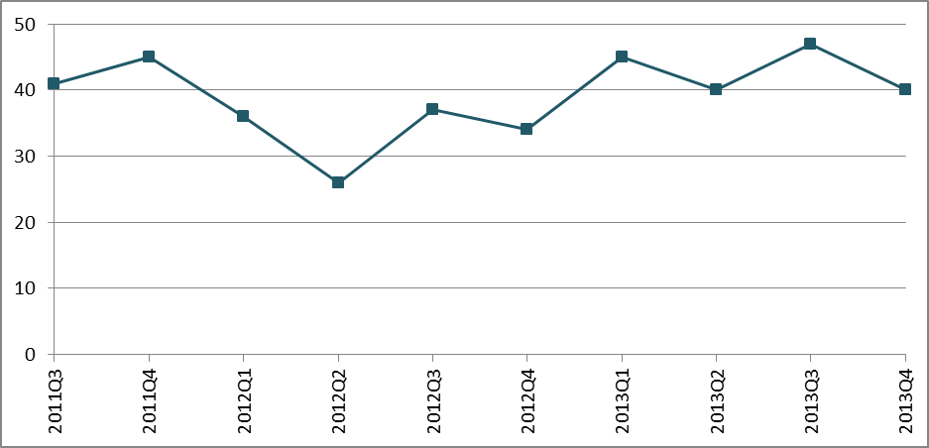Figure 1: Patients starting omalizumab by quarter of Authority Approval
Source: Authority Approvals Database, extracted March 2014
Between 40 and 50 new patients received their first Authority Approval in each quarter of 2013.

Continuation
Table 3 presents the proportion of patients who received a second Authority Approval for omalizumab. This cohort of patients received their first Authority approval on or before
30 June 2013.
Table 3: Omalizumab continuation rates
 | % continuing | Patients in cohort
All patients | 81% | 304
Subgroups | Subgroups | Subgroups
All patients (excluding grandfathered patients)ª | 80% | 287
Patients starting treatment from 2012 | 82% | 218
Year 2 initiators (July 2012 onwards) | 84% | 156
Source: Authority approvals database, extracted 2 April 2014
ª Classification of grandfather patients may not be accurate
Due to difficulty in identifying grandfathered patients, a number of different subgroups within the cohort were also analysed. These results suggest a fairly high level of continuation of 80% or greater in initiating patients.

Dosage and quantity
Figure 2 presents the number of omalizumab vials approved per prescription on the 2011 approvals cohort (first six months of listing), vials per prescription for all omalizumab approvals to March 2014 and the distribution of vials per prescription supplied in 2013-Q3.

Figure 2: Distribution of the number of omalizumab vials per prescription
Source: DHS Medicare Severe Allergic Asthma Initial PBS Authority Applications 2001, extracted May 2014. Authority Approvals Database, extracted March 2014; DHS Supplied Prescription Database, extracted April 2014
The number of vials per prescription dispensed in 2013-Q3 is consistent with the approvals data.
The average number of vials per prescription for all approvals was 3.76. The average number of vials in the 2013-Q3 supply data was 3.90. The average number of vials per prescription was 3.83 in the data from initial authority approvals for the first six months of listing. The majority of patients required 4 or more vials. The average dose was 506 mg (standard deviation = 201).

Immunoglobulin E levels
Patient IgE level and weight determine the appropriate omalizumab dose for the patient.
Figure 3 presents the baseline IgE levels of the cohort. The IgE ranges are presented in similar categories to the omalizumab dosing algorithm found in the Product Information.
Figure 3: Patient IgE levels (IU/mL)
Source: DHS Medicare Severe Allergic Asthma Initial PBS Authority Applications 2011, extracted May 2014.
The mean baseline IgE level was 448.1 IU/mL (SD 511.5). The median IgE was 278.5 IU/mL. As it can be seen from Figure 3, a small proportion of patients had very high IgE levels, exceeding 1,300 IU/mL.

Patient weight
Table 4 presents the distribution of patient weight.

Table 4: Patient weight
Patient weight | Percentage of Patients
Less than 60 kg | 12%
60-69 kg | 16%
70-79 kg | 22%
80-89 kg | 12%
90-99 kg | 9%
100-109 kg | 14%
110 kg | 15%
Source: DHS Medicare Severe Allergic Asthma Initial PBS Authority Applications 2011, extracted May 2014.
The mean weight of the cohort was 85 kg. The median weight was 79 kg.

Oral Corticosteroid Use
Table 5 presents prior oral corticosteroid use by drug in the patient cohort. Prednisolone was the most commonly used corticosteroid. Only 6% of patients were considered intolerant to oral corticosteroid use.

Table 5: Oral corticosteroid use by drug
Corticosteroid | Percentage of Patients | Average dose (mg)
Dexamethasone | 2% | 2.5
Prednisolone | 74% | 18.2
Prednisone | 11% | 12.7
Intolerant | 6% | -
Not recordedª | 7% | -
Source: DHS Severe Allergic Asthma Initial PBS Authority Applications 2011, extracted May 2014.
ª Data not recorded for 7 grandfathered patients.
Figure 4 presents the duration of oral corticosteroid use in the patient cohort.
Figure 4: Duration (in days) of oral corticosteroid use
Source: DHS Severe Allergic Asthma Initial PBS Authority Applications 2001, extracted May 2014.
The average duration of corticosteroid use was 432 days. The median duration of use was 92 days. As it can be seen from Figure 4, half of patients used corticosteroids for less than 100 days; however 19% of patients had used oral corticosteroids for over 500 days.

Analysis of expenditure
Figure 5 presents omalizumab expenditure by quarter since listing based on the published price for omalizumab. A Special Pricing Arrangement applies to the PBS listing of omalizumab, which means that the price published in the Schedule of Pharmaceutical Benefits is different from the actual price of omalizumab.
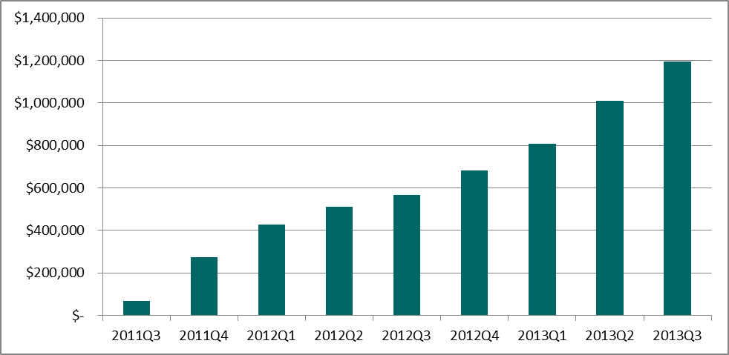
Figure 5: Omalizumab expenditure since listing
Source: Highly Specialised Drugs Database, extracted March 2014
Note: Special Pricing Arrangements Apply
Omalizumab expenditure has continued to increase since listing.

Analysis of actual versus predicted utilisation
The total number of patients treated with omalizumab in the second year of PBS listing has increased from the first year of listing, however utilisation continues be substantially lower than predicted.
In the second year of listing 258 patients received an authority approval for omalizumab, including 156 new patients. This is fewer total and new patients than predicted. In the first year of PBS listing 148 patients received an authority approval for omalizumab.

Over 80% of patients who received an initial authority approval received a continuing authority approval. This continuation rate is higher than that estimated in the submission to the PBAC based on trial continuation rates.

An average 3.76 vials was approved per prescription over the first two years of listing, and 3.86 over the total approvals to February 2014, which was approximately 20% more than predicted. The submission prediction was based on trial data. The patients in the trials may have had less severe disease than the eligible PBS population with only 19.8-23.4% of participants using maintenance systemic corticosteroids.

Discussion
The utilisation of omalizumab continues to be lower than predicted, albeit to a slightly smaller degree than in the first year of listing. The DUSC considered the reasons for this were likely to be similar to those outlined in the 12 month predicted versus actual utilisation analysis. These include:
- overestimation of the eligible population, which was considered highly uncertain;
- difficulty collecting data to fulfil the administrative requirements; and
- reluctance to use long-term oral corticosteroids due to toxicity.
The DUSC considered that uptake may increase following the listing of the new pre-filled syringe formulation due to easier administration.
The pattern of omalizumab uptake has also been different from what was predicted. It was estimated there would be higher initial uptake and lower levels of patient growth in subsequent years. The true pattern of uptake has been different, with a relatively steady number of patients commencing treatment every quarter.
The 12 month analysis suggested continuation may be low and this may be a factor contributing to lower than estimated utilisation. The continuation analysis in this report showed that continuation rates were 80% or higher for the cohort who received their first Authority approval for omalizumab on or before 30 June 2013. This is higher than that predicted, which was based on trial data, and hence continuation of treatment with omalizumab was not considered to be a factor contributing to low utilisation.
The DUSC noted that the omalizumab restriction requires patients to trial and experience an asthma exacerbation while using a relatively high dose of oral corticosteroids (10mg prednisolone or equivalent) for at least six weeks while also using high doses of inhaled corticosteroids. It was noted that many of the clinical criteria in the restriction were decided upon at the 2010 PBAC Stakeholder meeting. The DUSC considered that it is not clear whether the dose and duration of oral corticosteroid use specified in the restriction reflects what is current best practice for severe refractory asthma.
The DUSC noted from the sponsor and clinician responses that a number of administrative barriers to prescribing PBS omalizumab remain. These include the collection of historical data such as tests undertaken to diagnose patients’ asthma and allergies, dates of exacerbations and hospitalisations, dates of commencement of background therapies and treatment of exacerbations. The DUSC noted that the collection of this data would be difficult, particularly in public hospital outpatient clinics. The DUSC also considered the requirement for patients to have been under the care of the prescribing physician for 12 months may be difficult in practice, particularly for rural patients and patients attending outpatient respiratory clinics where the patient may not be continuously managed by a single clinician. Additionally, private clinics may not have the staff and facilities to prepare, administer and monitor omalizumab patients. These patients may require referral to hospital clinics with facilities and capacity to administer omalizumab.
The DUSC noted that the average dose was higher than expected. The committee considered this to be due to a high prevalence of obesity in this patient group.

DUSC actions
The DUSC referred the report to PBAC for information, and for PBAC to consider if a review of the restriction is required.
DUSC requested the Secretariat continue to liaise with DHS Medicare to obtain omalizumab Authority application data.

Context for analysis
The DUSC is a Sub Committee of the Pharmaceutical Benefits Advisory Committee (PBAC). The DUSC assesses estimates on projected usage and financial cost of medicines.
The DUSC also analyses data on actual use of medicines, including the utilisation of PBS listed medicines, and provides advice to the PBAC on these matters. This may include outlining how the current utilisation of PBS medicines compares with the use as recommended by the PBAC.
The DUSC operates in accordance with the quality use of medicines objective of the National Medicines Policy and considers that the DUSC utilisation analyses will assist consumers and health professionals to better understand the costs, benefits and risks of medicines.
The utilisation analysis report was provided to the pharmaceutical sponsors of each drug and comments on the report were provided to DUSC prior to its consideration of the analysis.

Sponsors’ comments
Novartis Pharmaceuticals Australia Pty Ltd: There are a number of factors related to the PBS eligibility criteria and DHS Medicare application requirements that are likely to be contributing to the lower than predicted utilisation of omalizumab. Novartis has lodged a submission to the PBAC to be considered at its November 2014 meeting proposing modifications to the PBS restrictions aimed at improving patient access, while retaining the original intent of the restrictions, which is to target patients in whom omalizumab is effective and cost-effective.

Appendix A: clinical criteria
The Thoracic Society of Australia and New Zealand 2009 consensus paper³ recommends use of omalizumab in patients meeting the following criteria:
- 12 years of age or older;
- duration of asthma ≥ 1 year;
- poor control as evidenced by the presence of 2 of 6 asthma symptoms most days per week over at least a 3 months period: breathlessness, wheezing, limitation in activities, relief by bronchodilators, night awaking, morning asthma symptoms;
- objective confirmation of asthma: forced expiratory volume (FEV1) reversibility ≥ 12% at baseline within 30 minutes after administration of salbutamol (100-200ug) or equivalent, airway hyperresponsiveness or increased peak expiratory (PEF) variability, previously documented;
- adherent to maximal inhaled therapy: treatment with budesonide 1600ug/day or fluticasone propionate 1000ug/day or equivalent, plus long-acting beta agonist, for 3 months; and
- total serum IgE ranging from ≥ 30IU/mL to ≤ 700IU/mL.
Use is not recommended in the following patient groups:
- current smoker or stopped smoking less than 3 months ago;
- evidence for masquerading or complicating asthma conditions such as: vocal cord dysfunction, chronic obstructive pulmonary disease, allergic bronchopulmonary aspergillosis or Churg-Strauss syndrome;
- any respiratory related illness (excluding upper airway disease) other than asthma;
- acute upper respiratory tract infection within 1 month;
- pregnant or lactating; or
- unable to attend clinic regularly.

Appendix B: Asthma Control Questionnaire – 5 Item (ACQ-5)
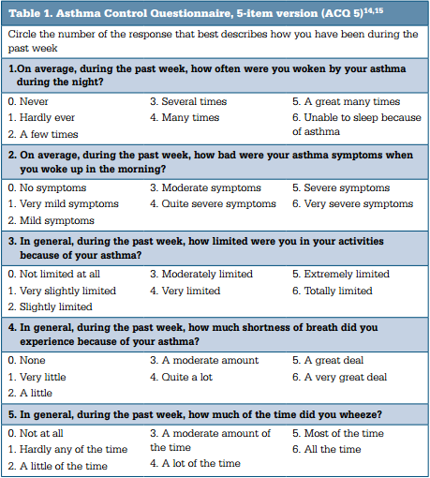
The overall score is the average of the answers of the 5 questions. The assessment of severity is shown in the following table.
ACQ-5 Score | Severity
<0.75 | Well-controlled asthma
0.75-1.5 | Not well-controlled asthma
>1.5 | Uncontrolled asthma

Disclaimer
The information provided in this report does not constitute medical advice and is not intended to take the place of professional medical advice or care. It is not intended to define what constitutes reasonable, appropriate or best care for any individual for any given health issue. The information should not be used as a substitute for the judgement and skill of a medical practitioner.
The Department of Health (DoH) has made all reasonable efforts to ensure that information provided in this report is accurate. The information provided in this report was up-to-date when it was considered by the Drug Utilisation Sub-committee of the Pharmaceutical Benefits Advisory Committee. The context for that information may have changed since publication.
To the extent provided by law, DoH makes no warranties or representations as to accuracy or completeness of information contained in this report.
To the fullest extent permitted by law, neither the DoH nor any DoH employee is liable for any liability, loss, claim, damage, expense, injury or personal injury (including death), whether direct or indirect (including consequential loss and loss of profits) and however incurred (including in tort), caused or contributed to by any person’s use or misuse of the information available from this report or contained on any third party website referred to in this report.

Xolair (omalizumab) Consumer Medicines Information. Sydney: Novartis Pharmaceuticals Australia Pty Ltd. Approved August 2013. Available from <https://www.ebs.tga.gov.au>. Accessed 4 July 2014.
Xolair (omalizumab) Product Information. Sydney: Novartis Pharmaceuticals Australia Pty Ltd. Approved 17 April 2014. Available from https://www.ebs.tga.gov.au. Accessed 4 July 2014.
The Thoracic Society of Australia and New Zealand. Omalizumab Recommendations for use in the Australasian context (A consensus paper of The Thoracic Society of Australia and New Zealand). Sydney: The Thoracic Society of Australia and New Zealand; April 2009. Available from <http://www.thoracic.org.au/imagesDB/wysiwyg/Omalizumabfinalfrmweb.pdf>.
Henderson J, Hancock KL, Armour C, Harrison C, Miller G. Asthma control in general practice - GP and patient perspectives compared. Aust Fam Physician. 2013 Oct;42(10):740-3.

