Pazopanib and sunitinib for renal cell carcinoma: analysis of predicted versus actual utilisation

Drug utilisation sub-committee (DUSC)

June 2014

Abstract

Purpose
Pazopanib and sunitinib are tyrosine kinase inhibitors. They inhibit factors that contribute to tumour growth in patients with renal cell carcinoma (RCC). Prior to the PBS listing of these medicines, there was some uncertainty regarding the number of patients who would receive treatment, the distribution of strengths, and the length of treatment. This analysis was undertaken to assess how the predicted use of pazopanib and sunitinib for RCC compared to actual use.

Date of listing on PBS
Sunitinib and pazopanib were PBS-listed for RCC on 1 May 2009 and 1 October 2012, respectively. The current PBS listings (restrictions and item codes) for RCC indications for sunitinib and pazopanib are available from the PBS website.

Data Source / methodology
The utilisation of pazopanib and sunitinib for RCC was determined by extracting data on the number of PBS/RPBS prescriptions and the benefits paid from the Department of Human Services (DHS) PBS prescription database for the period May 2009 to September 2013 inclusive. The analysis was based on the date the prescription was supplied to the patient.

Key Findings
- Following the PBS listing of sunitinib, more patients started treatment for RCC than originally predicted.
- The number of new patients who start treatment with either pazopanib or sunitinib for RCC each year is approximately 500.
- Following the PBS listing of pazopanib, the number of prevalent patients receiving either pazopanib or sunitinib increased from approximately 600 patients in the 12-month period prior to listing to approximately 700 patients in the 12-month period after listing.
- The number of prescriptions for sunitinib were lower than originally expected, indicating that patients treated with sunitinib received fewer prescriptions per year than originally estimated.
- The number of prescriptions for pazopanib were more than double that expected. Pazopanib appeared to be substituting for sunitinib, with sunitinib prescriptions decreasing after the PBS listing of pazopanib.

Purpose of analysis
This analysis was undertaken to assess how the predicted use of pazopanib and sunitinib for renal cell carcinoma (RCC) compared to actual use.

Background

Pharmacology
Pazopanib and sunitinib are tyrosine kinase inhibitors. They inhibit factors that contribute to tumour growth in patients with RCC.

Therapeutic Goods Administration (TGA) approved indications
Pazopanib is approved by the TGA for the treatment of patients with advanced and/or metastatic RCC. It is also approved for use in some patients with soft tissue sarcoma.
Sunitinib is approved by the TGA for the treatment of patients with advanced RCC. It is also approved for use in some patients with gastrointestinal stromal tumours and unresectable, well-differentiated pancreatic neuroendocrine tumours.

Dosage and administration

Pazopanib
Pazopanib is usually administered at a dose of 800 mg orally once daily for the treatment of RCC. The dose can be decreased in order to manage adverse reactions: this is usually done in stepwise increments of 200 mg.

Sunitinib
Sunitinib is usually administered in a dose of 50 mg orally once daily for the treatment of RCC. Treatment is for 4 consecutive weeks followed by a 2-week rest period to comprise a complete cycle of 6 weeks. The dose may be modified in increments of 12.5 mg to improve tolerability, but a dose range of between 25 to 75 mg is recommended. Dose interruptions may also be required.
Information on the currently approved TGA indications as well as dosage and administration is available in the Product Information (PI). This can be found on the TGA website product information page. Further information for consumers is available from the Consumer Medicine Information (CMI). This can also be found on the TGA website consumer medicines information page.

Clinical situation
Renal cell carcinoma is the most common form of kidney cancer. According to data from the Australian Institute of Health and Welfare (AIHW), the number of new cases of kidney cancer has increased from approximately 2000 cases per year in the year 2000 to approximately 2,700 cases per year in 2010. Kidney cancer is associated with a high death rate, with approximately 850 to 900 patients dying from the disease each year.¹

PBS listing details as at 14 April 2014
Pazopanib (Votrient®), film-coated tablets, 200 mg and 400 mg (as hydrochloride), GlaxoSmithKline Australia Pty Ltd.
Sunitinib malate (Sutent®), capsules, 12.5 mg, 25 mg and 50 mg (base), Pfizer Australia Pty Ltd.

Table 1: PBS item listing history for RCC indications for sunitinib and pazopanib
Drug | Item Listing Date | PBS item code | Form and Strength | Maximum Quantity | Max. Repeats | DPMQ*  (as at 1/4/2014) | Brand Name
Sunitinib | 1/05/2009 | 9417P | Capsule 12.5 mg (as malate) | 28 | 1 | $ 1,834.41 | Sutent
 |  | 9418Q | Capsule 25 mg (as malate) | 28 | 1 | $ 3,521.97 | Sutent
 |  | 9419R | Capsule 50 mg (as malate) | 28 | 1 | $ 6,897.65 | Sutent
 |  | 9420T | Capsule 12.5 mg (as malate) | 28 | 3 | $ 1,834.41 | Sutent
 |  | 9421W | Capsule 25 mg (as malate) | 28 | 3 | $ 3,521.97 | Sutent
 |  | 9422X | Capsule 50 mg (as malate) | 28 | 3 | $ 6,897.65 | Sutent
Pazopanib | 1/10/2012 | 2029T | Tablet 200 mg (as hydrochloride) | 90 | 2 | $ 3,542.03 | Votrient
 |  | 2030W | Tablet 400 mg (as hydrochloride) | 60 | 2 | $ 4,673.85 | Votrient
 |  | 2034C | Tablet 200 mg (as hydrochloride) | 90 | 5 | $ 3,542.03 | Votrient
 |  | 2035D | Tablet 400 mg (as hydrochloride) | 60 | 5 | $ 4,673.85 | Votrient
 | 1/12/2012 | 2201W | Tablet 400 mg (as hydrochloride) | 30 | 5 | $ 2,410.21 | Votrient
 |  | 2232L | Tablet 200 mg (as hydrochloride) | 30 | 5 | $ 1,256.46 | Votrient

Source: PBS Item History file accessed 14/4/2014
*Note: Special Pricing Arrangements apply, indicating that the price listed does not necessarily reflect the price paid by the Government
Abbreviations: DPMQ = dispensed price for maximum quantity

Restriction
Pazopanib and sunitinib are listed as Authority Required items, with PBS-subsidised treatment limited to patients with Stage IV, clear cell variant RCC. To be eligible for treatment, patients must meet the Memorial Sloan Kettering Cancer Centre (MSKCC) low to intermediate risk group criteria and have a World Health Organization (WHO) performance status of 2 or less. Patients are eligible to continue on treatment if they have stable or responding disease (as defined according to the Response Evaluation Criteria In Solid Tumours (RECIST)). Patients who have progressive disease are not eligible for ongoing PBS-subsidised treatment. Sunitinib and pazopanib cannot be used together. Patients are allowed to switch from one medicine to the other if they develop intolerance of a severity necessitating permanent treatment withdrawal.

Date of listing on PBS
Sunitinib and pazopanib were PBS-listed for RCC on 1 May 2009 and 1 October 2012, respectively. The current PBS listings (restrictions and item codes) for RCC indications for sunitinib and pazopanib are available from the PBS website.

Relevant aspects of the PBAC consideration
The Pharmaceutical Benefits Advisory Committee (PBAC) consider the effectiveness, safety and cost-effectiveness of medicines prior to their listing on the PBS. When considering sunitinib at its July 2008 meeting, the committee decided that the medicine had acceptable but high cost-effectiveness compared with best supportive care at the price proposed. The high cost-effectiveness ratio was considered acceptable due to the high clinical need for treatment in patients with advanced RCC and due to the lack of an effective alternative treatment.
The PBAC had previously considered sunitinib for renal cell carcinoma at its March 2007 and March 2008 meetings where it did not recommend listing. For details refer to the Public Summary Documents (links below).
In March 2012, when considering pazopanib for listing, the committee decided that the medicine was not inferior to sunitinib in terms of effectiveness in this patient population and that it had a different safety profile. While listing was recommended on a cost-minimisation basis compared to sunitinib, pazopanib was listed at a lower price per outcome. In making this recommendation, the PBAC recalled that it had accepted that its consideration of sunitinib in RCC was influenced by the fact that no effective alternative treatments were available for patients with this disease. This had the effect of accepting a higher incremental cost effectiveness ratio (ICER) and thus a higher price for sunitinib than would have been the case had there been effective alternative treatments. The PBAC noted that this factor, which was relevant for sunitinib, was not relevant for pazopanib because, by definition, sunitinib constitutes an effective alternative treatment for RCC patients.
The PBAC had previously considered pazopanib for renal cell carcinoma at its July 2010 meeting where it did not recommend listing. For details refer to the Public Summary Documents (links below).
Public summary documents for the PBAC considerations can be found on the website for the Pharmaceutical Benefits Scheme. To access these documents, click on the links below:
Sunitinib public summary document, PBAC July 2008.
Pazopanib public summary document, PBAC March 2012.

Approach taken to estimate utilisation
In the PBAC submission for sunitinib, an epidemiological approach was used to estimate the number of patients in Australia with stage IV, unresectable, clear cell RCC. Assumptions were made regarding the expected uptake rate, number of prescriptions per patient per year, and the likely number of dose reductions and withdrawals from treatment with reference to clinical trial data and data from the pharmaceutical sponsor’s patient access program.
For pazopanib, a market share approach was used to estimate the number of packs likely to be dispensed on the PBS each year. The submission assumed that the market would continue its existing growth rate and that uptake of pazopanib while initially low would increase over the first five years of listing.

Methods
The utilisation of pazopanib and sunitinib for RCC was determined by extracting data on the number of PBS/RPBS prescriptions and the benefits paid from the Department of Human Services (DHS) PBS prescription database for the period May 2009 to September 2013 inclusive. The analysis was based on the date the prescription was supplied to the patient.
The analysis also looked at the number of patients treated. This was determined by counting the number of individual de-identified personal identification numbers in the time period. New (initiating) patients were defined as those who had not had a prior PBS or RPBS prescription of the drug or drug group of interest.

Results

Analysis of drug utilisation

Overall utilisation
The number of initiating and prevalent patients treated with a therapy for RCC is illustrated in Figure 1. The figure shows that approximately 500 new patients start treatment for RCC with either pazopanib or sunitinib each year. In the 12-month period following the PBS listing of pazopanib, the number of new patients grew by 11.0 %: there were 533 new patients in this period compared to 480 patients in the 12-month period prior to listing. Prior to this time, the number of new patients initiating treatment each year remained fairly steady. The average number of prevalent patients per quarter increased by 16.7 % in the 12-month period following pazopanib listing (700 patients) compared with the 12-month period prior to listing (600 patients).
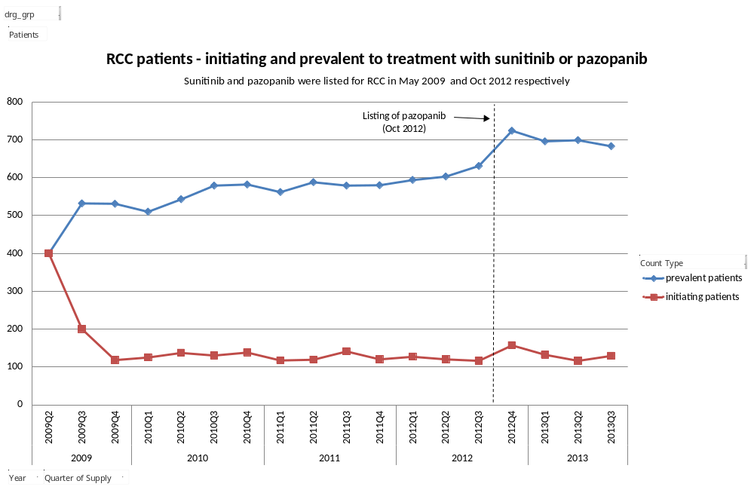
Figure 1: RCC patients – initiating and prevalent to treatment with pazopanib or sunitinib
Note: Sunitinib and pazopanib were listed for RCC in May 2009 and Oct 2012 respectively.
2009Q2 only contains 2 months of data as listing occurred in May 2009
Figure 2 illustrates the number of initiating and prevalent patients supplied with either pazopanib or sunitinib. Since the PBS listing of pazopanib, the number of prevalent patients supplied with sunitinib has been decreasing. The number of patients dropped from just over 600 in quarter 3 2012 to just over 400 in quarter 3 2013. In the same period of time, the number of prevalent patients on pazopanib has steadily increased. This indicates that patients have switched from sunitinib to pazopanib.
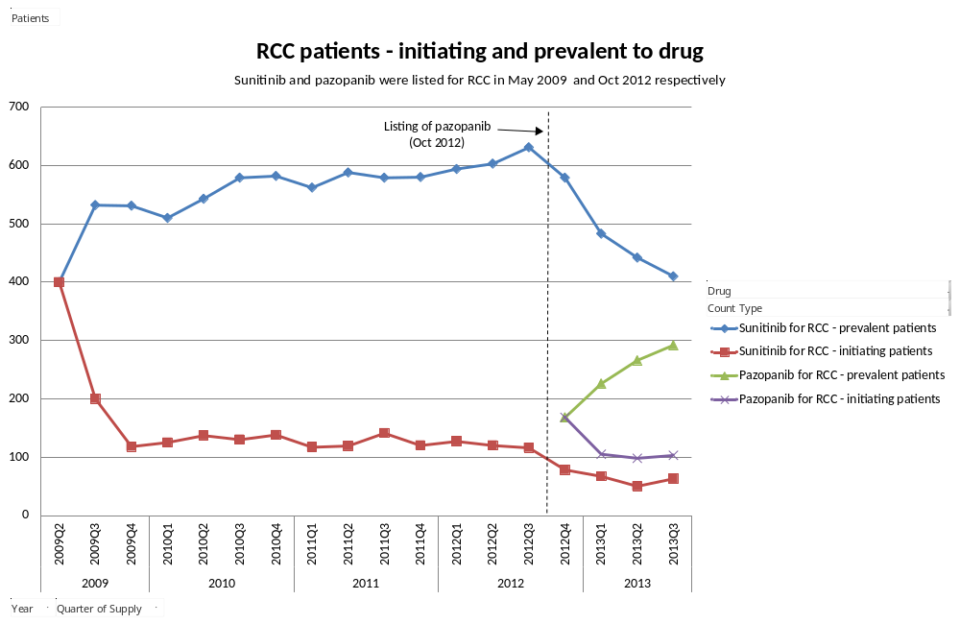
Figure 2: RCC patients – initiating and prevalent to treatment with either pazopanib or sunitinib
Note: Sunitinib and pazopanib were listed for RCC in May 2009 and Oct 2012 respectively.
2009Q2 only contains 2 months of data as listing occurred in May 2009.
The number of PBS/RPBS prescriptions of pazopanib and sunitinib supplied per quarter is illustrated in Figure 3. The data shows that the number of prescriptions per year increased at a rate of 16.7% in the 12-month period following the PBS listing of pazopanib. However, since a sunitinib prescription is meant to last 1.4 times as long as a pazopanib prescription, after taking this factor into account, adjusted prescription growth rate was 6.6%. This was similar to the market growth rate estimated in the pazopanib submission. In the year prior to PBS listing, the prescription growth rate was 1.6%.
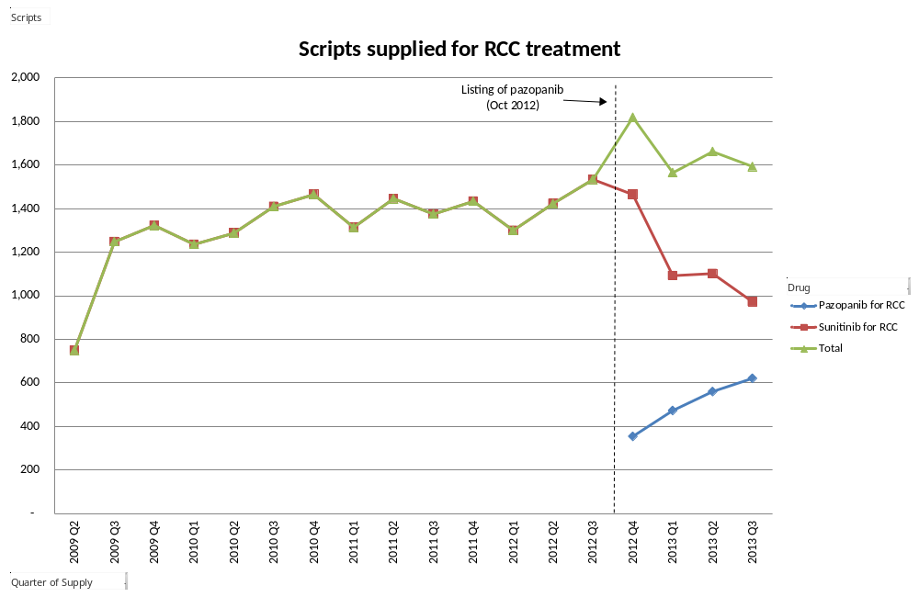
Figure 3: Prescriptions supplied for RCC treatment
Note: 2009 Q2 only contains 2 months of data as listing of sunitinib occurred in May 2009

Utilisation by relevant sub-populations/regions or patient level analysis

Age at initiation of therapy
Patient age at initiation to therapy is shown in Figure 4. The figure illustrates that initiation to therapy is most common in the 60-64 year age group for both pazopanib and sunitinib.

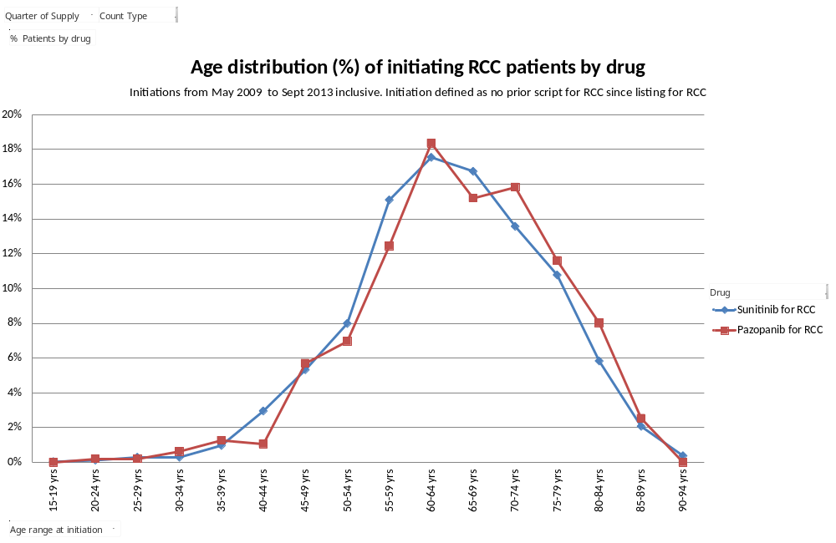
Figure 4: Age distribution (%) of initiators to drug
Note: Initiations from May 2009 to Sept 2013
Utilisation of pazopanib by prior therapy
Utilisation of pazopanib by prior therapy is illustrated in Figure 5. Over half (55.1%) of RCC treatment initiators who started therapy on pazopanib had not been treated with sunitinib in the 12-month period immediately following the PBS listing of pazopanib.
In the first quarter following the PBS listing of pazopanib, use was initially spread almost equally between initiators who had previously received sunitinib treatment and those who had not. After this the majority of initiators were naïve to PBS drug treatment for RCC.
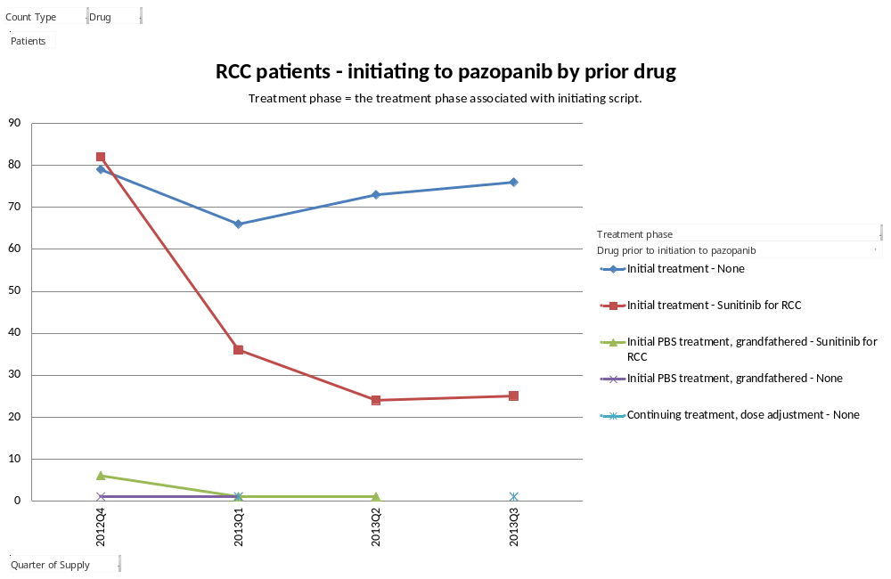
Figure 5: Initiations to pazopanib by prior drug

Length of treatment
Analysis of length of treatment showed that median length of treatment for sunitinib was 7.6 months. This was consistent with the duration of treatment in the recently published COMPARZ trial. There were insufficient data available to estimate the median length of treatment for pazopanib.

Analysis of expenditure
The cost of pazopanib and sunitinib, based on date of supply and the published price, for the 4-year period between quarter 4 2009 up to quarter 3 2013 is presented in Table 2. The actual cost to the PBS/RPBS is different to this, as special pricing arrangements apply to both medicines.
Table 2: PBS/RPBS expenditure (based on published price and date of supply) for RCC by drug
Year | Sunitinib | Pazopanib | Total
2009 Q4 to 2010 Q3 | $21,427,907 |  | $21,427,907
2010 Q4 to 2011 Q3 | $23,130,279 |  | $23,130,279
2011 Q4 to 2012 Q3 | $24,231,829 |  | $24,231,829
2012 Q4 to 2013 Q3 | $19,443,068 | $8,855,027 | $28,298,095

Analysis of actual versus predicted utilisation
Compared to what was expected (based on revised estimates agreed to by the Department of Health and the sponsor prior to listing) the analysis showed a greater number of patients were treated with sunitinib in years 2 to 4 of listing. The number of prescriptions for sunitinib were lower than expected. This suggests that patients treated with sunitinib received a lower number of prescriptions per year than originally estimated. Expenditure on sunitinib was also lower than that estimated, with a similar cost to what would have been expected based on the supply of a reduced number of prescriptions. This may indicate that supply of the various strengths of sunitinib was similar to that originally predicted.
For pazopanib, the analysis showed that prescriptions were approximately triple that expected. The cost to the PBS/RPBS for pazopanib was also higher than estimated, with the actual cost being greater than that which would have been expected from increased prescriptions alone. The higher relative increase in cost compared to prescriptions suggests the supply of more prescriptions of the higher strengths compared to what was originally predicted. Patient numbers for pazopanib were not estimated prior to listing.

Discussion
Prescriptions for pazopanib in the first year of PBS listing were significantly higher than predicted. This indicates greater than predicted uptake of pazopanib in the Stage IV clear cell variant RCC market. In year 1, the market share of pazopanib based on prescription numbers was approximately three times greater than predicted. Within the context of a market that is not expanding, this suggests that pazopanib is being used instead of sunitinib. This is consistent with the assumptions of a cost-minimisation analysis. Stronger patient preference for pazopanib would explain the greater than expected market share for pazopanib in year 1.
More patients started treatment with sunitinib for RCC than predicted prior to listing. This is probably due to an underestimate of the eligible population as several assumptions were needed to estimate patients who would meet the PBS criteria (Stage IV, unresectable, clear cell histology).
The number of prescriptions for sunitinib per patient has been lower than expected. In year 3 (i.e. the most recent year not confounded by the listing of pazopanib) it was predicted that prevalent patients would on average be supplied 7.3 prescriptions but the actual number was 5.6. The continuation rates from the clinical trials used in the estimates were not realised in practice.

DUSC actions
The DUSC considered that a subsequent analysis of the utilisation of RCC therapies should be undertaken once 24-month utilisation data is available for everolimus (another therapy for RCC, which was recommended for second-line treatment at the March 2014 meeting of the PBAC).
The DUSC recommended that the PBS listings of pazopanib and sunitinib be referred to the Post-market Review of Authority Required PBS Listings for consideration of whether a change to an Authority Required (Streamlined) PBS listing would be appropriate.
The DUSC referred the report to the PBAC for information.

Context for analysis
The DUSC is a Sub Committee of the Pharmaceutical Benefits Advisory Committee (PBAC). The DUSC assesses estimates on projected usage and financial cost of medicines.
The DUSC also analyses data on actual use of medicines, including the utilisation of PBS listed medicines, and provides advice to the PBAC on these matters. This may include outlining how the current utilisation of PBS medicines compares with the use as recommended by the PBAC.
The DUSC operates in accordance with the quality use of medicines objective of the National Medicines Policy and considers that the DUSC utilisation analyses will assist consumers and health professionals to better understand the costs, benefits and risks of medicines.
The utilisation analysis report was provided to the pharmaceutical sponsors of each drug and comments on the report were provided to DUSC prior to its consideration of the analysis.

Sponsors’ comments
GlaxoSmithKline Australia Pty Ltd: GSK regard the DUSC action to consider a subsequent analysis of RCC therapies once 24 months of utilisation data is available for everolimus, as reasonable.
Pfizer Australia Pty Ltd: The sponsor has no comment.
Disclaimer
The information provided in this report does not constitute medical advice and is not intended to take the place of professional medical advice or care. It is not intended to define what constitutes reasonable, appropriate or best care for any individual for any given health issue. The information should not be used as a substitute for the judgement and skill of a medical practitioner.

The Department of Health (DoH) has made all reasonable efforts to ensure that information provided in this report is accurate. The information provided in this report was up-to-date when it was considered by the Drug Utilisation Sub-committee of the Pharmaceutical Benefits Advisory Committee. The context for that information may have changed since publication.

To the extent provided by law, DoH makes no warranties or representations as to accuracy or completeness of information contained in this report.
To the fullest extent permitted by law, neither the DoH nor any DoH employee is liable for any liability, loss, claim, damage, expense, injury or personal injury (including death), whether direct or indirect (including consequential loss and loss of profits) and however incurred (including in tort), caused or contributed to by any person’s use or misuse of the information available from this report or contained on any third party website referred to in this report.

Australian Institute of Health and Welfare (AIHW). Australian Cancer Incidence and Mortality book for Kidney cancer. Canberra; 2014 Available from <AIHW website>.
Motzer RJ, Hutson TE, Cella D, Reeves J, Hawkins R, Guo J. et al. Pazopanib versus Sunitinib in Metastatic Renal-Cell Carcinoma. NEJM 2013;369(8):722-31. Available from <the NEJM website>.

