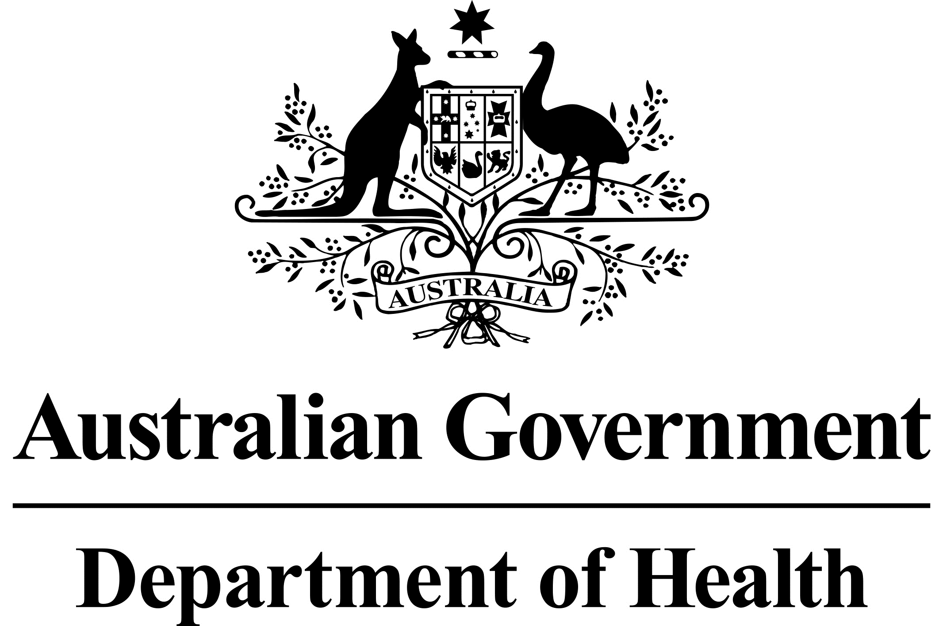

Information for Healthcare Professionals and Patients

Pharmaceutical Benefits Scheme (PBS) – Revised PBS listings for Pulmonary Arterial Hypertension Medicines

In November 2018, the Pharmaceutical Benefits Advisory Committee (PBAC) considered the Post-market Review of Pulmonary Arterial Hypertension (PAH) medicines. Consequently, the PBAC recommended changes to individual listings of PBS-subsidised PAH medicines. Further details are available from the PBAC outcome statements for the November 2018, March 2019 and November 2019 PBAC meetings.
Commencing 1 May 2020:

- PAH patients with World Health Organisation (WHO) Functional Class (FC) II symptoms will be able to access PBS-subsidised monotherapy with endothelin receptor antagonist (ERA) medicines (ambrisentan, bosentan and macitentan) or phosphodiesterase type 5 (PDE-5) inhibitor medicines (sildenafil and tadalafil). All initial PBS restriction criteria must be met.

- PAH patients will not be required to demonstrate a response to initial PBS-subsidised treatment through the provision of Right Heart Catheter (RHC) composite assessment, ECHO composite assessment and 6 Minute Walk Test (6MWT) results to access continued monotherapy.
The written Authority ‘First Continuing’ and telephone Authority ‘Subsequent Continuing’ restrictions have been replaced by one Authority Required (Telephone) ‘Continuing’ PBS restriction.

The PBS restrictions for all PAH medicines include the following additional changes:

- An updated definition of PAH
- All WHO Group 1 PAH patient subtypes can access PBS-subsidised PAH medicines
- Patients must be assessed by a physician with expertise in the management of PAH
- Applications for exemptions from right heart catheterisation for diagnosis and access to initial PBS subsidised therapy require reconfirmation from a second expert cardiologist or PAH physician
- The trial of vasodilator treatment has been removed from the initial restrictions
Refer to the Schedule of Pharmaceutical Benefits, available online, in PDF and in prescribing software, for detailed information on the PBS prescribing restrictions.

What does this change mean for prescribers?
Effective 1 May 2020, a summary of patient access to PBS-subsidised PAH medicine monotherapy by WHO FC is shown in the table below.
PBS listed PAH medicines by WHO Functional Class
PAH medicines (all forms, strengths, listed brands) | Medicine Class |  | PAH Symptoms
 |  | WHO FC II | WHO FC III | WHO FC IV
Bosentan | ERA
Ambrisentan
Macitentan
Sildenafil | PDE-5i |  |  | ×
Tadalafil |  |  |  | ×
Iloprost | Prostanoid | × | Second line treatment, except for first line treatment for drug and toxin induced PAH
Epoprostenol |  | x | Second line treatment only
Riociguat | sGC stimulator | ×
ERA: endothelin receptor antagonist, PDE-5i: phosphodiesterase 5 inhibitor, sGC stimulator: soluble guanylate cyclase stimulator, WHO FC: World Health Organization Functional Class

Effective 1 May 2020, a summary of restriction phases for all PBS subsidised PAH medicines (MONOTHERAPY) is shown in the table below.

Treatment Phase/  Restriction | Level of Authority | Test Requirements | Supporting Documentation
Initial 1  (new patients) | Written | - Right Heart Catheterisation (RHC)  - Echocardiogram  - Six Minute Walk Test  OR  - preferred combination  Exemptions from the RHC require reconfirmation from a second expert cardiologist or PAH physician | - completed authority prescription form; and  - a completed PAH PBS Authority Application - Supporting Information form
Initial 2  (change) | Telephone  /Written | Nil | - completed authority prescription form
Continuing treatment | Telephone /Written | Nil | - completed authority prescription form
Bosentan 62.5mg only:  Cessation of treatment  (all patients) | Telephone /Written | Nil | - completed authority prescription form

Prescribing information (including Authority Application forms and other relevant documentation as applicable) is available on the Services Australia website.
For written Authority applications,
- upload through HPOS
- post to:
Services Australia
Complex Drugs Programs
Reply Paid 9826
HOBART TAS 7001
- contact Services Australia on 1800 700 270 Monday to Friday, 8 am to 5 pm AEST
For more information about the prescribing, dispensing or claiming of PBS drugs, please call Services Australia on 132290 or visit the Services Australia website or the PBS website.

General questions about the PBS should be directed to the PBS general enquiry line on 1800 020 613 or email to pbs@health.gov.au.

What does this change mean for pharmacists?
There are no changes to the PBS item codes for these medicines.

Prescriptions written prior to 1 May 2020 will be valid for the lifetime of the prescription.

From 1 May 2020, the initial Authority application for these medicines remains a written Authority. The written Authority ‘First Continuing’ and telephone Authority ‘Subsequent Continuing’ restrictions have been replaced by one Authority Required (Telephone) ‘Continuing’ PBS restriction.

Pharmacists are required to ensure that prescriptions have a valid Authority approval prior to dispensing. If a pharmacist is presented with an authority PBS prescription and is not sure if it has been approved, he or she should contact Services Australia. Please note that Services Australia will not provide clinical information.

