6.09 OBINUTUZUMAB,
Solution for I.V. infusion 1000 mg in 40 mL,
Gazyva®,
Roche Products Pty Ltd.
- Purpose of submission
  - The Category 2 submission requested Section 100 (Highly Specialised Drugs Program) Authority Required (telephone/online) listing of obinutuzumab for the treatment of patients with a confirmed diagnosis of active class III or IV lupus nephritis with or without class V who are receiving standard therapy with mycophenolate mofetil (MMF) and corticosteroids.
  - Listing was requested on the basis of cost-utility analysis versus standard of care (SOC). Table 1 summarises the components of the overall clinical claim addressed by the submission.
Table 1: Key components of the clinical issue addressed by the submission
Component | Description
Population | Patients with active class III/IV ± V LN as per the ISN/RPS classification of LN
Intervention | Obinutuzumab plus standard therapy (glucocorticoids and MMF)
Comparator | Standard therapy (glucocorticoids and MMF)
Outcomes | - Complete renal response at Week 76  - Complete renal response with successful prednisone taper at Week 76  - Proteinuria response at Week 76  - Mean change in eGFR from baseline to Week 76  - Death or renal-related events through Week 76  - Overall renal response at Week 50  - Safety
Clinical claim | In patients with active class III/IV ± V LN, treatment with obinutuzumab plus standard therapy (glucocorticoids and MMF) is superior in effectiveness and inferior but manageable in safety compared with standard therapy alone.
Source: Table 1.1, p3 of the submission.
eGFR=estimated glomerular filtration rate; ISN/RPS=International Society of Nephrology/Renal Pathology Society; LN=lupus nephritis; MMF=mycophenolate mofetil;
- Background

Registration status
  - The sponsor sought an assessment of obinutuzumab for lupus nephritis through the PBAC/TGA parallel process. The proposed TGA indication was: ‘the treatment of adult patients with active lupus nephritis who are receiving standard therapy’.
  - The TGA Delegate’s Overview was received on 6 January 2026. The Delegate’s Overview noted (pp26-27) that results from REGENCY and NOBILITY showed a modest effect when obinutuzumab is used in combination with MMF and corticosteroid in adult patients with lupus nephritis class III/IV with and without class V and considered the benefit/risk profile for obinutuzumab to be positive for some patients. However, the Delegate considered that the optimal dosing/ need for further dosing (after week 52) of obinutuzumab was unknown. The Delegate considered that it remained unclear if lower doses of obinutuzumab would have achieved similar results, given no dose-response relationship was explored in the trials and only a single dose (1,000 mg IV) was used in both REGENCY and NOBILITY.
  - The TGA Delegate’s Overview recommended approval (pending advice from the Advisory Committee on Medicines and completion of Product Information negotiations) with the following indication: ‘the treatment of adult patients with active Class III or IV, with or without concomitant Class V, lupus nephritis (LN) who are receiving standard therapy.’
  - The Minutes of the TGA’s Advisory Committee on Medicines (ACM) were provided in February 2026. The ACM Minutes noted the absence of data following week 52 of treatment and that some patients continued to improve up until week 52, and thus the ACM advised that treatment should be continued for a total of 52 weeks (doses on day 1, weeks 2, 24, 26, (50), and 52) with re-evaluation of response at week 72. The ACM further advised monitoring of renal function tests, serology panels, urine microscopy and protein studies be completed routinely throughout the course of treatment. The ACM agreed to include a statement in the Prescribing Information instructing clinicians to discontinue treatment if no renal response is observed at the re-evaluation conducted at week 72.

Previous PBAC consideration
  - The PBAC had not previously considered obinutuzumab for the treatment of lupus nephritis. Obinutuzumab is currently listed on the PBS for the treatment of chronic lymphocytic leukaemia (CLL), small lymphocytic lymphoma (SLL) and follicular lymphoma (FL).
  - If recommended, obinutuzumab would be the first biologic treatment available on the PBS for lupus nephritis. Currently, belimumab is the only biologic therapy TGA-registered for active lupus nephritis in adult patients on standard therapy, but it is not PBS listed. Belimumab was considered by the PBAC for systemic lupus erythematosus (SLE) in November 2019 and July 2020 but was not recommended on both occasions. Anifrolumab was recommended by the PBAC for SLE in March 2024 (listed July 2024), but it is not TGA-registered for the treatment of lupus nephritis. While rituximab is not TGA-registered for lupus nephritis, it has an unrestricted PBS listing.
For more detail on PBAC’s view, see section 7 PBAC outcome.
- Requested listing
MEDICINAL PRODUCT  medicinal product pack | Dispensed Price for Max. Qty | Max. qty packs | Max. qty units | №.of  Rpts | Available brands
Obinutuzumab
Initial treatment  1000 mg / 40 mL vial, solution for IV infusion | $redacted content (public)  $redacted content (private) | 1 | 1 | 4 | GAZYVA®
Continuing treatment  1000 mg / 40 mL vial, solution for IV infusion | $redacted content (public)  $redacted content (private) | 1 | 1 | 1 | GAZYVA®
Category / Program: Section 100 – Highly Specialised Drugs Program
Prescriber type: Dental Medical Practitioners Nurse practitioners Optometrists
Restriction type: Authority Required (telephone/online PBS Authorities system)
Indication: Lupus nephritis
Treatment Phase: Initial treatment
Clinical criteria:
Patient must have a confirmed diagnosis of active class III or IV lupus nephritis with or without class V disease as per the International Society of Nephrology (ISN)/Renal Pathology Society (RPS) classification of lupus nephritis;
AND
Clinical criteria:
Patient must not have severe renal impairment, defined by an estimated glomerular filtration rate (eGFR) less than 30 mL/min per 1.73 m2 of body surface area, or end stage kidney disease requiring dialysis or renal transplantation;
AND
Clinical criteria:
Patient must have a urinary protein-to-creatinine ratio (UPCR) of at least 113 mg/mmol;
AND
Clinical criteria:
Treatment must be administered with mycophenolate and corticosteroids unless contraindicated.
Treatment criteria:
Patient must be treated by a specialist physician experienced in the management of this condition.
Treatment Phase: Continuing treatment
Clinical criteria:
Patient must have previously been issued with an authority prescription for this drug for this condition;
AND
Clinical criteria:
Patient must not have new end-stage kidney disease or need for chronic dialysis or renal transplantation;
AND
Clinical criteria:
Patient must not have clinically significant, sustained worsening in urinary protein-to-creatinine ratio (UPCR) and/or estimated glomerular filtration rate (eGFR) that leads the specialist physician to conclude that the patient is no longer responding to obinutuzumab.
Treatment Phase: Transitioning from non-PBS to PBS-subsidised supply – ‘Grandfather’ arrangements
Clinical criteria:
Patient must have received non-PBS-subsidised treatment with this drug for this PBS indication prior to [listing date];
AND
Clinical criteria:
Patient must not have new end-stage kidney disease or need for chronic dialysis or renal transplantation;
AND
Clinical criteria:
Patient must not have clinically significant, sustained worsening in urinary protein-to-creatinine ratio (UPCR) and/or estimated glomerular filtration rate (eGFR) that leads the specialist physician to conclude that the patient is no longer responding to obinutuzumab
Source: Tables 1.7 and 1.8, pp23-24, Tables 1.9, 1.10 and 1.11, pp25-27 of the submission.
  - Each dispensed pack containing a single-dose vial would provide for one infusion. The requested maximum quantities for initial treatment of 1 x 1000 mg vial plus four repeats were sufficient to provide 76 weeks of treatment. For continuing treatment, the requested maximum quantities of 1 x 1000 mg vial plus one repeat would allow for two doses of obinutuzumab treatment per year. Refer to paragraph 7.4.
  - The evaluation considered that it was unclear what the optimal number of obinutuzumab doses should be, particularly whether an additional script at Week 52 (i.e., the fifth script) is necessary. The Sub-Committees agreed that there was lack of clarity on the optimal number of obinutuzumab doses. Clinical data from the NOBILITY trial suggest that patients who stopped treatment at Week 26 (four-dose regimen) achieved better renal response at one year post-treatment (Week 76) compared to those who received additional treatment at Week 50-52 (five and six-dose regimens) in the REGENCY trial (TGA CER). The Pre-Sub-Committee Response (PSCR) stated that the 5 dose (2-2-1) regimen rather than the 6 dose (2-2-2) regimen had been submitted for TGA approval and recommended by the Delegate. The PSCR also suggested that patients in REGENCY who received the additional dose of obinutuzumab at Week 52 with 6 monthly maintenance dosing continued to show improvement in CRR, based on unpublished masked and open-label extension data on CRR from Week 76 to Week 210 which ranged from 66.7% to 72.4%. It was noted that these analyses were exploratory, based on small patient numbers and restricted to the adequate responder population. The PBAC noted that the ACM advised that treatment should be continued for a total of 52 weeks (doses on day 1, weeks 2, 24, 26, (50), and 52) with re-evaluation of response at week 72.
  - The submission requested a grandfathering restriction for eligible patients currently receiving obinutuzumab through a compassionate access program for active lupus nephritis, as well as those enrolled in a formal patient access program planned to commence following TGA approval. Details about patients in the compassionate access program were not provided; however, the submission indicated that eligibility for the patient access program aligns with the eligibility criteria of REGENCY and the proposed initial PBS restriction. The number of patients in these programs had not been quantified. The submission’s financial estimates assumed that these patients would be included in the prevalent population.
  - The proposed wording in the requested restriction was based on the key eligibility criteria of REGENCY and feedback from the sponsor-commissioned clinical advisors (Advisory Board Minutes 2025), comprising nephrologists and rheumatologists from Australia. The Sub-Committees noted that the proposed wording in the requested restriction was consistent with the REGENCY trial. The requested PBS restriction criteria permit use of obinutuzumab in patients with a confirmed diagnosis of active class III/IV ± V lupus nephritis according to the International Society of Nephrology/Renal Pathology Society (ISN/RPS) classification. In the requested restriction, patients must not have severe renal impairment, defined as estimated glomerular filtration rate (eGFR) <30mL/min per 1.73 m² of body surface area, or end stage kidney disease (ESKD) requiring dialysis or kidney transplantation, and urine protein-to-creatinine ratio (UPCR) ≥113 mg/mmol (or ≥1 g/g equivalent using American standard unit measurement). Patients must be receiving concomitant treatment with MMF and corticosteroid unless contraindicated. The Sub-Committees considered that the patient population for treatment with obinutuzumab was clearly defined. Refer to paragraph 7.4.
  - The requested restriction was silent on age. However, in the modelled economic evaluation and financial estimates the submission assumed that only adult patients would access treatment. The proposed TGA indication was limited to adult patients, and the REGENCY trial enrolled only adults (aged 18-75 years). The Sub-Committees noted that this meant that patients aged <18 years could be treated, for which there are no evidence. The PBAC considered that the restriction should be age agnostic, as proposed by the submission.
  - The REGENCY trial enrolled patients with class III/IV ± V lupus nephritis based on ISN/RPS 2003, however, based on clinical feedback, the wording of the requested restriction allows patients with a confirmed diagnosis of active lupus nephritis classified using any version of ISN/RPS classification to initiate obinutuzumab treatment.
  - In the requested listing, for continuing treatment, patients must not have new ESKD, need for chronic dialysis or renal transplantation and must not have clinically significant, sustained worsening in UPCR and/or eGFR that leads the specialist physician to conclude that the patient is no longer responding to obinutuzumab, based on the REGENCY trial definition of treatment failure. In REGENCY, treatment failure included the use of rescue therapy (such as cyclophosphamide (CYC), biologics with anti-CD20 agents including rituximab, ocrelizumab and ofatumumab, calcineurin inhibitor (CNI) or other biologics for lupus nephritis), except corticosteroid-only rescue. Treatment failure due to clinically significant, sustained worsening in UPCR and/or eGFR was from Week 24 onwards. The Sub-Committees noted that while an aim of treatment is to reduce UPCR, UPCR is just one measure of response and can remain elevated due to chronic damage despite other objective measures of remission. Therefore, the Sub-Committees considered that it was reasonable not to specify a fixed UCPR percentage reduction in the restriction text for continuing treatment.
  - The submission indicated that a kidney biopsy (MBS item 36561) is used as diagnostic confirmation of lupus nephritis and would be part of routine assessment for patients with SLE and signs of kidney involvement. Routine monitoring also includes blood tests and urinalysis to assess treatment response and disease progression. In the REGENCY trial, complete renal response (CRR) was assessed at Week 76 and then every six months. Optimal follow-up intervals for lupus nephritis are not well defined and vary by treatment phase, therapy intensity, clinical response, and comorbidities. Clinical guidelines noted that patients with active disease should have blood serum and urine protein assessed at every clinic visit (initially every 1–4 weeks), with subsequent frequency based on response and complications. Patients in sustained remission should be monitored every 3–6 months, while those without CRR are monitored at least every three months (APLAR 2025, ACR 2024).
  - The requested PBS listing for continuing treatment did not specify the criteria for clinical response and enabled patients to continue treatment as long as they do not have new ESKD, need for chronic dialysis or renal transplantation and do not have clinically significant, sustained worsening in UPCR and/or eGFR that specialist physicians determined as treatment failure. Refer to paragraph 7.4. There is currently no consensus definition of CRR; however, the key components of response are improvement in proteinuria and stabilisation or improvement in kidney function. The definitions used differed between REGENCY and NOBILITY as outlined in paragraphs 6.17 and 6.18, with the key REGENCY trial defining CRR as achieving UPCR <0.5 g/g, eGFR ≥85% of baseline, and no intercurrent events (i.e. rescue therapy, treatment failure, death or early study withdrawal). Treatment failure was defined as ESKD, initiation of long-term dialysis or renal transplantation, receipt of rescue therapy (except for glucocorticoid-only rescue), or clinically significant and sustained worsening of UPCR or eGFR beyond Week 24 that led the investigator to conclude that the assigned treatment had failed.
  - The Sub-Committees noted that the PSCR supported retaining the generic reference to ‘specialist physician’ in the treatment criteria because the multidisciplinary approach to the management of lupus nephritis requires the combined expertise of nephrologists and rheumatologists and may include haematologists or immunologists. The Sub-Committees considered that, while immunologists may also be involved in the management of lupus nephritis, the role of haematologists in managing this condition was unclear although they likely have experience with obinutuzumab for other indications (i.e. CLL and lymphoma). The Sub-Committees considered that overall, the majority of patients with lupus nephritis are likely to be treated by both nephrologists and rheumatologists. The PBAC did not support specifying particular specialist types (e.g. nephrologist or rheumatologist only), to allow flexibility in clinical practice and access, especially in rural and regional settings.
  - The Sub-Committees noted that the PSCR clarified that while clinical practice guidelines have suggested that following renal response, treatment should continue for at least 3 years, the most recent update from the European Alliance of Associations for Rheumatology (EULAR) stated that courses of treatment with obinutuzumab longer than the maximum of 1 year used in the REGENCY trial awaited further evaluation.
For more detail on PBAC’s view, see section 7 PBAC outcome.
- Population and disease
  - SLE is a chronic autoimmune disease characterised by autoantibody formation and immune complex deposition, leading to inflammation and end-organ damage. Lupus nephritis is the most common organ-threatening manifestation of SLE, developing in up to 40% of patients with SLE, often within five years of SLE diagnosis. The pathogenesis of lupus nephritis is driven by the deposition of immune complexes in the glomeruli and the tubulointerstitium of the kidney, leading to inflammation and irreversible scarring (fibrosis). The clinical signs and symptoms of lupus nephritis often overlap with those of SLE, and its presentation varies widely between individuals. Common symptoms include systemic features such as arthritis, fever, fatigue, rash, hair loss, oral or nasal ulcers, swollen glands, swelling in the legs or around the eyes, and abdominal pain.
  - The natural history of lupus nephritis features a relapsing-remitting disease course characterised by cycles of inflammatory renal flares, which are measurable increases in kidney disease activity (i.e. worsening kidney function), marked by increases in proteinuria, haematuria, urine sediment and/or decreasing eGFR. Cumulative damage from repeated renal flares is the main mechanism driving disease progression to chronic kidney disease (CKD) and/or ESKD. The frequency and duration of renal flares are associated with increased risk of ESKD and mortality. Treatment advances for lupus nephritis have improved renal function and overall survival, with 10-year survival rate of approximately 86% (Wang 2018). Lupus nephritis is most commonly diagnosed in individuals between 15 and 45 years old. It predominantly affects women and is more prevalent among individuals of African, Asian or Hispanic ethnic descent.
  - At the initial diagnosis of SLE, most patients will have clinical evidence of kidney disease, and patients with SLE undergo routine monitoring for signs and symptoms of the development or progression of lupus nephritis. Assessments for lupus nephritis include blood tests and urinalysis. Blood tests measure serum creatinine to determine eGFR. Urinalysis assesses protein (proteinuria), red blood cells (haematuria) and cellular debris (urinary sediment) in the urine. The UPCR is used to detect proteinuria by quantifying daily protein excretion.
  - The gold standard for diagnosing lupus nephritis is histologic confirmation by percutaneous kidney biopsy. The classification of lupus nephritis is based on the ISN/RPS classification, which categorises the disease into six histological classes according to the type and severity of glomerular morphological changes identified on kidney biopsy. ISN/RPS classification for lupus nephritis was developed in 2003 to standardise diagnosis, and revisions were proposed in 2018 to include an increased emphasis on the National Institutes of Health activity index and chronicity index. Clinical guidelines generally recommend assessment of kidney biopsy according to ISN/PRS 2003 classification and/or its revisions in the diagnosis and guidance of treatment. The ISN/PRS 2018 revised classification has not been officially approved by the institutional entities that developed the initial 2003 classification. Several validation studies have indicated that the revised version has a stronger correlation (in terms of chronicity index) to kidney outcomes of lupus nephritis compared to the original version; however, further evidence-based evaluations are required (Choi 2023).
  - Classes I and II are considered mild forms of renal involvement with a good prognosis. Class III and IV are known as active lupus nephritis and have a worse prognosis, requiring prompt treatment. Class III (focal lupus nephritis) and class IV (diffuse lupus nephritis) often present with proteinuria, haematuria and impaired kidney function. Class IV is the most prevalent and most severe form of lupus nephritis. It is associated with the highest risk of ESKD (Gasparotto 2020). Class V (membranous lupus nephritis) is characterised by thickened glomerular capillary walls and it may occur in isolation or in combination with class III/IV. It presents with signs of nephrotic syndrome and has a relatively low rate of progression to ESKD but is accompanied by a high rate of complications. Class VI (advanced sclerosing lupus nephritis) represents progressive loss of renal function (i.e. ESKD), resulting from any class of active lupus nephritis and implies an impending need for a kidney transplant.
  - The short-term treatment goals include rapid attainment of remission and minimisation of treatment-related toxicity. Long-term goals include preventing flares, preventing CKD progression, preserving kidney function, and reducing morbidity and mortality. The choice of the treatment mainly depends on the histological class, activity and chronicity indexes (Parodis 2025, Gasparotto 2020).
  - The standard therapy for lupus nephritis for over 40 years has been glucocorticoids and immunosuppressants (i.e. dual therapy) to control intrarenal inflammation and attenuate autoimmune activity. However, recent updates to clinical guidelines include initial treatment with combination biologic or small molecule agent in a triple therapy regimen for patients with active lupus nephritis class III/IV ± V. This was based on the approval of belimumab (BAF inhibitor) and voclosporin (CNI) by the United States Food and Drug Administration (FDA) and the European Medicines Agency (EMA) as add-on immunosuppressives to SOC for the treatment of lupus nephritis.
  - In Australia, voclosporin is not TGA registered. While belimumab is TGA registered for SLE and active lupus nephritis, it is not listed on the PBS. Belimumab is however available through private prescription and through several hospitals in Australia. A study of longitudinal data from patients with SLE in the Australian Lupus Registry and Biobank (ALRB) between June 2010-2021 identified 10 patients who received belimumab; three for lupus nephritis class III/IV/V (Malaweera 2023). Patients with refractory disease may also be treated with rituximab (off-label), despite trial results demonstrating no benefit in patients with class III/IV ± V lupus nephritis (Rossi 2025, Rovin 2012). A retrospective study by Nakagawa 2025, using ALRB data, found that 3% and 7% of patients with class III/IV ± V lupus nephritis initiated treatment with rituximab monotherapy and rituximab combination with immunosuppressants, respectively.
  - Anifrolumab is the only biologic agent available on the PBS for SLE, but its market authorisation specifically excludes use in lupus nephritis. Previous studies (TULIP-LN, NCT02547922) of anifrolumab in active lupus nephritis did not demonstrate a treatment effect across the trial endpoints, including CRR. Under the requested PBS restriction, it was unclear whether patients who initiate combination therapy with anifrolumab for the treatment of SLE without lupus nephritis would then discontinue anifrolumab and switch to obinutuzumab or add-on obinutuzumab to SOC when the patient develops lupus nephritis. (The PBAC advised that combination use of anifrolumab and obinutuzumab should be prohibited in the PBS restrictions due to lack of clinical evidence especially of safety.) There is also limited evidence on the profile of patients with lupus nephritis who may need more than SOC (Gatto 2025, Rovin 2024). Multi-agent regimens may offer better renal remission rates than dual therapy, but the choice of treatment may depend on cost, access and patient characteristics (Parodis 2025).
  - There is a gap between the international guidelines and current practice in Australia, as no biologics or small molecule agents are specifically listed on the PBS for lupus nephritis (though rituximab is an unrestricted listing). Australian clinicians on the sponsor’s advisory board indicated that the position of obinutuzumab in practice is likely aligned with belimumab for lupus nephritis on the international treatment algorithm. The clinicians further noted that the suitability of triple therapy for all patients remains unclear. While there is a need for upfront triple therapy as an initial course of treatment in at least some patients with lupus nephritis, there is also general consensus for initial treatment with conventional dual therapy in many patients, with add-on obinutuzumab treatment for patients who do not respond or have worsening disease on dual therapy (Advisory Board Minutes 2025).
  - Obinutuzumab is a recombinant monoclonal humanised, glyco-engineered type II anti-CD20 antibody of IgG1 isotype. Obinutuzumab binds to CD20 protein complexes on the surface of B cells, utilising three main mechanisms to elicit B cell death: (i) internal cell-killing mechanisms such as classical apoptosis or direct cell death; (ii) complement-dependent cytotoxicity (CDC); and (iii) intercellular interactions such as antibody dependent cellular cytotoxicity (ADCC) and antibody dependent cellular phagocytosis (ADCP). Obinutuzumab anatomical therapeutic chemical classification (ATC) is L01FA03.
  - The recommended dosage regimen is 1000 mg IV on Day 1 and Weeks 2, 24, 26, and 52 (i.e. five administrations in the first year, also called 2:2:1 regimen) and every 6 months thereafter. The draft product information (PI) states that obinutuzumab IV should be administered through a dedicated line in an environment where full resuscitation facilities are available and under the supervision of an experienced physician. Premedication with corticosteroid IV, oral analgesics/antipyretic and anti-histamine drug to reduce risk of infusion-related reactions (IRRs) must be completed 30‒60 minutes before administration of obinutuzumab IV.
  - The Sub-Committees noted that for maintenance treatment with obinutuzumab, while guidelines recommend stopping treatment after 3 years if there is no response, there are no longer term data to support this. The ACM advised that treatment should be continued for a total of 52 weeks with re-evaluation of response at week 72.
For more detail on PBAC’s view, see section 7 PBAC outcome.
- Comparator
  - The submission nominated SOC alone as the main comparator for obinutuzumab plus SOC in patients with class III/IV ± V lupus nephritis, comprising conventional dual therapy with: i) a glucocorticoid and ii) MMF (an immunosuppressant). The evaluation considered and the Sub-Committees agreed that the nomination of SOC with conventional dual therapy was reasonable; however, in practice, SOC includes immunosuppressant monotherapy or dual therapy with glucocorticoid and immunosuppressant.
  - The main arguments in support of this nomination were that SOC with conventional dual therapy were based on available treatments in Australia and feedback from Australian clinicians (Advisory Board Minutes 2025). Furthermore, the specific nomination of MMF was because it is the most commonly used immunosuppressant for lupus nephritis and is less toxic than cyclophosphamide. In REGENCY, all patients received SOC with oral prednisone plus MMF.
  - There were no near-market comparators identified in the submission. The submission did not consider belimumab a near-market comparator, given that it was not recommended by the PBAC, and that the sponsor of belimumab stated it will not resubmit to the PBAC for this subset of patients living with severe SLE (paragraph 9, belimumab Public Summary Document [PSD] July 2020 PBAC meeting).
  - The PBAC considered that the submission should have explored rituximab as a potential comparator. While the PBAC noted rituximab failed to meet its primary endpoint for the treatment of lupus nephritis in the LUNAR randomised controlled trial (Rovin 2012, refer to paragraph 4.8), real world registry data were available (e.g., BILAG-BR) that showed improvements in renal response in patients with treatment‑resistant lupus nephritis, with some international guidelines positioning rituximab as an option for patients who have not responded to conventional therapy e.g. those with refractory lupus nephritis. The PBAC has not specifically evaluated rituximab for lupus nephritis and noted that its usage would be hard to ascertain as rituximab now has an unrestricted listing.
For more detail on PBAC’s view, see section 7 PBAC outcome.
- Consideration of the evidence

Sponsor hearing
  - The sponsor requested a hearing for this item. At the hearing, a nephrologist with expertise in the management of lupus nephritis outlined the clinical meaningfulness of achieving a complete renal response at Week 76, noting that early reductions in proteinuria and preservation of kidney function are associated with improved long‑term renal outcomes, including renal survival, and a reduced likelihood of progression to end‑stage kidney disease.
  - The clinician explained that renal flares represent episodes of immune‑mediated kidney injury that can result in cumulative nephron loss and irreversible kidney damage. He outlined that reducing the frequency of renal flares was therefore important in limiting long‑term disease progression and the future need for intensive therapies such as dialysis or transplantation. The clinician also noted that treatments which reduce the need for prolonged or repeated courses of high‑dose glucocorticoids may lessen treatment‑related toxicity.
  - In addition to renal outcomes, the clinician highlighted the broader impacts of lupus nephritis on patients, including the psychosocial burden of chronic disease, the effects of glucocorticoid-related toxicity on wellbeing, and the consequences for quality of life. The clinician considered that therapies that improve disease control while allowing reduction in glucocorticoid exposure may provide meaningful benefits for patients beyond measured renal endpoints.

Consumer inputs
  - The PBAC noted and welcomed the input from health care professionals (7) and organisations (7) via the Office of Health Technology Assessment Consultation Hub. The four consumer organisations which provided input were Kidney Health Australia, Dragon Claw Charity, Global Healthy Living Foundation and Creaky Joints Australia, and Arthritis Australia. Submissions emphasised the limitations of current standard of care, particularly incomplete responses to steroids and mycophenolate and the cumulative harms associated with prolonged corticosteroid exposure. Impacts on daily functioning, employment, continuous appointments, family life and long‑term planning (including fertility and pregnancy) were highlighted. The impacts on young women were particularly noted including the desire to maintain fertility and keep disease activity under control.
  - Consumer organisations considered obinutuzumab to represent an important additional treatment option, particularly due to higher rates of renal response when added to standard therapy, the potential to reduce disease flares, and the opportunity to taper use of corticosteroids which had significant side effects. These effects were viewed as likely to translate into meaningful quality‑of‑life improvements and reduced long‑term complications. Submissions noted that, without PBS subsidy, the cost of obinutuzumab would be prohibitive for most patients. While the input acknowledged risks of infection and infusion‑related reactions, these were generally considered comparable to existing immunosuppressive therapies. Intravenous administration and reliance on infusion services were identified as potential barriers for patients in regional and remote areas, with associated travel and accommodation costs.
  - The PBAC noted the advice received from seven healthcare professionals and 3 medical organisations (Australian Rheumatology Association, Australasian Society of Clinical Immunology and Allergy, Australia and New Zealand Society of Nephrology). Their submissions focused on unmet clinical need and alignment with contemporary, evidence‑based care. Contributors noted that current therapies result in suboptimal response rates and ongoing reliance on corticosteroids, with associated toxicity. Obinutuzumab was considered to demonstrate clinically meaningful improvements in complete renal response, proteinuria reduction and preservation of kidney function, which were viewed as likely to reduce progression to kidney failure and downstream health system costs. Reduced cumulative glucocorticoid exposure was highlighted as a key benefit with potential long‑term quality‑of‑life and safety advantages. Submissions acknowledged safety risks associated with B‑cell depletion, including infection and infusion reactions, but considered these manageable within specialist care.
  - Medical organisations supported a restricted PBS listing for biopsy‑proven active class III or IV (±V) lupus nephritis, specialist prescribing and objective continuation criteria. The PBAC noted that lupus nephritis disproportionately affects females and is more prevalent among individuals of Asian and African ethnic descent and First Nations people and that lupus nephritis is not only more prevalent in First Nations people but is also associated with a significantly higher disease burden characterised by more severe disease, increased morbidity and higher mortality rates compared to patients who are not of First Nations descent.

Clinical trials
  - The submission was based on two randomised controlled trials (RCTs) comparing obinutuzumab plus SOC (glucocorticoid and MMF) versus placebo plus SOC (REGENCY and NOBILITY) in patients with active lupus nephritis class III/IV ± V. The submission described REGENCY as the pivotal trial as it included a dosing regimen for obinutuzumab consistent with the draft PI. The NOBILITY trial provided supportive evidence as it used one less initial dose of obinutuzumab and the definition of CRR was inconsistent with the REGENCY trial, preventing pooling of the trial results. Details of the trials presented in the submission are provided in Table 2 below.
Table 2: Trials and associated reports presented in the submission
Trial ID | Protocol title/ Publication title | Publication citation
REGENCY  (NCT04221477) | CSR for REGENCY 2024. Primary Clinical Study Report – Study CA41705 (REGENCY) – A Phase III, Randomized, Double-Blind, Placebo-Controlled, Multicenter Study to Evaluate the Efficacy and Safety of Obinutuzumab in Patients with active ISN/RPS 2003 Class III or IV Lupus Nephritis. Report No. 1131275. | December 2024
REGENCY  (NCT04221477) | Furie RA, Rovin BH, Garg JP, Santiago MB, Aroca-Martínez G, Zuta Santillán AE, Alvarez D, Navarro Sandoval C, Lila AM, Tumlin JA, Saxena A, Irazoque Palazuelos F, Raghu H, Yoo B, Hassan I, Martins E, Sehgal H, Kirchner P, Ross Terres J, Omachi TA, Schindler T, Pendergraft WF 3rd, Malvar A; REGENCY Trial Investigators. Efficacy and Safety of Obinutuzumab in Active Lupus Nephritis. | New England Journal of Medicine 2025. 392(15):1471-1483
NOBILITY  (NCT02550652) | CSR for NOBILITY 2020. Primary Study WA29748WA29748, (NOBILITY) A Randomized, Double-Blind, Placebo-Controlled, Multi-Center Study to Evaluate the Safety and Efficacy of Obinutuzumab in Patients With active ISN/RPS 2003 Class III or IV Lupus Nephritis. Report No. 1094412 | January 2020
NOBILITY  (NCT02550652) | Furie RA, Aroca G, Cascino MD, Garg JP, Rovin BH, Alvarez A, Fragoso-Loyo H, Zuta-Santillan E, Schindler T, Brunetta P, Looney CM, Hassan I, Malvar A. B-cell depletion with obinutuzumab for the treatment of proliferative lupus nephritis: a randomised, double-blind, placebo-controlled trial. | Annals of Rheumatic Diseases 2022. 81(1):100-107
Source: Table 2.3, pp34-37 of the submission.
  - The submission identified a number of obinutuzumab studies, which were excluded from the analysis, including:
  - A randomised, double-blind, placebo-controlled trial (POSTERITY, NCT05039619) evaluating obinutuzumab in adolescents with active class III/IV lupus nephritis and obinutuzumab dose confirmation in paediatric (aged 5-12 years), was excluded on the basis of ‘wrong population’. While the trial is ongoing, it is potentially relevant given that the requested restriction would allow treatment in patients aged <18 years with active lupus nephritis. An interim pharmacokinetic and simulation analysis by Cosson 2025 confirmed the dosing in paediatric patients (20 mg/kg IV for patients weighing <45 kg or 1000 mg IV for patients weighing ≥45 kg on Day 1, Weeks 2, 24, 26 and 52).
  - A systematic review and meta-analysis (Izcovich 2025) of the comparative effectiveness and safety of initial treatments for active lupus nephritis, was excluded on the basis of ‘wrong comparator’. The systematic review included 40 trials (including REGENCY and NOBILITY) comparing 12 drugs (abatacept, anifrolumab, belimumab, cyclosporin, guselkumab, leflunomide, obinutuzumab, rituximab, tacrolimus, voclosporin, CYC and mycophenolic acid analogues e.g. MMF as common comparator) administered alone or in combination. No additional relevant trials of obinutuzumab were identified in the review. The results indicated that voclosporin, belimumab, or obinutuzumab combined with an immunosuppressant were the most effective initial treatments for patients with class III/IV ± V lupus nephritis, with respect to improvement in CRR and PRR. The effect of rituximab on renal response was considered highly uncertain. Overall, there was a high level of uncertainty in the analysis due to heterogeneity across trials: sample sizes (N=16 to 867), dosing regimens for the same drug, outcome definitions and duration of follow-up (6 months to two years).
  - The key features of the included trials are summarised in Table 3.
Table 3: Key features of the included evidence
Trial | N | Design/ duration | Bias | Treatment | Population | Outcome(s) | Modelled evaluation
Obinutuzumab
REGENCY | 271 | R, MC, DB, PBO 76 wks / 5 years^{ab} (+ f/up ≥12-18 mths)^{c}  15 August 2024 DCO: up to 184 wks | Low | OBI 1000 mg IV, Day 1, Wks 2, 24, 26, 50, 52^{f}  OBI 1000 mg IV, Day 1, Wks 2, 24, 26, 52^{f}  PBO^{f} | Class III/IV ± V  Aged 18-75 | 1°: CRR^{d} (Wk 76)  2°: eGFR, PRR, ORR  Other: UPCR, time to LN flare | ü
NOBILITY | 125 | R, MC, DB, PBO 52 wks (+f/up 52 wks) | Low | OBI 1000 mg IV, Day 1, Wks 2, 24, 26^{f}  PBO^{f} | Class III/IV ± V  Aged 18-75 | 1°: CRR^{e} (Wk 52)  2°: PRR, ORR | -
Source: Section 2.3, pp38-43 of the submission.
CRR=complete renal response; DB=double blind; eGFR= estimated glomerular filtration rate; LN=lupus nephritis; MC=multi-centre; OBI=obinutuzumab; OL=open label; ORR=overall renal response; PBO=placebo; PRR=partial renal response; R=randomised; RBC/hpf=red blood cells per high-power field; ULN=upper limit of normal; UPCR=urinary protein-to-creatinine ratio; wk=week; mth=month;
a The end of the study after the last patient is enrolled is 5 years, and the total length of the study is 8 years.
b Patients with an adequate treatment response at Wk 76 continued blinded infusions (OBI or PBO) every 6 months starting at Wk 80 until study unblinding. Patients with inadequate treatment response at Wk 76 or with loss of response during blinded treatment after Wk 80 can enter open-label treatment with OBI.
c Patients who discontinue blinded infusions and do not enter open-label treatment with OBI enter study follow-up. Patients are followed through Wk 76 and for at least 12 months to a maximum of 18 months from the last dose of OBI or PBO.
d In REGENCY, CRR defined as achievement of the following: UPCR < 0.5 g/g, eGFR ≥ 85% of baseline, and no occurrence of rescue therapy, treatment failure, death, or early study withdrawal.
e In NOBILITY, CRR defined as achievement of the following: UPCR < 0.5 g/g, normalization of serum creatinine (≤the ULN if baseline above ULN or ≤15% above baseline and ≤ ULN if baseline is ≤ ULN) and inactive urinary sediment (<10 RBCs/hpf and absence of red cell casts).
f All patients received MMF and corticosteroids (oral prednisone and pre-infusion methylprednisolone IV or equivalent).

  - REGENCY and NOBILITY were multicentre (no patients in Australia), randomised, double-blind and placebo-controlled trials where patients received either placebo or obinutuzumab in addition to SOC. The REGENCY trial consists of a blinded treatment period, an open-label treatment and study follow-up. Patients on obinutuzumab 1000 mg IV received one of two dosing regimens: on Day 1 and at Weeks 2, 24, 26, and 52 (i.e. 2-2-1 regimen, consistent with draft PI), or with an additional dose at Week 50 (i.e. 2-2-2 regimen). Patients with an adequate response at Week 76 without the need for intensification of therapy, or unmanageable AEs continued to receive a single blinded obinutuzumab or placebo infusion every 6 months beginning at Week 80. Patients who experienced a loss of adequate response at Week 76 or during blinded treatment after Week 80 were eligible for open-label obinutuzumab treatment. The Sub-Committees noted that a key limitation of the REGENCY trial was the lack of published long-term follow-up data (although the Sub-Committee also noted the PSCR provided some unpublished masked and open-label extension data as outlined in paragraph 3.2). In NOBILITY, patients were randomised to receive obinutuzumab or placebo at Weeks 0, 2, 24 and 26. Patients continued SOC treatment through Week 104. Across the trials, the primary outcome was CRR, which is a composite measure incorporating eGFR and UPCR (and absence of urinary RBCs in NOBILITY), assessed at Week 76 (REGENCY) or Week 52 (NOBILITY).
  - In REGENCY, descriptive analysis showed that the two obinutuzumab dose regimens compared with placebo had comparable efficacy at Week 76. As of the 15 August 2024 data cutoff (DCO), 218 (80.4%) patients remained in the study (116 (85.9%) in the obinutuzumab arm and 102 (75.0%) in the placebo arm). Of these, 116 (42.8%) patients entered the post-Week 76 blinded treatment period (67 (49.6%) in the obinutuzumab arm and 49 (36.0%) in the placebo arm.
  - Overall, the risk of bias for REGENCY and NOBILITY was considered low by the evaluation. In REGENCY, all patients randomised were included in the intention-to-treat (ITT) population. Three patients randomised to the placebo arm did not receive any study treatment and were excluded from the safety population. In NOBILITY, efficacy analyses were conducted in a modified ITT (mITT) population consisting of all randomised patients who had received at least one dose of study drug. One patient in the obinutuzumab arm did not receive treatment due to a positive pregnancy test and was excluded from the mITT. One patient randomised to the placebo arm inadvertently received obinutuzumab and was included under the obinutuzumab arm in the safety population.
  - The evaluation considered that baseline characteristics were generally balanced between treatment arms in the trials, with the exception of the NOBILITY trial, in which the obinutuzumab arm had a longer mean disease duration compared to placebo (61.7 vs 43.0 months). Across the trials, there were some differences in baseline characteristics, including fewer patients in REGENCY with class IV lupus nephritis (58.5-62.5%) compared to NOBILITY (72.6-77.8%), indicating more severe disease with worse prognosis. Further, a small proportion of patients in REGENCY (6.6-8.1%) received prior treatment for lupus nephritis with anifrolumab, belimumab and rituximab. The use of prior treatments was not reported for NOBILITY.
  - The submission proposed a minimally clinically important difference (MCID) for the proportion of patients achieving CRR at Week 52 as the absolute risk difference ≥10%, based on clinical trial data for belimumab by Furie 2020 (BLISS-LN) and for voclosporin by Rovin 2021 (AURORA-1), and long-term observational data in patients with class III/IV ± V LN. The submission also proposed a MCID for proteinuria (UPCR) as ≥50% reduction from baseline, which is used to define a partial response at 6 months and treatment targets in clinical guidelines (KDIGO 2024 and EULAR 2025). EULAR 2025 also noted that the treatment goal should be an absolute UPCR value <700 mg/g at 12 months, which is associated with good long-term outcomes.

Comparative effectiveness
  - The requested PBS criteria for initiating and continuing treatment did not specify the criteria for clinical response. Patients could continue treatment as long as they do not have new ESKD, need for chronic dialysis or renal transplantation and do not have clinically significant, sustained worsening in UPCR and/or eGFR that specialist physicians determined as treatment failure. The EMA guideline 2015 recommends that clinical trials of lupus nephritis include as primary or secondary outcomes CRR demonstrated by improvement in eGFR and reduction in protein excretion and findings in active urinary sediment, such as normalisation/return to baseline of eGFR or proteinuria <0.5 g/24h. There is currently no consensus definition of CRR; however, the key components of response are improvement in proteinuria and stabilisation or improvement in kidney function.
  - As outlined in paragraph 3.9, in REGENCY, CRR was defined as achieving UPCR <0.5 g/g, eGFR ≥85% of baseline, and no intercurrent events (i.e. rescue therapy, treatment failure, death or early study withdrawal). Treatment failure was defined as ESKD, initiation of long-term dialysis or renal transplantation, receipt of rescue therapy (except for glucocorticoid-only rescue), or clinically significant and sustained worsening of UPCR or eGFR beyond Week 24 that led the investigator to conclude that the assigned treatment had failed.
  - In NOBILITY, CRR was defined as achievement of UPCR <0.5 g/g, normal renal function (serum creatinine ≤ULN) without worsening of baseline serum creatinine by more than 15%, and inactive urinary sediment (<10 red blood cells (RBCs)/high-power field (HPF) without RBC casts). However, an additional post-hoc re-analysis was conducted by the submission for the NOBILITY efficacy data up to Week 76 using the REGENCY outcome definitions and data handling rules.
  - Table 4 presents the results of the primary and key secondary outcomes to Week 76 in REGENCY and NOBILITY. The table also presents the post-hoc re-analyses of NOBILITY efficacy data to Week 76 using REGENCY outcome definitions where available.
Table 4: Primary and key secondary outcomes to Week 76 in REGENCY and NOBILITY
 | REGENCY |  | NOBILITY |  | NOBILITY (post-hoc)^{c}
 | OBIª  N=135 | PBO  N=136 | OBI  N=63 | PBO  N=62 | OBI  N=64 | PBO  N=62
CRR (UPCR <0.5 g/g, eGFR ≥85% of baseline and no occurrence of intercurrent events^{b}), Wk 76
Responders observed, n(%) | 60 (45.8%)^{f} | 45 (33.3%)^{f} | 24 (38.1%)^{g} | 11 (17.7%)^{g} | - | -
% Responders (95%CI)^{d} | 46.4 (38.0,54.9) | 33.1 (25.2,41.0) | - | - | 50.6  (38.1, 63.2) | 28.2  (16.7, 39.7)
% Difference (95%CI)^{d} | 13.4 (2.0, 24.8) |  | 20.4 (5.0, 35.7)^{e} |  | 23.1 (6.3, 40.0)
CRR with prednisone taper (prednisone ≤7.5 mg/day), Wks 64-76
% Responders (95%CI)^{d} | 42.7  (34.32, 51.09) | 30.9  (23.12, 38.65) | - | - | 50.4  (37.9, 63.0) | 26.6  (15.2, 37.9)
% Difference (95%CI)^{d} | 11.9 (0.57, 23.2) |  | - |  | 24.6 (7.8, 41.3)
PRR (≥50% reduction in UPCR, UPCR <1, eGFR ≥85% of baseline, no occurrence of intercurrent events^{b}), Wk 76
Responders observed, n(%) | 18 (13.7%) | 15 (11.1%) | 31 (49.2%)^{h} | 18 (29%)^{h} | - | -
% Responders (95%CI)^{d} | 14.0  (8.1, 19.9) | 11.8  (6.4, 17.2) | - | - | - | -
Difference (95%CI)^{d} | 2.1 (-6.2, 10.5) |  | 20.2 (3.4, 36.9)^{e} |  | -
ORR (CRR or PRR), Wk 50 (REGENCY) Wk 52 (NOBILITY)
Responders observed, n(%) | 68 (54.8%) | 56 (47.1%) | 35 (55.6%) | 22 (35.5%) | - | -
% Responders (95%CI)^{d} | 59.1  (50.8, 67.4) | 50.7  (42.2, 59.2) | - | - | 65.6  (54.0, 77.3) | 48.4  (36.0, 60.8)
% Difference (95%CI)^{d} | 8.4 (-3.4, 20.1) |  | 20.1 (3.0, 37.2)^{e} |  | 17.8 (1.2, 34.5)
Proteinuric response (UPCR <0.8 g/g and no intercurrent events^{b}), Wk 76
% Responders (95%CI)^{d} | 55.5  (47.1, 64.0) | 41.9  (33.6, 50.2) | - | - | 60.9  (48.6, 73.2) | 46.9  (34.3, 59.6)
% Difference (95%CI)^{d} | 13.7 (2.0, 25.4) |  | - |  | 14.5 (-2.8, 31.8)
Mean change from baseline in eGFR to Wk 76
Adjusted mean (SE) | 2.3 (2.7) | -1.5 (2.7) | - | - | 6.50 (5.00) | -3.58 (5.30)
Difference (95%CI)^{d} | 3.8 (-1.8, 9.5) |  | - |  | 10.1 (0.79, 19.4)
Death or renal related events (death, treatment failure, worsening proteinuria, worsening eGFR) to Wk 76
%Patients with events (95%CI)^{d} | 18.9  (12.1, 25.6) | 35.6  (27.5, 43.8) | - | - | 24.5  (13.7, 35.4) | 33.5  (21.5, 45.4)
% Difference (95%CI)^{d} | -16.8 (-27.4, -6.2) |  | - |  | -8.4 (-24.3, 7.5)
Source: Table 2.20, p61, tables 2.23 to 2.27, pp65-66 of the submission, PRR status by week, commercial in confidence.pdf, Table 5, p56 of Clinical Overview.pdf, Table 8, p21 of Delegate’s overview (obinutuzumab) 5 Jan 2026.
Bold text in the % Difference row indicates a statistically significant result.
CMH=Cochrane-Mantel Haenzel; CRR=complete renal response; eGFR=estimated glomerular filtration rate; LN=lupus nephritis; NE=not estimable; OBI=obinutuzumab; ORR=overall response rate; PBO=placebo; RBC/hpf=red blood cells per high-power field; PRR=partial renal response; ULN=upper limit of normal; UPCR=urinary protein-to-creatinine ratio; wk=week;
a Data from pooled OBI dose regimens (2-2-1 and 2-2-2).
b In REGENCY, intercurrent events included rescue therapy, treatment failure, death, or early study withdrawal.
c Results from the post-hoc re-analysed NOBILITY data (using REGENCY outcomes definitions and data handling rules) were descriptive and nominal p-values was exploratory.
d The main analytical approach included multiple imputation for missing data using fully conditional specification predicted mean matching method. CMH test with stratification factors race and region was performed. The adjusted difference (i.e. common risk difference) and its CI based on stratified Newcombe CI calculated using Mantel-Haenszel weights.
e Imputation rules were applied for missing data. P-value assessed using CMH test.
f The submission used the observed CRR response data from REGENCY in the modelled economic evaluation.
g In NOBILITY, CRR defined as UPCR <0.5, normal renal function (serum creatinine ≤ULN) without worsening of baseline serum creatinine by more than 15%, and inactive urinary sediment (<10 red blood cells (RBCs)/high-power field (HPF) without RBC casts).
h In NOBILITY, PRR defined as ≥50% reduction in UPCR from baseline to a value <1 (to <3 if baseline UPCR was ≥3), serum creatinine not increased >15% from baseline and urinary RBCs/hpf <10 or ≤50% increase over the baseline value.
  - Figure 1 presents the Kaplan-Meier plot of the time to event outcomes though Week 76 in REGENCY and Week 104 (NOBILITY).
Figure 1: Kaplan-Meier plot of time to event outcomes through Week 76 (REGENCY) and Week 104 (NOBILITY)

A. Time to LN flare (eGFR decrease >20%, UPCR increase and rescue therapy except corticosteroid rescue) after Wk 24
REGENCY | NOBILITY (post-hoc)ª
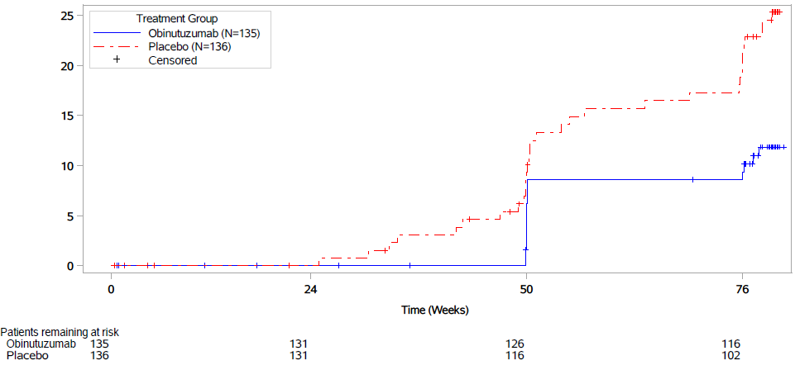 | 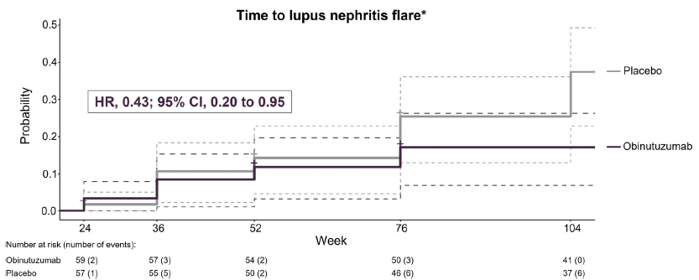
B. Time to unfavourable kidney outcomes (first of the following: treatment failure, serum creatinine doubling, or death)
REGENCY | NOBILITY (post-hoc)ª
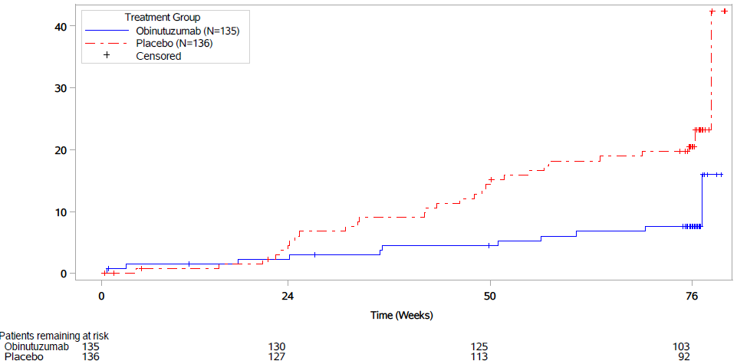 | 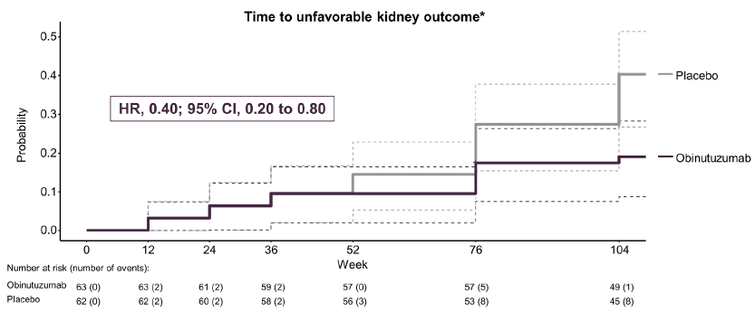
C. Time to onset of CRR (UPCR <0.5 g/g, eGFR ≥85% of baseline and no occurrence of intercurrent events^{b})
REGENCY | NOBILITY^{c}
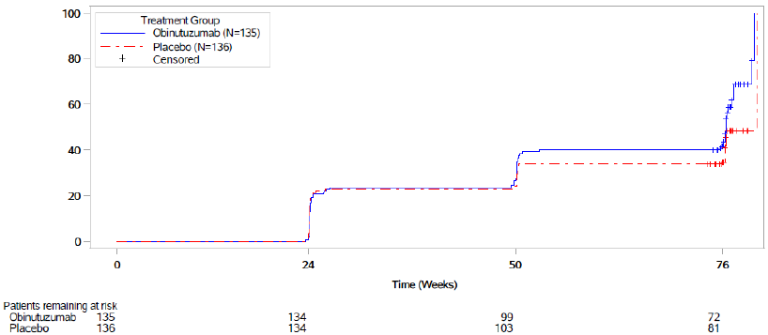 | 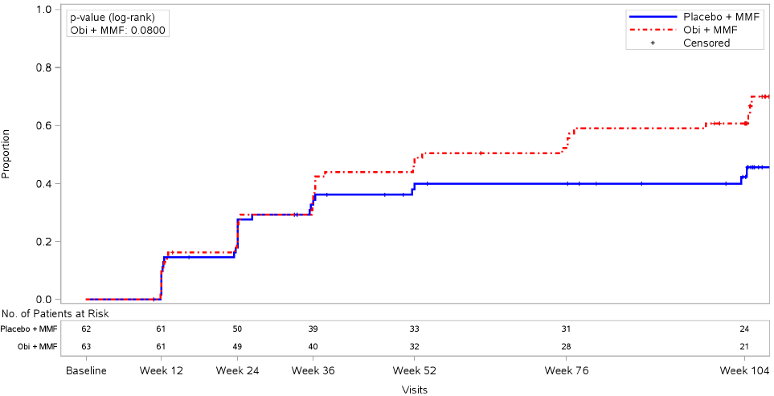
Source: g_km_TTUKO_EE_15AUG2024_41705 and g_km_TTUKO_EE_15AUG2024_41705, pp205-206 of REGENCY CSR.pdf, Figure 1 and Figure 2, Rovin 2024 (NOBILITY post-hoc analysis).
CRR=complete renal response; eGFR=estimated glomerular filtration rate; LN=lupus nephritis; UPCR=urinary protein-to-creatinine ratio; ULN=upper limit of normal; wk=week;
a Results from the post-hoc re-analysed NOBILITY data (using REGENCY outcomes definitions and data handling rules) were descriptive and nominal p-values was exploratory.
b In REGENCY, intercurrent events included rescue therapy, treatment failure, death, or early study withdrawal.
c In NOBILITY, CRR defined as UPCR <0.5, normal renal function (serum creatinine ≤ULN) without worsening of baseline serum creatinine by more than 15%, and inactive urinary sediment (<10 red blood cells (RBCs)/high-power field (HPF) without RBC casts).
  - The results demonstrated that:
- Across the trials, there was improvement from baseline in renal response (CRR, PRR, ORR and proteinuric response) for both obinutuzumab and placebo-treated patients at Week 76. In REGENCY, CRR, CRR with prednisone taper and proteinuric response at Week 76 were significantly higher in the obinutuzumab group compared to placebo. Fewer patients had intercurrent events (treatment failure, rescue therapy, deaths and early withdrawal) in the obinutuzumab group compared to placebo (11.1% vs 25.0%). However, there were no differences between groups in terms of ORR at Week 50 and PRR and eGFR at Week 76. In NOBILITY, there was no difference between groups in the primary outcome of CRR at Week 52 (12.3%, 95%CI: -3.4%, 28.1%)), however, there were statistically significant improvements in ORR and PRR in the obinutuzumab group compared to placebo. Follow-up data showed improvements in CRR, PRR and ORR at Weeks 76 and 104 were statistically significant, consistent with delayed and sustained responses. In addition, post-hoc re-analyses of NOBILITY data using the REGENCY outcome definitions and data handling rules showed that obinutuzumab-treated patients who stopped treatment at Week 26 (four-dose regimen) in NOBILITY had greater improvement in CRR and CRR with prednisone taper one year post-treatment (Week 76) compared to those who received additional treatment at Week 50‒52 (five and six-dose regimens) in the REGENCY trial. The submission described the improvement in CRR at Week 76 as clinically meaningful based on the proposed MCID >10% absolute risk difference in the proportion of patients achieving CRR at Week 52. It was noted, however, that in REGENCY the difference between groups in CRR response at Week 50 (5.59%, 95%CI: -5.75%, 16.92%) was less than 10%. The Sub-Committees noted that the PSCR provided some additional context to explain these results. The PSCR noted the observed difference in CRR efficacy between NOBILITY and REGENCY at Week 76 was already evident at weeks 25 and 50/52 which suggests that it may be the result of other trial-related differences rather than the dosing regimen. The PSCR suggested that this observed difference in efficacy between NOBILITY and REGENCY may be driven by the placebo response given the higher CRR in the placebo arm at Week 24 in NOBILITY. The PSCR noted that at Week 24 in both NOBILITY and REGENCY, overall CRR was very similar between placebo and obinutuzumab, suggesting that it takes time for the treatment effect of obinutuzumab to become apparent. As outlined in paragraph 3.2, the PSCR noted that patients in REGENCY who received the additional dose of obinutuzumab at Week 52 continued to show improvement. In contrast, the overall proportion of patients who achieve CRR appears to plateau between Weeks 52 and 76 in NOBILITY. The PSCR argued that this suggested a benefit of additional obinutuzumab dosing.
- In REGENCY, subgroup analyses for CRR at Week 76 were generally consistent with the ITT population, with the exception of two subgroups (male and patients with low eGFR of 30‒<60 mL/min/1.73 m² at baseline), which showed greater improvement in CRR for the placebo compared to the obinutuzumab group. Efficacy analysis of blinded obinutuzumab treatment beyond Week 76 showed that improvement in CRR (59.3‒72.2%) was maintained to Week 184 in the obinutuzumab-treated patients who were adequate responders at Week 76. These results should be interpreted with caution, given that the analysis was exploratory, sample sizes were small and blinded treatment beyond Week 76 was restricted to the adequate-responder population (i.e. only 18 patients in the obinutuzumab group were included in the post-Week 76 analysis at Week 184).
- There were fewer deaths and renal-related events for the obinutuzumab group compared to placebo to Week 76, which was not statistically significant (due to statistical significance not reached for the key secondary outcome of eGFR in the testing hierarchy). Time to CRR (HR: 1.31, 95%CI: 0.91, 1.89) was similar between groups at Week 76. However, time to lupus nephritis flare (HR: 0.44, 95%CI: 0.24, 0.82) and time to unfavourable kidney events (HR: 0.37, 95%CI: 0.18, 0.75) favoured obinutuzumab treatment to Week 76. The difference between treatment groups was driven by a higher proportion of treatment failures requiring rescue therapy. Post-hoc analysis of NOBILITY data using the REGENCY outcome definitions showed consistently decreased time to unfavourable kidney events (HR: 0.40, 95%CI: 0.20, 0.80) and lupus nephritis flare (HR: 0.43, 95%CI: 0.20, 0.95) in favour of obinutuzumab treatment to Week 104.
  - The submission presented results for other outcomes, including change in serologic biomarkers, which showed greater improvement in C3 (p<0.05), C4, and anti-dsDNA antibody levels (p<0.05) for the obinutuzumab group compared to placebo to Week 50/52. For patient-reported outcomes (FACIT-F and EQ-5D-5L), there were no differences between groups through to Week 76.

Comparative harms
  - Table 5 summarises the key safety outcomes to Week 76 in REGENCY and Week 52 in NOBILITY.
Table 5: Summary of key adverse events to Week 76 in REGENCY and Week 52 in NOBILITY
N (%) | OBI | PBO | RR (95%CI) | RD (95%CI)
REGENCY | N=136 | N=132
≥1 AEs | 126 (92.6) | 117 (88.6) | 1.05 (0.97, 1.13) | 0.04 (-0.03, 0.11)
AE leading to discontinuation | 0 | 0 | - | -
SAE | 44 (32.4) | 24 (18.2) | 1.78 (1.15, 2.75) | 0.14 (0.04, 0.24)
Deaths | 3 (2.2) | 1 (0.8)ª | 2.91 (0.31, 27.64) | 0.01 (-0.01, 0.04)
AE related to blinded OBI or MMF | 84 (61.8) | 61 (46.2) | 1.34 (1.07, 1.68) | 0.16 (0.04, 0.27)
AEs of interest
Infusion related reactions | 21 (15.4) | 15 (11.4) | 1.36 (0.73, 2.52) | 0.04 (-0.04, 0.12)
Grade 3–5 infection | 21 (15.4) | 9 (6.8) | 2.26 (1.08, 4.76) | 0.09 (0.01, 0.16)
Drug related neutropenia | 17 (12.5) | 5 (3.8) | 3.30 (1.25, 8.69) | 0.09 (0.02, 0.15)
Drug related thrombocytopenia | 1 (0.7) | 0 | 2.91 (0.12, 70.86) | 0.01 (-0.01, 0.03)
Worsening of pre-existing cardiac conditions | 0 | 2 (1.5) | 0.19 (0.01, 4.01) | -0.02 (-0.04, 0.01)
NOBILITY | N=64 | N=61
≥1 AEs | 55 (85.9) | 52 (85.2) | 1.01 (0.87, 1.16) | 0.01 (-0.12, 0.13)
AE leading to discontinuation | 0 | 0 | - | -
SAE | 9 (14.1) | 13 (21.3) | 0.66 (0.30, 1.43) | -0.07 (-0.21, 0.06)
Deaths | 0 | 2 (3.3) | 0.19 (0.01, 3.89) | -0.03 (-0.09, 0.02)
AE related OBI or MMF or methylprednisolone | 37 (57.8) | 28 (45.9) | 1.26 (0.89, 1.78) | 0.12 (-0.05, 0.29)
AEs of interest
Infusion related reactions | 10 (15.6) | 6 (9.8) | 1.59 (0.61, 4.11) | 0.06 (-0.06, 0.17)
Grade 3–5 infection | 1 (1.6) | 11 (18.0) | 0.09 (0.01, 0.65) | -0.16 (-0.27, -0.06)
Drug related neutropenia | 3 (4.7) | 1 (1.6) | 2.86 (0.31, 26.75) | 0.03 (-0.03, 0.09)
Drug related thrombocytopenia | 0 | 0 | - | -
Gastrointestinal perforations | 1 (1.6) | 0 | 2.86 (0.12, 68.92) | 0.02 (-0.03, 0.06)
Risk statistics calculated using Review Manager (version 5.3).
Source: Table 2.29, pp70-71 of the submission.
AE=adverse event; MMF=mycophenolate mofetil; OBI=obinutuzumab; PBO=placebo; PML=progressive multifocal leukoencephalopathy; SAE=serious AE.
a One patient in PBO experienced an AE (B-cell lymphoma) during the 76-week blinded treatment, which resulted in death after Week 76.
  - Across the trials, the incidence of AEs was similar between the obinutuzumab and placebo groups through to Week 76 in REGENCY or Week 52 in NOBILITY. The majority of AEs were non-serious and did not lead to study discontinuation. The most frequently reported AEs included COVID-19, diarrhoea, urinary tract infection, IRRs, upper respiratory tract infection and neutropenia. There was also a higher incidence of AEs of special interest (IRRs, Grade 3-5 infections and drug-related neutropenia) in the obinutuzumab group than in the placebo group. These safety results were observed under trial conditions in which patients in the placebo group received sham infusions; therefore, additional infusion reactions are to be expected for obinutuzumab in clinical practice compared with placebo.
  - In REGENCY, the incidence of SAE and AEs related to obinutuzumab or MMF was higher in the obinutuzumab group compared to placebo through Week 76. There were four deaths (3 in the obinutuzumab group and 1 in the placebo group), which were due to COVID-19 (2 in the obinutuzumab group and 1 in the placebo group) and nephrotic syndrome (1 in the obinutuzumab group). In NOBILITY, the incidences of SAEs and AEs related to obinutuzumab or MMF or methylprednisolone were similar between groups to Week 52. Two patients in the placebo group experienced fatal events due to renal failure and SLE. The follow-up data to Week 104 were generally consistent with the safety data to Week 52, with no new safety signals. However, there were higher incidences of AEs related to obinutuzumab, MMF or methylprednisolone in the obinutuzumab group compared to placebo (65.6% vs 45.9%) at Week 104.

Benefits/harms
  - The comparative benefits and harms for obinutuzumab versus placebo (i.e. SOC) in patients with lupus nephritis can be drawn from Table 4 and Table 5 above. On the basis of direct evidence presented in the submission, for every 100 patients treated with obinutuzumab in comparison with placebo (SOC):
- Approximately 13 to 23 additional patients will achieve CRR at Week 76, depending on the trial and analysis used. The submission considered that the absolute risk difference between groups of >10% for the proportion of patients achieving CRR at Week 52 was clinically meaningful. It is unclear how many patients achieved CRR at Week 52.
- Approximately 12 to 25 additional patients will achieve CRR with prednisone taper at Week 76. The submission considered that an improvement in the absolute risk difference >10% for the proportion of patients achieving CRR at Week 52 was clinically meaningful.
- Approximately 14 additional patients will achieve proteinuric response at Week 76.
- Approximately 17 fewer patients will experience death or renal related events by Week 76.
- Approximately 14 additional patients will experience SAE at Week 76, based on the REGENCY trial data.
- Approximately 16 additional patients will experience AE related to obinutuzumab or MMF at Week 76, based on the REGENCY trial data.
- Approximately 9 additional patients will experience Grade 3‒5 infection at Week 76, based on the REGENCY trial data.
- Approximately 9 additional patients will experience drug related neutropenia at Week 76, based on the REGENCY trial data.

Clinical claim
  - The submission described obinutuzumab plus SOC (MMF plus glucocorticoids) as superior in terms of effectiveness and inferior in terms of safety compared with placebo plus SOC in patients with class III/IV ± V lupus nephritis. The claim was based on the results from the REGENCY and NOBILITY trials, which showed that patients treated with obinutuzumab achieved sustained remission while minimising exposure to glucocorticoids with safety profile consistent with known class effect.
  - The evaluation considered that overall, the clinical claim for superior efficacy versus placebo may be reasonable, however the following issues were noted:
- The REGENCY results favoured obinutuzumab in terms of CRR, CRR with prednisone taper and proteinuric response at Week 76, which may be clinically meaningful based on the proposed MCID (≥10% absolute difference in CRR at Week 52). While there was no difference between groups in other secondary and exploratory outcomes including ORR, PRR, eGFR and time to onset of CRR, there was a trend towards improved renal response and decreased time to flares and unfavourable kidney function for obinutuzumab-treated patients compared to placebo to Week 76.
- Post-hoc analyses of NOBILITY data using REGENCY outcome definitions and data handling rules showed obinutuzumab-treated patients who stopped treatment at Week 26 (four-dose regimen) in NOBILITY had greater improvement in CRR and CRR with prednisone taper one year post-treatment (Week 76) compared to those who received additional doses at Week 50‒52 (five and six-dose regimens) in REGENCY. However as outlined in paragraph 6.21 the PSCR suggested reasons why the results of these post-hoc analyses do not rule out a benefit from additional obinutuzumab dosing. Further, the PBAC noted that the ACM advised that treatment should be continued for a total of 52 weeks (doses on day 1, weeks 2, 24, 26, (50), and 52) with re-evaluation of response at week 72.
- There was limited long-term comparative evidence of treatment beyond 1.5 years; in REGENCY, blinded data beyond Week 76 were limited to the adequate responder population up to Week 184. As outlined in paragraph 6.11 ,the Sub-Committees considered that the lack of data on maintenance treatment beyond 12 months was a limitation of the evidence.
- There was no evidence in patients aged <18 years and >75 years; REGENCY and NOBILITY included adults aged 18‒75 years. The proposed PBS population was not restricted by age.
  - The evaluation considered that the claim of inferior safety versus placebo was reasonable. The incidence of AEs was similar between obinutuzumab and placebo groups to Week 52‒76 in NOBILITY and REGENCY; however, patients treated with obinutuzumab experienced a higher incidence of AEs of special interest, including IRRs, Grade 3‒5 infections and drug-related neutropenia compared to placebo. The safety results were obtained under trial conditions in which patients were administered sham infusions in the placebo arm; therefore, additional infusion reactions are to be expected for obinutuzumab in clinical practice compared with placebo. The Sub-Committees agreed that there is an increased risk of AEs of special interest with obinutuzumab treatment.
  - The PBAC considered that the claim of superior comparative effectiveness was reasonable.
  - The PBAC considered that the claim of inferior comparative safety was reasonable.

Economic analysis
  - The submission presented a stepped cost-utility analysis of obinutuzumab plus standard therapy (glucocorticoids and MMF) compared to standard therapy alone (herein obinutuzumab arm and SOC arm, respectively), primarily based on the REGENCY trial, with long-term extrapolation based on observational data from the US-based Hopkins Lupus Cohort (Davidson et al., 2018) and Australia and New Zealand dialysis and transplant registry (ANZDATA 2024). A summary of the key components is presented in Table 6. Many of the model components (including choice of data sources) were informed by an Institute for Clinical and Economic Review economic model (Tice 2021, published as Mandrik 2022 with costs later updated by Kennedy 2024), which compared voclosporin and belimumab for lupus nephritis.
Table 6: Summary of model structure, key inputs and rationale
Component | Summary
Treatments | Obinutuzumab plus SOC (obinutuzumab arm) vs SOC alone (SOC arm)
Time horizon | 20 years in the model base case versus 76 weeks in REGENCY. There were few end-stage kidney disease (dialysis or transplant) events or deaths observed in REGENCY, and therefore the long-term modelling of these events was based on extrapolation from non-randomised data (4 years of data from the Hopkins Lupus cohort, 1 year of data from the ANZDATA). The PBAC had previously accepted a 15-year time horizon for anifrolumab in SLE with no active LN (para 7.10 anifrolumab PSD March 2024). The Sub-Committees advised that a shorter 15 year time horizon was more appropriate, given the already considerable uncertainty of extrapolating from 76 week trial data.
Outcomes | Costs, life years gained, quality-adjusted life years, transplants.
Methods used to generate results | Markov cohort model. The PBAC previously accepted a Markov model for SLE (para 7.8-7.9 anifrolumab PSD March 2024)
Health states | 6 states: complete response (CR), partial response (PR), active disease (AD, model entry state), dialysis, transplant, death. These were similar to previously published economic models of LN.
Cycle length | 6 months, with half-cycle correction for outcomes and health state costs, except treatment costs in the first cycle. LN status may vary over 6 months, so the model cycle length may not capture all events. It was incorrect to apply half-cycle correction to obinutuzumab treatment costs in any cycle, based on the timing of treatment in REGENCY.
Transition probabilities (see  Table 8) | Months 0-18: percentages from REGENCY Weeks 0-76.  Months 19 onwards:  - Response: From Month 19, the model fixed each patient’s health state (AD, PR, or CR) based on their Month 18 response. No further transitions between these health states were allowed. The submission assumed that patients continued to accrue AD/PR/CR costs and utilities until they transitioned to dialysis, transplant, or death, although this was not well supported by the submission. For patients in CR and PR, the likelihoods of leaving these states were minimal. The Sub-Committees noted that this assumption means that responders at Month 18 had lower rates of dialysis and death, lower health state costs and higher utilities, applied across the time horizon.  - Mortality from AD, PR, CR: REGENCY pooled data (could not be verified).  - Probability of dialysis from AD: Davidson 2018 at Year 4 with mortality removed (assumed 50% from Chen 2008), converted to 6-month probability. Probability of dialysis from CR/PR when receiving SOC: AD to dialysis probabilities with Davidson 2018 HR 0.254 applied. Probability of dialysis from CR/PR when receiving OBI: Same as SOC with an additional HR 0.44 applied (based on time to LN flares between obinutuzumab and placebo arms in REGENCY Weeks 24 to 76). The evaluation considered that the use of REGENCY flare rates to predict additional benefit of obinutuzumab on dialysis risk was not well justified. The Sub-Committees agreed that it was not well justified to apply an additional treatment benefit of reduced dialysis from obinutuzumab versus SOC for responders, based on the HR for flares across treatment arms.  - Probability of transplant, dialysis or death from dialysis or transplant: ANZDATA 47th Annual report (Chapters 4, 5 and 7). The mortality rate from dialysis could not be verified in the ANZDATA report and appeared to be underestimated compared to the source. This is discussed further in the error-corrected base case below.  - General population mortality was added to all mortality rates per cycle.  Time on obinutuzumab: per cycle 6.8% discontinuation rate applied in Months 0-18 for AD, Months 0-36 for CR/PR, 100% patients discontinue obinutuzumab thereafter.
Health related quality of life | Utilities for AD, PR and CR: were taken from Mandrik 2022 (AD 0.624, PR 0.710, CR 0.800). The CR value was originally from Bexelius 2013, and PR and AD were derived by applying utility decrements between health states from Mohara 2014. The submission reasonably did not use REGENCY utilities because REGENCY reported higher utility in AD and PR than in CR, which was not clinically plausible. The Mohara 2014 decrements were applied additively to the Bexelius 2013 values; this may not be appropriate and may have overestimated the utility difference between CR, PR and AD.  Utility for dialysis: A weighted dialysis utility of 0.455 was applied, based on Lee 2005 (peritoneal dialysis 0.53; haemodialysis 0.44) and weighted using ANZDATA dialysis modality prevalence. This was corrected during evaluation as the submission reversed the peritoneal and haemodialysis utilities and therefore overestimated the weighted dialysis utility (0.515 in the submission versus 0.455 after correction).  One-off QALY loss for transition to dialysis: A one-off QALY loss was applied for patients moving from CR/PR to dialysis, estimated as the difference between CR (or PR) and AD utilities multiplied by 1.206 years (assumed time spent in AD after Month 18 for those progressing to dialysis). As very few patients moved from CR/PR to dialysis, this decrement had little impact on the ICER. The Sub-Committees noted that this approach is unable to capture periods of AD and associated costs/QALY losses over time for those who do not progress to dialysis.
Source: compiled during the evaluation
AD=active disease, CR=complete response, ICER=incremental cost-effectiveness ratio, LY=life-year, MMF= mycophenolate mofetil, MP=methylprednisolone, OBI=obinutuzumab, PR=partial response, QALY=quality-adjusted life-year, SOC=standard or care
  - During the evaluation, several errors and inconsistencies were identified in how the model implemented the data inputs described in Table 6. The evaluation therefore generated an error-corrected base case using the inputs as described in the submission. The Sub-Committees noted that the sponsor acknowledged these errors in the PSCR and accepted the error-corrected base case.
  - The effects of these changes are presented in Table 7. The error-corrected base case ICER was $35,000 to < $45,000 per QALY gained, compared with $15,000 to < $25,000 in the submitted base case. Although the error-corrected base case corrected the implementation of the submission inputs, the evaluation considered that it did not account for the uncertainty in the model structure and input sources, and should not be considered a ‘preferred’ base case. The Sub-Committees advised the model structure was adequately reliable for decision-making with the changes applied in the error-corrected base case (subject to additional changes to address remaining model uncertainties as discussed below).

Table 7: Error-corrected base case
Model component | Incremental |  |  | ICER ($/QALY) | % change
Model component | Cost | LY | QALY | ICER ($/QALY) | % change
Submission base case | $redacted content | 0.070 | 0.336 | $redacted content¹ | -
OBI doses included in every cycle (i.e., 3 doses in first cycle, 1 dose per 6-month cycle thereafter)ª | $redacted content | 0.070 | 0.336 | $redacted content² | redacted content%
No half-cycle correction for OBI, MP or administration costs across time horizon^{b} | $redacted content | 0.070 | 0.336 | $redacted content² | redacted content%
Unit cost of MMF updated ($138.72 vs $181.20 in the submission^{c}) and dosing of MMF and oral prednisone corrected^{d} | $redacted content | 0.070 | 0.336 | $redacted content¹ | -redacted content%
MP use corrected (SOC arm: no MP; OBI arm: MP cost applied only for every OBI dose plus additional 1000mg in first cycle)^{e} | $redacted content | 0.070 | 0.336 | $redacted content¹ | redacted content%
Dialysis utilities match source (Lee 2005) | $redacted content | 0.070 | 0.348 | $redacted content¹ | -redacted content%
Graft loss due to death excluded from transplant to dialysis transition probability | $redacted content | 0.069 | 0.333 | $redacted content¹ | redacted content%
Dialysis mortality based on 6-month survival rates in ANZDATA 2024 | $redacted content | 0.119 | 0.363 | $redacted content² | redacted content%
Error corrected base case | $redacted content | 0.116 | 0.370 | $redacted content³ | redacted content%
Source: compiled during the evaluation using Excel workbook ‘Economic Evaluation.xlsb’
ICER=incremental cost-effectiveness ratio, LY=life year MMF= mycophenolate mofetil, MP=methylprednisolone, OBI=obinutuzumab, QALY=quality-adjusted life-year, SOC=standard of care
a This scenario was intended to be used with the removal of half-cycle correction, to ensure doses occur at the start of the cycle and more closely follow the proposed dosing schedule. Furthermore, as the model estimated total administration for obinutuzumab and methylprednisolone separately, total administration costs may not be correct in this scenario. The overall corrected base case also corrects administrations
b To make sure doses occurred at the beginning on the cycle, matching the dosing schedule. Half-cycle correction for all other costs, including other treatments, unchanged from the base case (i.e., half-cycle correction always applied, except for treatment costs in the first cycle)
c DPMQ 14000W 60-day supply (6 packs of 50x500mg tablets) as stated by the submission.
d The submission’s base case estimated weekly cost of MMF and prednisone, and then rounded weeks to the nearest cycle. This resulted in higher costs in some cycles than others (e.g., the twelfth cycle had higher costs than the eleventh or thirteenth), which was only reasonable for the first cycle. The revision estimated average daily costs based on the submission’s proposed dosing schedules (MMF 2500mg/day, prednisone 0.5mg/kg/day not exceeding 60mg/day until Week 24, 5mg/day thereafter) and applied to each 6-month cycle, with the first cycle adjusted for the proposed higher dose of prednisone.
e The model assumed MP usage as per the REGENCY trial (1000mg prior to treatment initiation, 80mg prior to every obinutuzumab dose). However, MP was used in REGENCY to prevent infusion reactions for patients receiving obinutuzumab or placebo. Patients receiving SOC in practice will not receive placebo infusions, and therefore, it was not reasonable to assume a cost of MP for these patients. Assumed full pack wastage as per the submission’s base case.
The redacted values correspond to the following ranges:
¹ $15,000 to < $25,000
² $25,000 to < $35,000
³ $35,000 to < $45,000
  - Figure 2 summarises the model structure in the submission. Patients entered the model in active disease (AD) and up to Month 18, could remain in AD or transition to complete response (CR), partial response (PR), dialysis, or death each cycle based on REGENCY total percentages. From Month 18 onwards, patients in AD, PR or CR could only remain in their current state or move to dialysis or death; no further movement between AD, PR or CR was permitted. Patients in dialysis could remain in dialysis, or transition to transplant or death each cycle, and patients in transplant could remain in transplant or move to dialysis or death. All health states reflected kidney disease status only, with no modelling of other SLE manifestations. As the submission did not claim benefits of obinutuzumab beyond renal outcomes, the evaluation considered that this was a reasonable simplification.
Figure 2: Model diagram
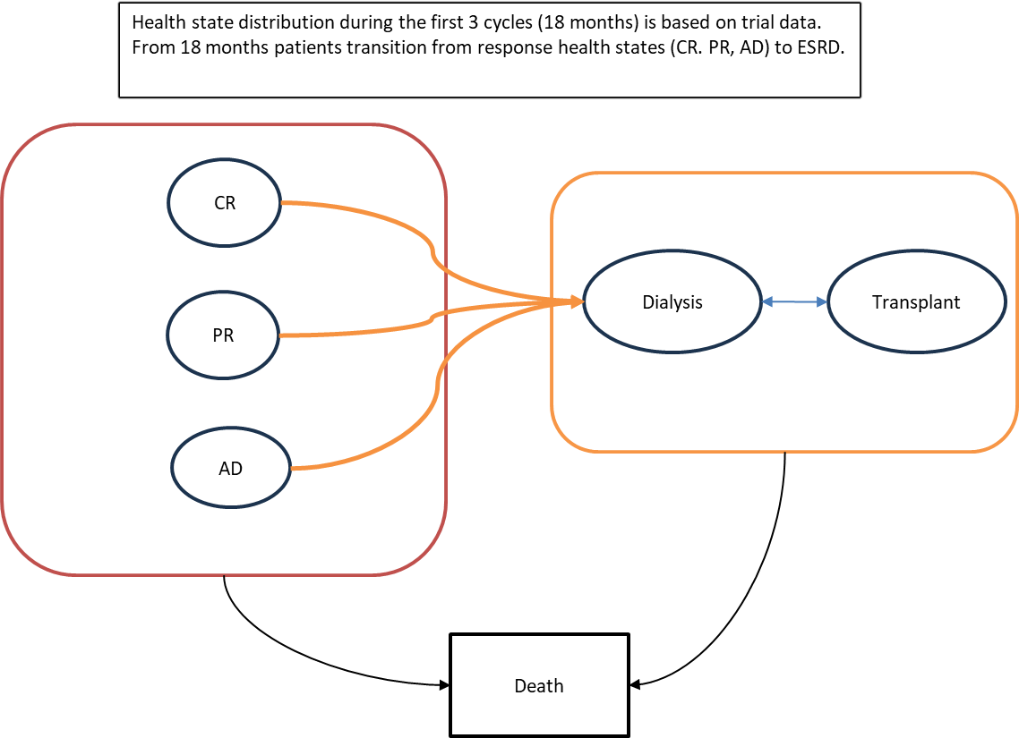
Source: Figure 3.2, p101 of the submission
AD=active disease, CR=complete response, ESRD=end stage renal disease, PR=partial response

  - Table 8. In summary, REGENCY data informed health state allocations to Month 18, after which the model relied on a combination of Davidson 2018, ANZDATA 2024 and additional REGENCY data. In general, the evaluation considered that using multiple sources likely introduced uncertainty because the underlying populations differed.
  - These differences included disease characteristics (ANZDATA includes all dialysis or kidney transplant patients, not just lupus nephritis resulting from SLE), demographics (e.g., 14.8% of patients were described as Black in REGENCY versus 53.4% in Davidson 2018; 84.5% females in REGENCY versus 91.5% in Davidson 2018), treatments (e.g., all patients received MMF, methylprednisolone and prednisone, with 88.1% receiving other concomitant therapy in REGENCY versus 24.4% that received no induction therapy in Davidson 2018), and timing of response (e.g., 76 weeks in REGENCY versus 24 months post baseline in Davidson 2018). A recent single-centre study of 60 patients in Australia by Nakagawa 2025 highlights that some demographics likely differ between the modelled studies and the Australian population, with a larger Asian population in Australia (52% of patients in Nakagawa 2025, compared to 5.9% in REGENCY, NR in Davidson 2018); and worse lupus nephritis class (20% class III versus 25% in Davidson 2018; 37% III or IV+V versus 31.4% in REGENCY).

Table 8: Summary of transitions in the model (error-corrected base case)
Transition | Probabilities |  | Source/calculation
Allocation to AD, PR, CR, up to Month 18 (percentage of total cohort) | OBI arm | SOC arm | REGENCY Weeks 24, 50, 76.
 | Cycle 1: AD: 57.5%, PR: 16.9%, CR: 25.6% | Cycle 1: AD: 57.5%, PR: 20.9%, CR: 23.7% | REGENCY Weeks 24, 50, 76.
 | Cycle 2: AD: 46.7%, PR: 16.9%, CR: 36.4% | Cycle 2: AD: 54.0%, PR: 15.1%, CR: 30.9% | REGENCY Weeks 24, 50, 76.
 | Cycle 3: AD: 38.3%, PR: 13.7%, CR: 45.8% | Cycle 3: AD: 53.4%, PR: 11.1%, CR: 33.3% | REGENCY Weeks 24, 50, 76.
Allocation to dialysis or death at Month 18 (percentage of total cohort) | Dialysis: 0.0% | Dialysis: 1.5% | REGENCY Week 76.
 | Dead: 2.2% | Dead: 0.7% | REGENCY Week 76.
Treatment discontinuation | Obinutuzumab: 6.8% per cycle until Month 18 for patients in AD, Month 36 for patients in CR/PR; 100% discontinue from Month 18 in AD, Month 36 in CR/PR.  SOC: 0% patients discontinue in either arm while in AD, PR or CR. |  | REGENCY Week 76 (26/136 patients discontinue), assumption beyond Week 76.
AD to dialysis from Month 18 | 1.10% per cycle. |  | Davidson 2018 non-respondersª proportion ESKD or dead at Year 4 (16.2%), converted to 6-month probability (2.19%), then adjusted by 50% to exclude mortality (based on Chen 2008).
CR or PR to dialysis from Month 18 | On SOC: 0.28% per cycle (1.10% with HR 0.254 applied) |  | HR for respondersª (PR or CR) based on Davidson 2008 CR.
CR or PR to dialysis from Month 18 | On obinutuzumab: 0.12% per cycle (SOC rate 0.28% with HR 0.44 applied) |  | HR for obinutuzumab based on LN flare HR from REGENCY.
Dialysis to transplant | 3.20% per cycle |  | Figure 7.2 ANZDATA 47th Annual report.
Transplant to dialysis | 1.36% per cycle |  | Table 7.12 ANZDATA 47th Annual report excluding mortality (submission reported 3.20% per cycle which include graft loss due to death with functioning graft).
AD to death | 0.76% per cycle |  | REGENCY (data source could not be verified).
PR to death | 0.17% per cycle |  | REGENCY (data source could not be verified).
CR to death | 0.07% per cycle |  | REGENCY (data source could not be verified).
Dialysis to death | 5.07% per cycle |  | Tables 4.3 and 5.10 ANZDATA 47th Annual report 6-month mortality weighted by number of haemodialysis and peritoneal dialysis deaths (submission 2.8% per cycle could not be verified).
Transplant to death | 1.01% per cycle |  | Table 7.23 ANZDATA 47th Annual report.
General population mortality | Age-based mortality added to each mortality transition probability |  | ABS statistics.
Source: Section 3.4 of the submission and ‘Model Inputs’ of Excel workbook ‘Economic Evaluation.xlsb’
AD=active disease, CR=complete response, ESKD=end stage kidney disease, HR=hazard ratio, OBI=obinutuzumab, PR=partial response, SOC=standard of care
ª response in Davidson was measured 24 months post initial biopsy, treatment could have occurred at any time
  - The use of REGENCY to inform transitions to Month 18 was generally reasonable. The main concerns with the transition probabilities arose from the assumptions applied after Month 18.
  - The model extrapolated time to dialysis based on AD, PR and CR status at Month 18, but did not allow patients to transition between these health states after that point. The Sub-Committees agreed with the evaluation that the assumption that a patient’s response status at Month 18 is predictive of their long term risk of progressing to ESKD has not been validated. The Sub-Committees noted that this assumption means that responders at Month 18 were assumed to have lower rates of dialysis and death, lower health state costs and higher utilities, applied across the time horizon. To account for deterioration from PR or CR to AD prior to dialysis, the submission applied one-off costs and QALY decrement equivalent to 1.206 years upon transition to dialysis (consistent with Mandrik 2022). The 1.206 years assumption originated from Tice 2021, and was based on an estimated time with eGFR <30mL/min estimated from Hanly 2016. As very few patients transition from CR or PR to dialysis, this adjustment had minimal effect on the ICER. However, the evaluation noted that many patients may experience periods of AD and associated costs and QALY losses, even without progressing to dialysis, meaning the long-term incremental difference between response states and AD was likely overestimated. The Sub-Committees agreed that this approach is not able to capture periods of AD and associated costs/QALY losses over time for those who do not progress to dialysis.
  - The probability of dialysis from the AD, PR, and CR states under SOC was estimated using time to ESKD from Davidson 2018, with the assumption that 50% of transitions represented mortality (based on Chen 2008), consistent with Mandrik 2022. Among the studies considered, Davidson 2018 appeared to have the most conservative difference in time to ESKD between responders and non-responders compared to other studies considered by the submission. However, the evaluation considered that the extrapolation was not consistent with the underlying data, as the model underestimated time to ESKD (including mortality) for AD beyond 5 years compared to Davidson 2018 (see Figure 2a, brown and black dashed lines).
  - Figure 3b illustrates that applying constant probabilities and a fixed hazard ratio led to extrapolations of time to ESKD (excluding mortality) for AD and CR that diverged over the time horizon, which may not be reasonable. In contrast, Mandrik 2022 used a Weibull distribution for AD and a log-normal distribution for CR/PR to extrapolate time to ESKD. This approach resulted in an increasing probability of ESKD over time and convergence of the AD and CR/PR extrapolations (Figure 3a, pink and purple lines). The pre-PBAC response argued that the submission’s approach (applying constant probabilities) was more conservative than the approach used in Mandrik 2022 (applying time-varying probabilities i.e. Weibull) until approximately Year 15 at which point the constant probabilities begin to outweigh the slowing Weibull probabilities. Thus, the pre-PBAC response argued that the model ‘does not overstate the long-term benefit of achieving a response’.
Figure 3: Extrapolation of Davidson 2018, time to ESKD, by response
a) Time to ESKD or death | b) Modelled time to ESKDª
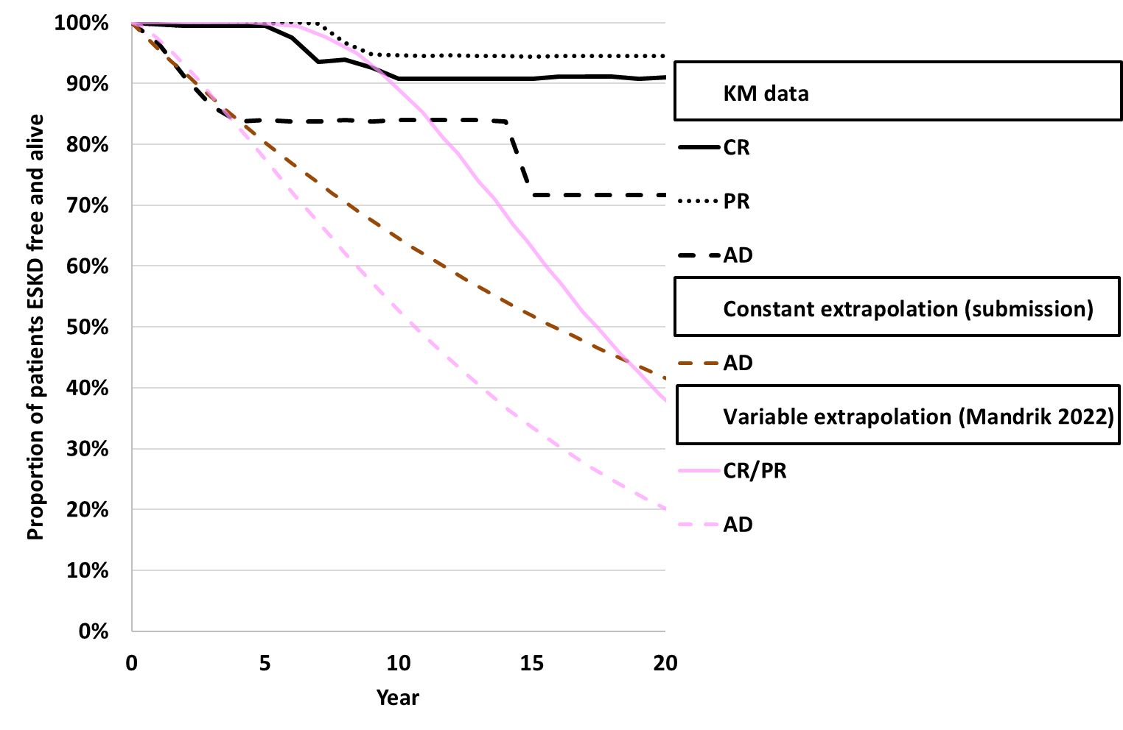 | 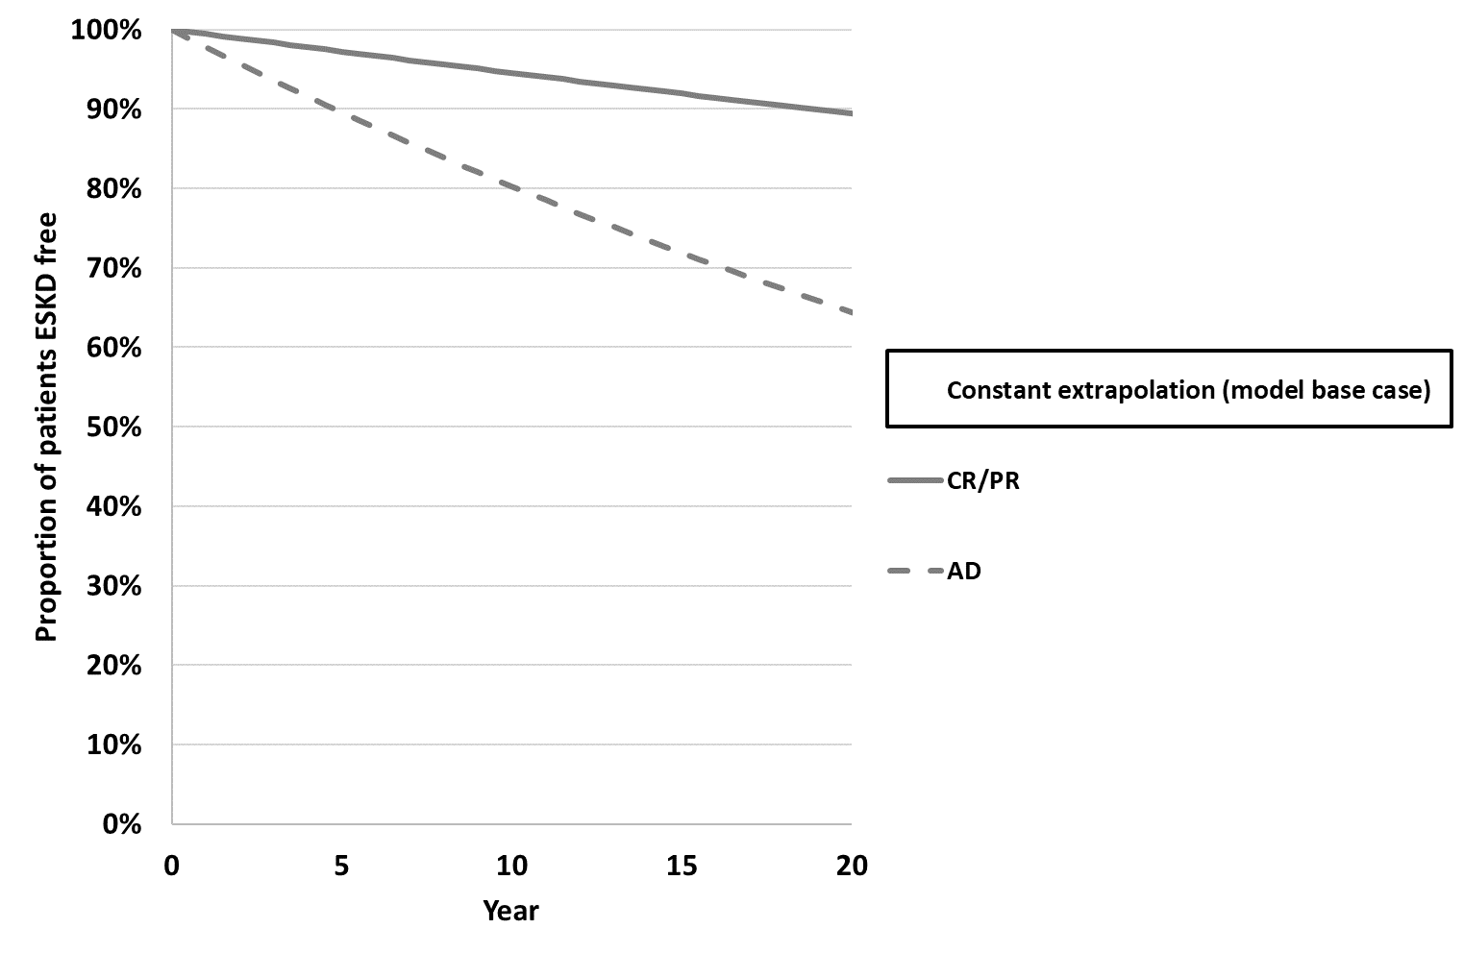
Source: compiled during the evaluation from Sheets ‘ESKD data’ and ‘Model Inputs’ of the Excel workbook ‘Economic Evaluation.xlsb’. KM data in the Excel workbook included implausibilities (such as increases in ESKD free survival across time), likely due to extraction errors or noisy original plots. These KM therefore should be interpreted as illustrative of trend, rather than accurate.
AD=active disease (non-responders in Davidson 2018), CR=complete response, ESKD=end stage kidney disease, KM=Kaplan-Meier, PR=partial response
Time 0 equal to time when response status was captured (24 months post lupus nephritis diagnosis in all studies), i.e., not Time 0 in the submission (lupus nephritis diagnosis)
a The submission estimated mortality separately, based on pooled REGENCY data. Therefore, the constant extrapolation curves are not equal to final modelled ESKD free survival in the submission.
  - The submission argued that patients in CR/PR receiving obinutuzumab should accrue additional benefit to those in CR/PR receiving SOC, but did not present evidence of a benefit for responders receiving obinutuzumab versus those receiving SOC beyond Month 18. The applied hazard ratio of 0.44 was derived from differences in time to flare between REGENCY trial arms from Weeks 24 to 76, was not limited to CR/PR patients, and was assumed to underestimate the true effect. The evaluation considered that this assumption was without justification. The evaluation considered that a hazard ratio for flares is unlikely to translate directly to a hazard ratio for dialysis risk and it may therefore be more reasonable to assume no additional post-Month-18 benefit for responders receiving obinutuzumab compared to responders receiving SOC. The PBAC noted that the relationship between the reduction in flares to reduction in dialysis risk is probable but imprecise, and that therefore the use of a HR of 1 in the model would be conservative.
  - The per cycle probabilities of patients in dialysis moving to transplant, and from transplant to dialysis were estimated from the annual probability of transplants (6.3 transplants per 100 dialysis-years) and graft loss (2.7 per 100 graft-years) reported for Australia from ANZDATA 2024. Lupus nephritis patients may have different long-term probabilities of graft loss and transplantation compared with other patients, who likely make up the majority of the ANZDATA data, particularly as lupus nephritis patients have underlying SLE, which is a complex, multi-organ disease.
  - The probability of death from dialysis per cycle was reported as 2.8% in the submission, but the source of this value could not be verified by the evaluation. Based on the reported source in Tables 4.3 and 5.10, ANZDATA 2024, and weighting by the number of haemodialysis and peritoneal dialysis deaths, the error-corrected base case estimated a per cycle mortality from dialysis to be 5.07%. In practice, the probability of death from dialysis was more likely to increase with longer time spent in the health state, and therefore, this likely remained an underestimate of dialysis mortality. The probability of death from the transplant state (1.01% per cycle) was based on annual survival reported in the ANZDATA 2024. As with death from dialysis, this probability is unlikely to be constant over time.
  - The submission stated that the assumed maximum treatment duration of 3 years was based on clinical practice guidelines (Practice Point 10.2.3.2.4, KDIGO 2024), although the quoted guidelines stated that treatment should be at least 36 months. Furthermore, the submission assumed non-responders (those in AD) at Month 18 would receive no further obinutuzumab. The Delegate’s Overview noted that given the significant number of non-responders in REGENCY and NOBILITY, it was unclear if or when obinutuzumab should be discontinued for these patients. The Sub-Committees considered that 18 months was a possible average treatment duration, although some patients with more severe disease will likely require a longer treatment duration. The Sub-Committees noted that the model estimated that more than 65% of patients were still receiving obinutuzumab treatment at 3 years (then cease due to the maximum treatment duration assumed in the economic model) which was considered to be high. However, the Sub-Committees considered that a 3-year treatment cap for responders in the model could be retained as a potentially conservative assumption for the base case. The Sub-Committees also considered that this 3-year treatment cap for obinutuzumab should be reflected in the restriction and/or a risk sharing arrangement (RSA). The PBAC agreed that the maximum treatment duration of 3 years should be reflected in the RSA (to align with the economic model), but that the restriction should allow clinicians flexibility regarding treatment duration in patients who have not exhibited a failure of treatment response.
  - REGENCY reported quality of life data for patients, but the submission considered them clinically implausible, as utility was higher in AD than in CR. The submission, therefore, used health state utilities for AD, PR and CR from Mandrik 2022, and dialysis and transplant utilities from Lee 2005. In Mandrik 2022, the CR utility was taken from Bexelius 2013, which reported EQ-5D values (version and valuation not reported) for Swedish SLE patients with low disease activity (Systemic Lupus Activity Questionnaire score 0-9). Although relatively high, this CR utility was still lower than utility values in other sources, including NICE TA882 (0.830, based on SF-36 collected in AURORA trial cross-walked to EQ-5D-3L), REGENCY (0.884, EQ-5D-5L), and Mohara 2014 (0.94, EQ-5D).
  - Utilities for PR and AD were estimated by applying the Mohara 2014 health-state differences to the CR utility. A multiplicative application of the Mohara 2014 decrements may be more appropriate. Under this approach, PR utility would equal 0.723, and AD utility would equal 0.650, compared with 0.710 and 0.624 in the submission. Incorporating these multiplicative utilities increased the ICER to $35,000 to < $45,000 per QALY gained compared with $35,000 to < $45,000 in the error-corrected base case, demonstrating the sensitivity of the ICER to the utility assumptions.
  - Utilities for dialysis and transplant were sourced from Lee 2005, a single centre study of dialysis and renal transplant patients in Wales. Participants completed a postal survey using the EQ-5D-3L, and utilities were valued using a UK tariff. Lee 2005 utility values may be slightly conservative: a meta-analysis of EQ-5D studies by Liem 2008 reported higher average utilities for haemodialysis (0.56), peritoneal dialysis (0.58), and transplant (0.81) across studies published 2001 to 2005. Mandrik 2022 also derived a dialysis utility of 0.55 by applying the Mohara 2014 utility decrements to their CR value, broadly consistent with the findings from the Liem 2018 meta-analysis.
  - No disutilities associated with treatments or SLE or lupus nephritis disease progression, such as adverse events, flares, or prednisolone use, were included in the submission.
  - The model included costs (reported in 2025 prices unless otherwise stated) for drugs, dialysis, kidney transplants, healthcare resource use, and adverse events.
  - Obinutuzumab was costed as $redacted content per 1000mg vial, based on the proposed AEMP of $redacted content and weighted for a 76% public hospital use and 24% private hospital use (which incurred a $40 markup fee). In Cycle 1, patients were expected to have 3 x 1000mg infusions ($redacted content) to align with dosing in Weeks 0, 2 and 24 of REGENCY. From Cycle 2 onwards, the error-corrected base case applied one 1000mg dose per 6-month cycle, in line with REGENCY and the proposed restriction. Patients who received obinutuzumab were also costed to receive methylprednisolone (80mg per dose with full pack wastage equal to $28.43, PBS item 1928L) prior to each obinutuzumab infusion, plus an additional initial 1000mg dose of methylprednisolone. The cost of IV drug administration (MBS item 13950) was applied to the administrations of obinutuzumab and methylprednisolone. Where these drugs were administered in the same session, a single administration cost was applied for both drugs.
  - All patients in AD, CR or PR in both the obinutuzumab and SOC arms were expected to receive MMF and prednisone (PBS items 14000W and 13944X), with dosing informed by REGENCY. The model did not incorporate the prednisone taper observed in REGENCY, however, prednisone costs had very little impact on the ICER. The submission did not include other SLE drug costs (assuming they would be similar across arms), which was reasonable.
  - A one-off subsequent treatment cost was applied to patients who transitioned to dialysis from AD, PR or CR: $10,248.03 in the SOC arm (rituximab, cyclophosphamide, and tacrolimus) and $9,119.11 in the obinutuzumab arm (cyclophosphamide and tacrolimus). Although there was some uncertainty in the choice of downstream therapies, particularly the use of rituximab for SOC patients, the ICER was not sensitive to subsequent treatment costs.
  - The per-cycle health state costs for AD ($2,501.10), PR ($1,549.93), and CR ($598.75) were derived from NICE TA882 (voclosporin with MMF for lupus nephritis), using 6 months resource use for patients with AD, PR and CR in CKD stage 1-3a, with relevant MBS costs applied. While this approach was generally appropriate, the small number of patients transitioning from CR or PR to dialysis meant that the cost differences between AD and the PR, CR health states became a significant driver of the incremental costs.
  - Patients in the dialysis state accrued an average per cycle cost of $33,035, calculated using the annual costs of peritoneal dialysis ($29,967), home haemodialysis ($30,001), satellite ($44,626), hospital haemodialysis ($106,372) from Deloitte 2023, weighted by modality proportions from ANZDATA 2024 (7% peritoneal, 7% home haemodialysis, 54% satellite, 22% hospital haemodialysis) inflated to 2025 dollars and converted to a 6-month cost. Dialysis costs were a significant cost offset in the submission and a key driver of the incremental costs, despite health state allocation to dialysis being low.
  - Patients entering the transplant state accrued a one-off cost of $98,522.32 based on Deloitte 2023, inflated to 2025 prices and weighted by the percentage of living and deceased donor transplants reported in ANZDATA 2024. Patients were also assumed to incur an ongoing per cycle cost in the transplant state of $8,907 based on the annual cost for subsequent post-transplant years from Table 17, dapagliflozin, CKD, Public Summary Document July 2021 ($14,722), inflated to 2025 costs and converted to a 6 monthly cost. The costs in the transplant state were reasonable.
  - The submission included per-cycle adverse event costs for COVID-19, urinary tract infection, gastroenteritis, pneumonia, COVID-19 pneumonia, and neutropenia (Grade 3-5 adverse events affecting ≥5% of patients in either arm of REGENCY), with REGENCY incidence converted to per-cycle probabilities for patients receiving obinutuzumab or SOC. Unit costs were based on AR-DRG codes with minor complexity, as reported in 2019-2020 and were not updated to 2025 costs. The ICER was not sensitive to changes in adverse event costs.
  - Health state allocation plots were compiled during the evaluation and are presented in Figure 4. Overall, the health state allocation plots demonstrate that a significant driver of the model was the difference in occupancy between the AD and CR health states.
Figure 4: Health state allocation
Submission | Error-corrected base case
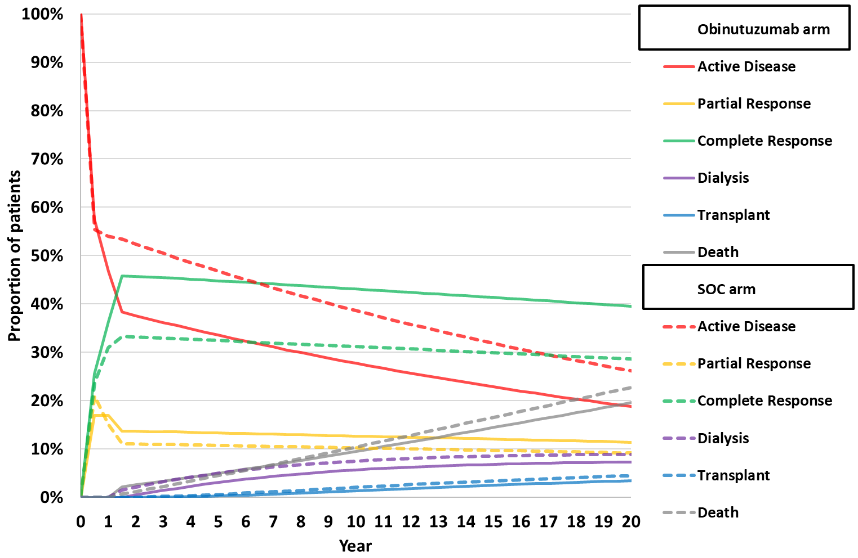 | 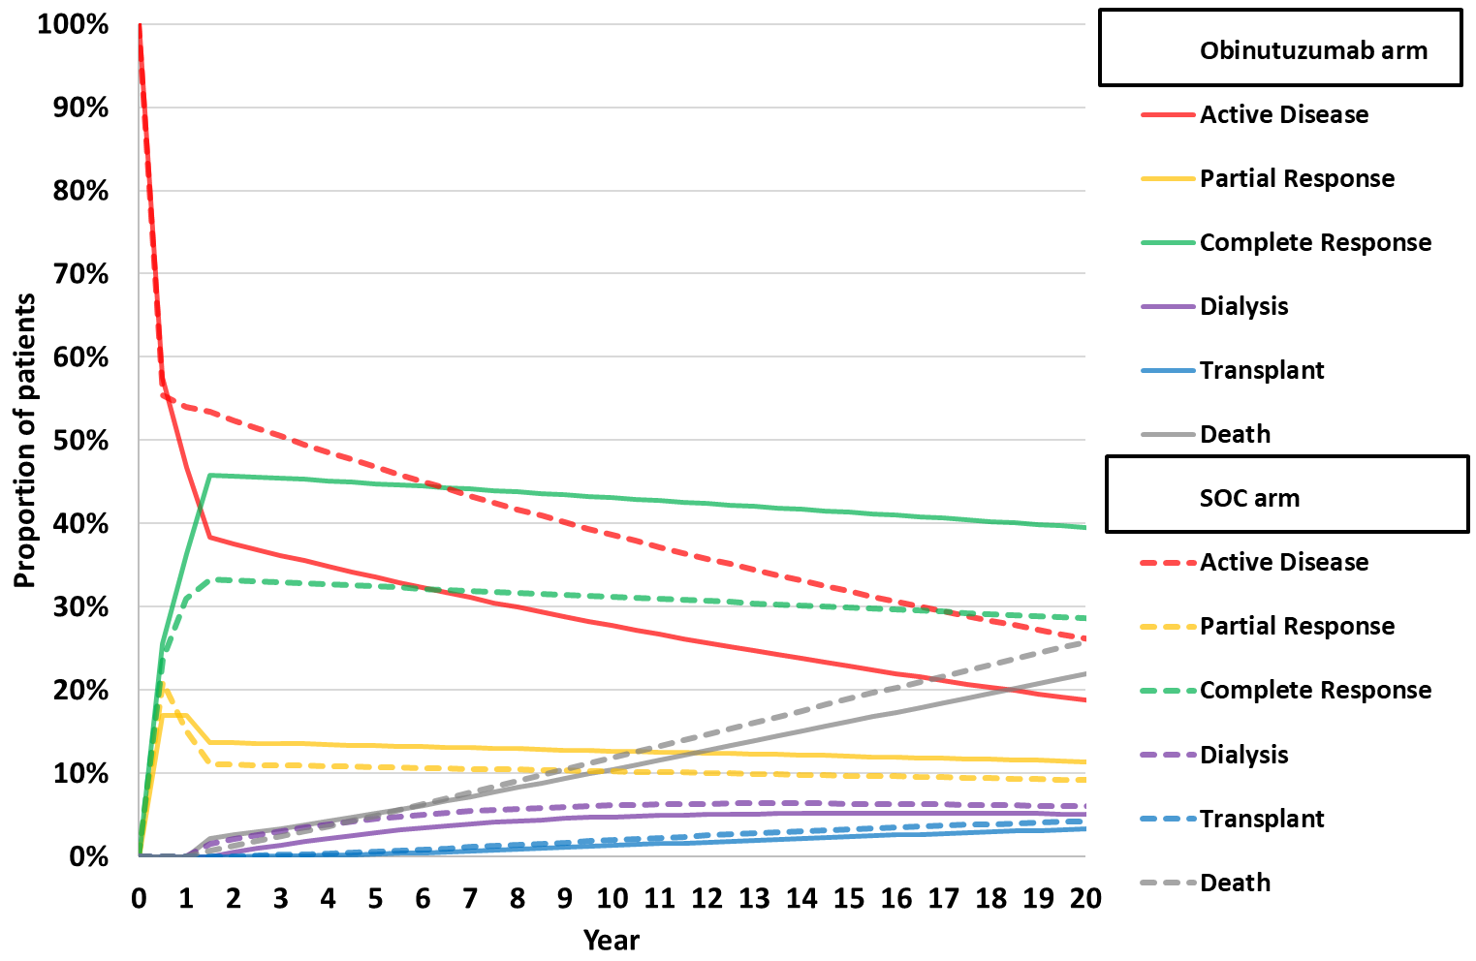
Source: compiled from Sheets ‘Obinutuzumab + ST Markov Model’ and ‘ST Markov Model’ of Excel workbook ‘Economic Evaluation.xlsb’ Patients who transition to dialysis from complete or partial response were assumed to spend 1.206 years in active disease and therefore allocation to active disease is underestimated
  - A summary of the key drivers of the model is presented in Table 9.
Table 9: Key drivers of the model
Description | Method/Value | Impact  Error-corrected base case: $redacted content¹/QALY gained.
Time horizon | 20 years compared to 76 weeks in REGENCY. PBAC previously accepted a time horizon of 15 years for anifrolumab in SLE (para 7.10 anifrolumab PSD March 2024) | High, favoured obinutuzumab. If the time horizon was reduced to 15 years, the ICER increased to $redacted content²/QALY gained.
Benefits for responders | Responders (patients in CR or PR) at Month 18 had lower rates of dialysis and death, lower health state costs and higher utilities, applied across the time horizon.  Response has not yet been validated as a surrogate for time to dialysis; there was also limited evidence that response at 18 months can accurately predict differences in costs and utilities across AD, PR and CR states over 20 years. | High, favoured obinutuzumab. If health state costs in CR and PR were set equal to AD from Year 10, the ICER increased to $redacted content³/QALY gained, and if health state utilities in CR and PR were set equal to AD from Year 10 the ICER increased to $redacted content²/QALY gained.
Progression to dialysis | Time to dialysis by response was constant, based on Davidson 2018.  Davidson 2018 appeared to have the most conservative difference in time to ESKD between responders and non-responders compared to other studies considered by the submission; and a more optimistic time to ESKD for AD patients, but the use of constant probabilities and hazard ratio also led to extrapolation of time to dialysis (excluding mortality) that diverged across the time horizon for the model arms. | High. The commentary considered that use of a constant probability likely favoured obinutuzumab. If the probability of CR/PR to dialysis was equal to AD from Year 10 the ICER increased to $redacted content³/QALY gained. Use of Davidson 2018 favoured SOC. If Luo 2022 was used as the source of the transitions to dialysis by response, the ICER decreased to $redacted content⁴ per QALY gained.  However the pre-PBAC response argued that using constant probabilities for the risk of ESKD or death as a function of response introduced a conservative bias against obinutuzumab within a 15-year time horizon when compared against the Mandrik 2022 model which used time-varying probabilities.
Mortality in dialysis | 5.07% per cycle based on Tables 4.3 and 5.10 ANZDATA 47th Annual report 6-month mortality weighted by number of haemodialysis and peritoneal dialysis deaths (submission 2.8% per cycle could not be verified). | High favoured SOC: as the dialysis health state was expensive, an increase in mortality in dialysis increased the ICER, due to more costs avoided in the SOC arm for a small LY loss compared to the obinutuzumab arm. If the probability of mortality from dialysis was decreased 50% to 2.54% per cycle, the ICER decreased to $redacted content⁵ per QALY gained
Utilities in AD, PR, CR | Utility by response consistent with Mandrik 2022 AD 0.624, PR 0.710, CR 0.800. | High, favoured obinutuzumab. If AD utility increased 10% to 0.686 (base 0.624) the ICER increased to $redacted content³/QALY gained
Time on obinutuzumab | Discontinuation was 6.8% per cycle until Month 18 for patients in AD, Month 36 for patients in CR/PR; then 100% discontinued from Month 18 in AD, Month 36 in CR/PR. No maximum time on treatment was required by the proposed restriction. | High, favoured obinutuzumab. If no maximum time on obinutuzumab was assumed for responders (AD patients still stopped at Month 18), and the per-cycle discontinuation was kept at 6.8%, the ICER increased to $redacted content²/QALY gained.
Source: compiled during the evaluation.
The redacted values correspond to the following ranges:
¹ 35,000 to < $45,000
² $55,000 to < $75,000
³ $45,000 to < $55,000
⁴ $15,000 to < $25,000
⁵ $25,000 to < $35,000

  - A summary of the results is presented in Table 10. The majority of the QALY gains and cost-offsets occurred beyond Month 18. Obinutuzumab was associated with an ICER of $35,000 to < $45,000 per QALY gained ($115,000 to < $135,000 per LY gained, $55,000 to < $75,000 per ESKD LY avoided) in the error corrected base case. The results highlight the difference between the total incremental LYs and QALYs in the model. For example, with a time horizon of 18 months, patients in the obinutuzumab arm were expected to accrue fewer LYs (-0.004 LYs discounted), in line with the high proportion of deaths at the end of REGENCY, but had a greater number of QALYs (0.010 discounted), reflecting the higher rates of CR in the obinutuzumab arm of REGENCY compared to the SOC arm. Over the 20-year time horizon, the obinutuzumab arm accrued more LYs and QALYs than the SOC arm, but the incremental QALYs (0.370) far exceeded the incremental LYs (0.116). Incremental LYs were significantly larger in the error-corrected base (0.116) than in the submission’s base case (0.070), attributable to the higher dialysis-related mortality in the error-corrected base case.
Table 10: Results of the stepped economic evaluation
 | Submission |  |  | Error-corrected base case
Step and component | Obinutuzumab | SOC | Increment | Obinutuzumab | SOC | Increment
Step 1: time horizon 18 months, treatment costs only: drug, administration, adverse event and subsequent treatment; LYs in ESKD, discounting 5% per year
Costs | $redacted content | $2,869 | $redacted content | $redacted content | $1,589 | $redacted content
LY (ESKD) | 0.000 | 0.004 | -0.004 | 0.000 | 0.004 | -0.004
Incremental cost/extra LY in ESKD avoided |  |  | $redacted content¹ |  |  | $redacted content¹
Step 2: time horizon 18 months, all costs, LYs in ESKD, discounting 5% per year
Costs | $redacted content | $8,704 | $redacted content | $redacted content | $7,424 | $redacted content
LY (ESKD) | 0.000 | 0.004 | -0.004 | 0.000 | 0.004 | -0.004
Incremental cost/ extra LY in ESKD avoided |  |  | $redacted content¹ |  |  | $redacted content¹
Step 3: time horizon 18 months, all costs, utilities, QALYs, discounting 5% per year
Costs | $redacted content | $8,704 | $redacted content | $redacted content | $7,424 | $redacted content
LY (ESKD) | 0.000 | 0.004 | -0.004 | 0.000 | 0.004 | -0.004
LY total | 1.459 | 1.462 | -0.004 | 1.459 | 1.462 | -0.004
QALYs | 1.000 | 0.990 | 0.010 | 1.000 | 0.990 | 0.010
Incremental cost/extra QALY gained |  |  | $redacted content¹ |  |  | $redacted content¹
Step 4: 20-year time horizon, all costs and utilities, discounting 5% per year (base case)
Costs | $redacted content | $110,788 | $redacted content | $redacted content | $93,911 | $redacted content
LY (ESKD) | 0.679 | 0.954 | -0.275 | 0.576 | 0.805 | -0.228
LY Total | 11.874 | 11.804 | 0.070 | 11.771 | 11.655 | 0.116
QALYs | 8.445 | 8.110 | 0.336 | 8.366 | 7.996 | 0.370
Incremental cost/ extra LY in ESKD avoided |  |  | $redacted content² |  |  | $redacted content³
Incremental cost/LYG |  |  | $redacted content⁴ |  |  | $redacted content⁵
Incremental cost/extra QALY gained (base case) |  |  | $redacted content⁶ |  |  | $redacted content⁶
Source: Table 3.30, p145; Table 3.31, p146 of the submission and compiled during the evaluation. The results for the 18-month time horizon were corrected, as the submission incorrectly presented results for 24 months.
ESKD=end stage kidney disease, LY=life year, LYG= life year gained QALY=quality adjusted life year, SOC=standard of care
The redacted values correspond to the following ranges:
¹ > $1,055,000
² $25,000 to < $35,000
³ $55,000 to < $75,000
⁴ $95,000 to < $115,000
⁵ $115,000 to < $135,000
⁶ $15,000 to < $25,000
⁷ $35,000 to < $45,000

  - The main driver of the incremental costs was the drug cost of obinutuzumab (incremental cost of $redacted content). The main cost offsets were health state costs in dialysis (incremental cost -$16,657,) and AD (incremental cost -$10,337), a result of the higher rates of AD and dialysis in the SOC arm and the higher per cycle costs in these states compared CR, PR or post-transplant.
  - With the small total incremental LYs (0.26), all health states were drivers of the incremental LYs between obinutuzumab and SOC, with incremental time in CR and PR contributing the majority (2.70 LYs). This was offset by relatively fewer life years spent in AD, dialysis and transplant in the obinutuzumab arm compared with SOC (-2.44 LYs). The main drivers of the incremental QALYs were QALYs accrued in CR (incremental QALYs 1.80) and PR (incremental QALYs 0.32). The main QALY offsets were QALYs accrued in AD (incremental QALYs -1.29). The QALY decrement for CR/PR patients who transitioned to dialysis after Month 18 resulted in a small reduction in incremental QALYs (- 0.002), attributable to a few patients transitioning from CR or PR to dialysis over the time horizon.
  - The results of key sensitivity analyses are summarised in Table 11. The ICER was most sensitive to inputs that affected the size and duration of response to treatment (e.g., time horizon, progression to dialysis, utility decrement in AD compared to CR and PR), additional benefit of obinutuzumab beyond Month 18, time on obinutuzumab, and mortality from dialysis. The Sub-Committees noted that the multi-variate sensitivity analyses including a 15 year time horizon resulted in ICERs ranging from $115,000 to < $135,000 to $155,000 to < $255,000. The Sub-Committees advised that the shorter 15 year time horizon was more appropriate, given the already considerable uncertainty of extrapolating from 76 week trial data.
  - The Sub-Committees considered that the multi-variate analyses which incorporated the removal of the assumption of a 3 year maximum treatment duration likely overestimated the costs of obinutuzumab treatment and therefore the ICER. The Sub-Committees therefore advised that additional multi-variate sensitivity analyses (MA5 and MA6 in Table 11 below) be undertaken based on a 15-year time horizon, removal of the added treatment benefit of obinutuzumab versus SOC for responders (i.e., CR/PR to dialysis HR=1 compared to HR=0.44 in the base case) and with or without CR/PR health state costs and utilities equal to AD from Year 10. These additional analyses (reported in MA5 and MA6) resulted in ICERs ranging from $55,000 to < $75,000 to $75,000 to < $95,000.
  - To address remaining uncertainties, the PBAC recommended the economic model be amended to reduce the time horizon from 20 years to 15 years, remove the assumption that patients with a complete or partial response on obinutuzumab receive an additional reduction in dialysis risk compared with responders receiving standard therapies, and assume that responder and non‑responder health state costs and utilities were equal from Year 10 of the model (as per multivariate analyses 5 and 6 proposed by the Joint Committees).
Table 11: Sensitivity analyses
Analyses | Incremental cost | Incremental QALY | ICER | % change
Error-corrected base case | $redacted content | 0.370 | $redacted content¹ | 0.0%
Discount rate (base case 5% costs and outcomes)
- 0% costs and outcomes | $redacted content | 0.630 | $redacted content² | -redacted content%
- 3.5% costs and outcomes | $redacted content | 0.430 | $redacted content³ | -redacted content%
Time horizon (base case 20 years)
- 15 years | $redacted content | 0.277 | $redacted content⁴ | redacted content%
- Lifetime (to age 100) | $redacted content | 0.698 | $redacted content⁵ | -redacted content%
Obinutuzumab treatment duration (base maximum duration CR/PR 36 months, AD 18 months, 6.8% discontinue per cycle)
- No maximum time in CR/PR, AD 18 months (6.8% discontinue per cycle) | $redacted content | 0.389 | $redacted content⁴ | redacted content%
- No maximum time in CR/PR, AD 18 months (no discontinuation per cycle) | $redacted content | 0.429 | $redacted content⁶ | redacted content%
Source of SOC progression to dialysis (base constant probabilities from 5 year of Davidson 2018 data, assuming 50% of Davidson 2018 transitions were mortality events: AD to dialysis 1.10%, CR/PR to dialysis: 0.28%
- Rates from Luo 2022 | $redacted content | 0.411 | $redacted content³ | -redacted content%
- Variable extrapolation of Davidson 2018 from Mandrik 2022 | $redacted content | 0.360 | $redacted content¹ | redacted content%
- Assume CR/PR probabilities equal to AD probability from Year 10 | $redacted content | 0.351 | $redacted content⁷ | redacted content%
Benefit of obinutuzumab CR/PR to dialysis (base HR 0.44)
- OBI HR=1 | $redacted content | 0.357 | $redacted content¹ | redacted content%
Per cycle probability dialysis to transplant (base 3.2%)
- 4.8% (increase 50%) | $redacted content | 0.360 | $redacted content¹ | redacted content%
- 1.6% (decrease 50%) | $redacted content | 0.382 | $redacted content¹ | -redacted content%
- 5.29% (ANZDATA for ages 15-64) | $redacted content | 0.357 | $redacted content¹ | redacted content%
Mortality probabilities
Assume CR/PR transition to death equal to AD after Year 10 | $redacted content | 0.342 | $redacted content¹ | redacted content%
Per cycle probability dialysis to death (base 5.07%)
- 7.61 % (increase 50%) | $redacted content | 0.390 | $redacted content¹ | redacted content%
- 2.54% (decrease 50%) | $redacted content | 0.342 | $redacted content³ | -redacted content%
Health state utilities (base AD: 0.624, PR: 0.710, CR: 0.800 [Mandrik 2022, Mohara 2014 difference applied to Bexelius 2013]; dialysis: 0.455, transplant: 0.71 [Lee 2005])
- AD 0.650, PR 0.723, CR 0.800 based on Mohara 2014 difference applied multiplicatively to Bexelius 2013 | $redacted content | 0.338 | $redacted content¹ | redacted content%
- AD, PR, CR 0.624 from Year 10 | $redacted content | 0.264 | $redacted content⁴ | redacted content%
- Dialysis and transplant values from Liem 2008 (HD: 0.56, PD:0.58, transplant: 0.81) | $redacted content | 0.346 | $redacted content¹ | redacted content%
CR/PR health state costs (base CR $598.75, PR $1,549.93 per cycle)
- CR/PR $1,549.93 | $redacted content | 0.370 | $redacted content⁷ | redacted content%
- CR/PR $2,501.10 (equal to AD) from Year 10 | $redacted content | 0.370 | $redacted content⁷ | redacted content%
Multivariate analyses
MA1: OBI vs SOC CR/PR to dialysis HR=1 & no maximum time on OBI in CR/PR, AD 18 months (6.8% discontinue per cycle) | $redacted content | 0.357 | $redacted content⁸ | redacted content%
MA2: MA1 & CR/PR costs and utilities equal to AD from Year 10 | $redacted content | 0.253 | $redacted content⁹ | redacted content%
MA3: MA1 & time horizon 15 years | $redacted content | 0.267 | $redacted content⁹ | redacted content%
MA4: MA2 & time horizon 15 years | $redacted content | 0.210 | $redacted content¹⁰ | redacted content%
MA5: Time horizon 15 years and OBI vs SOC CR/PR to dialysis HR=1 | $redacted content | 0.267 | $redacted content⁴ | redacted content%
MA6: MA5 & CR/PR costs and utilities equal to AD from Year 10 | $redacted content | 0.210 | $redacted content⁸ | redacted content%
Source: Compiled during the evaluation and during the preparation of Sub-Committee advice based on Tables 3.35-3.40, pp148-152 of the submission and Excel workbook ‘Economic Evaluation.xlsb’
AD=active disease, CR=complete response, ESKD= end stage kidney disease, HR=hazard ratio, ICER=incremental cost-effectiveness ratio, OBI=obinutuzumab, PR=partial response, QALY=quality adjusted life year, SOC=standard of care
The redacted values correspond to the following ranges:
¹ $35,000 to < $45,000
² 5,000 to < $15,000
³ $25,000 to < $35,000
⁴ $55,000 to < $75,000
⁵ $15,000 to < $25,000
⁶ $135,000 to < $155,000
⁷ $45,000 to < $55,000
⁸ $75,000 to < $95,000
⁹ $115,000 to < $135,000
¹⁰ $155,000 to < $255,000

Obinutuzumab cost/patient at the price proposed in the submission*
Table 12: Drug cost per patient for obinutuzumab at the price proposed in the submission (and using the submission inputs for the economic model and financial estimates)
 | Trial dose and duration | Model | Financial estimates
Mean dose | 1,000mg per dose | 1,000mg per dose  (6,840mg total) | 1,000mg per dose  (8,150mg total)
Mean duration | 5.1 doses (0.91 years)ª | 6.84 doses (1.92 years) | 8.15 doses (2.57 years)
Cost/patient/year | - | Yr 1: $redacted content (5 doses)  Yr 2+: $redacted content (2 doses) | Yr 1: $redacted content (5 doses)  Yr 2+: $redacted content (2 doses)
Cost/patient/course | - | $redacted content
*$redacted content weighted DPMQ
Source: Table 15 of the REGENCY CSR and Excel workbooks ‘Economic Evaluation.xlsb’ and ‘Section 4 Workbook.xlsx’
Obinutuzumab costs only. No costs of MMF, prednisone, methylprednisolone or other standard of care costs included.
a Estimated for all patients who received obinutuzumab in REGENCY, including patients who received 5 or 6 doses in the first year. The requested restriction is for 5 doses in the first year.

Estimated PBS usage & financial implications
  - This submission was considered by the joint DUSC-ESC. The submission estimated the financial implications of the proposed listing of obinutuzumab for class III/IV ± V lupus nephritis, using an epidemiological approach based on prevalence and incidence rates reported in the literature. Table 13 outlines the key inputs relied on in the financial estimates.
Table 13: Key inputs for financial estimates
Data | Value | Source | Comment
Eligible population
Incident SLE patients | Yr 2: 1,145  Yr 3: 1,164  Yr 4: 1,182  Yr 5: 1,199  Yr 6: 1,216 | Incidence rate 5.14 per 100,000 (Tian 2023) applied to ABS population estimates 2026-2031  The submission reported incident population for Yr 1, but these were not separately included in the calculations (assumed to be included in the prevalent population) | A global incidence rate may not be appropriate for an Australian population. In Tian 2023, the global prevalence rate was 43.7 per 100,000, much lower than the previously accepted prevalence rate in Australia.  The Sub-Committees compared the incidence of LN (i.e. 5.14*40% =2.06 per 100,000) with a recent Australian estimate of LN incidence (Roper et al. 2025) and considered that the result may be reflective of the Australian population.
Prevalent SLE patients | Yr 1: 20,664 | Prevalence rate 94.33 per 100,000 (Table 16, anifrolumab PSD March 2024) applied to ABS population estimate for 2026.  The submission reported the prevalent populations for Yrs 2-6, but these were not included in the calculations for financial estimates. | The evaluation noted that Roper 2025 estimated SLE prevalence at 57.86 per 100,000 persons across Australian studies.  The Sub-Committees noted the prevalence rate was derived based on five Australian studies via an inverse variance-weighted approach. It was heavily weighted towards a large study of SLE in childbearing women in NSW (Shand 2013). The Sub-Committees considered that the prevalence estimates should omit the Shand study, which yields a prevalence of 46 per 100,000. The Sub-Committees noted that the revised estimates are comparable to the global prevalence. The pre-PBAC response disagreed with the omission of the Shand study on the basis that it captures an important population cohort of women of child-bearing age. However, the PBAC considered that the SLE prevalence rate from the Roper 2025 meta-analysis of 57.86 per 100,000 should be applied in the financial estimates.
Proportion of SLE patients who develop LN | 40% | The submission noted rates of 40% across the literature. All papers seem to reference Hanly 2016 (38.3% of 1,827 US patients with LN across a mean 4.6 years follow-up, the majority had LN at baseline). | The Sub-Committees considered the assumption as reasonable. The PBAC noted that while Hanly 2016 reported a proportion of 38.3%, only 21% of the cohort had biopsy proven lupus nephritis, and only 14% had biopsy proven class III/IV lupus nephritis.
Proportion LN that is class III/IV±V | 75% | Assumed to be higher than 66-73% reported for Class III/IV, no Australian-specific percentages were identified. | In total, the submission estimated that 27% of SLE patients developed class III/IV±V LN (40%x75%x90%). In comparison 60/369 (16%) patients with SLE treated in Monash Health Lupus Clinic (Nakagawa 2025) had class III/IV±V LN and received induction therapy. The PBAC considered that the total of 27% as estimated by the submission was reasonable in the context of using the SLE prevalence rate of 57.86 per 100,000 from the Roper 2025 meta-analysis.
Proportion Class III/IV±V LN that requires immunosuppression | 90% | Assumed, based on Advisory Board Minutes 2025
Grandfathered patients | 0 | Though a patient access program exists, the submission assumed these patients were captured in the prevalent population. | The number of grandfathered patients should be quantified as these patients would be expected to have a shorter treatment duration.
Treatment utilisation
Initial uptake of obinutuzumab | Yr 1: redacted content%  Yr 2: redacted content%  Yr 3: redacted content%  Yr 4: redacted content%  Yr 5: redacted content%  Yr 6: redacted content% | Assumed uptake for patients upon eligibility for obinutuzumab. Applied to the prevalent population in Year 1, the incident population only in Years 2-6. | The evaluation considered that the uptake appeared low, particularly for incident patients. The Advisory Board Minutes 2025 estimated redacted content% of active class III/IV±V LN patients would be treated with obinutuzumab.  The Sub-Committees agreed with the evaluation that the uptake rates were likely underestimated, particularly, for both incident patients and patients eligible for subsequent treatment, given that triple therapy is expected to become the standard of care in Australia.  The Sub-Committees considered the uptake rates should be redacted content% in Year 1 increasing to redacted content% in Year 6. However, the PBAC considered that the Y1 uptake rate of redacted content% (applied to prevalent patients) was underestimated and should be increased to redacted content%. The PBAC considered that the uptake rates for incident patients should be adjusted to redacted content%, redacted content%, redacted content%, redacted content% and redacted content% for years 2 to 6.
Patients who initiate SOC (i.e., no initial uptake of obinutuzumab), but have no response or worsening disease | 66.9% | Proportion of patients who did not achieve CRR in the placebo arm of REGENCY when adjusted for multiple imputation. Applied to the prevalent population from Year 1 plus incident patients in Years 2-6, excluding those who already initiated obinutuzumab. | The Sub-Committees considered the assumption as reasonable.
Subsequent uptake of obinutuzumab following SOC with no response or worsening disease | Yr 1: redacted content%  Yr 2: redacted content%  Yr 3: redacted content%  Yr 4: redacted content%  Yr 5: redacted content%  Yr 6: redacted content% | Assumption.  A 6 month delay was applied to subsequent uptake (i.e., 6 months of uptake assumed in the current year, 6 months in the following year). | The evaluation considered the assumed uptake rates appeared low; the Advisory Board Minutes 2025 estimated redacted content% of active class III/IV±V LN patients would be treated with obinutuzumab. No year-by-year scaling was suggested.  The Sub-Committees agreed with the evaluation that the uptake rates for subsequent treatment were likely underestimated due to the increasing acceptance of triple therapy in Australia. The Sub-Committees considered that the uptake rates (for subsequent uptake following no response/worsening on SOC) should also be adjusted to redacted content%, redacted content%, redacted content% redacted content%, redacted content% and redacted content% for years 1 to 6. However, the PBAC considered these should be adjusted to redacted content% in Year 1, redacted content% in Year 2, redacted content% in Years 3 to 6.
Proportion continuing treatment | 1st year: 100%  2nd year: 78.7%  3rd year: 100%  4th year: 0% | 1st year (initiating year): no discontinuation assumed  2nd year: 100% minus 21.3% patients who discontinued obinutuzumab in REGENCY (including those who died) by Week 76.  3rd year: no further discontinuation assumed  4th year: all patients assumed to discontinue treatment | No maximum treatment duration was included in the proposed restriction. The application of the discontinuation rate did not align with REGENCY (Week 76 applied at Month 12 in the financial estimates, no further discontinuation included).  The financial estimates estimated 8.15 doses per person compared to 6.84 doses in the economic model.
Costs
MBS costs | $126.00 ($100.80 for 80% rebate rate) | MBS item number 13950 (additional cost of administration) | Reasonable, although the evaluation noted that the estimates did not include the cost of treating adverse events, which were more frequent in the obinutuzumab arm of REGENCY.
Source: Section 4.2.1 p160-167, Table 4.13 p168, Table 4.15 p169 of the submission and compiled from Excel workbook ‘Section 4 Workbook.xlsx’.
ABS= Australian Bureau of Statistics; CRR=complete renal response; LN= lupus nephritis; PR=partial response; SLE=systemic lupus erythematosus; SOC=standard of care; Yr=year
  - Table 14 summarises the estimated net financial impact to PBS and MBS of the proposed listing of obinutuzumab for class III/IV ± V lupus nephritis, as estimated in the submission.
Table 14: Estimated use and financial implications
 | Year 1 | Year 2 | Year 3 | Year 4 | Year 5 | Year 6 | Total
Estimation of number of treated patients
SLE patients
Incident | - | 1,145 | 1,164 | 1,182 | 1,199 | 1,216 | 7,031
Prevalent | 20,664 | - | - | - | - | - | 20,664
Lupus nephritis patients
Incident | - | 458 | 466 | 473 | 480 | 486 | 2,813
Prevalent | 8,265 | - | - | - | - | - | 8,265
Eligible to receive obinutuzumab (Class III/IV±V requiring immunosuppression)
Incident | - | 309 | 314 | 319 | 324 | 328 | 1,898
Prevalent | 5,579 | - | - | - | - | - | 5,579
Initial uptake | redacted content¹ | redacted content² | redacted content² | redacted content² | redacted content² | redacted content² | redacted content¹
Patient years who receive SOC first
Incident | - | redacted content² | redacted content² | redacted content² | redacted content² | redacted content² | redacted content¹
Prevalent | redacted content³ | redacted content¹ | redacted content¹ | redacted content¹ | redacted content¹ | redacted content² | redacted content⁴
No/worse response | redacted content¹ | redacted content¹ | redacted content¹ | redacted content¹ | redacted content¹ | redacted content² | redacted content³
Subsequent uptake | redacted content¹ | redacted content¹ | redacted content¹ | redacted content¹ | redacted content¹ | redacted content² | redacted content¹
With 6 month delay | redacted content¹ | redacted content¹ | redacted content¹ | redacted content¹ | redacted content¹ | redacted content² | redacted content
Total initiating | redacted content¹ | redacted content¹ | redacted content¹ | redacted content¹ | redacted content¹ | redacted content¹ | redacted content¹
Total continuing after first year | - | redacted content¹ | redacted content¹ | redacted content¹ | redacted content¹ | redacted content¹ | redacted content³
Total number of patients on treatment | redacted content¹ | redacted content¹ | redacted content¹ | redacted content¹ | redacted content¹ | redacted content¹ | redacted content⁴
Estimated financial implications for the PBS/RPBS and the health budget
Net change in PBS scripts | redacted content³ | redacted content⁴ | redacted content⁴ | redacted content³ | redacted content³ | redacted content³ | redacted content⁵
Net changed in RPBS scripts | 0 | 0 | 0 | 0 | 0 | 0 | 0
Net change in authorities (telephone) | redacted content³ | redacted content⁴ | redacted content⁴ | redacted content³ | redacted content³ | redacted content³ | redacted content⁵
Cost obinutuzumab to PBS | $redacted content⁶ | $redacted content⁷ | $redacted content⁹ | $redacted content⁷ | $redacted content⁶ | $redacted content⁸ | $redacted content¹⁰
Net cost PBS (less copayments) | $redacted content⁶ | $redacted content⁷ | $redacted content⁹ | $redacted content⁷ | $redacted content⁶ | $redacted content⁸ | $redacted content¹⁰
Net cost MBS (item 13950) | $redacted content¹¹ | $redacted content¹¹ | $redacted content¹¹ | $redacted content¹¹ | $redacted content¹¹ | $redacted content¹¹ | $redacted content¹¹
Net change to government budget | $redacted content⁶ | $redacted content⁷ | $redacted content⁹ | $redacted content⁷ | $redacted content⁶ | $redacted content⁸ | $redacted content¹⁰
Source: Section 4.2.1 p160-167, Table 4.16 p169, Table 4.19 p171, Tables 4.20, 4.21 p172 of the submission and compiled from Excel workbook ‘Section 4 Workbook.xlsx’.
SLE=systemic lupus erythematosus; SOC=standard of care
The redacted values correspond to the following ranges:
¹ 500 to < 5,000
² < 500
³ 5,000 to < 10,000
⁴ 10,000 to < 20,000
⁵ 50,000 to < 60,000
⁶ $30 million to < $40 million
⁷ $40 million to < $50 million
⁸ $20 million to < $30 million
⁹ $50 million to < $60 million
¹⁰ $200 million to < $300 million
¹¹ $0 to < $10 million

  - The total cost to the PBS/RPBS of listing obinutuzumab was estimated (by the submission) to be $20 million to < $30 million in Year 6, and a total of $200 million to < $300 million in the first 6 years of listing.
  - The evaluation considered that the financial estimates were likely overestimated due to a likely overestimate of the numbers of patients with class III/IV±V lupus nephritis that required immunosuppression. A recent systematic review of Australian studies (Roper 2025) estimated the incidence of lupus nephritis in Australia to be 1.02 per 100,000 persons and prevalence to be 11.20 per 100,000 persons. This would result in up to 241 incident lupus nephritis patients annually and 2,453 prevalent lupus nephritis patients in Year 1, compared with 450-486 incident lupus nephritis patients and 8,265 lupus nephritis prevalent patients in the submission. Alternatively, Nakagawa 2025 identified 16% of SLE cases treated in Monash Health Lupus Clinic as class III/IV±V lupus nephritis and received induction therapy, which would result in 180-195 eligible incident patients and 3,306 eligible prevalent patients. The evaluation considered that, while there is limited Australian data, it may be more reasonable to assume a smaller population than estimated in the submission. The Sub-Committees agreed that the prevalence estimates used for SLE were likely overestimated as they were heavily weighted towards a large study of childbearing women in NSW (Shand 2013) and exceeded recent global and Australian estimates. The pre-PBAC response disagreed with the omission of Shand 2013 on the basis that it captures an important population cohort of women of child-bearing age. The pre-PBAC response further argued that Roper 2025 reported a lower SLE prevalence than some international estimates with the authors acknowledging it was lower than some contemporary US (65–81 per 100,000) or UK (97–107 per 100,000) estimates. However, the PBAC noted the authors also acknowledged it was higher than a recent global estimate of 43.7 per 100,000. The authors also noted the limitations such as the age of the studies and the reliance on single hospital or clinician sources.
  - The PBAC agreed with the Sub-Committees that including Shand 2013 overestimated general SLE prevalence. On balance, the PBAC considered that the SLE prevalence rate from the Roper 2025 meta-analysis (of 57.86 per 100,000) should be applied in the financial estimates, along with the proportion of SLE patients who develop lupus nephritis of 40% as per the submission. The PBAC acknowledged the limitations of Roper 2025, but considered it was the best estimate currently available. While the pre-PBAC response had argued that the prevalence should be higher, the PBAC considered that, on the other hand, substantially lower estimates could be plausible (e.g. the estimate that 16% of SLE patients develop class III/IV LN from Nakagawa 2025 appeared plausible, and also noting the limitations of Hanly 2016). The PBAC also noted the approach of using the SLE prevalence from Roper 2025 and assuming 40% of these patients develop lupus nephritis (i.e. resulting in an overall lupus nephritis prevalence of 23.1), resulted in a higher number of patients than directly using the lupus nephritis incidence and prevalence rates from Roper 2025 which reported a lupus nephritis prevalence of 11.2 per 100,000).
  - The evaluation also considered that the financial estimates were likely overestimated as no cost offsets, such as changes in SOC or downstream therapies, were included in the analysis. The PBAC considered that there may be offsets for reduced use of anifrolumab (given the restriction would prohibit concurrent use of the two therapies), though noted these would be difficult to quantify (e.g. there is potential for sequencing of the two therapies given the relapsing–remitting nature of the condition, with the anifrolumab Product Information stating ‘the safety and efficacy of anifrolumab have not been evaluated in patients with severe active lupus nephritis’).
  - The evaluation considered that there were some parameters in the financial estimates that were likely underestimated:
- The low uptake rates. The Advisory Board Minutes 2025 indicated that redacted content% of eligible patients would receive obinutuzumab, whereas the uptake rates ranged from redacted content% to redacted content% depending upon line of treatment and year. However, due to the cumulative nature of the uptake rates (patients remained eligible for treatment in subsequent years) and restricted treatment duration (maximum 3 years), this likely had a limited impact upon the financial estimates, with 93.1% of the total eligible population (5,000 to < 10,000/5,000 to < 10,000patients) initiating treatment over six years. The Sub-Committees and the PBAC agreed with the evaluation that the uptake rates were likely underestimated, particularly, for both incident patients and patients eligible for subsequent treatment following SOC with no response or worsening disease, given that triple therapy is expected to become the standard of care in Australia. Refer to paragraph 6.75.
- No adverse event costs were included in the financial estimates. However, the economic analysis demonstrated that these costs had a minor impact on the overall cost of obinutuzumab treatment.
  - Treatment duration was capped at a maximum of 3 years in the financial estimates (consistent with the economic model) despite no maximum treatment duration being included in the requested restriction. However, the financials estimated a higher average number of doses per patient compared with the economic model (8.15 doses per person compared with 6.84 doses in the economics). This was because the financial estimates assumed all patients accrued at least one full year of treatment (5 doses) with the discontinuation rate at 12 months based on the Week 76 continuation rate from REGENCY of 78.7% (no further discontinuations occurred beyond the second year of treatment until the 3 year treatment cap). On the other hand, the economic model assumed a six-monthly treatment discontinuation rate (of 6.8%) based on the proportion of patients that discontinued obinutuzumab treatment at 76 weeks (for reasons other than death) converted to a six-monthly probability (and also applied the 3 year treatment cap). The PBAC considered that treatment duration in the financial estimates should be updated to be consistent with the economic model given it was more closely aligned with the trial data (Table 12).
  - Overall, the evaluation considered that the financial estimates were likely overestimated.
  - The Sub-Committees noted the results of the following sensitivity analyses to the baseline estimates model:
- the SLE prevalence was adjusted to 46 per 100,000, which was derived by omitting the Shand 2013 study. The Sub-Committees noted that the adjusted prevalence is more comparable to the global prevalence. This change reduced the cost to the R/PBS by around 42% (Scenario 1). However, the PBAC considered the SLE prevalence should be based on the Roper 2025 meta-analysis (57.86 per 100,000), which reduced the cost to the R/PBS by around 32%.
- the uptake rates for the incident patients increased to redacted content% to redacted content% for years 2 to 6; and uptake rates for patients with no response or worsening on standard therapy (i.e. receiving obinutuzumab as subsequent treatment) to redacted content-redacted content% for years 1 to 6 (Scenario 2). The Sub-Committees considered these adjustments would be more appropriate, given the increasing acceptance of triple therapy in Australia. This change increased cost to the PBS by around 5%. However, the PBAC considered the following uptake rates would be appropriate:
  - uptake would likely be higher for prevalent patients in Year 1 (initial uptake) and should be increased from redacted content% to redacted content%, reflecting high initial uptake.
  - initial uptake among incident patients should be adjusted to redacted content%, redacted content%, redacted content%, redacted content% and redacted content% for Years 2 to 6 to reflect more gradual uptake in Years 2 to 3, then high uptake in Year 4 onwards. The PBAC considered that a maximum uptake of redacted content% was appropriate in this group as some prescribers would likely prefer to start with standard therapy and escalate as required.
  - subsequent uptake following lack of response to standard therapy should be adjusted to redacted content% in Year 1, redacted content% in Year 2, then redacted content% in Years 3 to 6 reflecting high clinical need and a lack of alternative options in this group.
- A combination of Scenarios 1 and 2. This change reduced the cost to the PBS by around 38% with the Sub-Committee’s preferred prevalence rate of 46 per 100,000 (or around 27% with the PBAC’s preferred prevalence rate of 57.86 per 100,000) at the price proposed by the sponsor.
  - The submission did not propose an RSA.

For more detail on PBAC’s view, see section 7 PBAC outcome
- PBAC Outcome
  - The PBAC recommended obinutuzumab for the treatment of patients with active class III or IV lupus nephritis with or without class V who are receiving standard therapy with mycophenolate mofetil (MMF) and corticosteroid, on the basis that it should be available only under special arrangements under Section 100 under the Highly Specialised Drugs (HSD) program. The PBAC considered that obinutuzumab was associated with improvements in complete renal response (CRR), CRR with prednisone taper and proteinuric response compared with standard therapy alone. The PBAC considered the submission’s economic model included some assumptions that were uncertain and overly optimistic with regard to the extrapolated benefits beyond the trial period, such as long-term impacts on kidney dialysis, transplant and mortality. As such, the PBAC’s recommendation was based on, among other matters, its assessment that the cost effectiveness of obinutuzumab would be acceptable with a price reduction using an economic model respecified by the PBAC. The PBAC considered that revisions were also required to the submission’s financial estimates around the prevalence and uptake assumptions, and also advised that a risk-sharing arrangement was required given the uncertain duration of treatment.
  - The PBAC welcomed input from health care professionals and consumer and medical organisations highlighting the high clinical need for effective therapies for lupus nephritis. The input outlined that lupus nephritis is more prevalent among young women, First Nations people and individuals of Asian and African ancestry. The input described the impact on young women including the desire to maintain fertility and keep disease activity under control. The PBAC also acknowledged the disease burden in First Nations people who experience more severe disease, increased morbidity and higher mortality rates compared to patients who are not of First Nations descent.
  - The input outlined the limitations of current therapies, including poor response rates. Obinutuzumab was described as an important additional treatment option, particularly due to increased rates of renal response and reductions in flares when added to standard therapy. The input outlined that an important additional benefit of obinutuzumab is the potential for improved quality of life due to reductions in corticosteroid doses, and thus reductions corticosteroid-related toxicities. The PBAC noted the consumer inputs highlighted intravenous administration and reliance on infusion services as potential barriers for patients in regional and remote areas, with associated travel and accommodation costs.
  - With regards to the requested restriction, the PBAC advised that:
- Use in combination with anifrolumab should be precluded given the lack of data for combination therapy (and noting that the anifrolumab TGA Product Information states ‘the safety and efficacy of anifrolumab have not been evaluated in patients with severe active lupus nephritis’). The PBAC noted that there is potential for sequencing of the two therapies (obinutuzumab and anifrolumab) given the relapsing–remitting nature of the condition. The PBAC considered that the proposed restriction provided sufficient flexibility to accommodate clinically appropriate treatment breaks, retreatment and switching.
- The restriction should be age agnostic, as proposed by the submission.
- The PBAC did not support specifying particular specialist types (e.g. nephrologist or rheumatologist only), to allow flexibility in clinical practice and access, including in rural and regional settings.
- The listing should consist of three phases: an initial treatment phase with one repeat (to cover the doses at Day 1 and Week 2); a first continuing treatment phase with one repeat (to cover the doses at Weeks 24 and 26); and a subsequent continuing treatment phase with no repeats. This would cover the maintenance dosing that would occur every six months thereafter, starting at week 52.
- Prior to initiation of obinutuzumab, the patient must have a confirmed diagnosis of active class III or IV lupus nephritis with or without class V disease, confirmed by renal biopsy. The patient must not have severe renal impairment demonstrated by an eGFR of <30 mL/min/1.73 m². The PBAC considered it was unnecessary to specify that the patient must not have end stage kidney disease requiring dialysis or renal transplantation. The patient must also have (or previously had) a UPCR of at least 113 mg/mmol (equivalent to 1g/g).
- To continue treatment in each treatment phase, the patient must at the very least, not have sustained clinically significant worsening in UPCR and/or eGFR. To be eligible for the Week 24 dose (first continuing treatment phase), patients must not have clinically significant, sustained worsening in UPCR and/or eGFR, as determined by the treating physician. Prescribing doctors will need to document UPCR and eGFR at baseline and during therapy on the patient’s records, to determine that the patient is responding to treatment. To be eligible for the Week 52 dose (and every subsequent dose i.e. the subsequent continuing treatment phase), the patient must not have demonstrated evidence of clinically significant worsening of the condition, demonstrated by either (i) an increase in UPCR or (ii) a reduction in eGFR from baseline values, due to persisting active class III or IV lupus nephritis based on 2 measurements 3 months apart. This aligned with the clinical data in the submission, noting that response to treatment could take up to 52 weeks.
- Grandfathered patients would be able to access obinutuzumab through the initial treatment phase and would then be expected to transition through the first continuing, and subsequent continuing treatment phases thereafter. The sponsor had not provided further information on when the compassionate access program would be initiated.
- The restrictions proposed would be listed as S100 (HSD) non-complex authority required (CAR) items, dispensed in hospital setting (but not in the community pharmacies), due to the requirement for the IV infusion to be administered within a hospital setting.
  - The PBAC accepted the proposed clinical place (patients with Class III/IV lupus nephritis identified via kidney biopsy) noting it was clearly defined and consistent with International guidelines (which recommend initial treatment with a biologic or small molecule agent in a triple therapy regimen). The PBAC noted that the requested dosing schedule of administration at Day 1 and Week 2, followed by doses at Weeks 24, 26 and 52, and six‑monthly dosing thereafter was aligned with the REGENCY trial and the ACM Minutes. The PBAC noted the ACM advised that obinutuzumab treatment should be continued for a total of 52 weeks, with re‑evaluation of renal response at Week 72, and that treatment should be discontinued if no renal response is observed at that re‑evaluation.
  - The PBAC considered that the proposed comparator of standard therapy with mycophenolate mofetil (MMF) and a corticosteroid was acceptable as voclosporin and belimumab are not widely used (voclosporin is not TGA registered and belimumab is not PBS-listed). The PBAC considered that the submission should have explored rituximab as a potential comparator (refer to paragraph 5.4). While the PBAC noted rituximab failed to meet its primary endpoint in the LUNAR trial, real world registry data were available (i.e. BILAG-BR) that showed improvements in renal response in patients with treatment‑resistant lupus nephritis (a subset of the population proposed for obinutuzumab). The extent of use of rituximab for this indication in current Australian practice was unknown. A published analysis of the ALRB data (Nakagawa 2025, refer to paragraph 4.8) found limited use of rituximab, however this was based on a single centre with data collected prior to rituximab becoming an unrestricted benefit on the PBS. The PBAC also noted the Izcovich 2025 meta-analysis which suggested that rituximab was inferior to voclosporin, belimumab and obinutuzumab. The PBAC considered that the impact of excluding rituximab as a comparator on the clinical claim and economic analysis was unknown, but accepted that rituximab was likely inferior in efficacy to obinutuzumab and that an indirect treatment comparison would be unlikely to be informative.
  - The PBAC noted the primary evidence was the REGENCY trial, a randomised controlled trial that was considered to have a low risk of bias. The REGENCY trial found statistically significant improvements in CRR, CRR with prednisone taper and proteinuric response at week 76. The PBAC considered the improvements observed were likely clinically meaningful given the proposed minimally clinically important difference (MCID ≥10% absolute difference in CRR at Week 52) was met (i.e. 13.4% difference in CRR at week 76, with a 45.8% responder rate in the obinutuzumab arm). The PBAC considered that the NOBILITY trial was supportive of these outcomes.
  - The PBAC considered that the evidence suggested that the safety of obinutuzumab was inferior relative to standard therapy with the REGENCY trial reporting higher rates of: serious adverse events (32.4% versus 18.2%, respectively), Grade 3-5 infections (15.4% versus 6.8%) and infusion-related reactions(15.4% versus 11.4%).
  - Overall, the PBAC considered that the submission’s claim of superior comparative effectiveness and inferior safety versus standard therapy was reasonable. However, the PBAC also considered that limitations of the evidence included the lack of longer term comparative evidence beyond 76 weeks and absence of evidence presented for younger (<18 years) and older (>75yrs) patients.
  - The PBAC noted that the economic model (as corrected by the evaluation and accepted in the PSCR) resulted in an ICER of $35,000 to < $45,000 per QALY gained. The PBAC considered that the key uncertainties with the economic model were the assumptions regarding long‑term outcomes following response, including the relationship between renal response at Month 18 and long-term progression to end‑stage kidney disease (which resulted in lower rates of dialysis, death and lower long-term health‑state utilities and costs in the obinutuzumab arm). The PBAC also considered that the assumption that responders who received obinutuzumab have additional benefits beyond 18 months compared with responders who received standard therapies was uncertain and that removal of this benefit in its entirety would be conservative. Further, the PBAC noted the utility decrement between complete response and active disease was a key driver of the model and considered the assumption of a sustained utility difference over time was not well supported, given that patients with lupus nephritis typically experience alternating periods of active disease and remission throughout their lifetimes.
  - Overall, the PBAC considered that the most appropriate model parameters were:
- a time horizon of 15 years (compared with 20 years in the submission base case);
- removal of the assumption that responders on obinutuzumab receive an additional reduction in dialysis risk compared with responders on standard therapy (noting this would be conservative); and
- equalise the responder (complete response and partial response) and non‑responder (active disease) health state costs and utilities from Year 10 of the model.
  - The PBAC noted that this increased the ICER by redacted content% (MA6, per Table 11). The PBAC acknowledged the claims in the pre-PBAC response that the submission’s approach to extrapolation of time to end-stage kidney disease based on response using constant probabilities was more conservative than the approach used in Mandrik 2022 (applying time-varying probabilities i.e. Weibull) until approximately Year 15. The PBAC also acknowledged the pre-PBAC response’s claims that truncating the model at 15 years excludes time spent in the end‑stage kidney disease state, which is associated with high management costs and low utility values. While the PBAC acknowledged that some assumptions in the model were potentially conservative, overall, the PBAC considered the revisions to the model outlined in paragraph 7.11 were necessary given the lack of long-term comparative data and the uncertain extrapolations beyond the trial duration.
  - The PBAC considered that obinutuzumab for lupus nephritis would be acceptably cost-effective (using the aforementioned respecified parameters) with an ICER in the range of $45,000 to < $55,000 to $55,000 to < $75,000 per QALY, noting the challenges in projecting long‑term benefits, but in the context of high clinical need and a lack of alternative therapies. The PBAC noted that a price reduction would be required to achieve an ICER in this range.
  - The PBAC advised the financial estimates should be updated as follows:
- the prevalence rate should be reduced to 57.86 per 100,000 based on Roper 2025 (rather than 94.33 per 100,000 as estimated in the submission). The PBAC agreed with the Sub-Committees that the submission overestimated SLE prevalence as the estimate was heavily weighted towards a large study of childbearing women in NSW (Shand 2013).
- the uptake rates should be increased given that triple therapy is expected to become the standard of care in Australia. The PBAC advised the uptake rates should be increased to: redacted content% in Year 1 for initial uptake in prevalent patients; redacted content% to redacted content% in Years 2 to 6 for incident patients; and redacted content% to redacted content% in Years 1 to 6 for patients with no response or worsening on standard therapy (i.e. receiving obinutuzumab as subsequent treatment) as outlined in paragraph 6.75.
- the treatment duration in the financial estimates should be updated to be consistent with the economic model (i.e. revised from an average of 8.15 to 6.84 doses per person) given it was more closely aligned with the trial data.
- the price of obinutuzumab should be consistent with paragraph 7.13.
  - The PBAC considered that a RSA would be required to manage the risk of obinutuzumab being used for longer than estimated, noting that the cost-effectiveness of obinutuzumab relied on an assumption that patients would not be treated for longer than 3 years (though the PBAC agreed that the restriction should allow clinicians flexibility regarding treatment duration).
  - The PBAC considered that a 2 tier RSA may be appropriate with:
- Tier 1 based on the financial estimates derived from paragraph 7.14 with a rebate less than redacted content%, however requiring the sponsor to rebate the majority of expenditure above this threshold until Tier 2;
- Tier 2 with a constant threshold each year based on the highest year of expenditure (i.e. Year 2) based on the financial estimates derived from paragraph 7.14. The rationale was because the financial estimates would peak at Year 2 (i.e. with the PBAC’s revised uptake rates and treatment duration, although noting the peak would be in Year 3 with the submission’s assumptions) then reduced in Years 3 to 6. This peak reflects rapid uptake in the large prevalent pool of patients in Year 1 together with an assumption that patients would not be treated for longer than 3 years. However, the rate of uptake in these patients is unknown and may extend beyond the first year. The PBAC considered that use above the highest year of expenditure would be inconsistent with the expected use of obinutuzumab in lupus nephritis and thus a rebate of redacted content% for expenditure above Tier 2 was considered appropriate.
  - The PBAC advised that there may be a reduction in R/PBS expenditure on anifrolumab for SLE (given the restriction would prohibit concurrent use of the two therapies), though noted any such reductions would be difficult to quantify. The PBAC considered that inclusion of obinutuzumab in the existing anifrolumab expenditure cap was not appropriate due to differences in indication and restriction.
  - The PBAC requested that the utilisation of obinutuzumab for lupus nephritis be reviewed by the Drug Utilisation Sub‑Committee (DUSC) approximately two years after listing, to assess predicted versus actual use and expenditure.
  - The PBAC advised the Early Supply Rule should apply, consistent with anifrolumab.
  - The PBAC advised that obinutuzumab should not be treated as interchangeable with any other drugs under Section 101 (3BA) of the National Health Act 1953.
  - The PBAC advised that obinutuzumab is not suitable for prescribing by nurse practitioners.
  - The PBAC considered whether the criteria prescribed by the National Health (Pharmaceuticals and Vaccines – Cost Recovery) Regulations 2022 for Pricing Pathway A were met. Specifically, the PBAC found that in the circumstances of its recommendation for obinutuzumab:
- The treatment is expected to provide a substantial and clinically relevant improvement in efficacy over standard therapy, on the basis of the clinically relevant improvement in key renal outcomes such as CRR observed in the REGENCY trial in the context of a serious, organ‑threatening condition.
- The treatment is expected to address a high and urgent unmet clinical need given no other TGA-indicated biological therapies are PBS‑listed for lupus nephritis, the limitations of existing standard therapy, and the significant long‑term consequences of inadequate disease control.
- It would be in the public interest for the subsequent pricing application to be progressed under Pricing Pathway A on the basis of the preceding findings.
  - The PBAC noted that this submission is not eligible for an Independent Review as it received a positive recommendation.
  - The PBAC advised that flow-on changs to the anifrolumab restriction would be required to preclude use in combination with obinutuzumab.
Outcome:
Recommended
- Recommended listing
Add new item:
MEDICINAL PRODUCT  medicinal product pack |  |  | PBS item code | Max. qty packs | Max. qty units | №.of  Rpts | Available brands
OBINUTUZUMAB
obinutuzumab 1 g/40 mL injection, 40 mL vial |  |  | NEW/ HSD Public/  MP | 1 | 1 | 1 | Gazyva
obinutuzumab 1 g/40 mL injection, 40 mL vial |  |  | NEW/ HSD Private  MP | 1 | 1 | 1 | Gazyva
Concept ID (for internal Dept. use) |  | Category / Program:  Section 100 – Highly Specialised Drugs Program – Public (Code HB) / Private (Code HS)
Prescriber type:
Medical Practitioners
Restriction type:
Authority Required (telephone/online PBS Authorities system)
Authority type:
Non-complex Authority Required (non-CAR)
Prescribing rule level |  | Administrative Advice: No increase in the maximum quantity or number of units may be authorised.
Prescribing rule level |  | Administrative Advice: No increase in the maximum number of repeats may be authorised.
Prescribing rule level |  | Administrative Advice:  Applications for authorisation under this restriction may be made in real time using the Online PBS Authorities system (see www.servicesaustralia.gov.au/HPOS) or by telephone by contacting Services Australia on 1800 888 333.
Restriction Summary [new] 1 / Treatment of Concept: [new] 1A
 |  | Indication: Lupus nephritis
 |  | Treatment Phase: Initial treatment
 |  | Clinical criteria:
 |  | Patient must have a confirmed diagnosis of active class III or IV lupus nephritis with or without class V disease, confirmed by renal biopsy.
 |  | AND
 |  | Clinical criteria:
 |  | Patient must not have severe renal impairment, demonstrated by an estimated glomerular filtration rate (eGFR) less than 30 mL/min/1.73 m2
 |  | AND
 |  | Clinical criteria:
 |  | Patient must have/ have had a urinary protein-to-creatinine ratio (UPCR) of at least 113 mg/mmol (equivalent to 1g/g) prior to initiation of treatment with this drug;
 |  | AND
 |  | Clinical criteria:
 |  | Treatment must be administered with mycophenolate and corticosteroids unless contraindicated /intolerant necessitating treatment withdrawal.
 |  | Treatment criteria:
 |  | Patient must be treated by a specialist physician experienced in the management of this condition.
 |  | Treatment criteria:
 |  | The treatment must not be used in combination with anifrolumab
Prescribing Instructions:
The baseline values of the eGFR and UCPR must be documented in the patient’s medical records, as it will inform the basis for determining if worsening of the condition has occurred.
Restriction Summary [new] 2 / Treatment of Concept: [new] 2A
 |  | Indication: Lupus nephritis
 |  | Treatment Phase: First Continuing treatment
 |  | Clinical criteria:
 |  | Patient must have previously received PBS-subsidised treatment with this drug for this condition under the initial treatment restriction
 |  | AND
 |  | Clinical criteria:
 |  | Patient must not have sustained clinically significant, worsening from baseline values of either (i) urinary protein-to-creatinine ratio (UPCR) and/or (ii) estimated glomerular filtration rate (eGFR), as determined by the treating physician.
 |  | AND
 |  | Clinical criteria:
 |  | Treatment must be administered with mycophenolate and corticosteroids unless contraindicated /intolerant necessitating treatment withdrawal.
 |  | Treatment criteria:
 |  | Patient must be treated by a specialist physician experienced in the management of this condition.
 |  | Treatment criteria:
 |  | The treatment must not be used in combination with anifrolumab
Prescribing Instructions:
The current values for UPCR and eGFR, used to determine the patient’s response to treatment, must be documented in the patient’s medical records.

Subsequent continuing treatment:
MEDICINAL PRODUCT  medicinal product pack |  |  |  | PBS item code | Max. qty packs | Max. qty units | №.of  Rpts | Available brands
OBINUTUZUMAB
obinutuzumab 1 g/40 mL injection, 40 mL vial |  |  |  | NEW/ HSD Public/  MP | 1 | 1 | 0 | Gazyva
obinutuzumab 1 g/40 mL injection, 40 mL vial |  |  |  | NEW/ HSD Private  MP | 1 | 1 | 0 | Gazyva
Concept ID (for internal Dept. use) |  | Category / Program:  Section 100 – Highly Specialised Drugs Program – Public (Code HB) / Private (Code HS)
Prescriber type:
Medical Practitioners
Restriction type:
Authority Required (telephone/online PBS Authorities system)
Authority type:
Non-complex Authority Required (non-CAR)
Prescribing rule level |  |  | Administrative Advice: No increase in the maximum quantity or number of units may be authorised.
Prescribing rule level |  |  | Administrative Advice: No increase in the maximum number of repeats may be authorised.
Prescribing rule level |  |  | Administrative Advice:  Applications for authorisation under this restriction may be made in real time using the Online PBS Authorities system (see www.servicesaustralia.gov.au/HPOS) or by telephone by contacting Services Australia on 1800 888 333.
Restriction Summary [new] 3 / Treatment of Concept: [new] 3A
 |  | Indication: Lupus nephritis
 |  | Treatment Phase: Subsequent Continuing treatment
 |  | Clinical criteria:
 |  | Patient must have previously received PBS-subsidised treatment with this drug for this condition under the first continuing treatment restriction
 |  | AND
 |  | Clinical criteria:
 |  | Patient must not have demonstrated evidence of clinically significant worsening of the condition, confirmed by either (i) an increase in urinary protein-to-creatinine ratio (UPCR) or (ii) a reduction in estimated glomerular filtration rate (eGFR), from baseline values, due to persisting active class III or IV lupus nephritis based on 2 measurements, taken 3 months apart.
 |  | AND
 |  | Clinical criteria:
 |  | Treatment must be administered with mycophenolate and corticosteroids unless contraindicated /intolerant necessitating treatment withdrawal.
 |  | Treatment criteria:
 |  | Patient must be treated by a specialist physician experienced in the management of this condition.
 |  | Treatment criteria:
 |  | The treatment must not be used in combination with anifrolumab
Prescribing Instructions:
The values for UPCR and eGFR, taken 3 months apart, used to determine the patient’s response to treatment, must be documented in the patient’s medical records.

Flow ons:
Add new concept to Anifrolumab (for SLE) to exclude combination treatment with obinutuzumab:
- 14189T/ anifrolumab 300 mg/2 mL injection, 2 mL vial (initial and Continuing or recommencement of treatment (within 12 months of a treatment break)) – HSD Private
- 14195D/ anifrolumab 300 mg/2 mL injection, 2 mL vial (initial and Continuing or recommencement of treatment (within 12 months of a treatment break)) – HSD Public

Treatment criteria:
The treatment must not be used in combination with obinutuzumab

These restrictions may be subject to further review. Should there be any changes made to the restriction the sponsor will be informed.

9 Context for Decision
The PBAC helps decide whether and, if so, how medicines should be subsidised through the Pharmaceutical Benefits Scheme (PBS) in Australia. It considers applications regarding the listing of medicines on the PBS and provides advice about other matters relating to the operation of the PBS in this context. A PBAC decision in relation to PBS listings does not necessarily represent a final PBAC view about the merits of the medicine or the circumstances in which it should be made available through the PBS. The PBAC welcomes applications containing new information at any time.

10 Sponsor’s Comment
Roche welcomes the PBAC’s decision to recommend obinutuzumab for the treatment of patients with active class III or IV ± V lupus nephritis and is working with the Department of Health towards a PBS listing.

Practice Point 10.2.3.2.4, KDIGO 2024 . Clinical Practice Guideline for the Evaluation and Management of Chronic Kidney Disease.
Fanouriakis A, Kostopoulou M, Anders H-J, et al. (2026) EULAR recommendations for the management of systemic lupus erythematosus with kidney involvement: 2025 update. Annals of the Rheumatic Diseases 85: 75-90.
Wang H, Ren YL, Chang J, Gu L, Sun LY. A Systematic Review and Meta-analysis of Prevalence of Biopsy-Proven Lupus Nephritis. Arch Rheumatol. 2017. 33(1):17-25.
Choi SE, Fogo AB, Lim BJ. Histologic evaluation of activity and chronicity of lupus nephritis and its clinical significance. Kidney Res Clin Pract. 2023. 42(2):166-173.
Gasparotto M, Gatto M, Binda V, Doria A, Moroni G. Lupus nephritis: clinical presentations and outcomes in the 21st century. Rheumatology (Oxford). 2020. 59(Suppl5):v39-v51.
Parodis I, Rovin BH, Tektonidou MG, Anders HJ, Malvar A, Mok CC, Mohan C. Lupus nephritis. Nat Rev Dis Primers. 2025. 11(1):69. doi: 10.1038/s41572-025-00653-y.
GSK. 23 July 2014. New medicine for lupus now available in Australia. Available from: https://au.gsk.com/en-au/media/press-releases/new-medicine-for-lupus-now-available-in-australia/ [accessed on 1/12/2025].
Malaweera A, Dayan S, Pellicano R, Hoi A, Kitching AR, Kent JR. The use of belimumab in three cases of refractory lupus nephritis. Intern Med J. 2023. 53(10):1901-1906.
Rossi GM, Vaglio A. New Treatment Regimens, New Drugs, and New Treatment Goals for Lupus Nephritis. J Clin Med. 2025. 14(2):584. doi: 10.3390/jcm14020584.
Rovin BH, Furie R, Latinis K, Looney RJ, Fervenza FC, Sanchez-Guerrero J, Maciuca R, Zhang D, Garg JP, Brunetta P, Appel G; LUNAR Investigator Group. Efficacy and safety of rituximab in patients with active proliferative lupus nephritis: the Lupus Nephritis Assessment with Rituximab study. Arthritis Rheum. 2012. 64(4):1215-26.
Nakagawa S, Yeung EK, Hoi A, Morand EF, Kent JR, Kandane-Rathnayake R. Early Renal Remission Is Associated with Increased Likelihood of Subsequent Remission in Lupus Nephritis: Single-Centre Observational Study in Australia. Int J Mol Sci. 2025. 26(19):9634. doi: 10.3390/ijms26199634.
Jayne D, Rovin B, Mysler EF, Furie RA, Houssiau FA, Trasieva T, Knagenhjelm J, Schwetje E, Chia YL, Tummala R, Lindholm C. Phase II randomised trial of type I interferon inhibitor anifrolumab in patients with active lupus nephritis. Ann Rheum Dis. 2022. 81(4):496-506.
Gatto M, Zen M, Cruciani C, Iaccarino L, Doria A. Navigating the landscape of SLE treatment: An expert viewpoint on the rationality and limitations of early biologic intervention. Autoimmun Rev. 2024. 23(10):103612. doi: 10.1016/j.autrev.2024.103612.
Rovin BH, Ayoub IM, Chan TM, Liu ZH, Mejía-Vilet JM, Balk EM, Gordon CE, Adam G, Tonelli MA, Cheung M, Earley A, Floege J. Executive summary of the KDIGO 2024 Clinical Practice Guideline for the Management of Lupus Nephritis. Kidney Int. 2024. 105(1):31-34.
Rodziewicz M, et al. The British Isles Lupus Assessment Group Biologics Register (BILAG-BR) consortium, P153 The effectiveness of rituximab in the real-world treatment of lupus nephritis: results from the British Isles Lupus Assessment Group Biologics Register (BILAG-BR), Rheumatology, Volume 64, Issue Supplement_3, April 2025, keaf142.191, https://doi.org/10.1093/rheumatology/keaf142.191
Cosson V, Meneses-Lorente G, D’Arienzo V, Van Someren C, Wood N, Lehane P. POS1159 Interim population pharmacokinetic analysis of obinutuzumab in adolescents with active class III or IV lupus nephritis and simulations to confirm obinutuzumab dose selection in a younger paediatric cohort aged 5 to 12 years in POSTERITY clinical study. Annals of the Rheumatic Diseases. 2025. 84 (suppl 1):1231-1232.
Izcovich A, Tortosa F, Bengolea A, Pissinis MM, Ragusa M, Fielli M, Agnoletti C, Quintana R, Malvar A, Scolnik M, Bonfá E, Borba EF, Monticielo OA, Dos Reis-Neto ET, Massardo L, Gómez-Puerta JA, Toro-Gutiérrez CE, Esquivel-Valerio JA, Loyo HF, Mejia-Vilet JM, Alarcón GS, Ugarte-Gil MF, Pons-Estel BA, Pons-Estel G; Grupo Latino Americano de Estudio del Lupus (GLADEL). Systematic Review and Network Meta-Analysis of Initial Treatments for Lupus Nephritis. Kidney Int Rep. 2025. 10(9):2977-2990. doi: 10.1016/j.ekir.2025.06.047
Davidson JE, Fu Q, Ji B, Rao S, Roth D, Magder LS, Petri M. Renal Remission Status and Longterm Renal Survival in Patients with Lupus Nephritis: A Retrospective Cohort Analysis. J Rheumatol. 2018 May;45(5):671-677. doi: 10.3899/jrheum.161554. Epub 2018 Mar 1. PMID: 29496892; PMCID: PMC5932209.
W Mulley, C Davies, E Au, S Bateman, J Chen, P Clayton, K Hurst, F Kholmurodova, D Lee, H McCarthy, S McDonald, M Roberts, B Solomon, T Sun, G Irish. 47th Report, Chapter 7: Kidney Transplantation. Australia and New Zealand Dialysis and Transplant Registry, Adelaide, Australia. 2024. Available at: http://www.anzdata.org.au
Tice JA, Mandrik O, Thokala P, Fotheringham J, Agboola F, Herron-Smith S, Chapman R, Pearson SD. Voclosporin and Belimumab for Lupus Nephritis: Effectiveness and Value; Evidence Report. Institute for Clinical and Economic Review, April 16, 2021. https://icer.org/wp-content/uploads/2020/11/ICER_Lupus-Nephritis_Final-Evidence-Report_041621.pdf
Mandrik, O., Fotheringham, J., Ren, S., Tice, J. A., Chapman, R. H., Stevenson, M. D., Pearson, S. D., Herron-Smith, S., Agboola, F., & Thokala, P. (2022). The Cost-Effectiveness of Belimumab and Voclosporin for Patients with Lupus Nephritis in the United States. Clin J Am Soc Nephrol, 17(3), 385–394. https://doi.org/10.2215/cjn.13030921
Kennedy, L., Lee, E., Flauto, R., Atencio, V., & Birardi, V. (2024). Evaluating the cost-effectiveness of voclosporin for the treatment of lupus nephritis in the United States. J Manag Care Spec Pharm, 30(8), 773–781. https://doi.org/10.18553/jmcp.2024.23324
Nakagawa S, Yeung EK, Hoi A, Morand EF, Kent JR, Kandane-Rathnayake R. Early Renal Remission Is Associated with Increased Likelihood of Subsequent Remission in Lupus Nephritis: Single-Centre Observational Study in Australia. Int J Mol Sci. 2025 Oct 2;26(19):9634. doi: 10.3390/ijms26199634. PMID: 41096898; PMCID: PMC12525387.
Hanly JG, Su L, Urowitz MB, Romero-Diaz J, Gordon C, Bae SC, Bernatsky S, Clarke AE, Wallace DJ, Merrill JT, Isenberg DA, Rahman A, Ginzler EM, Petri M, Bruce IN, Dooley MA, Fortin P, Gladman DD, Sanchez-Guerrero J, Steinsson K, Ramsey-Goldman R, Khamashta MA, Aranow C, Alarcón GS, Fessler BJ, Manzi S, Nived O, Sturfelt GK, Zoma AA, van Vollenhoven RF, Ramos-Casals M, Ruiz-Irastorza G, Lim SS, Kalunian KC, Inanc M, Kamen DL, Peschken CA, Jacobsen S, Askanase A, Theriault C, Farewell V. A Longitudinal Analysis of Outcomes of Lupus Nephritis in an International Inception Cohort Using a Multistate Model Approach. Arthritis Rheumatol. 2016 Aug;68(8):1932-44. doi: 10.1002/art.39674. PMID: 26991067; PMCID: PMC5858760.
Lee, A. J., Morgan, C. Ll., Conway, P., & Currie, C. J. (2005). Characterisation and comparison of health-related quality of life for patients with renal failure. Current Medical Research and Opinion, 21(11), 1777–1783. https://doi.org/10.1185/030079905X65277
Bexelius C, Wachtmeister K, Skare P, Jönsson L, Vollenhoven Rv. Drivers of cost and health-related quality of life in patients with systemic lupus erythematosus (SLE): a Swedish nationwide study based on patient reports. Lupus. 2013 Jul;22(8):793-801. doi: 10.1177/0961203313491849. Epub 2013 Jun 11. PMID: 23761101.
Liem, Y. S., Bosch, J. L., & Hunink, M. G. (2008). Preference-based quality of life of patients on renal replacement therapy: a systematic review and meta-analysis. Value Health, 11(4), 733–741. https://doi.org/10.1111/j.1524-4733.2007.00308.x
Tian J, Zhang D, Yao X, et al. Ann Rheum Dis, 2023;82:351–356.
Roper L, Cameron E, Yu T, Li N, Parker M, Nassar N, Nikpour M. Prevalence of vasculitis, systemic lupus erythematosus, rheumatoid arthritis, systemic sclerosis, idiopathic inflammatory myopathies and spondyloarthritis in Australia: a systematic review and meta-analysis. Intern Med J. 2025 Dec;55(12):1985-1996. doi: 10.1111/imj.70210. Epub 2025 Sep 15. PMID: 40955101; PMCID: PMC12704404.

