7.06 VORASIDENIB,
Tablet 10 mg,
Tablet 40 mg,
Voranigo®,
SERVIER LABORATORIES (AUST.) PTY. LTD.
- Purpose
  - The early re-entry resubmission sought the PBS listing of vorasidenib for the treatment of patients with isocitrate dehydrogenase (IDH)-mutant astrocytoma or oligodendroglioma.
  - The resubmission was based on the PBAC decision to not recommend vorasidenib for this indication from its July 2025 meeting. This resubmission addressed some of the issues raised by PBAC; see table below.
Table 1: Summary of key matters to be addressed from the July 2025 PBAC consideration
Matter of concern | Response | Addressed?  Y/N
Revision of the restrictions
The PBAC advised minor changes to restriction wording were required (Section 3 of vorasidenib PSD). | The resubmission accepted all of the PBAC’s recommendations. | Yes
Revision of the economic model
The PBAC considered that a more reasonable base case would incorporate more conservative assumptions regarding PFS/OS (Weibull extrapolation function for PFS) and utility values (as per dabrafenib + trametinib submission, March 2024 PBAC meeting). | The submission stated the only major revisions to the model include the incorporation of a reduced price for vorasidenib and the incorporation of updated PFS data from INDIGO.  No changes to structural PFS/OS assumptions.  No changes to the approach to utility values. | Partially addressed
Including the revisions of the economic model as proposed, the resultant ICER should be $redacted content¹/QALY or less, reflecting the high level of uncertainty regarding the magnitude of long-term benefits of treatment (paragraph 7.15). | The base case ICER for vorasidenib presented in the resubmission is $redacted content²/QALY. | No
Proposal of a risk sharing arrangement that addresses the potential for use beyond radiographic progression (paragraph 7.15). | The submission proposed a tiered RSA including reimbursement of redacted content% of expenditure exceeding financial caps by up to redacted content%, and reimbursement of redacted content% of any expenditure exceeding financial caps by greater than redacted content%. | Yes
Revision of price
The PBAC considered that at the proposed price for vorasidenib the cost per patient per month for treatment was very high, particularly in the context of a treatment that may continue for many years, due to the variable and often extended time period between surgery and symptomatic progression (paragraph 7.14). | The resubmission updated the effective DPMQ of vorasidenib to $redacted content (from $redacted content). | For PBAC consideration
Revision of financial estimates
The PBAC considered the resubmission should provide revised financial estimates with corrections to cost and persistence rate calculations, inclusion of prevalent patients from before 2020 (paragraph 7.13) and revised mean treatment duration (paragraph 7.14). | Prevalent patients have been recalculated to include incident patients diagnosed from 2008 onwards.  The persistence rate has been updated (increased) to reflect the new base case for PFS, which is based on PFS per investigator results from the INDIGO trial with 22 months of additional follow-up from the data submitted in the initial submission. | Yes
Source: Table A-1, pp2-6 of the submission, vorasidenib Public Summary Document (PSD), July 2025 PBAC Meeting
Abbreviations: OS = overall survival; PFS = progression-free survival; PSD = Public Summary Document
The redacted values correspond to the following ranges:
¹ $75,000 to < $95,000
² $95,000 to < $115,000
- Background
  - Vorasidenib was registered on the Australian Register of Therapeutic Goods (ARTG) on 11 September 2023 for the treatment of Grade 2 astrocytoma or oligodendroglioma with a susceptible IDH1 mutation or IDH2 mutation in adults and paediatric patients 12 years and older, who are not in need of immediate chemotherapy or radiotherapy following surgical intervention.
  - The PICO from the previous submission is presented below.
Table 2: Key components of the clinical issue addressed by the July 2025 submission (as stated in the submission)
Component | Description
Population | Patients with WHO Grade 2 IDH-mutant astrocytoma or oligodendroglioma who have residual or recurrent disease after at least one prior surgery for glioma, an ECOG performance score ≤1, and who are not in immediate need of radiotherapy or chemotherapy.
Intervention | Vorasidenib 40 mg once daily in addition to active surveillance.
Comparator | Active surveillance alone.
Outcomes | Radiographic progression-free survival; overall survival.
Clinical claim | Vorasidenib in conjunction with active surveillance is superior in terms of effectiveness and inferior in terms of safety, compared to placebo, as a proxy for active surveillance alone.
Source: Table 1.1, p2 of the July 2025 submission; Section 2.7.2, p71 of the July 2025 submission.
Abbreviations: ECOG, Eastern Cooperative Oncology Group; IDH, isocitrate dehydrogenase; WHO, World Health Organization.
Note: Data seen previously by the PBAC in the July 2025 consideration for vorasidenib are shaded in blue.
For more detail on PBAC’s view, see section 7 PBAC outcome.
- Requested listing
  - The resubmission accepted the following amendments to the proposed restrictions suggested by the PBAC in July 2025 (vorasidenib Public Summary Document [PSD], July 2025 PBAC meeting):
  - The PBAC considered the criterion limiting treatment to patients not in immediate need of radiotherapy or chemotherapy was appropriate and consistent with guidelines. (paragraph 7.3)
  - The PBAC considered it was appropriate for the listing to be silent on age to ensure the very small number of younger patients, who are likely to benefit from treatment, are not excluded. The proposed listing is narrower than the TGA indication, which does not limit treatment on the basis of previous anticancer therapy, performance status, the presence of residual or recurrent disease. The PBAC considered these differences between the TGA indication and proposed listing were appropriate to align with the population in the pivotal trial (INDIGO). (paragraph 7.4)
  - The PBAC considered it was appropriate to allow flexibility with regard to the time since surgery, as proposed in the restrictions. (paragraph 7.5)
  - The PBAC considered that the proposed clinical place for vorasidenib in patients with WHO Grade 2 IDH-mutant astrocytoma or oligodendroglioma who have residual or recurrent disease after at least one prior surgery for glioma, and who are not in immediate need of radiotherapy or chemotherapy was appropriate and consistent with guidelines and the clinical evidence available. (paragraph 7.6)
  - The resubmission proposed a redacted content% price reduction which reduced the effective dispensed price for maximum quantity (DPMQ) for both the 40 mg (30 tablets) and 10 mg (60 tablets) packs from $redacted content to $redacted content. The resubmission also proposed an increase to the published AEMP.
  - The resubmission maintained the request for grandfather provisions for patients enrolled in the sponsor’s compassionate access program. The resubmission noted there are < 500 patients (increased from < 500 patients) on treatment with vorasidenib through Servier’s Compassionate Access Program (as of 09/12/2025), the majority of these patients were recently diagnosed. The Pre-PBAC Response provided baseline demographics and clinical characteristics of patients who have received treatment through the Compassionate Access Program. These patients were included in the financial estimates the resubmission.
  - The revised restriction is presented below. Secretariat additions are in italics and deletions are in strikethrough.
MEDICINAL PRODUCT  medicinal product pack | Dispensed Price for Max. Qty | Max. qty packs | Max. qty units | №.of  Rpts | Available brands
VORASIDENIB
Vorasidenib 10 mg tablet, 30 | $redacted content published price  $redacted content effective price | 1 2 | 60 | 5 | Voranigo
Vorasidenib 40 mg tablet, 30 | $redacted content published price  $redacted content effective price | 1 | 30 | 5 | Voranigo
Category / Program:
GENERAL – General Schedule (Code GE)
Prescriber type: Medical Practitioners
Restriction type: Authority Required (Streamlined) [new code]
Prescribing rule level | Administrative Advice: No increase in the maximum quantity or number of units may be authorised.
Prescribing rule level | Administrative Advice: No increase in the maximum number of repeats may be authorised.
Prescribing rule level | Administrative Advice: Special Pricing Arrangements apply.
Episodicity: [blank]
Severity: [blank]
Condition: Adult-type IDH-mutant astrocytoma or oligodendroglioma
Indication: Adult-type IDH-mutant astrocytoma or oligodendroglioma
Restriction Summary [new1] / Treatment of Concept: [new1A]
Treatment Phase: Initial treatment
Clinical criteria:
Patient must have a World Health Organisation (WHO) Grade 2 astrocytoma or oligodendroglioma,
AND
Clinical criteria:
The patient must have a test of tumour tissue confirming the presence of a susceptible isocitrate dehydrogenase-1 (IDH1) R132H/C/G/S/L variant or isocitrate dehydrogenase-2 (IDH2) R172K/M/W/S/G variant,
AND
Clinical criteria:
Patient must have residual or recurrent disease after at least one prior surgery (biopsy, sub-total resection, or gross total resection) for this condition,
AND
Clinical criteria:
Patient must not be in immediate need of radiotherapy and/or chemotherapy for this condition,
AND
Clinical criteria:
The condition must not have been previously treated with systemic anticancer therapy or radiotherapy,
AND
Clinical criteria:
Patient must have an Eastern Cooperative Oncology Group (ECOG) performance status score of 1 or less,
Prescriber instructions:
Confirm that evidence of the presence of a pathogenic variant of the IDH1 or IDH2 gene is documented/retained in the patient's medical records once only with the first PBS prescription.
Restriction Summary [new2] / Treatment of Concept: [new2A]
Treatment Phase: Continuing treatment
Clinical criteria:
Patient must have previously received PBS-subsidised treatment with this drug for this condition.
AND
Clinical criteria
Patient must not have developed disease progression while receiving treatment with this drug for this condition.
Restriction Summary [new3] / Treatment of Concept: [new3A]
Treatment Phase: Transitioning from non-PBS to PBS-subsidised treatment - Grandfather arrangements
Clinical criteria:
Patient must have received non-PBS-subsidised treatment with this drug for this condition prior to [date of listing],
AND
Clinical criteria:
Patient must have a World Health Organisation (WHO) Grade 2 astrocytoma or oligodendroglioma
AND
Clinical criteria:
The patient must have a test of tumour tissue confirming the presence of a susceptible isocitrate dehydrogenase-1 (IDH1) R132H/C/G/S/L variant or isocitrate dehydrogenase-2 (IDH2) R172K/M/W/S/G variant
AND
Clinical criteria:
Patient must have had an Eastern Cooperative Oncology Group (ECOG) performance status score of 1 or less at the time of initiation of non-PBS subsidised treatment with this drug,
AND
Clinical criteria:
Patient must have had residual or recurrent disease after at least one prior surgery (biopsy, sub-total resection, or gross total resection) for this condition at the time of initiation of non-PBS-subsidised treatment with this drug for this condition,
AND
Clinical criteria:
The condition must not have been previously treated with systemic anticancer therapy prior to initiation non-PBS subsidised treatment with this drug for this condition
AND
Clinical criteria:
Patient must not have developed disease progression while receiving treatment with this drug for this condition.
Prescriber instructions:
Confirm that evidence of the presence of a pathogenic variant of the IDH1 or IDH2 gene is documented/retained in the patient's medical records once only with the first PBS prescription.
Administrative advice: This grandfather restriction will cease to operate from 12 months after the date specified in the clinical criteria.
Administrative advice: Patients may qualify for PBS-subsidised treatment under this restriction once only. For continuing PBS-subsidised treatment, a 'Grandfathered' patient must qualify under the 'Continuing treatment' criteria.

For more detail on PBAC’s view, see section 7 PBAC outcome.
- Consideration of the evidence

Sponsor hearing
  - The sponsor requested a hearing for this item. The clinician noted current treatment options for this rare condition are limited. The clinician noted the INDIGO trial demonstrated vorasidenib extended progression free survival, is well tolerated, provides patients and carers with relief from anxiety and depressive symptoms associated with treatment uncertainty and can help maintain good quality of life, enabling patients to maintain independence, fitness, employment, and caring/parenting roles. The clinician noted that due to the slow-progressing nature of grade 2 glioma, it is not feasible to observe long-term survival outcomes, but overall the main treatment objective is to delay progression, decreasing the risk of transition to high grade disease. This delays the need for more aggressive treatments such as radiation or chemotherapy, which are associated with toxicity and long-term sequelae. Following vorasidenib, patients retain access to standard therapies, with pre-clinical evidence suggesting that vorasidenib may improve the efficacy of subsequent chemoradiation. The clinician noted vorasidenib treatment has been observed to result in a reduction in seizure frequency which addresses a key driver of morbidity, functional impairment and loss of independence. The clinician also commented on the approach to utility values in the resubmission model, supporting the sponsor’s approach as being a reasonable approximation of QoL decline for patients with (IDH)-mutant astrocytoma or oligodendroglioma.
  - The clinician noted that, with more experience using vorasidenib, clinicians may consider a treatment break or to stop treatment after approximately 5 years. More evidence is required to confirm ideal treatment duration and the effectiveness of treatment after a break, but the clinician noted this is a topic of interest and that clinicians in this field are likely to carry out open surveillance. From a patient perspective, it appears the toxicity of vorasidenib is tolerable and patients are able to maintain good QoL while on treatment. Additionally, the clinician noted that it is unlikely that clinicians would treat beyond radiological progression given it may compromise outcomes for radiotherapy and surgery.
  - The PBAC considered that the hearing was informative as it provided insight into potential treatment duration with vorasidenib as well as a clinical perspective on the QoL impacts of this uncommon disease.

Consumer inputs
  - The PBAC noted and welcomed the input from individuals (774), health care professionals (31) and organisations (12) via the Office of Health Technology Assessment Consultation Hub.
  - The PBAC noted the inputs from health care professionals reiterated the same views for the July 2025 consideration including that there were limited current treatment options for IDH mutant gliomas, that vorasidenib is a novel and clinically meaningful treatment for patients with IDH-mutant glioma, stating it delays tumour progression, reduces tumour size, and directly targets the underlying IDH mutation that drives disease biology. The comments noted that based on clinical trial data and early real-world experience, there is persuasive evidence that earlier use of vorasidenib may improve disease stability and potentially survival outcomes, which is valuable given the long disease trajectory in this patient group. Of note, the inputs stated vorasidenib reduces seizure frequency, which is a significant cause of morbidity in this population. Clinicians highlighted that stable disease on imaging is a clinically meaningful outcome that supports both physical and emotional wellbeing. Preserving quality of life is described as particularly important for younger patients, who are often diagnosed during key life stages.
  - Vorasidenib was described as providing an intermediate treatment option that allows patients to delay radiotherapy and chemotherapy. Many inputs focused on delaying time to chemoradiation as being of paramount importance as these treatments severely impact QoL long-term, not only for the patient but also for families and carers. By delaying or avoiding radiotherapy and chemotherapy, input stated patients can preserve cognitive function, independence, and ability to work or engage in daily activities for longer. These treatments in paediatric and young adult patients carry particularly serious risks, including adverse effects such as fatigue, cognitive decline, fertility issues, and long-term neurocognitive impairment as well as an increased risk of second malignancies.
  - Comments noted vorasidenib is generally described by clinicians as well tolerated, with minimal toxicity compared with traditional treatments. The primary safety concern identified is hepatotoxicity, which is noted to typically occur early in treatment, but can be monitored and managed through dose interruption or reduction. Long-term safety data is acknowledged by clinicians to be limited, but they report no current signals of serious concern. Overall, the safety profile is noted as favourable, particularly when compared with the cumulative toxicities associated with chemotherapy and radiotherapy. The inputs also noted that the oral administration and outpatient management of vorasidenib are noted as an advantage that reduce treatment burden for patients, families, and carers.
  - Individuals who have used vorasidenib for treatment report it has been effective in stabilising their low-grade gliomas. Many describe since commencing vorasidenib that their tumours have remained stable or have shown slight shrinkage on imaging. Individuals with (IDH)-mutant astrocytoma or oligodendroglioma also reported the high psychological burden associated with “watchful waiting” (active surveillance). Contributors emphasised that vorasidenib has allowed them to delay or avoid more invasive treatments such as repeat surgery, radiotherapy, or chemotherapy. Some individuals also reported a reduction in seizure frequency and severity, contributing to better disease control overall. Individual contributors noted that any liver-related issues were monitored closely and managed through dose adjustments or temporary treatment interruptions, without long-term harm. Importantly, contributors consistently contrast the relatively mild safety profile of vorasidenib with the significant and often irreversible toxicities associated with chemotherapy and radiotherapy, including long-term cognitive impairment and functional decline. Individuals describe treatment with vorasidenib has had positive impacts on their quality of life including being able to continue working, studying, caring for family members, and participating in everyday activities while on treatment. Contributors highlighted the psychological benefits of disease stability, including reduced anxiety about progression, and an increased ability to plan for the future and reduction in loneliness and depression. The comments noted the convenience of an oral, once-daily medication. The comments reiterated the current price of vorasidenib to patients as extremely expensive, with inequality in access deeply concerning, especially considering it is the first targeted therapy specifically developed for low-grade gliomas with IDH mutation. Those accessing vorasidenib through compassionate means expressed concern that they will be unable to afford to continue treatment if it is not listed on the PBS.
  - Many inputs from carers highlighted the severe impacts of conventional treatments such as surgery, radiotherapy, and chemotherapy. These treatments are often associated with cognitive impairment, extreme fatigue, personality changes, and loss of independence, which can profoundly alter family dynamics. As a result, carers note they frequently take on additional responsibilities, including full‑time caregiving, managing medical appointments, and in some cases, becoming the sole income earner or primary caregiver for children. These changes place considerable pressure on families, both emotionally and practically.
  - Consumer groups (Rare Cancers Australia, Brain Tumour Alliance Australia, Brain Tumour Alliance Australia – NSW, The Brain Cancer Centre, Cure Brain Cancer Foundation, Peace of Mind Foundation, Sirv) were strongly supportive of the submission for vorasidenib and echoed the same sentiments as the comments received for the July 2025 submission. The comments from consumer groups described the high unmet need for effective treatments for patients with glioma, and the impact of glioma and treatments (surgery, chemotherapy and radiotherapy) on typically relatively young adult patients and on their families. They also described the potential benefit of vorasidenib in terms of offering patients more time and a better QoL by slowing disease progression and delaying the need for radiotherapy. The comments noted concerns regarding equity of access to vorasidenib treatment without PBS subsidisation.
  - Medical organisations (Australian and New Zealand Children’s Haematology/Oncology Group (ANZCHOG), Australian Brain Cancer Research Alliance, Cooperative Trial Group for Neuro-Oncology (COGNO), Macquarie University and Mark Hughes Foundation Centre for Brain Cancer Research) echoed those from consumer groups, and also noted the key trial evidence from the INDIGO trial and ongoing research including the ‘VIGOR’ trial which will assess vorasidenib as maintenance therapy in patients with high-risk grade 2 or grade 3 astrocytoma following standard post-operative chemoradiotherapy. The inputs noted additional follow-up data from INDIGO supported the robustness of previously reported data which showed consistent benefit in tumour growth suppression and suggested improved seizure control without negative effects on health-related quality of life or neurocognition compared with placebo.
  - The PBAC noted the inputs were supportive of the evidence provided in the submission.

Clinical claim
  - A new data cut from the INDIGO trial was presented in the early re-entry resubmission (see paragraph 4.21-4.22). This did not change the clinical claim of the submission.
  - The PBAC previously accepted the clinical claim of superior efficacy compared to active surveillance in terms of radiographic progression and acknowledged that delaying the need for chemotherapy and radiotherapy is a clinically meaningful outcome that is likely to impact on patient quality of life (QoL) (paragraph 7.1, vorasidenib PSD, July 2025 PBAC meeting). The PBAC considered the claim of inferior safety compared with active surveillance was reasonable, and that there were no major safety concerns, though long term safety data are not available (paragraph 7.11, vorasidenib PSD, July 2025 PBAC meeting).
  - The PBAC maintained its view that the claim of superior comparative effectiveness was reasonable.
  - The PBAC maintained its view that the claim of inferior comparative safety was reasonable.

Economic analysis
  - At the July 2025 meeting, the PBAC considered that a more reasonable base case would:
  - incorporate more conservative assumptions regarding PFS/OS (Weibull extrapolation function for PFS) and utility values (as per dabrafenib + trametinib submission, March 2024 PBAC meeting).
  - Including the revisions of the economic model as proposed, the resultant ICER should be of $75,000 to < $95,000/QALY or less, reflecting the high level of uncertainty regarding the magnitude of long-term benefits of treatment.
  - The resubmission noted that the structure and function of the economic model were unchanged, but a number of inputs were revised and corrections applied in the resubmission model as outlined in Table 3. The resubmission proposed a redacted content% reduction to the effective ex-manufacturer price of vorasidenib. As an early re-entry submission the revisions to the economic model have not been independently evaluated.
Table 3: Resubmission model changes
Input/issue | Description of change
Updates to fees, copayments and unit costs | Updates were made to fees, copayments, unit costs, life tables, utilisation data.
Model corrections | Revision of the MRI costs to reflect use in the INDIGO trial (paragraph 6.44, vorasidenib PSD, July 2025 PBAC meeting)  Correction to the calculation of costs per cycle to 30.44 days (paragraph 6.45, vorasidenib PSD, July 2025 PBAC meeting)  Correction of an error in transition probabilities.
Extrapolation of PFS | Updated PFS (INV) extrapolations are applied in the revised economic analysis based on updated data from INDIGO.
Duration of treatment with vorasidenib | Increased from 5.37 years (mean) to 10.16 years based on updated PFS (INV) extrapolations.
Translation of PFS to OS | Unchanged, presented additional evidence to support the relationship between PFS and OS.
Utilities | Unchanged (values from INDIGO and post-progression values based on linear decline)
Abbreviations: INV = investigator assessed; KM = Kaplan-Meier; MRI = magnetic resonance imaging; OS = overall survival; PFS = progression free survival; PSD = public summary document
Corrections and updates to fees, copayments, unit costs
  - The resubmission updated MBS fees, PBS prices, mark-ups and copayments and CGRP inhibitor utilisation data. Updated life tables were also applied (Nov 2025 release). In response to issues identified in the July 2025 submission, the calculation of drug costs per cycle were corrected (paragraph 6.45, vorasidenib PSD, July 2025 PBAC meeting) and MRI costs were revised to reflect use in the INDIGO trial (paragraph 6.44 vorasidenib PSD, July 2025 PBAC meeting). The resubmission also noted that there was an error in the July 2025 model that was identified and corrected in the resubmission model. The resubmission reported that together these changes resulted in a small increase in the ICER (from $155,000 to < $255,000 to $155,000 to < $255,000 per QALY). The resubmission applied wholesale mark-ups applicable from 1 July 2026 rather than current mark-ups, however this is likely to have a minimal impact on the ICER.
Extrapolation of PFS
  - In July 2025 the PBAC considered that the limited duration of follow up in the trial and the lack of OS data resulted in a high level of uncertainty in the modelled outcomes. The PBAC considered the main area of uncertainty was the extrapolation of PFS for patients treated with vorasidenib, which also resulted in a large OS difference because post-progression survival was assumed to be the same in both arms (paragraph 7.12, vorasidenib PSD, July 2025 PBAC meeting). The PBAC considered that the model should be revised to incorporate more conservative assumptions regarding PFS/OS (Weibull extrapolation function for PFS) (paragraph 7.15, vorasidenib PSD, July 2025 PBAC meeting). The resubmission did not apply a more conservative functions for PFS as requested by the PBAC. Instead, the resubmission provided additional follow-up from the INDIGO trial to address the PBAC's concerns regarding the uncertainty of PFS extrapolations.
  - In the July 2025 submission no comparative data were available beyond the extended follow-up analysis (herein referred to as the Mar 23 DCO), with a median follow-up of 17.3 months for PFS (paragraph 7.8, vorasidenib PSD, July 2025 PBAC meeting) as the INDIGO trial had been unblinded at that time because the prespecified efficacy boundary for PFS had been met. Patients in the placebo arm were then permitted to cross over to vorasidenib to ensure ethical access to treatment. The resubmission provided updated data from the INDIGO trial. The new data cut provides approximately 22 months of additional follow-up data, to 17 January 2025 (herein referred to as the Jan 25 DCO). Updated PFS data and extrapolations were applied in the revised economic analysis.
  - The resubmission noted that the economic model presented in the initial submission applied PFS data as assessed by the Blinded Independent Review Committee (BIRC), consistent with the primary endpoint of the INDIGO trial. Following unblinding of the study on 7 March 2023, PFS per BIRC assessment was no longer required to determine patient eligibility for crossover so central reading of study images was discontinued. Therefore, the Jan 25 DCO includes only PFS as assessed by the study investigators (INV).
Figure 1: Kaplan-Meier estimates of PFS
A - BICR as used in July 2025 submission B - INV Jan 25 DCO as used in the resubmission
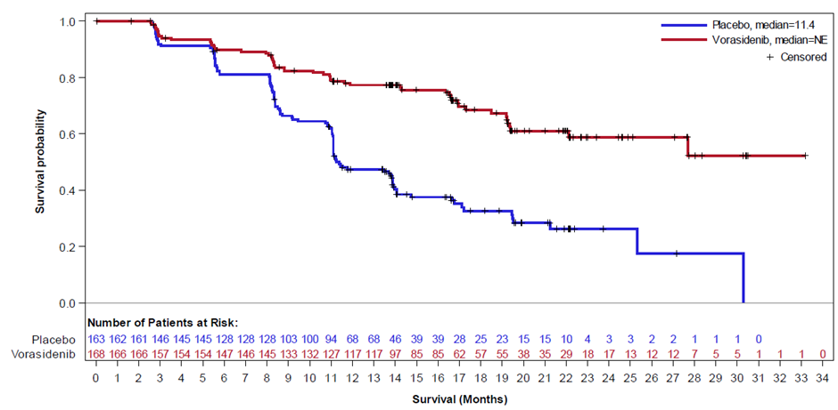
Source: Figure C-1 resubmission (p12), Figure 1 vorasidenib PSD, July 2025 PBAC meeting.
Abbreviations: INV = investigator assessed; DCO = data cut off; KM = Kaplan-Meier; PFS = progression free survival

  - The resubmission provided a comparison of PFS (BICR) with PFS (INV) based on the March 2023 DCO to examine the impact of the changing from BICR to INV (see Figure 2. The resubmission noted that for both the placebo and vorasidenib arms, PFS (INV) was longer than PFS (BIRC). The resubmission argued that results based on PFS (INV) are potentially more applicable to Australian practice than PFS (BIRC), given that clinician-based assessment of PFS is more likely to resemble PFS (INV) since, in practice, MRI scans are not sent to a blinded independent review committee for assessment.
  - The lognormal extrapolation was the function that best fit the Kaplan-Meier (KM) functions according to the Aikaike Information Criterion (AIC) for both INV and BICR for the March 2023 DCO. The resubmission noted that the modelled incremental PFS (discounted) was 31.37 months for PFS (BICR) and 37.96 for PFS (INV). Although the modelled incremental PFS benefit was greater using the INV data, the modelled incremental costs were also higher due to the longer time on treatment. The resubmission stated that the impact of the change from PFS (BIRC) to PFS (INV) results in slightly higher ICERs, and the change does not favour vorasidenib.
Figure 2: Comparison of PFS (INV) and PFS (BICR) KM functions March 2023 DCO with extrapolation (lognormal)
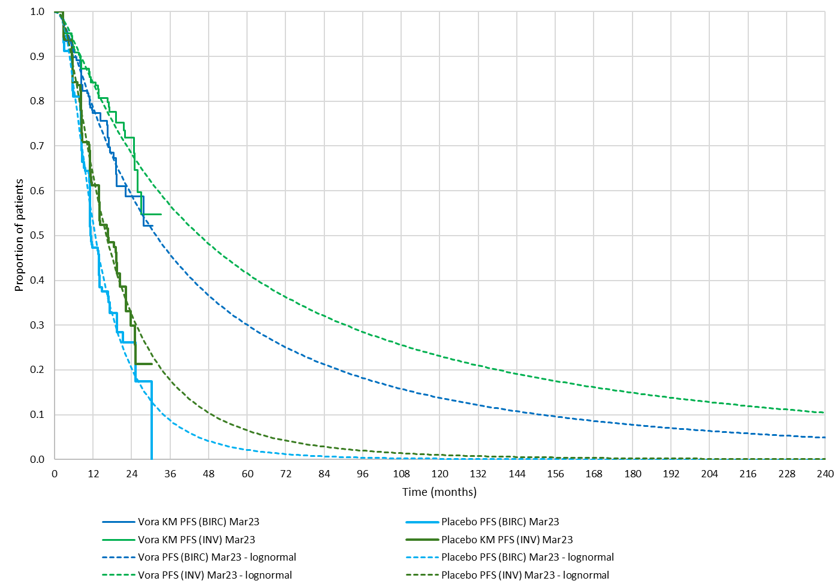
Source: Figure C-2 resubmission p13
Abbreviations: INV = investigator assessed; DCO = data cut off; KM = Kaplan-Meier; PFS = progression free survival

  - The resubmission also presented a comparison of the KM trace of PFS (INV) from the March 2023 and Jan 2025 DCOs (see Figure 3). The KM for PFS (INV) from Jan 2025 showed a less steep decline than was seen in the tail of the KM for PFS (INV) from Mar 2023 DCO, indicating the unreliability of the tail of the KM for the earlier data cut, where low numbers of patients remained at risk. The resubmission noted that there were few additional events in the placebo arm for the Jan 25 DCO, which may be because almost all patients had crossed over to vorasidenib at the time of unblinding.
Figure 3: Comparison of KM functions based on PFS (INV) from Mar 2023 DCO and based on PFS (INV) Jan 2025 DCO
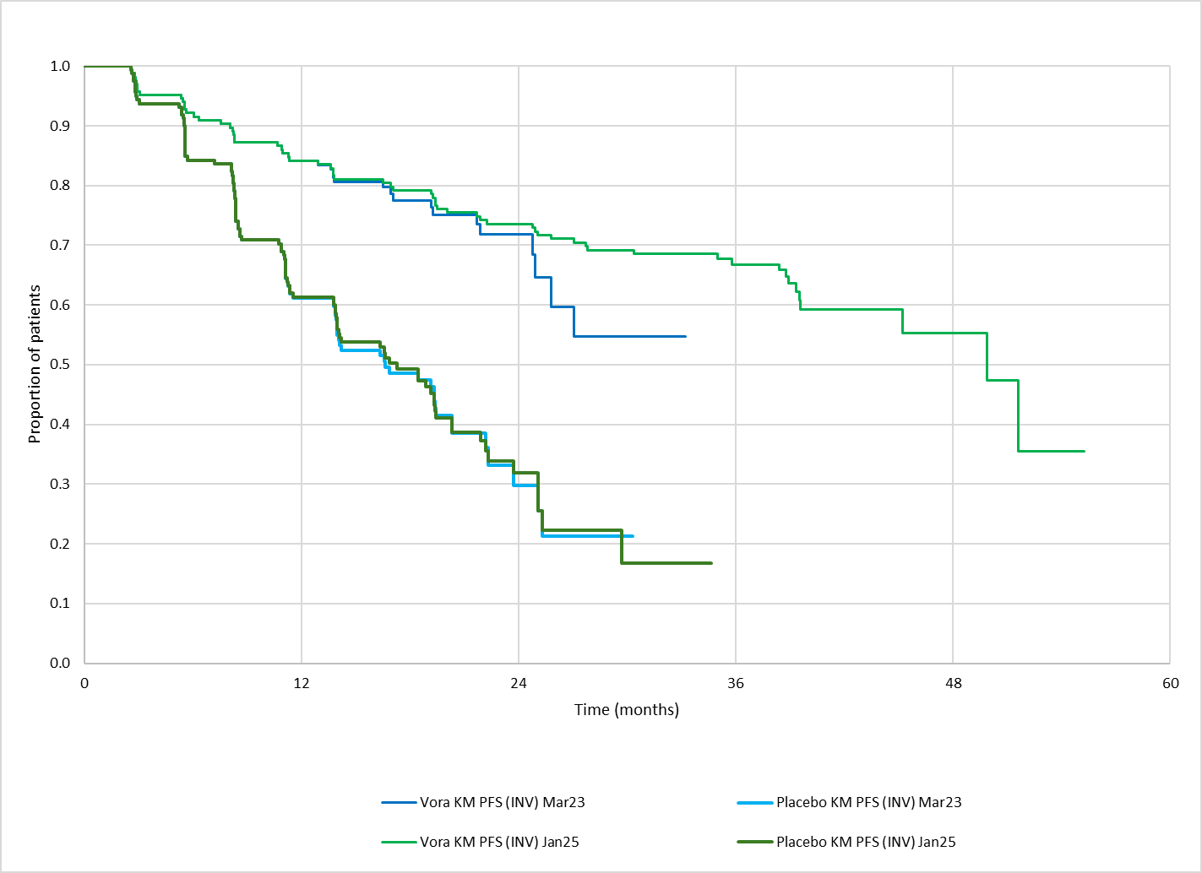
Source: Resubmission figure C-3 (p14)
Abbreviations: INV = investigator assessed; DCO = data cut off; KM = Kaplan-Meier; PFS = progression free survival
  - In July 2025 the PBAC noted the Weibull function was more conservative than lognormal, but was still a good fit for the KM data. The resubmission noted that for the updated data the parametric function with the best fit remained lognormal, but the parametric functions fit to the Jan 25 DCO suggested longer PFS for vorasidenib than those used in the July 2025 submission (Mar 2023 DCO). The resubmission also noted that the extent of uncertainty around the extrapolated PFS function was reduced with the additional follow-up data, with substantially less variation between the most conservative and most optimistic functions (see Figure 4). Using the most conservative function (Weibull) rather than the best fitting (lognormal) increased the ICER by redacted content%.
Figure 4: Comparison of KM functions, with most optimistic and most conservative parametric extrapolations based on PFS (INV) from Mar 2023 DCO and based on PFS (INV) Jan 2025 DCO
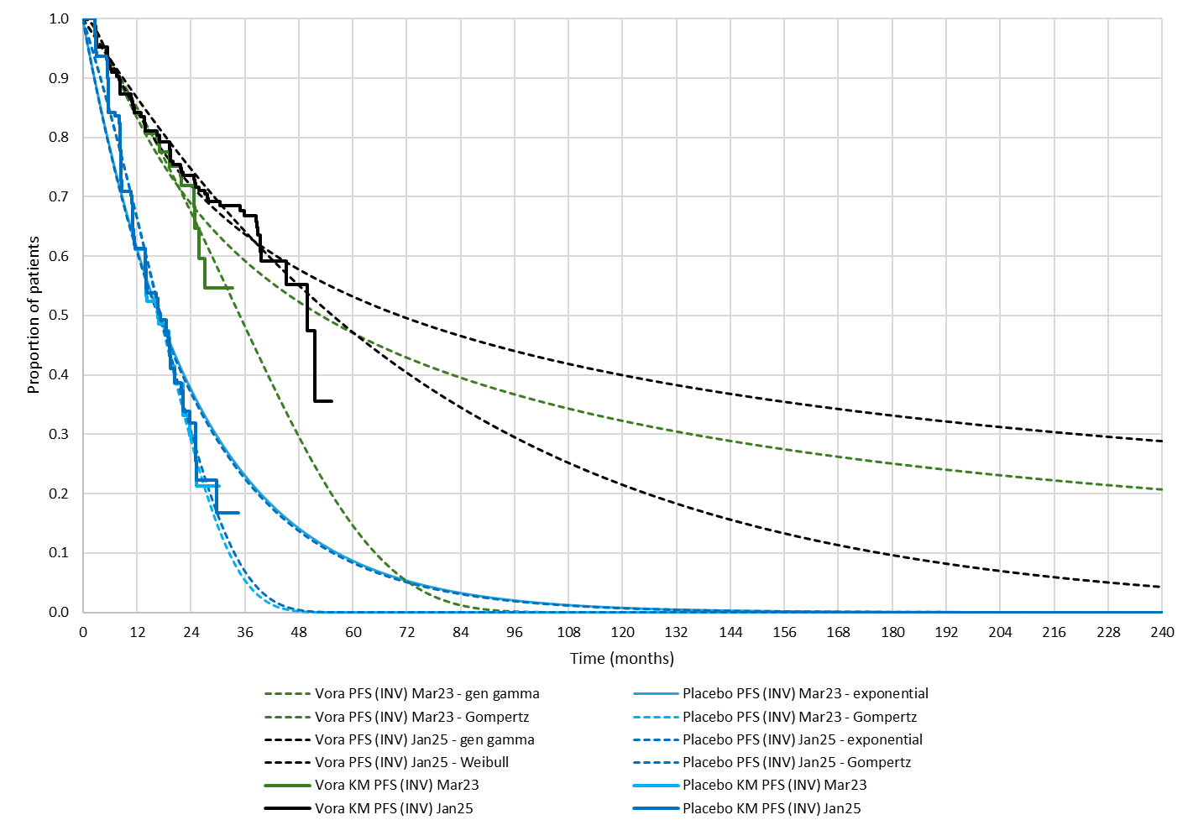
Source: Figure C-4 resubmission (p15)
Abbreviations: INV = investigator assessed; DCO = data cut off; KM = Kaplan-Meier; PFS = progression free survival
Duration of treatment with vorasidenib
  - In July 2025 the PBAC considered that the treatment duration for vorasidenib (64.5 months) was highly uncertain as it was based on extensive extrapolation of radiographic PFS for the vorasidenib arm in the INDIGO trial and was driven by the extrapolation function chosen (paragraph 7.13, vorasidenib PSD, July 2025 PBAC meeting). The resubmission noted that time on treatment is now estimated to be longer due to the switch from PFS (BIRC) to PFS (INV). The revised model resulted in a mean treatment duration of 10.16 years (121.9 months) based on the total progression-free life years (undiscounted) for the vorasidenib arm, for a 40-year time horizon.
Translation of PFS to OS
  - In July 2025 the PBAC considered it is unclear to what extent the improvements in radiographic PFS associated with vorasidenib treatment will translate into improvements in OS, and noted further analyses of the INDIGO trial will not be informative due to the large number of patients who crossed over from the placebo arm to receive vorasidenib. The PBAC noted that due to the indolent nature of the disease it was not possible to demonstrate a difference in OS within the trial (paragraph 7.9, vorasidenib PSD, July 2025 PBAC meeting). Due to the lack of meaningful OS data in the INDIGO trial, the probability of transitioning from the progressed disease health state to the dead state was derived from an analysis of Australian brain tumour registry data, and was assumed to be the same for the vorasidenib and active surveillance arms. This was unchanged in the resubmission, which did not revise the structure of the model. The resubmission stated that it is generally accepted that delaying glioma growth and malignant transformation to higher-grade disease improves long-term survival, and that evidence from other settings supports this relationship:
- The RTOG 9802 study, which compared radiotherapy (RT) with or without chemotherapy (CT) in high-risk low-grade glioma in patients with high-risk grade 2 glioma, showed that delaying progression translated into improved OS. As with INDIGO, the trial initially showed only a gain in PFS, OS gains emerged after long-term follow-up.
- A meta-analysis of 91 glioblastoma trials (Han 2014) demonstrated that prolonged PFS was associated with better OS outcomes. The meta-analysis demonstrated a strong correlation between PFS and OS (R² = 0.92 for hazard ratios).
- Analysis from the Australian brain tumour registry (BRAIN) indicates that longer PFS correlates with longer post-progression survival.
  - The resubmission also noted that there have now been 5 deaths in the vorasidenib arm of the INDIGO trial. Though this reflects a small proportion of patients, the projected KM OS function for vorasidenib produced by the model, by application of post-progression survival data from the BRAIN registry, is consistent with the actual KM OS function observed in the trial.
Utility values
  - In July 2025 the PBAC noted that the health state utilities, though based on the available quality of life data from INDIGO, appeared high given the symptom burden for patients with glioma (paragraph 7.12, vorasidenib PSD, July 2025 PBAC meeting) and considered that the economic model should be revised to use values as per the dabrafenib + trametinib submission (paragraph 7.15, vorasidenib PSD, July 2025 PBAC meeting). The resubmission did not revise the utility values in the base case as requested. The resubmission argued that the utility values from INDIGO were specific to the relevant patient population, whereas the values used in the dabrafenib + trametinib submission reflect quality of life in patients with with high-grade glioma who are stable after surgery, without undergoing radiotherapy or chemotherapy. The resubmission noted that use of values derived from the target population is consistent with the PBAC Guidelines. Sensitivity analyses applying the 0.89 utility weight for progression-free disease and 0.73 for post-progression (with linear decline) indicated that this had a minimal impact on the ICER (<redacted content% increase). The resubmission also provided sensitivity analyses using non-linear decline in post-progression utility, which increased the ICER by up to redacted content%.
Results
  - The resubmission presented stepped changes to the model, as shown in Table 4. The revised ICER was $95,000 to < $115,000 per QALY. The sponsor acknowledged that the base case ICER exceeds the $75,000 to < $95,000/QALY requested by the PBAC but maintained vorasidenib is a cost-effective treatment option and the ICER is within the range previously accepted for diseases where no other treatments are available. The Pre-PBAC Response stated the proposed ICER of $95,000 to < $115,000 /QALY sits within the range the PBAC has previously accepted for rare conditions with comparable PBAC assessment around the quality of evidence presented.
Table 4: Revised model (stepped changes)
 | Lifetime discounted costs |  | Incremental costs | Lifetime discounted QALYs |  | Incremental QALYs | ICER per QALY gained
 | Vorasidenib | Placebo | Incremental costs | Vorasidenib | Placebo | Incremental QALYs | ICER per QALY gained
Base case considered by the PBAC in July 2025 | $redacted content | $167,634 | $redacted content | 6.206 | 4.203 | 2.003 | $redacted content¹
1: Updates to fees, copayments, unit costs, life tables and corrections | $redacted content | $177,044ª | $redacted content | 6.143 | 4.130 | 2.013 | $redacted content¹
2: Updates to proposed price of vorasidenib | $redacted content | $177,044 | $redacted content | 6.143 | 4.130 | 2.013 | $redacted content²
3: Switch from PFS (BIRC) to PFS (INV) using Mar 2023 DCO | $redacted content | $175,982 | $redacted content | 6.782 | 4.355 | 2.427 | $redacted content²
4: Switch from PFS (INV) from Mar 2023 DCO to PFS (INV) from Jan 2025 DCO | $redacted content | $175,826 | $redacted content | 7.942 | 4.387 | 3.555 | $redacted content³
Revised base case economic evaluation presented in the resubmission | $redacted content | $175,826 | $redacted content | 7.942 | 4.387 | 3.555 | $redacted content³
Alternate revised base case  Application of SPRs^{b} to price of vorasidenib over time | $redacted content | $175,826 | $redacted content | 7.942 | 4.387 | 3.555 | $redacted content³
Source: Table C-6 resubmission pp25-26
Abbreviations: ABS = Australian Bureau of Statistics; CGRP = calcitonin gene-related peptide; DCO = data cutoff; INV = investigator-assessed; Jan = January; MBS = Medicare Benefits Schedule; MINS = PBAC minutes from the July 2025 PBAC meeting for item 5.15; Nov = November; PBS = Pharmaceutical Benefits Scheme; QALYs = quality-adjusted life years; SPRs = statutory price reductions.
a Value corrected in pre-PBAC response.
b The alternate base case assumes that a statutory reduction of 5% will be applied to the approved ex-manufacturer price (AEMP) at 5 years from the beginning of first cycle of the model, a further 5% reduction in AEMP will apply at 10 years, and then a 30% reduction in the AEMP will apply at 15 years. No changes are made to the proposed rebate.
The redacted values correspond to the following ranges:
¹ $155,000 to < $255,000
² $115,000 to < $135,000
³ $95,000 to < $115,000

  - The resubmission presented sensitivity analyses, the most relevant analyses are shown in Table 5.
Table 5: Sensitivity analyses for revised economic evaluation
 | Incremental costs | Incremental QALYs | ICER | Change to ICER
Base case | $redacted content | 3.555 | $redacted content¹ | -
Discount rate (base case = 5%)
0% | $redacted content | 7.325 | $redacted content² | -redacted content%
3.5% | $redacted content | 4.320 | $redacted content¹ | -redacted content%
Time horizon (base case = 40 years)
30 years | $redacted content | 3.386 | $redacted content¹ | +redacted content%
50 years | $redacted content | 3.607 | $redacted content¹ | -redacted content%
Parametric function fitted to PFS in the vorasidenib arm (base case = lognormal)
Exponential | $redacted content | 2.605 | $redacted content³ | +redacted content%
Weibull | $redacted content | 2.518 | $redacted content³ | +redacted content%
Gompertz | $redacted content | 2.825 | $redacted content¹ | +redacted content%
Generalised gamma | $redacted content | 4.216 | $redacted content¹ | -redacted content%
Loglogistic | $redacted content | 3.369 | $redacted content¹ | +redacted content%
Parametric function fitted to PFS in the active surveillance arm (base case = lognormal)
Exponential | $redacted content | 3.552 | $redacted content¹ | +redacted content%
Weibull | $redacted content | 3.711 | $redacted content¹ | -redacted content%
Gompertz | $redacted content | 3.747 | $redacted content¹ | -redacted content%
Generalised gamma | $redacted content | 3.555 | $redacted content¹ | -
Loglogistic | $redacted content | 3.507 | $redacted content¹ | +redacted content%
Parametric function fitted to post-progression survival (base case = Gompertz)
Exponential | $redacted content | 3.251 | $redacted content¹ | +redacted content%
Weibull | $redacted content | 3.433 | $redacted content¹ | +redacted content%
Generalised gamma | $redacted content | 3.585 | $redacted content¹ | -redacted content%
Lognormal | $redacted content | 3.206 | $redacted content¹ | +redacted content%
Loglogistic | $redacted content | 3.268 | $redacted content¹ | +redacted content%
Health state utilities (base case = progression-free 0.93; post-progression initially 0.93 constantly declining to 0 over 8.43 years)
Progression free: 0.93  Post-progression: initially 0.93 with non-linear decline to 0 over 8.43 years | $redacted content | 3.339 | $redacted content¹ | +redacted content%
Progression free: 0.93  Post-progression: initially 0.73 with linear decline to 0 over 8.43 years | $redacted content | 3.721 | $redacted content¹ | -redacted content%
Progression free: 0.93  Post-progression: initially 0.73 with non-linear decline to 0 over 8.43 years | $redacted content | 3.551 | $redacted content¹ | +redacted content%
Progression free: 0.89  Post-progression: initially 0.73 with linear decline to 0 over 8.43 years | $redacted content | 3.539 | $redacted content¹ | +redacted content%
Progression free: 0.89  Post-progression: initially 0.73 with non-linear decline to 0 over 8.43 years | $redacted content | 3.369 | $redacted content¹ | +redacted content%
Univariate analysis with utilities based on dabrafenib submission (progression-free: 0.89; progressed disease: 0.73). | $redacted content | 2.922 | $redacted content³ | redacted content%
Impact of anniversary SPRs (base case = not applied, alternate base case presented applying SPRs as detailed in the National Health Act 1953; 5% at year 5, 5% at year 10, 30% at year 15 after PBS listing)
Alternate base case* (SPRs included for patients starting treatment with vorasidenib on the day of PBS listing). | $redacted content | 3.555 | $redacted content¹ | -redacted content%
Patient starting treatment with vorasidenib 5 years after PBS listing (i.e., 5% SPR applied) | $redacted content | 3.555 | $redacted content² | -redacted content%
Patient starting treatment with vorasidenib 10 years after PBS listing (i.e., 5% SPR applied in addition to 5-year SPR) | $redacted content | 3.555 | $redacted content² | -redacted content%
Patient starting treatment with vorasidenib 15 years after PBS listing (i.e., 30% SPR applied in addition to 5- and 10-year SPRs) | $redacted content | 3.555 | $redacted content⁴ | -redacted content%
Multivariate sensitivity analyses
PFS extrapolation for vorasidenib arm: Weibull function  Utilities based on dabrafenib submission (progression-free: 0.89; progressed disease: 0.73) | $redacted content | 2.095 | $redacted content⁵ | redacted content%
Source: Table C9 resubmission p28, and conducted for submission overview.
Abbreviations: ICER = incremental cost effectiveness ratio; PFS = progression-free survival; SPR = statutory price reduction; QALY = quality adjusted life year
The redacted values correspond to the following ranges:
¹ $95,000 to < $115,000
² $75,000 to < $95,000
³ $115,000 to < $135,000
⁴ $55,000 to < $75,000
⁵ $135,000 to < $155,000

Vorasidenib cost/patient/year
  - The estimated drug cost/patient/year at the revised price (effective DPMQ = $redacted content), would be $redacted content, based on 30.4 days per month (as in the revised economic model), and a dose intensity of 93.6% (as in the model). The estimated drug cost/patient/year in the July 2025 submission was $redacted content (Table 13, vorasidenib ratified minutes, July 2025 PBAC meeting).

Estimated PBS usage & financial implications
  - At the July 2025 meeting, the PBAC considered that the approach to estimation of utilisation and financial estimates was generally reasonable (paragraph 7.13 vorasidenib PSD, July 2025 PBAC meeting). The PBAC considered a resubmission should include revised financial estimates with corrections to cost and persistence rate calculations, inclusion of prevalent patients from before 2020 and revised mean treatment duration (paragraph 7.15 vorasidenib PSD, July 2025 PBAC meeting). The changes applied in the revised estimates are summarised in Table 6.
Table 6: Changes the inputs for the financial estimates
Data | July 2025 input | July 2025 Commentary and Sub-Committees comments | March 2026 input
Eligible population
Prevalent cases of IDH-mutant glioma in Year 1 of listing | 369 | An error was identified by the evaluators in the financial worksheet where the persistence rate was applied to each previous year’s population rather than the initial population.  The PBAC considered that prevalent patients were likely to be underestimated and patients from before 2020 should be included in the financial estimates given the long natural history of the condition. | Error corrected  Prevalent patients have been recalculated to include incident patients diagnosed from 2008 onwards, increasing prevalent patients to 470 in year 1. An error was identified in the estimates where the year 1 persistence rate (84.08% was applied every year for patients diagnosed in 2008-2014 (cells Y26 – AC32 in 11. Persistent population).
Grandfathered patients | redacted content¹ patients | Grandfathered patients were appropriately removed from the prevalent patient pool. | Grandfathered patient estimates are updated to redacted content¹, based on the current number of patients on treatment with vorasidenib through Servier’s Compassionate Access Program (as of 09/12/2025)
Treatment utilisation
Vorasidenib treatment persistence | Yr 1: 100%  Yr 2: 77%  Yr 3: 59%  Yr 4: 49%  Yr 5: 39%  Yr 6: 32% | Progression events in the economic model were based on radiographic progression. It is unclear whether patients treated with vorasidenib in clinical practice will discontinue treatment with vorasidenib following an initial finding of radiographic disease progression. Additionally, patients may not receive MRI scanning as frequently as in the INIDIGO trial which may delay the identification of disease progression. | Persistence rate has been updated to reflect the new base case for PFS, which is based on PFS per investigator results from the INDIGO trial with 22 months of additional follow-up from the data submitted in the initial submission.  Updated persistence rate (based on PFS (per INV) – January 2025 datacut)  Yr 1: 100%  Yr 2: 84.08%  Yr 3: 73.41%  Yr 4: 66.56%  Yr 5: 55.01%  Yr 6: 49.79%
Costs
Vorasidenib | 40 mg × 30 tablets: $redacted content  10 mg × 60 tablets: $redacted content  10 mg × 30 tablets: $redacted content | - | The resubmission reduced the proposed effective dispensed price to the following:  40 mg × 30 tablets: $redacted content  10 mg × 60 tablets: $redacted content  10 mg × 30 tablets: $redacted content  These prices incorporate updated wholesalers markup effective July 2026
MBS costs | $300.20 (cost of MRI testing for progression)  $37.75 (MBS code 6612 + 91790) | The PBAC noted that costs associated with liver function test monitoring were not included in the financial estimates. This was not appropriate and differed from the economic model. | Liver function tests included in the updated budget impact model.  The resubmission assumed patients will receive liver function tests once before initiation, then once every 2 weeks for 2 months followed by once monthly indefinitely. However, the economic model and PI assume liver function tests will only occur for the first 2 years of treatment.  The estimates calculate the average number of services/patient/year for MRI and liver function tests based on the average difference in duration of treatment of vorasidenib and placebo (8.3 years). However, as the estimates only consider the first 6 years of treatment, the number of services is overestimated.
Source: Table D-2 resubmission pp33-34
Abbreviations: INV = investigator assessed; MBS = Medicare benefits schedule; MRI = magnetic resonance imaging; PFS = progression free survival
The redacted values correspond to the following ranges:
¹ < 500

  - Revised financial estimates are shown in Table 7. The estimated net cost to the PBS/RPBS in the resubmission’s revised financial implications was $40 million to < $50 million in Year 1, increasing to $50 million to < $60 million in Year 6, a total cost of $200 million to < $300 million over the first 6 years of listing. The total cost over the first 6 years of listing in the July 2025 submission was $200 million to < $300 million. The number of patients initiating treatment increased in year 1 due to additional prevalent patients; the number of patients continuing treatment in subsequent years increased substantially due to the increased number of prevalent patients and updated persistence rates from the revised economic model. Despite the increase in patient numbers the net cost over 6 years remained similar to the July 2025 submission due to the reduced price for vorasidenib.
Table 7: Revised estimated utilisation and financial implications
 |  | Year 1 |  | Year 2 | Year 3 | Year 4 | Year 5 | Year 6
Estimated extent of use July 2025 submission (corrected)
Number of patients treated |  | redacted content¹ |  | redacted content¹ | redacted content² | redacted content² | redacted content² | redacted content²
Estimated financial implications of vorasidenib (corrected)
Net cost to MBS |  | $redacted content³ |  | $redacted content³ | $redacted content³ | $redacted content³ | $redacted content³ | $redacted content³
Net cost to PBS/RPBS/MBS |  | $redacted content⁴ |  | $redacted content⁴ | $redacted content⁴ | $redacted content⁴ | $redacted content⁴ | $redacted content⁴
Estimated extent of use
Number of patients initiating treatment | redacted content¹ |  | redacted content² |  | redacted content² | redacted content² | redacted content² | redacted content²
Total number of patients treated | redacted content¹ |  | redacted content¹ |  | redacted content¹ | redacted content¹ | redacted content¹ | redacted content¹
Estimated financial implications of vorasidenib
Cost to PBS/RPBS less copayments | $redacted content⁴ |  | $redacted content⁴ |  | $redacted content⁴ | $redacted content⁴ | $redacted content⁴ | $redacted content⁵
Net cost to MBS ª | $redacted content³ |  | $redacted content³ |  | $redacted content³ | $redacted content³ | $redacted content³ | $redacted content³
Net cost to PBS/RPBS/MBS ª | $redacted content⁴ |  | $redacted content⁴ |  | $redacted content⁴ | $redacted content | $redacted content⁵ | $redacted content⁵
Net cost to PBS/RPBS less copayments – corrected patient numbers (cells Y26 – AC32 in 11. Persistent population) ^{b} | $redacted content⁴ |  | $redacted content⁴ |  | $redacted content⁴ | $redacted content⁴ | $redacted content⁴ | $redacted content⁵
Source: Resubmission financial estimates worksheet “5. Impact – net”, Table 15 July 2025 vorasidenib submission
a Values were incorrectly reported in the resubmission and have been corrected from the workbook
b Correction of the error identified in the estimates where the year 1 persistence rate (84.08% was applied every year for patients diagnosed in 2008-2014
The redacted values correspond to the following ranges:
¹ 500 to < 5,000
² < 500
³ $0 to < $10 million
⁴ $40 million to < $50 million
⁵ $50 million to < $60 million

Financial Management – Risk Sharing Arrangements
  - In July 2025, the PBAC considered that, given the high level of uncertainty regarding the duration of treatment, the uncertain benefit of treatment beyond radiographic progression, the high cost for vorasidenib, and uncertainty regarding the extent of overall gain in health outcomes, a risk sharing arrangement (RSA) would give the committee confidence that the cost for vorasidenib treatment would be contained and acceptably cost-effective. The PBAC considered it would be appropriate for financial caps for vorasidenib to be calculated based on a duration of treatment reflecting radiographic PFS consistent with the evidence from INDIGO (and extrapolated consistent with the revised model) and costs for use beyond progression should be rebated as such use is unlikely to be cost-effective (paragraph 7.14, vorasidenib PSD, July 2025).
  - The resubmission proposed an RSA with financial caps based on the estimated cost to PBS/RPBS as per Table 7, noting that these estimates have been revised to address concerns raised by the PBAC around the prevalence estimates and persistence rates. A two-tier RSA was proposed, with Tier 1 set at the level of the base case estimates and Tier 2 set at redacted content% higher than Tier 1. A rebate of redacted content% above Tier 1 and redacted content% above Tier 2 was proposed. The resubmission's rationale for the two tiers was that the base case estimates underpinning Tier 1 assume uptake below redacted content%; full uptake would increase cost above Tier 1 but remain within Tier 2. Uptake rates assumed in the financial estimates were redacted content% in year 1 and redacted content% thereafter for incident patients and redacted content% for prevalent patients. It is unclear whether it is reasonable for Tier 2 to be set above estimates based on redacted content% uptake. The Tier 1 and Tier 2 amounts should be updated to reflect corrections to the persistence rates for patients diagnosed in 2008-2014 (see Table 7). The Pre-PBAC Response acknowledged that Tier 2 of the proposed RSA should not exceed the financial estimates based on redacted content% uptake of vorasidenib in eligible patients and accepted Tier 2 of the proposed RSA to include redacted content0% uptake.
Table 8: Proposed RSA financial caps
Year | Tier 1ª | Tier 2^{b} | Financial estimates assuming redacted content% uptake
Y1 (2026) | $redacted content | $redacted content | $redacted content
Y2 (2027) | $redacted content | $redacted content | $redacted content
Y3 (2028) | $redacted content | $redacted content | $redacted content
Y4 (2029) | $redacted content | $redacted content | $redacted content
Y5 (2030) | $redacted content | $redacted content | $redacted content
a Based on Net effective PBS/RPBS cost estimated in Table 7.
b Calculated by adding redacted content% to Threshold 1
For more detail on PBAC’s view, see section 7 PBAC outcome.
- PBAC Outcome
  - The PBAC recommended the listing of vorasidenib for the treatment of isocitrate dehydrogenase-mutant (IDH) astrocytoma or oligodendroglioma. The PBAC maintained its view that there is a high unmet clinical need for effective treatments for astrocytoma and oligodendroglioma, noting that there are currently no other effective treatments available for patients not in immediate need of chemotherapy/radiotherapy. The PBAC was satisfied that vorasidenib provides, for some patients, a significant improvement in efficacy over active surveillance in terms of radiographic progression and acknowledged that delaying the need for chemotherapy and radiation therapy and reduction in epileptic seizures are clinically meaningful outcomes that are likely to positively impact on patient quality of life (QoL). The PBAC noted that due to the slow progressing nature of the disease it was not possible to demonstrate a difference in overall survival or QoL within the trial, and due to a substantial proportion of patients in the control arm of the trial crossing over to receive vorasidenib, further data from the trial are unlikely to address these data gaps. The PBAC considered the revised economic and financial models provided in the resubmission addressed most of the Committee’s previous concerns. The PBAC considered the cost-effectiveness estimate based on the revised model was still uncertain due to the limited data regarding the long-term benefits and the likely duration of treatment. However, vorasidenib was considered acceptably cost-effective at the reduced price proposed in the resubmission and the revised financial estimates were considered reasonable. The PBAC advised that amendments to the proposed Risk Sharing Arrangement (RSA) were required to address the potential for use beyond radiological progression.
  - The PBAC noted the very strong consumer support for the listing of vorasidenib for this condition. The PBAC noted the importance of addressing the clinical need associated with delaying progression of disease and delaying the need for more toxic therapies (chemoradiation). The inputs emphasised this is valuable to patients and likely to result in improved QoL over a number of years for patients, families and carers. Additionally, the PBAC noted inputs highlighted the significant QoL impacts of seizures in patients with astrocytoma or oligodendroglioma which the PBAC noted was not highlighted in the previous submission nor the clinical data. The PBAC also acknowledged that chemotherapy/radiotherapy is associated with substantial toxicity and worsening of neurological deficits. The inputs outlined the impact vorasidenib has had on consumers since commencing treatment, including offering hope, prolonging life and allowing for a better quality of life. The PBAC noted the sponsor hearing clarified that with more experience using vorasidenib clinicians may consider a treatment break or to stop treatment after approximately 5 years and clinicians are unlikely to treat beyond radiological progression given it may compromise outcomes for radiotherapy and surgery. It is still unclear whether patients would benefit from treatment breaks with vorasidenib and that further data and surveillance is required to inform this. The PBAC noted the inputs were supportive of the evidence provided in the submission. The PBAC valued the inputs provided as they allowed additional insight into the patient, carer and health care provider perspective for a rare disease.
  - The PBAC reaffirmed its view that the nominated comparator of active surveillance was appropriate as no other treatments are available for patients not in immediate need of radiotherapy/chemotherapy.
  - The resubmission presented a new data cut from the INDIGO trial which provided approximately 22 months of additional follow-up data, to 17 January 2025 (Jan 25 DCO). The PBAC maintained its view that that the claims of superior comparative effectiveness and inferior comparative safety were still reasonable. The PBAC reiterated its previous view that the PFS benefit shown was substantial, likely to be highly clinically relevant for patients and to result in QoL benefits.
  - The PBAC recalled its previous advice regarding the economic model and cost-effectiveness of vorasidenib (see Table 1 and paragraph 4.17) to:
  - incorporate more conservative assumptions regarding PFS/OS (Weibull extrapolation function for PFS) and utility values (as per dabrafenib + trametinib submission, March 2024 PBAC meeting).
  - Including the revisions of the economic model as proposed, the resultant ICER should be of $75,000 to < $95,000/QALY or less, reflecting the high level of uncertainty regarding the magnitude of long-term benefits of treatment.
  - The PBAC noted that the resubmission revised and corrected a number of inputs in the resubmission model as requested, however the structure and function of the economic model were unchanged.
  - The PBAC noted the updated PFS data (INV) from the INDIGO trial (Jan 25 DCO) was applied in the revised economic analysis. The PBAC noted the economic model presented in the initial submission applied PFS data as assessed by the Blinded Independent Review Committee (BIRC), consistent with the primary endpoint of the INDIGO trial. The resubmission stated that the impact of the change from PFS (BIRC) to PFS (INV) resulted in slightly higher ICERs, and the change did not favour vorasidenib. The PBAC considered it was reasonable to apply PFS (INV) as this was the outcome available for the extended data cut. The PBAC recalled that in July 2025, it noted the Weibull function resulted in more conservative PFS extrapolations than the lognormal, and was a good fit for the KM data. The PBAC noted the parametric function with the best fit with the updated data applied remained the lognormal. The PBAC accepted the lognormal function in the base case, noting that the extent of uncertainty around the extrapolated PFS function was reduced with the additional follow-up data (see Figure 4) and that using the Weibull function instead of the lognormal increased the ICER by redacted content%.
  - The PBAC noted that the modelled mean treatment duration increased from 5.37 years (64.5 months) to 10.16 years (121.9 months), based on the total progression-free life years (undiscounted) over a 40 year time horizon for the vorasidenib arm. The PBAC noted that this increase was mainly due to the switch from PFS (BIRC) to PFS (INV). The PBAC considered that the longer treatment duration assumed in the resubmission was plausible based on the longer PFS follow-up and the slow-progressing nature of the disease, and accepted that PFS (INV) would better represent clinical practice. However, the PBAC noted that input from the sponsor hearing suggested that clinicians may also look to stop treatment or have a treatment break after approximately 5 years.
  - The PBAC noted the resubmission did not revise the utility values in the base case as requested. The PBAC recalled that in July 2025, it noted that the health state utilities, though based on the available quality of life data from INDIGO, appeared high given the symptom burden for patients with glioma (paragraph 7.12, vorasidenib PSD, July 2025 PBAC meeting) and considered that the economic model should be revised to use values as per the dabrafenib + trametinib submission (paragraph 7.15, vorasidenib PSD, July 2025 PBAC meeting). The resubmission argued that the utility values from INDIGO were specific to the relevant patient population, whereas the values used in the dabrafenib + trametinib submission reflect quality of life in patients with with high-grade glioma who are stable after surgery, without undergoing radiotherapy or chemotherapy. The resubmission also argued that the approach to the linear decline in post-progression utility reflected the stepwise decline in QoL. The PBAC noted this was consistent with information provided in the sponsor hearing. The PBAC noted that the ICER increased to $115,000 to < $135,000/QALY when the dabrafenib + trametinib utility values were applied without linear decline. The PBAC considered there was uncertainty in the values applied, but accepted the utility values and linear decline in post-progression utility as applied in the resubmission base case were reasonable.
  - The PBAC noted that the resubmission included a reduction in the proposed price for vorasidenib. The PBAC noted the resubmission’s base case ICER exceeded the $75,000 to < $95,000/QALY requested by the PBAC previously. However, the PBAC considered that the additional PFS data helped to address the uncertainty from the previous consideration. Therefore, the PBAC accepted the revised ICER of $95,000 to < $115,000 /QALY.
  - Regarding the utilisation and financial estimates (see Table 1 and paragraph 4.34), the PBAC recalled its advice that they should include corrections to the cost and persistence rate calculations, prevalent patients from before 2020 and a revised mean treatment duration. The PBAC noted the financial estimates were revised as requested and appeared to be reasonable. The PBAC noted that despite the increase in patient numbers, the net cost over 6 years remained similar to the July 2025 submission due to the reduced price for vorasidenib.
  - The PBAC noted the resubmission’s proposal of a two-tier RSA, with Tier 1 set at the level of the base case estimates and Tier 2 set at redacted content% higher than Tier 1, with a rebate of redacted content% above Tier 1 and redacted content% above Tier 2. The PBAC maintained its view from July 2025 that there was a high level of uncertainty regarding the duration of treatment the benefit of treatment beyond radiographic progression, and the extent of overall gain in health outcomes. Noting the increase in estimated patient numbers and treatment duration in the resubmission, the PBAC advised the RSA should be a single tier with expenditure caps based on the corrected estimated financial impacts in Table 7, with a rebate of redacted content% for expenditure on vorasidenib over the agreed expenditure caps. The PBAC considered a single tier RSA provided more confidence that the cost for vorasidenib treatment would be contained and acceptably cost-effective. The PBAC advised that the utilisation of vorasidenib should be reviewed once listed on the PBS to ensure patient numbers reflect the estimates in the submission.
  - In terms of the restriction, the PBAC advised that vorasidenib should be listed as a General Schedule item with an Authority Required (Streamlined) listing. The PBAC reaffirmed its recommendations about the restrictions as outlined in paragraph 3.1. Additionally, the PBAC accepted a grandfather restriction to allow patients receiving non-PBS subsidised vorasidenib, including those enrolled in the sponsor’s compassionate access program, to initiate PBS-funded vorasidenib treatment. The PBAC advised applying a standard 12-month expiry along with the relevant clinical criteria as included in the recommended listing section.
  - The PBAC recommended that vorasidenib should not be treated as interchangeable on an individual patient basis with any other drugs.
  - The PBAC advised that vorasidenib is suitable for prescribing by medical practitioners only.
  - The PBAC advised that the early supply rule should be applied to vorasidenib as it currently applies to similar cancer drugs with oral administration.
  - The PBAC found that the criteria prescribed by the National Health (Pharmaceuticals and Vaccines – Cost Recovery) Regulations 2022 for Pricing Pathway A were not met. Specifically the PBAC found that in the circumstances of its recommendation for vorasidenib:
  - The treatment is not expected to provide a substantial and clinically relevant improvement in efficacy over alternative therapies. Although INDIGO trial demonstrated vorasidenib was associated with improvement in PFS compared to placebo, it is unclear to what extent the improvements in radiographic PFS associated with vorasidenib treatment will translate into improvements in OS.
  - The treatment is expected to address a high and urgent unmet clinical need.
  - It was not necessary to make a finding in relation to whether it would be in the public interest for the subsequent pricing application to be progressed under Pricing Pathway A because one or more of the preceding tests had failed.
  - The PBAC noted that this submission is not eligible for an Independent Review as it received a positive PBAC recommendation.
Outcome:
Recommended

- Recommended listing
  - Add new item:
MEDICINAL PRODUCT  medicinal product pack |  |  | PBS item code | Max. qty packs | Max. qty units | №.of  Rpts | Available brands
VORASIDENIB
Vorasidenib 10 mg tablet, 30 |  |  | NEW | 2 | 60 | 5 | VORANIGO
Vorasidenib 40 mg tablet, 30 |  |  | NEW | 1 | 30 | 5 | VORANIGO
Concept ID (for internal Dept. use) |  | Category / Program:  GENERAL – General Schedule (Code GE)
 |  | Prescriber type: Medical Practitioners
 |  | Restriction type: Authority Required (Streamlined) [new code]
Prescribing rule level |  | Administrative Advice: No increase in the maximum quantity or number of units may be authorised.
Prescribing rule level |  | Administrative Advice: No increase in the maximum number of repeats may be authorised.
Prescribing rule level |  | Administrative Advice: Special Pricing Arrangements apply.
 |  | Episodicity: [blank]
 |  | Severity: [blank]
 |  | Condition: Adult-type IDH-mutant astrocytoma or oligodendroglioma
Restriction Summary [new1] / Treatment of Concept: [new1A]
 |  | Indication: Adult-type IDH-mutant astrocytoma or oligodendroglioma
 |  | Treatment Phase: Initial treatment
 |  | Clinical criteria:
 |  | Patient must have a World Health Organisation (WHO) Grade 2 astrocytoma or oligodendroglioma,
 |  | AND
 |  | Clinical criteria:
 |  | The patient must have a test of tumour tissue confirming the presence of a susceptible isocitrate dehydrogenase-1 (IDH1) R132H/C/G/S/L variant or isocitrate dehydrogenase-2 (IDH2) R172K/M/W/S/G variant,
 |  | AND
 |  | Clinical criteria:
 |  | Patient must have residual or recurrent disease after at least one prior surgery (biopsy, sub-total resection, or gross total resection) for this condition,
 |  | AND
 |  | Clinical criteria:
 |  | Patient must not be in immediate need of radiotherapy and/or chemotherapy for this condition,
 |  | AND
 |  | Clinical criteria:
 |  | The condition must not have been previously treated with systemic anticancer therapy or radiotherapy,
 |  | AND
 |  | Clinical criteria:
 |  | Patient must have either a: (i) Karnofsky Performance Score of at least 80%, (ii) Lansky Performance Score of at least 80%.
Prescriber instructions:
Confirm that evidence of the presence of a susceptible IDH1 or IDH2 variant in the tumour tissue is documented/retained in the patient's medical records once only with the first PBS prescription.
Restriction Summary [new2] / Treatment of Concept: [new2A]
 |  | Treatment Phase: Continuing treatment
 |  | Clinical criteria:
 |  | Patient must have previously received PBS-subsidised treatment with this drug for this condition.
 |  | AND
 |  | Clinical criteria
 |  | Patient must not have developed disease progression while receiving treatment with this drug for this condition.
Restriction Summary [new3] / Treatment of Concept: [new3A]
 |  | Treatment Phase: Transitioning from non-PBS to PBS-subsidised treatment - Grandfather arrangements
 |  | Clinical criteria:
 |  | Patient must have received non-PBS-subsidised treatment with this drug for this condition prior to [date of listing],
 |  | AND
 |  | Clinical criteria:
 |  | Patient must have a World Health Organisation (WHO) Grade 2 astrocytoma or oligodendroglioma
 |  | AND
 |  | Clinical criteria:
 |  | Patient must have had a susceptible isocitrate dehydrogenase-1 (IDH1) mutation or isocitrate dehydrogenase-2 (IDH2) mutation at the time of initiation of non-PBS-subsidised treatment with this drug,
 |  | AND
 |  | Clinical criteria:
 |  | Patient must have had an Eastern Cooperative Oncology Group (ECOG) performance status score of 1 or less at the time of initiation of non-PBS subsidised treatment with this drug,
 |  | AND
 |  | Clinical criteria:
 |  | Patient must have had residual or recurrent disease after at least one prior surgery (biopsy, sub-total resection, or gross total resection) for this condition at the time of initiation of non-PBS-subsidised treatment with this drug for this condition,
 |  | AND
 |  | Clinical criteria:
 |  | The condition must not have been previously treated with systemic anticancer therapy prior to initiation of non-PBS subsidised treatment with this drug for this condition
 |  | AND
 |  | Clinical criteria:
 |  | Patient must not have developed disease progression while receiving treatment with this drug for this condition.
Prescriber instructions:
Confirm that evidence of the presence of a susceptible IDH1 or IDH2 variant in the tumour tissue is documented/retained in the patient's medical records once only with the first PBS prescription.
 |  | Administrative advice: This grandfather restriction will cease to operate from 12 months after the date specified in the clinical criteria.
 |  | Administrative advice: Patients may qualify for PBS-subsidised treatment under this restriction once only. For continuing PBS-subsidised treatment, a 'Grandfathered' patient must qualify under the 'Continuing treatment' criteria.
These restrictions may be subject to further review. Should there be any changes made to the restriction the sponsor will be informed.

7 Context for Decision
The PBAC helps decide whether and, if so, how medicines should be subsidised through the Pharmaceutical Benefits Scheme (PBS) in Australia. It considers applications regarding the listing of medicines on the PBS and provides advice about other matters relating to the operation of the PBS in this context. A PBAC decision in relation to PBS listings does not necessarily represent a final PBAC view about the merits of the medicine or the circumstances in which it should be made available through the PBS. The PBAC welcomes applications containing new information at any time.

8 Sponsor’s Comment
Servier welcomes the positive recommendation made by the PBAC to list vorasidenib on the PBS. Servier would like to thank the IDH-mutant astrocytoma and oligodendroglioma patient and clinical communities for their valuable input, which helped inform the PBAC's recommendation. Servier also wishes to acknowledge the work of the PBAC and Department of Health, Disability and Ageing and thank them for their constructive engagement throughout the process. We look forward to continuing to work constructively with the Department to make vorasidenib available on the PBS at the earliest possible opportunity for the patients who need access to treatment.

https://www.health.gov.au/sites/default/files/2024-12/first-pharmaceutical-wholesaler-agreement-1pwa.pdf

