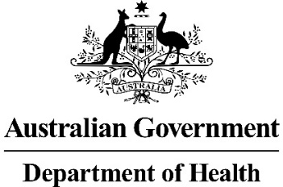
Simplified Chemotherapy Prescribing Arrangements
The Department of Health (the Department) has simplified the way Pharmaceutical Benefits Scheme (PBS) medicines can be prescribed for chemotherapy patients in public and private hospitals. These changes are enabled through legislative amendments to the National Health (Efficient Funding of Chemotherapy) Special Arrangement 2011 and the creation of the National Health (Chemotherapy Prescribing) Special Arrangement 2020.
These changes streamline the PBS prescribing and dispensing process for chemotherapy patients during the COVID-19 pandemic. The changes will improve the supply of PBS medicines to chemotherapy patients and apply on a national basis, enabling pharmacists to operate under a uniform, consistently applied framework.
Under the revised arrangements, all eligible PBS medicines for chemotherapy patients who are receiving treatment at or from a public or private hospital, can be prescribed and dispensed using a chemotherapy medication chart.
This is an interim arrangement, to support the prescribing and supply of medicines for chemotherapy patients amidst the COVID-19 pandemic. However, over the next six months, the Department will be developing a national PBS Chemotherapy Medication Chart in consultation with the Australian Commission on Safety and Quality in Healthcare and industry organisations. Requirements for electronic PBS Chemotherapy Medication Charts will also be developed as part of this process.
The revised arrangements for COVID-19, as outlined in this Fact Sheet, will remain in place until the national PBS Chemotherapy Medication Chart is available. The interim arrangement will then cease after a reasonable transition period.
The Department has developed a range of ‘Frequently Asked Questions’ to support hospitals, prescribers and pharmacists to adopt these changes, which are available on the PBS website. A fact sheet detailing how to generate Authority Prescription Numbers is also available on the PBS website to support PBS claiming. If you are interested in participating in the development of the PBS Chemotherapy Medication Chart, please provide an expression of interest via PBSHMC@health.gov.au.
For further information concerning the interim prescribing arrangements for chemotherapy, please contact the Department of Health via efc@health.gov.au.

