Pharmaceutical Benefits Scheme
Post-market Review of
Medicines to treat Pulmonary Arterial Hypertension
Term of Reference 2
Appendix 2 A
Final Report
November 2018

Term of Reference 2 Appendix 2
Contents

List of Tables 3
List of Figures 3
Abbreviations 4
PAH Medicines Utilisation Analysis 5
2.1 Summary 5
Purpose 5
Date of listing on PBS 5
Data Source / method 5
Key findings 5
2.2 Introduction 7
Background 7
2.3 PBS/RPBS claims data sources and Limitations 8
2.4 PBS/RPBS utilisation analysis methodology 9
Data sources, setting and population 9
Medicines of interest 9
Measures and data analysis 9
2.5 Results of utilisation analysis 12
Trends in PAH dispensing 12
Prevalence of PAH medicine use 16
Incidence of PAH medicine use 19
Time on treatment 22
Switching 22
Combination treatment 24
Appendix A 25
References 27

List of Tables
Table Number | Table Name
Table 2.1 | List of PAH medicines available from 2013-2016
Table 2.2 | Number of PAH dispensings and PBS benefits paid (in millions) by year
Table 2.3 | Annual number of prevalent users by patient characteristics
Table 2.4 | Annual number of incident (new) users by patient demographics and first medicine dispensed
Table 2.5 | Annual incidence of PAH use per 1,000,000 population by patient demographics
Table 2.6 | Persistence with treatment in first 720 days among incident PAH medicine users in 2014
Table 2.7 | Switching between PAH medicines among prevalent users 2013-2016
Table 2.8 | Characteristics of combination treatment
Table 2.9 | Characteristics of combination treatment – sensitivity analysis
Suppl. Table 1 | PBS listing details of PAH medicines by medicine class (as of November 2017).

List of Figures
Figure Number | Figure Name
Figure 2.1 | Quarterly dispensing by PAH medicine, 2013-2016
Figure 2.2 | Quarterly dispensing by medicine class, 2013-2016
Figure 2.3 | Quarterly dispensing by medicine class and strength, 2013-2016
Figure 2.4 | PBS benefit paid by medicine class (in millions AUD)
Figure 2.5 | PBS benefit paid by medicine (in millions AUD)
Figure 2.6 | Quarterly prevalence per 1,000,000 population by medicine class
Figure 2.7 | Quarterly prevalence per 1,000,000 population by sex
Figure 2.8 | Quarterly prevalence per 1,000,000 population by sex and age group
Figure 2.9 | Quarterly prevalence per 1,000,000 population by ''''''''''''' '''''''''
Figure 2.10 | Quarterly incidence and prevalence of use per 1,000,000 population

Abbreviations
Abbreviation | Full Name / Wording
ABS | Australian Bureau of Statistics
ACT | Australian Capital Territory
ATC | Anatomical Therapeutic Chemical
DoH | Department of Health
DUSC | Drug Utilisation Sub Committee
ERA | Endothelin receptor antagonist
FC | functional class
IQR | Inter quartile range
µg | micrograms
mg | milligrams
NSW | New South Wales
NT | Northern Territory
PAH | Pulmonary arterial hypertension
PBAC | Pharmaceutical Benefits Advisory Committee
PBS | Pharmaceutical Benefits Scheme
PDE-5 | Phosphodiesterase type-5
QLD | Queensland
RPBS | Repatriation Schedule of Pharmaceutical Benefits
SA | South Australia
TAS | Tasmania
TGA | Therapeutic Goods Administration
UNSW | University of New South Wales
VIC | Victoria
WHO | World Health Organization
WA | Western Australia

PAH Medicines Utilisation Analysis
Review the utilisation of PAH medicines in Australia, including sources of data that can provide additional information on clinical use that is not available from PBS data.

2.1 Summary

Purpose
To assess the utilisation of medicines listed on the Pharmaceutical Benefits Scheme (PBS) for the treatment of pulmonary arterial hypertension (PAH) from 1 July 2013 through to 31 December 2016.

Date of listing on PBS
There were seven PBS-listed medicines indicated for treatment of PAH in Australia between 2013 and 2016:
Table 2.1: List of PAH medicines available from 2013-2016
Drug name | Date listed on PBS
Bosentan | 1 March 2004
Iloprost | 1 April 2005
Epoprostenol | 1 August 2006
Sildenafil | 1 March 2007
Ambrisentan | 1 December 2009
Tadalafil | 1 April 2012
Macitentan | 1 September 2014

Data Source / method
- The analyses were based on PBS date of supply dispensing data from 1 July 2013 to 31 December 2016 for the total Australian population dispensed a PAH medicine at least once.

Key findings
- The annual number of PAH medicine dispensings increased from 20,454 in 2014 to 23,375 in 2016; the corresponding PBS benefit costs increased from $53.22 million to $58.75 million.
- Endothelin receptor antagonists (ERAs) were the most commonly dispensed medicine class, accounting for 77% of all PAH dispensings in 2016.
- Bosentan was the most commonly dispensed PAH medicine in 2015 and macitentan was the most commonly dispensed PAH medicine in 2016.
- The annual number of treated patients increased slightly, from 2,189 in 2014 to 2,394 in 2016.
- The majority of prevalent patients treated with PAH medicines were female (73% in 2016). Prevalent use increased with patient age until 65-74 years but declined thereafter. The largest proportion of prevalent patients resided in NSW/ACT.
- Incident (new) use of PAH medicines remained relatively stable across the study period.
- Incident use was higher among females (24.4 per 1,000,000 in 2016) than males (13.6 per 1,000,000 in 2016), and ''''' '''''''''' ''' ''''''' ''''''''''''''' '''' '''''''''''''''''' ''''''''''''' ''''''' ''''''''''''''''' '''' '''''''''''''
- The majority of incident patients started treatment with 10 mg macitentan (57% of new patients in 2016), followed by 20 mg sildenafil (18.7% of new patients in 2016).
- Among people who initiated on treatment in 2014, at the end of the first 360 days 70.9% of those still alive were still persistent with treatment (i.e. had not discontinued). By 720 days post-initiation, 61.9% of those still alive were still persistent with treatment.
- Switching between PBS-listed PAH medicines was not common. Among a total of 3187 treated patients, 418 (13%) switched medicines. Patients most commonly switched from PDE-5 inhibitors to ERAs.
- Combination treatment with PBS-listed PAH medicines was very rare; using a minimum period of overlapping use of 58 days, only 13 episodes of combination treatment were observed among a total of seven individuals.

2.2 Introduction

Background
Pulmonary arterial hypertension (PAH) is characterised by elevated pulmonary arterial pressure and pulmonary vascular resistance, which can ultimately lead to right ventricular failure and death.(1) PAH is a rare condition; studies from the United Kingdom, the United States, and the Czech Republic have found an estimated prevalence ranging from one to five cases per 100,000 individuals.(2-5)

Medicines used in the treatment of PAH were first listed on the PBS in 2004. Between July 2013 and 2016, PBS listed medicines fell into three classes: ERAs, synthetic prostacyclin / prostacyclin analogues, PDE-5 inhibitors. Riociguat, which was PBS listed in February 2017, belongs to a further class of PAH medicines: guanylate cyclase stimulators. A review of the PBS data estimated that in 2013 prevalent use of these medicines was 8.8 per 100,000 population and incident use was estimated at 1.9 per 100,000 population. The majority of patients treated were female (74%) and the mean age at initiation of 64.1 years.(6)

The prescription of subsidised medicines to treat PAH requires prior written authority approval from the Services Australia (formerly the Department of Human Services). The PBS restrictions for PAH medicines are complex and depend upon the patient’s symptom severity and functional classification (class I-IV) as described by the World Health Organization (WHO).

The Department of Health contracted a research team at the Centre for Big Data Research in Health from the University of New South Wales (UNSW) to undertake a medicine utilisation review of PBS listed PAH therapies in Australia. This review aimed to update and add to the Department’s previous work on PAH medicine utilisation ‘Pulmonary Arterial Hypertension (PAH) medicines utilisation analysis’ published in February 2015 by the Drug Utilisation Sub Committee (DUSC) of the Pharmaceutical Benefits Advisory Committee (PBAC).

In addition to traditional utilisation measures, such as incident and prevalent use, the use of combination therapy (i.e. use of more than one PAH medicine at once) was of particular interest. To date, no PAH medicines are PBS approved for use in dual or triple therapy, however, current clinical guidelines recommend combination therapy for patients who show inadequate clinical response or who deteriorate on monotherapy.(7) The practice of switching between medicines among patients treated for PAH, was also of interest, e.g. how often it occurred and between which medicine classes.

The main objective of the current review was to use PBS dispensing data from 2013-2016 to describe recent patterns of PAH medicine utilisation in Australia and provide information on the following:
- Trends in PAH dispensings by medicine class, specific medicine and strength.
- Prevalence and incidence of PAH medicine use and demographic characteristics of treated patients.
- Time on treatment according to medicine class among treated patients.
- Combination treatment, involving use of two or more PAH medicines at once.
- Switching patterns, including the overall number of observed switches, number of patients switching between medicines and between which medicine classes switches were most common.

2.3 PBS/RPBS claims data sources and Limitations
This analysis of PAH medicine utilisation patterns was based on PBS dispensing data provided by the Department of Health. Data were provided for all Australians ever dispensed a PAH medicine between 1 July 2013 and 31 December 2016. The dataset contains records on all dispensed PBS-listed medicines, including under co-payment medicines, for the study period. For each dispensed medicine the dataset contained information such as PBS item code, date of dispensing, quantity/volume of medicine dispensed, PBS benefit (cost to government), type of prescriber, prescriber post code; as well as patient information including patient age at dispensing, sex, state of residency and date of death.

The PBS data does not contain any clinical information on patients, e.g diagnosis or disease severity, nor any patient characteristics beyond basic demographic information. Therefore, the current review did not provide insights to the WHO Functional Class (FC) of patients treated with PAH medicines or other clinically relevant information beyond what was obtainable from dispensing claims data.

Furthermore, as the PBS data used in this review was restricted to dispensings during a
3.5-year time period (1 July 2013 to 31 December 2016), all analyses and resulting estimates were limited to that time-span.

Finally, based on PBS data alone, the magnitude of combination treatment with PAH medicines was underestimated. This is because during the observed period, additional PAH medicines were in most cases provided through sources other than the PBS – that is, directly by hospitals, pharmaceutical companies through compassionate access schemes or drug trials, or purchased privately, and therefore did not appear in the PBS data.

2.4 PBS/RPBS utilisation analysis methodology

Data sources, setting and population
The analyses were based on PBS dispensing data from 1 July 2013 through 31 December 2016 for the total Australian population dispensed a PAH medicine at least once.

Mid-year population statistics from the Australian Bureau of Statistics (ABS) were used as estimates of the underlying population (denominator) for the drug utilisation measures described below. These are provided stratified by patient’s age and sex.

In the analyses patient age was categorised into the following groups: <35, 35-44, 45-54, 55-64, 65-74, 75-84, and 85 years and older.

Medicines of interest
There were seven PBS-listed medicines indicated for treatment of PAH in Australia in 2013-2016: bosentan, ambrisentan, macitentan, epoprostenol, iloprost, sildenafil and tadalafil. Two further medicines used to treat PAH were not PBS-listed during the time period of observation: riociguat (first listed on 1 February 2017) and sitaxentan (listed from 1 April 2008 to 31 March 2011). Macitentan was listed on the PBS on 1 September 2014.

The medicines included in this analysis, their Anatomical Therapeutic Chemical (ATC) and PBS item codes, medicine class (ERAs, prostacyclin analogues, PDE-5 inhibitors) and other relevant dispensing information are shown in the Appendix. Only PBS item codes with an indication for the treatment of PAH were included in the analysis.

Measures and data analysis
Trends in PAH dispensings
The total number of PAH medicine dispensings and PBS benefits costs in each year from 2014 to 2016 were calculated overall, by medicine class and by medicine. The year 2013 was excluded in yearly analyses as it did not contain data for the full year. The quarterly number of PAH medicine dispensings and PBS benefits overall and by medicine class, each PAH medicine and medicine strength, were also presented graphically.
Prevalence of PAH medicine use
Annual prevalence (per 1,000,000) was calculated as the number of individuals dispensed a PBS-listed PAH medicine at least once in the calendar year (2014-2016) divided by the total population residing in Australia on 1 July of the same year. The prevalence of PAH medicine use overall, for each specific medicine, and stratified by relevant patient demography were calculated. The quarterly prevalence over time by medicine class, age group, sex, and state were also presented graphically.
Incidence of PAH medicine use
Incidence was calculated by the number of individuals who, during the relevant calendar year (2014-2016), were dispensed a first PAH medicine after a period of at least 6 months during which no PAH medicines were dispensed. The analysis also presented the annual number of patients who initiated PAH treatment by relevant patient demography and by each specific medicine and strength.
Time on treatment
Time on treatment was calculated for initiators in 2014 for the first 720 days of treatment. To establish time on treatment for each patient, the number of days by which 50% of the population has received a subsequent dispensing was first calculated by medicine class (i.e., the median time between dispensings). This resulted in 29 days and was the same for all medicine classes. If an individual had a period with no dispensings greater than 87 days (3 × 29 days) then they were considered to have discontinued therapy on the date of the last dispensing + 29 days. Persistence on treatment was calculated at 360 days post-initiation and 720 days post-initiation. An individual was considered persistent if they had not discontinued therapy prior to 360 or 720 days. Individuals who discontinued and restarted were not considered to be persistent. For each calculation, we excluded individuals who had died before 360 days and before 720 days.
Previous work suggests that stockpiling of medicines due to the PBS Safety Net is not a major issue for PAH medicines.(6) Nevertheless, the prevalence of stockpiling was investigated. A sensitivity analysis was therefore conducted adjusting the definition of time on treatment appropriately; however, it was determined that adjusting for stockpiling was unnecessary.
In some cases, an individual was dispensed multiple scripts of the same item on the same day. If these supplies were of different strengths, it was assumed they are taken concurrently to achieve the prescribed daily dose. In contrast, if an individual was dispensed multiple scripts of the same strength of the same medicine on the same day, they were considered to be taken consecutively. These potential patterns were explored in a sensitivity analysis and taken into account when calculating time on treatment.

Switching between PAH medicines
Individuals were considered to have switched between PAH medicines if they discontinued their first medicine class(es), defined as a period of 87 days (3 × the median time between dispensings) without any dispensings, and also initiated a new PAH medicine class(es) within 87 days from the last dispensing of the first medicine class(es). The most common switches (from and to which medicine classes) were identified. For the analysis of switching between PAH medicines, sensitivity analyses were performed both allowing and not allowing for a break between medicine classes.
Combination treatment with PAH medicines
Co-administered medicines were identified by examining which other PAH medicine classes were dispensed during the time that a patient is determined to be on PAH treatment. Using the methods described above, if the periods of active treatment for multiple PAH medicine classes overlapped each other for 58 days or more (2 × the median time between dispensings), this was considered combination treatment. When the end of an earlier treatment overlaps with the beginning of a new treatment by less than 58 days, this was considered switching, as described above. A particular course of combination treatment was considered to have ceased when the course of therapy for at least one of the individual medicine classes ended. By establishing the time on treatment for all medicines, for all patients, as described above, a complete treatment picture was built for each patient and differentiated between co-administration and switching, as well as estimating periods of co-administration of medicines.

Using this information, the most common types of combination treatment were described. The number of co-administered dispensings for each PAH medicine were identified; as well as the duration of overlap for co-administered medicines. The proportion of patients using PAH medicines who were on combination therapy was also determined. For the analysis of combination treatment, a sensitivity analysis was also conducted by varying the length of the overlap period and by taking into account stockpiling, if present.

All data analysis was performed using SAS v9.4 (SAS Institute Inc., Cary NC. USA), and R v3.3.3.

2.5 Results of utilisation analysis

Trends in PAH dispensing
The total number of PAH medicine dispensings increased from 20,454 in 2014 to 23,375 in 2016; the corresponding PBS benefit costs increased from $53.22 to $58.75 million (Table 2.2). ERAs were the most commonly dispensed class, accounting for 77% of all PAH dispensings in 2016.
Table 2.2: Number of PAH dispensings and PBS benefits paid (in millions) by year
 |  |  | Year
 | 2014 |  | 2015 |  | 2016
 | Disp. | AUD  (in million) | Disp. | AUD  (in million) | Disp. | AUD  (in million)
All medicine classes | 20,454 | $53.22 | 21,963 | $57.33 | 23,375 | $58.75
ERAs | 14,992 | $43.57 | 16,469 | $47.90 | 17,926 | $51.11
Prostacyclin analogues | 1,066 | $5.80 | 1,137 | $6.04 | 1,103 | $4.89
PDE-5 inhibitors | 4,396 | $3.85 | 4,367 | $3.39 | 4,346 | $2.75
Disp = dispensings; ERAs = ambrisentan, bosentan, macitentan; Prostacyclin analogues = epoprostenol, iloprost; PDE-5 inhibitors = sildenafil, tadalafil
Figure 2.1 shows the quarterly number of PAH dispensings from July 2013 through December 2016 by specific medicine. Bosentan was the most commonly dispensed PAH medicine through the year 2015. In 2016 macitentan, which was PBS-listed in September 2014, became the most commonly dispensed PAH medicine.
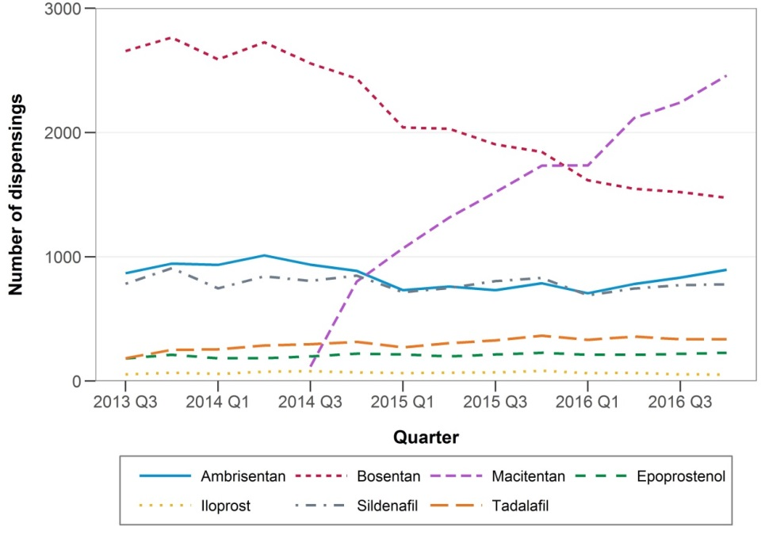
Figure 2.1: Quarterly dispensing by PAH medicine, 2013-2016
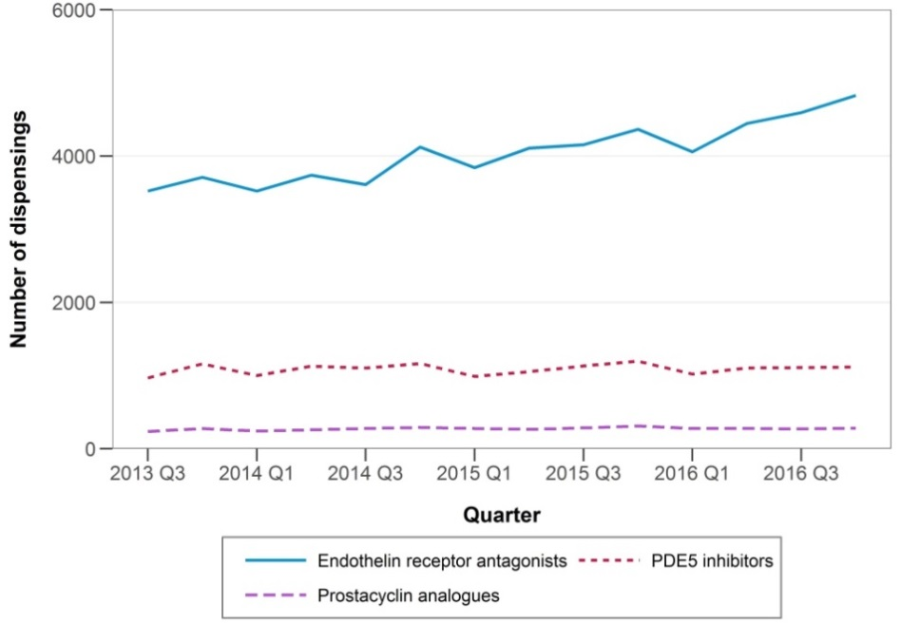
Figure 2.2: Quarterly dispensing by medicine class, 2013-2016

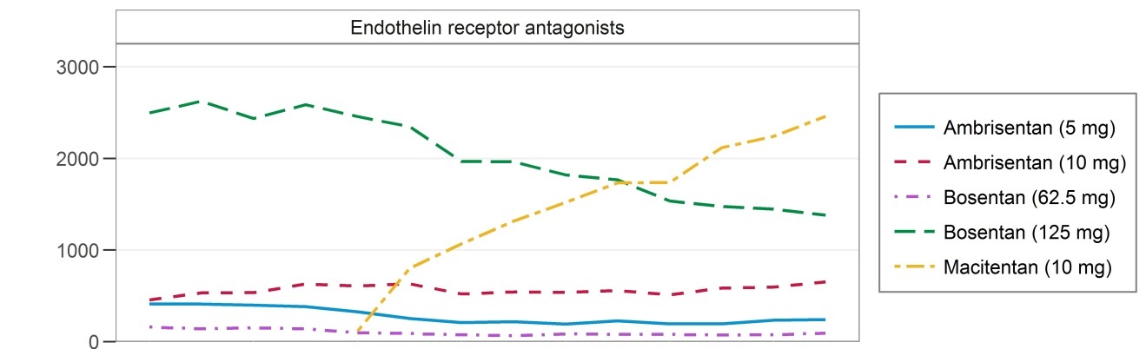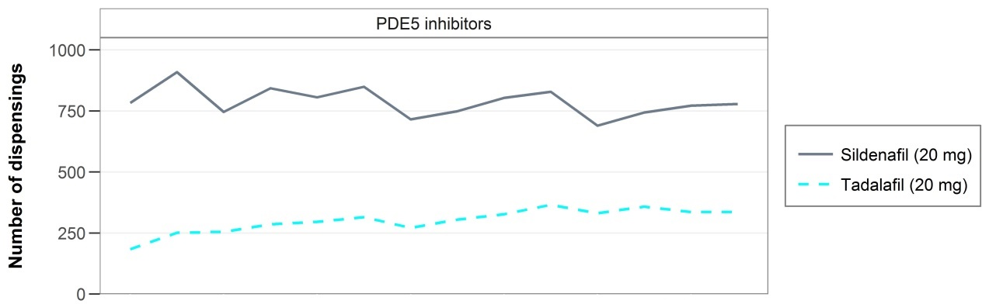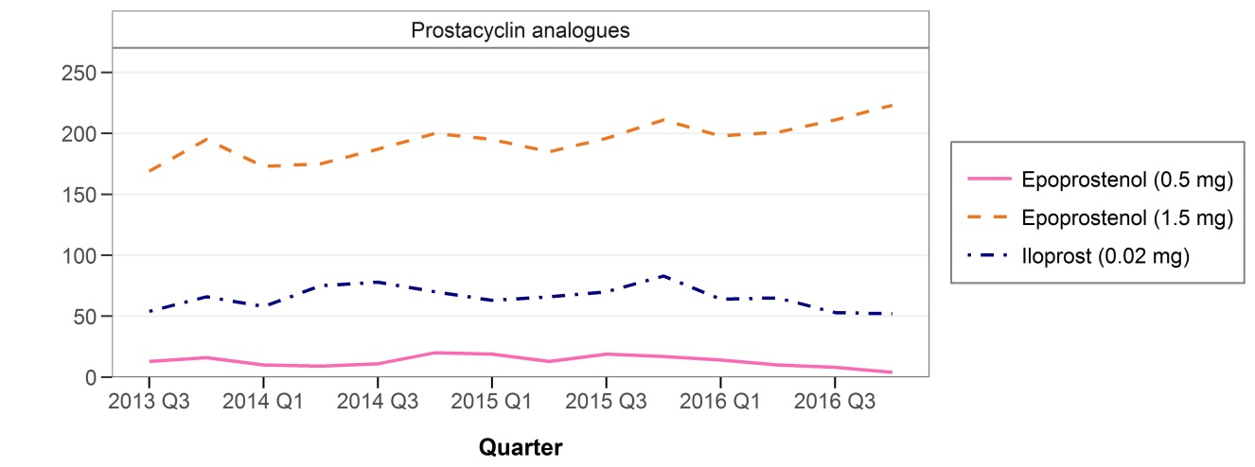
Figure 2.3: Quarterly dispensing by medicine class and strength, 2013-2016
The quarterly number of PAH medicine dispensings and corresponding PBS benefit costs remained relatively stable across calendar time (2013-2016) for each separate medicine and medicine strength, except for bosentan (120 mg) and macitentan (10 mg) (Figures 2.3 and 2.5). A simultaneous trend of decreasing bosentan and increasing macitentan dispensings occurred during the period of observation, which overlapped during the last quarter of 2015.
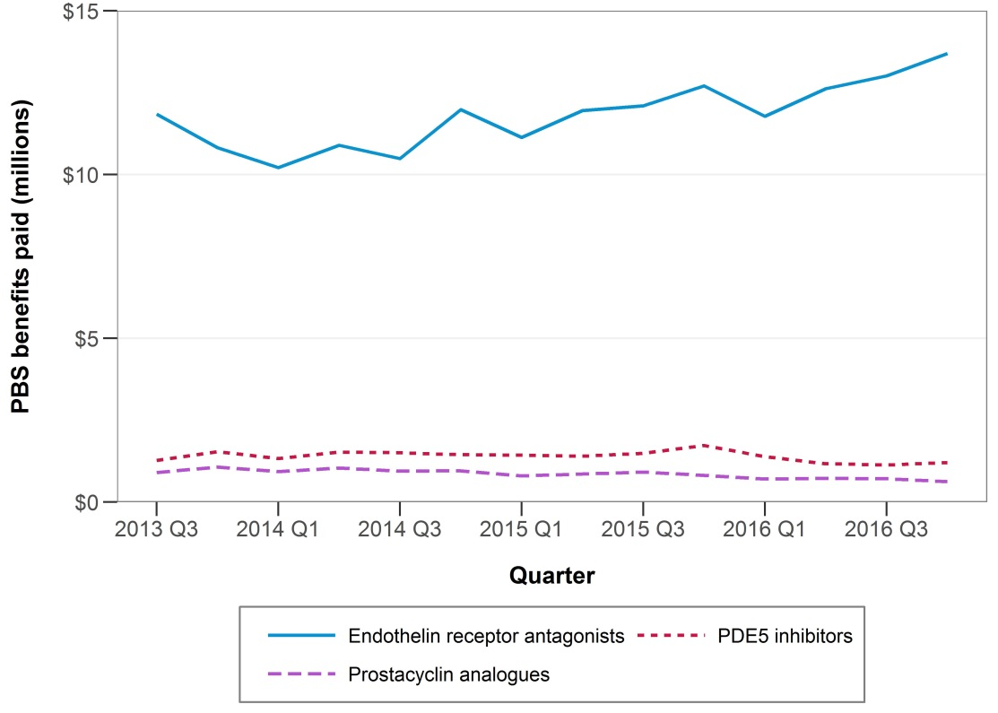
Figure 2.4: PBS benefit paid by medicine class (in millions AUD)
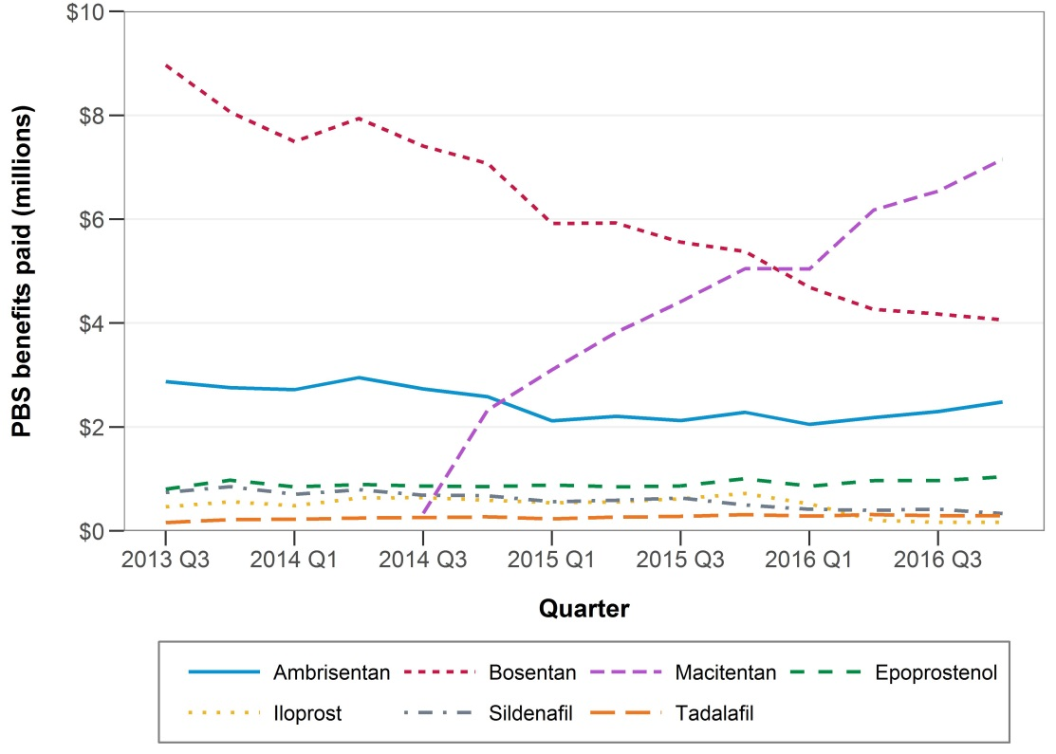
Figure 2.5: PBS benefit paid by medicine (in millions AUD)

Prevalence of PAH medicine use
Table 2.3 shows the distribution of demographic characteristics among prevalent PAH patients in 2014-2016. During this period, the number of patients increased slightly (from 2189 to 2394), but the patient demographics remained similar. The majority of prevalent patients on PAH treatment were female (73% in 2016). Treatment for PAH increased with patient age until 65-74 years and declined thereafter; the number of treated patients was smallest among those 85 years and older. The largest proportion of prevalent patients treated with PAH medicines resided in NSW/ACT.
Table 2.3: Annual number of prevalent users by patient characteristics
 |  | Year
 | 2014 | 2015 | 2016
Number of people | N= 2189 (100%) | N= 2304 (100%) | N= 2394 (100%)
Sex
Male | 555 (25.4) | 614 (26.6) | 647 (27.0)
Female | 1634 (74.6) | 1690 (73.4) | 1747 (73.0)
Age (years)
<35 | 211 (9.6) | 216 (9.4) | 213 (8.9)
34-44 | 211 (9.6) | 212 (9.2) | 208 (8.7)
45-54 | 253 (11.6) | 259 (11.2) | 280 (11.7)
55-64 | 382 (17.5) | 402 (17.5) | 401 (16.8)
65-74 | 574 (26.2) | 605 (26.3) | 657 (27.4)
75-84 | 443 (20.2) | 493 (21.4) | 500 (20.9)
≥85 | 115 (5.3) | 117 (5.1) | 135 (5.6)
''''''''' '''' ''''''''''''''''''
''''''''''''''''''' | '''''''' '''''''''''' | '''''' '''''''''''' | ''''''' '''''''''''
'''''''' | ''''''' ''''''''''' | '''''''' ''''''''''' | ''''''' '''''''''''
'''''' | '''''''' ''''''''''' | ''''''' ''''''''''' | '''''''' '''''''''''
''''' | '''''' ''''''''' | ''''''' ''''''''' | '''''''' '''''''''
'''''' | ''''''' '''''''' | '''''''' ''''''''' | '''''' ''''''''
'''''''' | ''''''' '''''''''' | '''''''' ''''''''' | '''''''' ''''''''
'''''' | ''''' ''''''''' | ''''' '''''''''' | ''''' ''''''''
Medicine class(es) dispensed
ERAs only | 1526 (69.7) | 1644 (71.4) | 1762 (73.6)
Prostacyclin analogue only | 101 (4.6) | 106 (4.6) | 98 (4.1)
PDE-5 inhibitor only | 475 (21.7) | 480 (20.8) | 448 (18.7)
Multiple classes | 87 (4.0) | 74 (3.2) | 86 (3.6)
*Percentages may add up to more than 100% as people can appear in multiple categories
Figures 2.6 to 2.9 demonstrate the quarterly prevalence of PAH medicine use per 1,000,000 population from Quarter 3 2013 to Quarter 4 2016 by medicine class, patient sex, age group and state of residence.
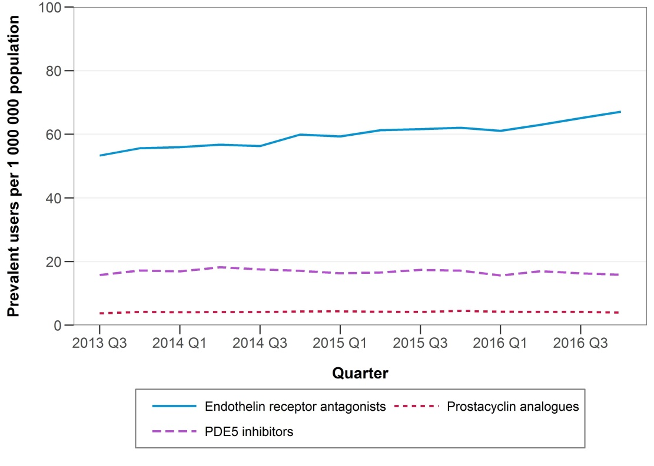
Figure 2.6: Quarterly prevalence per 1,000,000 population by medicine class
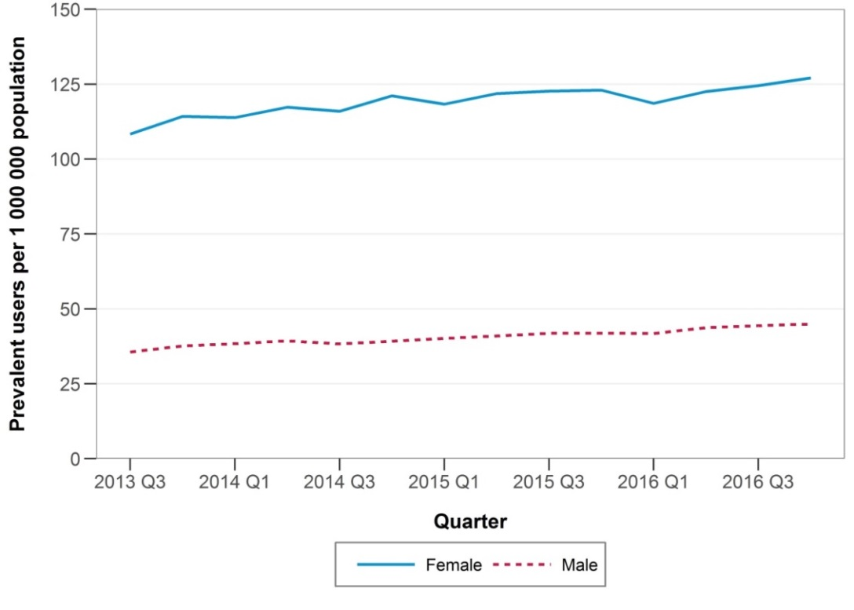
Figure 2.7: Quarterly prevalence per 1,000,000 population by sex
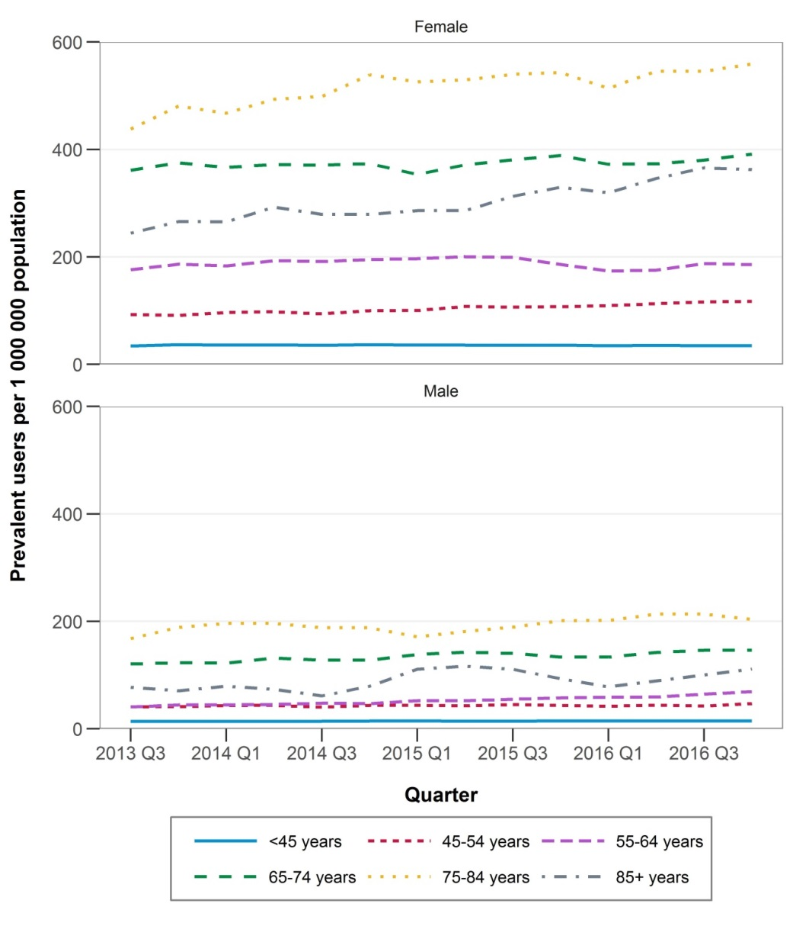
Figure 2.8: Quarterly prevalence per 1,000,000 population by sex and age group
Although prevalent PAH medicine use was higher among females than males, the age distribution did not differ by sex (Figure 2.8). Prevalence was lowest among the youngest patients, under 45 years, and highest among those 75-84 years.
'''''''''''' '''''' '''''''''''''''' ''''''''''''''''''' ''''''' ''''''''''''''''' ''''''''''''''''''' ''''' ''''''''''''' '''''''''
'''''''''''''''''''''' ''''' ''''''' ''''''' ''''''''''''''' '''' '''''''''''''''''' ''''' ''''' '''''''''''' '''''' '''''''''''''''''''' '''' ''''''''''''''' ''''''''''''''''''''''''

Incidence of PAH medicine use
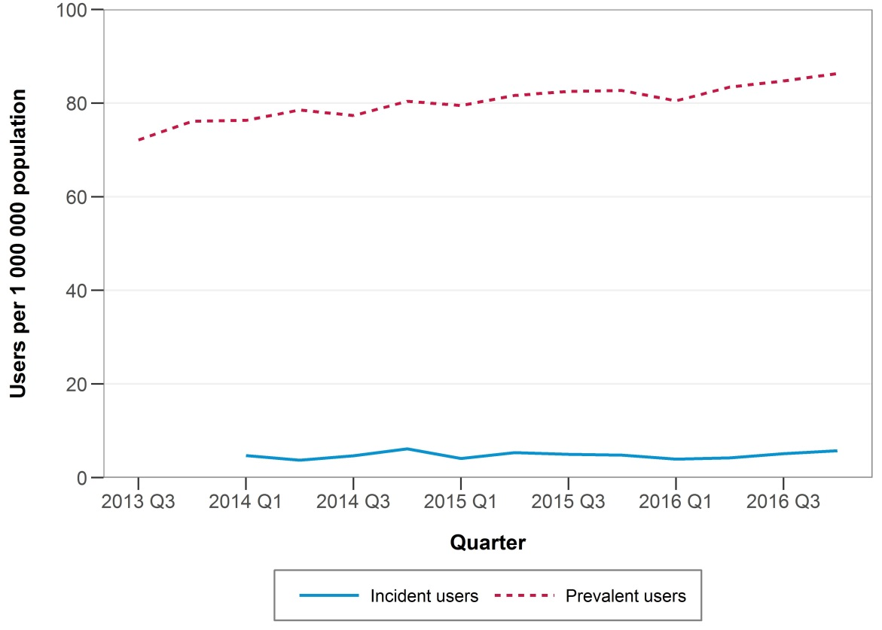
Figure 2.10: Quarterly incidence and prevalence of use per 1,000,000 population
Figure 2.10 indicates that while incident use of PAH medicines by quarter remained relatively stable across calendar time in 2013-2016, prevalent use by quarter increased slightly (from 72.3 per 1,000,000 in Quarter 3 2013 to 86.3 per 1,000,000 population in Quarter 4 2016).
Table 2.4: Annual number of incident (new) users by patient demographics and first medicine dispensed
 | Year
 | 2014 | 2015 | 2016
Number of people | N= 454 (100%) | N= 457 (100%) | N= 461 (100%)
Sex Males | 134 (29.5) | 173 (37.9) | 163 (35.4)
Females | 320 (70.5) | 284 (62.1) | 298 (64.6)
Age (years) <35 | 39 (8.6) | 40 (8.8) | 33 (7.2)
34-44 | 33 (7.3) | 20 (4.4) | 23 (5.0)
45-54 | 41 (9.0) | 45 (9.9) | 45 (9.8)
55-64 | 84 (18.5) | 66 (14.4) | 79 (17.1)
65-74 | 127 (28.0) | 131 (28.7) | 144 (31.2)
75-84 | 102 (22.5) | 130 (28.5) | 108 (23.4)
85+ | 28 (6.2) | 25 (5.5) | 29 (6.3)
'''''''''''''''''''''''''''' | ''''''' '''''''''''' | ''''''' ''''''''''' | ''''''' ''''''''''
'''''''' | ''''' '''''''''' | '''''' '''''''''''' | '''''''' ''''''''''
''''''' | ''''' '''''''''' | ''''' ''''''''''' | '''''' ''''''''''''
''''' | ''''' ''''''''' | ''''' '''''''''''' | ''''' '''''''''''
''''''' | '''''' '''''''''' | '''''' '''''''''' | ''''' '''''''''
''''''' | '''''' ''''''''' | ''''' '''''''' | ''''' '''''''''
'''''' | ''' ''''''''' | ''''' | ''' '''''''''
Medicine class initiated on:
ERA | 312 (68.7) | 312 (68.3) | 346 (75.1)
Prostacyclin analogue | 11 (2.4) | 9 (2.0) | <6
PDE-5 inhibitor | 131 (28.9) | 136 (29.8) | 110 (23.9)
Medicine and strength initiated on:
Ambrisentan – 5 mg | 22 (4.8) | 21 (4.6) | 32 (6.9)
Ambrisentan – 10 mg | 26 (5.7) | 18 (3.9) | 42 (9.1)
Bosentan – 62.5 mg | 114 (25.1) | 18 (3.9) | 10 (2.2)
Bosentan – 125 mg | 7 (1.5) | <6 | <6
Macitentan – 10 mg | 143 (31.5) | 253 (55.4) | 261 (56.6)
Epoprostenol - 500 µg | <6 | <6 | <6
Epoprostenol – 1.5 mg | <6 | <6 | <6
Iloprost – 20 µg | 6 (1.3) | <6 | <6
Sildenafil – 20 mg | 106 (23.3) | 103 (22.5) | 86 (18.7)
Tadalafil – 20 mg | 25 (5.5) | 33 (7.2) | 24 (5.2)
The distribution of demographic characteristic among incident patients was similar as among prevalent patients (Tables 2.3 and 2.4). The majority of incident patients started treatment with 10 mg macitentan (57% of new patients in 2016), followed by 20 mg sildenafil (18.7% of new patients in 2016).
Table 2.5 shows the annual incident PAH medicine use per 1,000,000 population by patient demographics. Incidence was higher among females (24.4 per 1,000,000 in 2016) than males (13.6 per 1,000,000 in 2016) and ''''' ''''' '''''''''''' ''''''''''''' ''' '''''''''''''''''''' '''''''''''' '''''' '''''''''''''''''' '''' ''''''''''.
Table 2.5: Annual incidence of PAH use per 1,000,000 population by patient demographics
 | Year
 | 2014 | 2015 | 2016
Number of patients | N= 454 | N= 457 | N= 461
Incidence per 1,000,000 population
Total | 19.32 | 19.16 | 19.04
Sex
Males | 11.47 | 14.61 | 13.57
Females | 27.06 | 23.65 | 24.43
Age (years)
<35 | 3.53 | 3.57 | 2.90
34-44 | 10.24 | 6.19 | 7.11
45-54 | 13.21 | 14.40 | 14.25
55-64 | 31.30 | 24.16 | 28.38
65-74 | 65.69 | 65.24 | 69.08
75-84 | 96.51 | 120.34 | 97.62
85+ | 61.73 | 53.36 | 60.07
'''''''''
''''''''''''''''''' | ''''''''''' | '''''''''''' | ''''''''''
'''''''' | ''''''''''' | ''''''''''' | '''''''''''
'''''' | '''''''''''' | ''''''''''' | '''''''''''
''''' | '''''''''''' | '''''''''' | ''''''''''''
''''''' | '''''''''' | '''''''''' | ''''''''''
''''''' | '''''''''''' | '''''''''''' | '''''''''''''
'''''' | '''''''''' | '''''''''' | '''''''''''

Time on treatment
Among people who initiated on treatment in 2014, in the first 360 days 14.5% had died, but 70.9% of those still alive were still persistent (had not discontinued) (Table 2.6). By 720 days post-initiation, 24.9% had died and 61.9% of those still alive were still persistent.
Table 2.6: Persistence with treatment in first 720 days among incident PAH medicine users in 2014
 | Primary analysis | Sensitivity analysis
Number of patients | 454 | 454
360 days post-initiation
Died within 360 days, n (%) | 66 (14.5) | 66 (14.5)
Proportion of those still alive persistent on treatment, n (%)^ | 275/388 (70.9) | 299/388 (77.1)
720 days post-initiation
Died within 720 days, n (%) | 113 (24.9) | 113 (24.9)
Proportion of those still alive persistent on treatment, n (%)^ | 211/341 (61.9) | 240/341 (70.4)
^Persistence was defined as still on treatment without discontinuation. Discontinuation was defined as a period of 87 days or more (3 × median number of days between dispensings) without any dispensing. In the sensitivity analysis, a period of 116 days is used (4 × median number of days between dispensings).

Switching
Switching between PAH medicines was not common.
Among a total of 3187 patients treated with PAH medicines, 418 (13%) switched medicines. Of these, the majority (82%) of patients only switched once (Table 2.7). Patients most commonly switched from PDE-5 inhibitors to ERAs (37% of all switches, allowing for breaks).

Table 2.7: Switching between PAH medicines among prevalent users 2013-2016
 | Switching type
 | Not allowing for breaks* | Allowing for breaks^
Number of switches | 364 | 418
Number of people switching | 247 (7.8) | 293 (9.2)
1 switch only | 203 (82.2) | 240 (81.9)
>1 switch | 44 (17.8) | 53 (18.1)
Most common switches
ERA to:
Prostacyclin analogue | 69 (19.0) | 77 (18.4)
PDE-5 inhibitor | 91 (25.0) | 109 (26.1)
ERA/PDE-5 inhibitor in combination | <6 | <6
Prostacyclin analogue to:
ERA | 7 (1.9) | 10 (2.4)
PDE-5 inhibitor | 19 | <6
PDE-5 inhibitor to:
ERA | 128 (35.2) | 154 (36.8)
Prostacyclin analogue | 25 (6.9) | 27 (6.5)
PDE-5 inhibitor/ERA in combination | 6 (1.7) | <6
Prostacyclin analogue/PDE-5 inhibitor in combination | <6 | <6
Combination treatment to monotherapy:
ERA/PDE-5 inhibitor in combination to ERA | 7 (1.9) | 6 (1.4)
ERA/PDE-5 in combination to PDE-5 inhibitor | <6 | <6
Prostacyclin/PDE-5 inhibitor in combination to PDE-5 inhibitor | <6 | <6
*Switching (not allowing for breaks) was defined as dispensing of a new medicine class(es) within 87 days (i.e. 3 × median time between dispensings) of a dispensing for a different medicine class.
^Switching (allowing for breaks) was defined as dispensing of a new medicine class(es) after dispensing for a different medicine class allowing for a break between them.

Combination treatment
Based on the PBS data only, combination treatment was very rare; only 13 episodes of combination treatment were observed among a total of seven individuals.
Table 2.8: Characteristics of combination treatment
Combination type | Number (%) | Days on combination treatment, range | No. of overlapping dispensings, range
ERA and PDE-5 inhibitor | <13 | 63-294 | 4-15
Prostacyclin analogue and PDE-5 inhibitor | <6 | 91-136 | 4-8
Combination treatment was defined as overlapping treatment for a period of ≥58 days (i.e. 2 × median time between dispensings).

Sensitivity analysis
Using a less strict definition of combination treatment, 33 episodes of combination treatment were observed among a total of 13 individuals.
Table 2.9: Characteristics of combination treatment – sensitivity analysis
Combination type | Number (%) | Days on combination treatment, range | No. of overlapping dispensings, range
ERA and PDE-5 inhibitor | <33 | 30-294 | 2-8
Prostacyclin analogue and PDE-5 inhibitor | 11/33 (33) | 32-136 | 2-8
ERA and prostacyclin analogue | <6 | 31-35 | 2-2
Combination treatment was defined as overlapping treatment for a period of ≥29 days (i.e. 1 × median time between dispensings).

Appendix A
Suppl. Table 1. PBS listing details of PAH medicines by medicine class (as of November 2017).
Medicine | ATC Code | Date PBS listed | Item code |  | Strength and formulation | Pack Size |  |  | Route of administration
Endothelin receptor antagonists (ERAs)
ambrisentan | C02KX01 | 1-Dec-09 | 9648T |  | Tablet 5 mg | 30 |  |  | ORAL
 |  | 1-Jul-10 | 5607D |  | Tablet 5 mg | 30 |  |  | ORAL
 |  | 1-Dec-09 | 9649W |  | Tablet 10 mg | 30 |  |  | ORAL
 |  | 1-Jul-10 | 5608E |  | Tablet 10 mg | 30 |  |  | ORAL
bosentan | C02KX01 | 1-Mar-04 | 6429J |  | Tablet 62.5 mg (as monohydrate) | 60 |  |  | ORAL
 |  | 1-Jul-10 | 5618Q |  | Tablet 62.5 mg (as monohydrate) | 60 |  |  | ORAL
 |  | 1-Mar-04 | 6430K |  | Tablet 125 mg (as monohydrate) | 60 |  |  | ORAL
 |  | 1-Jul-10 | 5619R |  | Tablet 125 mg (as monohydrate) | 60 |  |  | ORAL
macitentan | C02KX04 | 1-Sep-14 | 10134J |  | Tablet 10 mg | 30 |  |  | ORAL
 |  | 1-Sep-14 | 10136L |  | Tablet 10 mg | 30 |  |  | ORAL
Synthetic prostacyclin /prostacyclin analogues
epoprostenol | C02KX | 1-Aug-06 |  | 6477X | Powder for I.V. infusion 500 micrograms (as sodium) with diluent |  | 1 |  | INJECTION
 |  | 1-Aug-06 |  | 6478Y | Powder for I.V. infusion 1.5 mg (as sodium) with diluent |  | 1 |  | INJECTION
 |  | 1-Jul-10 |  | 5731P | Powder for I.V. infusion 500 micrograms (as sodium) with diluent |  | 1 |  | INJECTION
 |  | 1-Jul-10 |  | 5732Q | Powder for I.V. infusion 1.5 mg (as sodium) with diluent |  | 1 |  | INJECTION
 |  | 1-Jan-12 |  | 5030R | Powder for I.V. infusion, 500 micrograms (as sodium) infusion administration set |  | 1 |  | INJECTION
 |  | 1-Jan-12 |  | 5035B | Powder for I.V. infusion, 1.5 mg (as sodium) infusion administration set |  | 1 |  | INJECTION
 |  | 1-Jan-12 |  | 5036C | Powder for I.V. infusion, 500 micrograms (as sodium) infusion administration set |  | 1 |  | INJECTION
 |  | 1-Jan-12 |  | 5042J | Powder for I.V. infusion, 1.5 mg (as sodium) infusion administration set |  | 1 |  | INJECTION
 |  | 1-Aug-14 |  | 10111E | Powder for I.V. infusion 500 micrograms (as sodium) |  | 1 |  | INJECTION
 |  | 1-Aug-14 |  | 10117L | Powder for I.V. infusion 1.5 mg (as sodium) |  | 1 |  | INJECTION
 |  | 1-Aug-14 |  | 10129D | Powder for I.V. infusion 1.5 mg (as sodium) |  | 1 |  | INJECTION
 |  | 1-Aug-14 |  | 10130E | Powder for I.V. infusion 500 micrograms (as sodium) |  | 1 |  | INJECTION
 |  | 1-Apr-17 |  | 11065J | Powder for I.V. infusion 1.5 mg (as sodium) with 2 vials diluent 50 mL |  | 1 |  | INJECTION
 |  | 1-Apr-17 |  | 11069N | Powder for I.V. infusion 500 micrograms (as sodium) with 2 vials diluent 50 mL |  | 1 |  | INJECTION
 |  | 1-Apr-17 |  | 11082G | Powder for I.V. infusion 1.5 mg (as sodium) with 2 vials diluent 50 mL |  | 1 |  | INJECTION
 |  | 1-Apr-17 |  | 11090Q | Powder for I.V. infusion 500 micrograms (as sodium) with 2 vials diluent 50 mL |  | 1 |  | INJECTION
iloprost | C02KX | 1-Apr-05 |  | 6456T | Solution for inhalation 20 micrograms (as trometamol) in 2 mL |  | 30 |  | INHALATION
 |  | 1-Jul-10 |  | 5751Q | Solution for inhalation 20 micrograms (as trometamol) in 2 mL |  | 30 |  | INHALATION
Phosphodiesterase type-5 (PDE-5) inhibitors
sildenafil | C02KX | 1-Mar-07 | 9605M |  | Tablet 20 mg (as citrate) | 90 |  | ORAL
 |  | 1-Jul-10 | 9547L |  | Tablet 20 mg (as citrate) | 90 |  | ORAL
tadalafil | C02KX | 1-Apr-12 | 1304P |  | Tablet 20 mg | 56 |  | ORAL
 |  | 1-Apr-12 | 1308W |  | Tablet 20 mg | 56 |  | ORAL
Soluble guanylate cyclase (sGC) stimulator
riociguat | C02KX05 | 1-Feb-17 | 11024F |  | Tablet 2.5 mg | 84 |  | ORAL
 |  | 1-Feb-17 | 11028K |  | Tablet 1 mg | 42 |  | ORAL
 |  | 1-Feb-17 | 11030M |  | Tablet 2 mg | 84 |  | ORAL
 |  | 1-Feb-17 | 11031N |  | Tablet 500 micrograms | 42 |  | ORAL
 |  | 1-Feb-17 | 11035T |  | Tablet 2.5 mg | 84 |  | ORAL
 |  | 1-Feb-17 | 11038Y |  | Tablet 2 mg | 42 |  | ORAL
 |  | 1-Feb-17 | 11039B |  | Tablet 2 mg | 84 |  | ORAL
 |  | 1-Feb-17 | 11040C |  | Tablet 500 micrograms | 42 |  | ORAL
 |  | 1-Feb-17 | 11045H |  | Tablet 2 mg | 42 |  | ORAL
 |  | 1-Feb-17 | 11046J |  | Tablet 1.5 mg | 42 |  | ORAL
 |  | 1-Feb-17 | 11047K |  | Tablet 1.5 mg | 42 |  | ORAL
 |  | 1-Feb-17 | 11048L |  | Tablet 1.5 mg | 84 |  | ORAL
 |  | 1-Feb-17 | 11052Q |  | Tablet 2.5 mg | 42 |  | ORAL
 |  | 1-Feb-17 | 11053R |  | Tablet 1 mg | 84 |  | ORAL
 |  | 1-Feb-17 | 11054T |  | Tablet 1 mg | 42 |  | ORAL
 |  | 1-Feb-17 | 11057Y |  | Tablet 2.5 mg | 42 |  | ORAL
 |  | 1-Feb-17 | 11058B |  | Tablet 500 micrograms | 84 |  | ORAL
 |  | 1-Feb-17 | 11059C |  | Tablet 500 micrograms | 84 |  | ORAL
 |  | 1-Feb-17 | 11060D |  | Tablet 1 mg | 84 |  | ORAL
 |  | 1-Feb-17 | 11061E |  | Tablet 1.5 mg | 84 |  | ORAL
*The number of repeats for all PAH PBS items is 0. The number of repeats must be specified by the prescriber when requesting the approval.

References
1. Galiè N, Torbicki A, Barst R, Dartevelle P, Haworth S, Higenbottam T, et al. Guidelines on diagnosis and treatment of pulmonary arterial hypertension: The Task Force on Diagnosis and Treatment of Pulmonary Arterial Hypertension of the European Society of Cardiology. Eur Heart J. 2004;25(24):2243-78.
2. Peacock A, Murphy N, McMurray J, Caballero L, Stewart S. An epidemiological study of pulmonary arterial hypertension. Eur Respir J. 2007;30(1):104-9.
3. Frost AE, Badesch DB, Barst RJ, Benza RL, Elliott CG, Farber HW, et al. The changing picture of patients with pulmonary arterial hypertension in the United States: how REVEAL differs from historic and non-US Contemporary Registries. Chest. 2011;139(1):128-37.
4. Ling Y, Johnson MK, Kiely DG, Condliffe R, Elliot CA, Gibbs JSR, et al. Changing demographics, epidemiology, and survival of incident pulmonary arterial hypertension: results from the pulmonary hypertension registry of the United Kingdom and Ireland. Am J Respir Crit Care Med. 2012;186(8):790-6.
5. Jansa P, Jarkovsky J, Al-Hiti H, Popelova J, Ambroz D, Zatocil T, et al. Epidemiology and long-term survival of pulmonary arterial hypertension in the Czech Republic: a retrospective analysis of a nationwide registry. BMC Pulm Med. 2014;14(1):45.
6. Drug utilisation sub-committee (DUSC). Pulmonary Arterial Hypertension (PAH) medicines utilisation analysis. Department of Health: Australia, 2015. http://www.pbs.gov.au/info/industry/listing/participants/public-release-docs/pulmonary-arterial-hypertension-pah-medicines-utilisation.
7. Ruiz G, Besinque GM, Lickert CA, Raspa S. Combination therapy in pulmonary arterial hypertension: is this the new standard of care? Am J Manag Care. 2015;21(8 Suppl):s151-61.
8. Galiè N, Humbert M, Vachiery JL, Gibbs S, Lang I, Torbicki A, et al. 2015 ESC/ERS Guidelines for the diagnosis and treatment of pulmonary hypertension. Eur Heart J. 2015;46:903-975.

“Classes” as patients can switch to/from combination treatment.

